

Operating Systems


Process Scheduling Project

Reg No: 11605748

Roll No.: B26

Email: adiprakash.prakash@gmail.com

Questions: 9
Q9 :

CODE :
#include<stdio.h>

int main()
{
int i, size, total = 0, x, count = 0, TimeQuantum;
int waitTime = 0, TAT = 0, AT[10], BT[10], Temp[10];
float AWT, ATAT;
printf("\nEnter Total Number of Processes:\t");
scanf("%d", &size);
x = size;
for(i = 0; i < size; i++)
{
printf("\nEnter Details of Process[%d]\n", i + 1);
printf("Arrival Time:\t");
scanf("%d", &AT[i]);
printf("Burst Time:\t");
scanf("%d", &BT[i]);
Temp[i] = BT[i];
}
printf("\nEnter Time Quantum:\t");
scanf("%d", &TimeQuantum);
printf("\nProcess ID\t\tBurst Time\t Turnaround Time\t Waiting Time\n");
for(total = 0, i = 0; x != 0;)
{
if(Temp[i] <= TimeQuantum && Temp[i] > 0)
{
total = total + Temp[i];
Temp[i] = 0;
count = 1;
}
else if(Temp[i] > 0)
{
Temp[i] = Temp[i] - TimeQuantum;
total = total + TimeQuantum;
}
if(Temp[i] == 0 && count == 1)
{
x--;
printf("\nProcess[%d]\t\t%d\t\t %d\t\t\t %d", i + 1, BT[i], total - AT[i], total - AT[i] - BT[i]);
waitTime = waitTime + total - AT[i] - BT[i];
TAT = TAT + total - AT[i];
count = 0;
}
if(i == size - 1)
{
i = 0;
}
else if(AT[i + 1] <= total)
{
i++;
}
else
{
i = 0;
}
}
AWT = waitTime * 1.0 / size;
ATAT = TAT * 1.0 / size;
printf("\n\nAverage Waiting Time:\t%f", AWT);
printf("\nAvg Turnaround Time:\t%f\n", ATAT);
return 0;
}

1. Explain the problem in terms of operating system concept?

This question involves a pre-emptive scheduling algorithm based on priority . The process with higher priority is executed first. Priorities must keep on changing dynamically according to the given condition. If two processes are having same priority the process which is not executed recently is executed first. Arrival time, Burst time must be entered by the user dynamically. While calculating I found that both
the question and round robin are giving the same output.

Boundary Conditions:

Arrival time must not be negative.

Burst time must not be negative.

Number of queues must be positive.

Number of process must not be negative.

Priority of queue1 must not be less than queue2 as mentioned in the question.
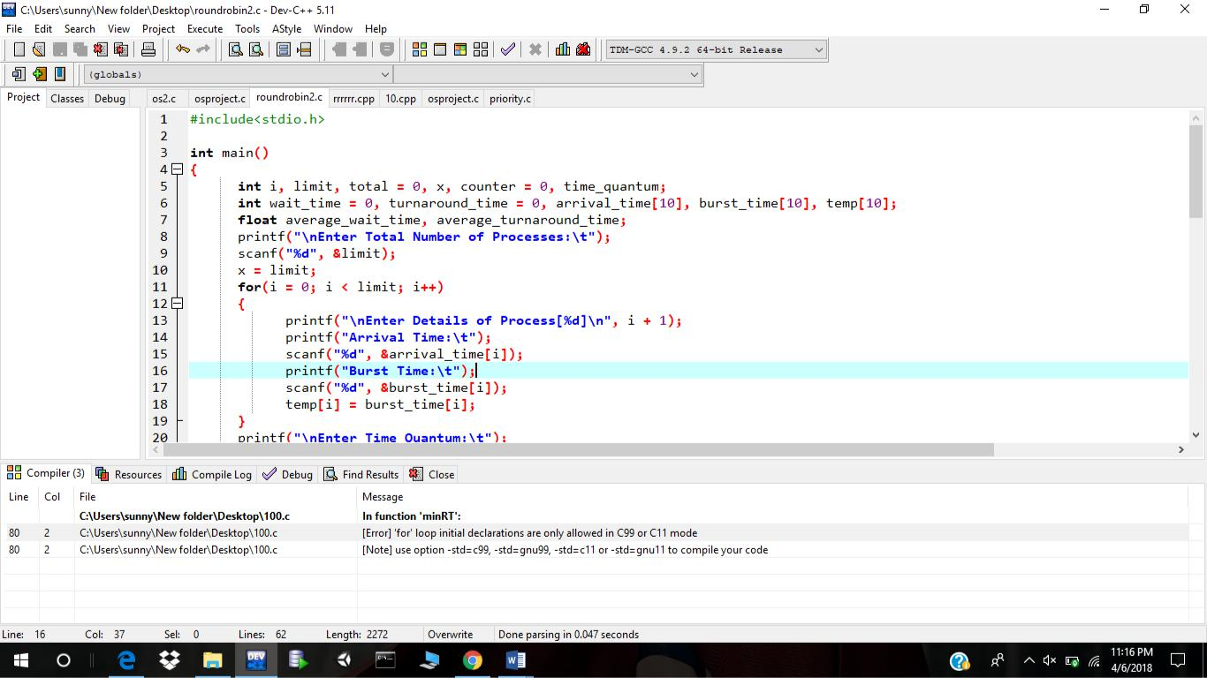
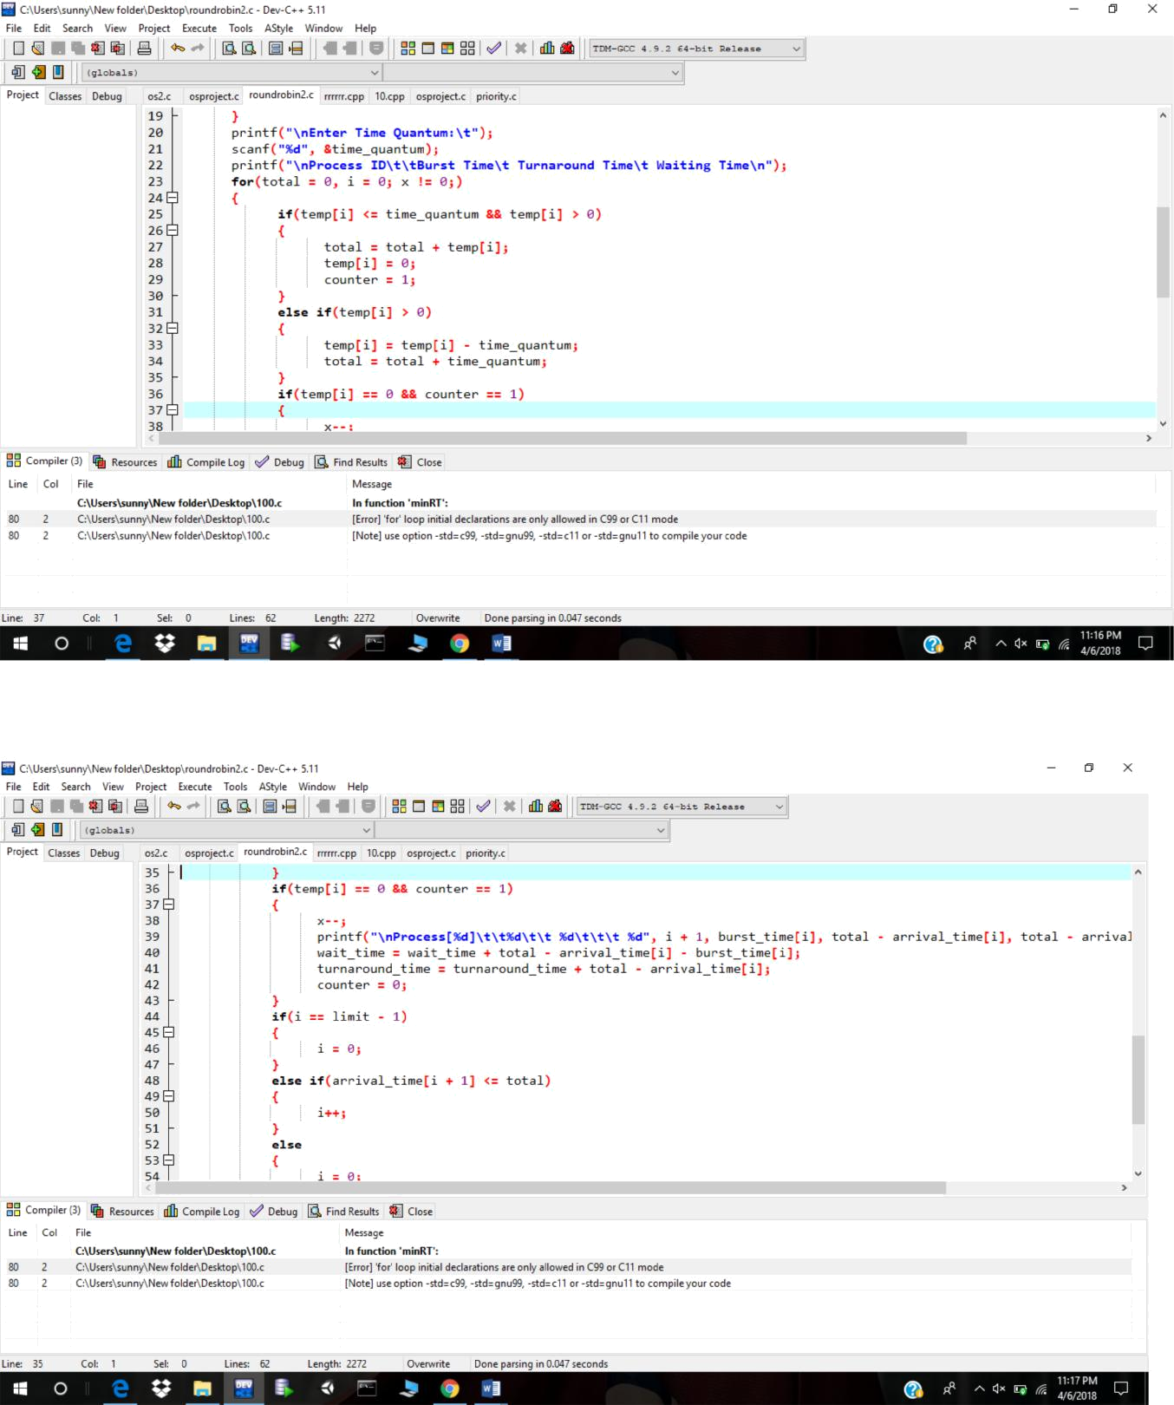
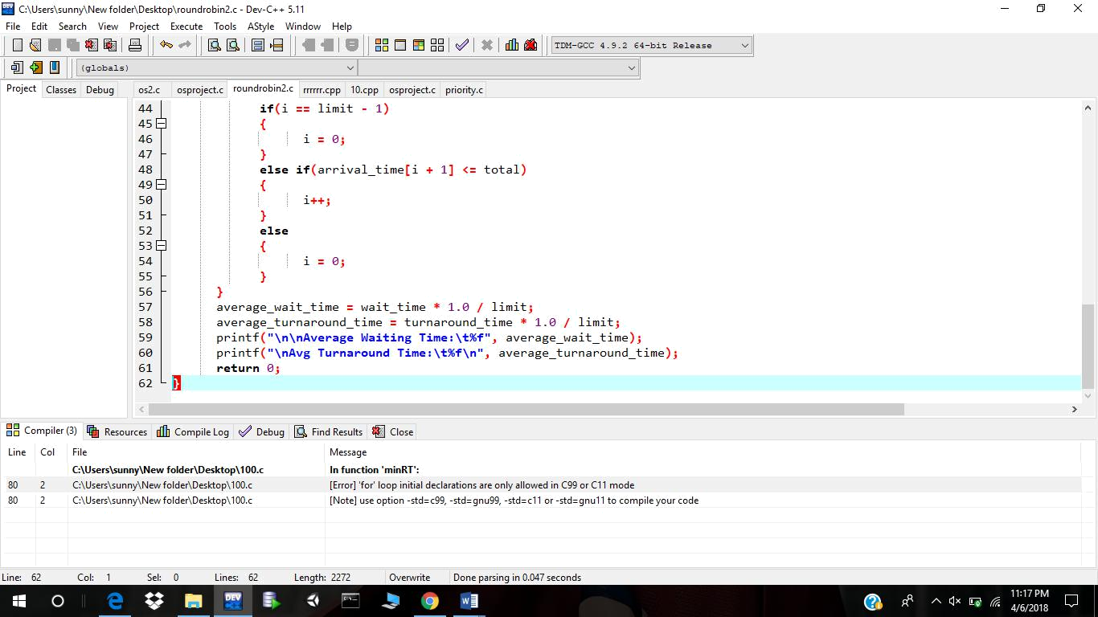

Test Cases:

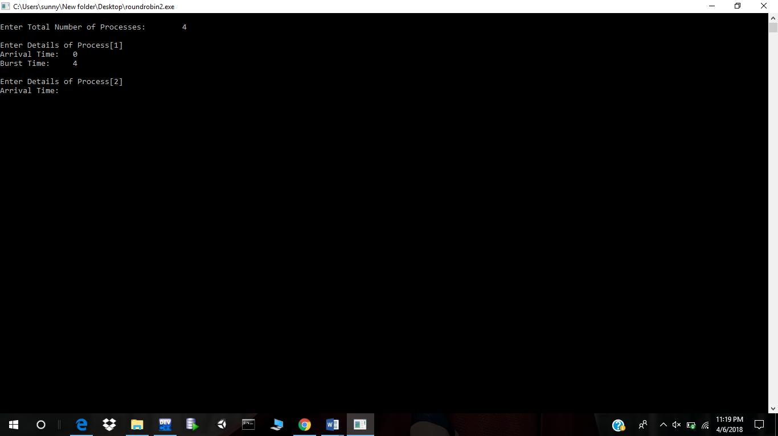
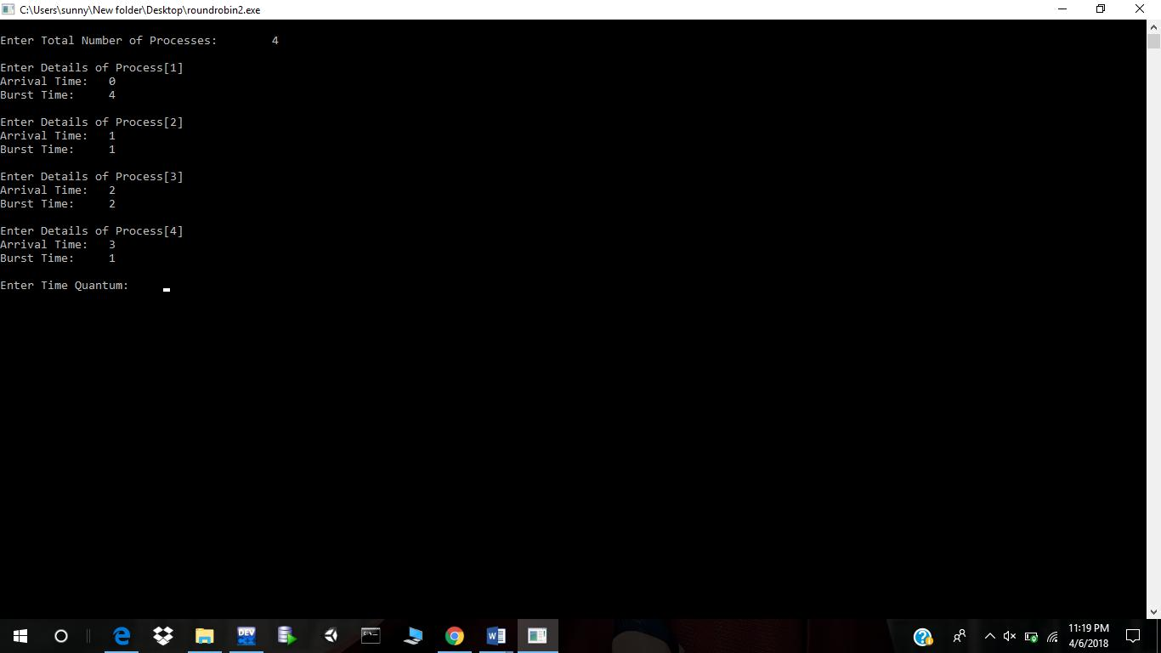
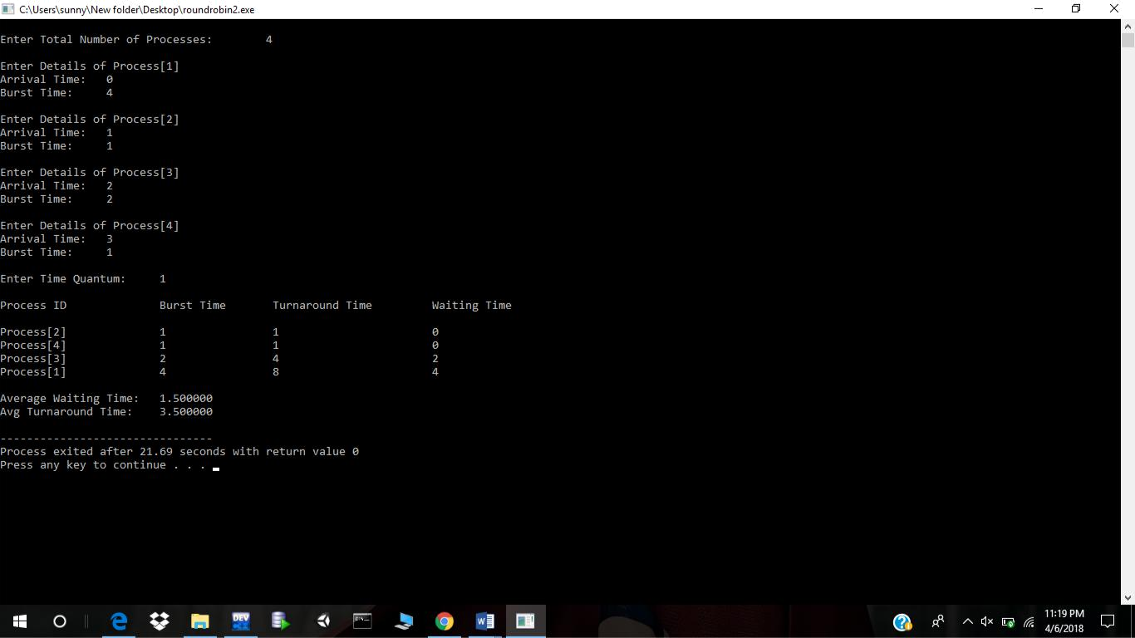

Process ID | ARRIVAL TIME | BURST TIME
1 | 0 | 4
2 | 1 | 1
3 | 2 | 3
4 | 4 | 1

If you have implemented any additional algorithm to support the solution, explain the need and usage of the same.

I have used round robin algorithm which works on a time quantum.

GitHub Link :- https://github.com/aditya487/OS-Assignment

