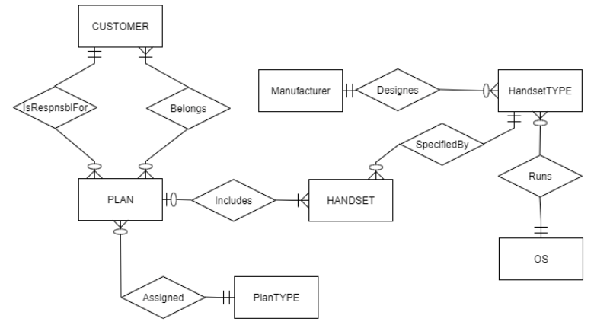

* 1. Cellular Operator Database Figure 2-24 questions:

1. *Can a customer have an unlimited number of plans?*

Yes. A Customer may be responsible for 0, 1, or many Plans.

1. *Can a customer exist without a plan?*

Yes. The minimum cardinality of the Belongs relationship from the Customer to the Plan states that a Customer may exist without a Plan (the minimum cardinality is 0).

1. *Is it possible to create a plan without knowing who the customer is?*

No. The minimum cardinality of both the “responsible for” and “belongs” relationships between Plan and Customer states that at least one Customer must be related to a Plan.

1. *Does the operator want to limit the types of handsets that can be linked to a specific plan type?*

Yes, the cellular operator requires that a Handset (that is a particular type and a particular operating system) is linked to one Plan (that is a particular type of plan). This business rule is to be implemented in this design by indirectly requiring that a Plan Type has 0:M Plans, and each Plan is associated with certain Handsets, and each Handset is of some Handset Type. A given Plan Type is related to Handset Type through the intermediary entity types in this design.

[Alternative interpretation: No, there is nothing in the current model that creates a condition that would limit – in advance – the handset types that can be related to a specific plan type.]

1. *Is it possible to maintain data regarding a handset without connecting it to a plan?*

Yes. The minimum cardinality of the Includes relationship between Plan and Handset states that a Handset may be included in 0 or 1 plan. The 0 minimum cardinality means that we can track data about the handset even if it is not connected to a plan; the Handset has optional participation in the Includes relationship with Plan.

1. *Can a handset be associated with multiple plans?*

No. The minimum cardinality of the Includes relationship between Plan and Handset states that a Handset may be included in 0 or 1 plan, not multiple plans.

1. *Assume a handset type exists that can utilize multiple operating systems. Could this situation be accommodated within the model included in Figure 2-24?*

No. The current model shows that a handset type is associated with one and only one operating system.

1. *Is the company able to track a manufacturer without maintaining information about its handsets?*

Yes. The minimum cardinality of the relationship between Manufacturer and Handset Type indicates that we can track data about a Manufacturer even if we have no (or zero) Handset Types in our database.

1. *Can the same operating system be used on multiple handset types?*

Yes. The maximum cardinality on the relationship between Operating System and Handset Type indicates that an Operating System may be used on 0, 1, or many Handset types.

1. *There are two relationships between Customer and Plan. Explain how they differ.*

The Responsible For relationship is an overall 1:M relationship between Customer and Plan. A Customer can be responsible for 0, 1, or many Plans yet any one Plan will be linked to only 1 Customer for responsibility purposes. The Belongs relationship is an overall M:M relationship that permits the linking of multiple customers to a single plan, as in the case of family members being part of a particular plan or different plans.

1. *Characterize the degree and the cardinalities of the relationship that connects Customer to itself. Explain its meaning.*

The “Family Member” relationship that connects Customer to itself has a degree of 1 (unary). It permits the tracking of each family member as a Customer. Any Customer may be a Family Member of 0, 1, or many Customer(s); as a Family Member Customer, the Customer may be linked to 0 or 1 Customer.

1. *Is it possible to link a handset to a specific customer in a plan with multiple customers?*

No, this is not possible according to the current model. However, the current model could be adjusted to create an Associative Entity to track the particular Customer instance with a particular Plan instance, that is then associated with a particular Handset. This suggested extension to the current model also permits a design that will easily extend the database’s ability to track additional data about the particular Customer instance with a particular Plan instance.

1. *Can the company track a handset without identifying its operating system?*

No. The minimum cardinality of the relationship between Handset Type and Operating System is 1 and only 1; the minimum of 1 is a mandatory participation for the Handset Type with the Operating System.