Software Requirements Specification
for
Bus Ticket Booking System
Version 2.0 approved
Prepared by A Aditya - 15IT201
National Institute Of Technology Karnataka, Surathkal
09 Jan 2018
Table of Contents
Table of Contents ii
Revision History ii
1. Introduction 1
1.1 Purpose 1
1.2 Document Conventions 1
1.3 Intended Audience and Reading Suggestions 1
1.4 Product Scope 1
1.5 References 2
2. Overall Description 2
2.1 Product Perspective 2
2.2 Product Functions 2
2.3 User Classes and Characteristics 2
2.4 Operating Environment 3
2.5 Design and Implementation Constraints 3
2.6 User Documentation 3
2.7 Assumptions and Dependencies 3
3. External Interface Requirements 3
3.1 User Interfaces 3
3.2 Hardware Interfaces 3
3.3 Software Interfaces 3
3.4 Communications Interfaces 4
4. System Features 4
4.1 Login and Registration 4
4.2 Book bus tickets 4
4.3 Add and remove buses 5
4.4 View trips 6
4.5 Add money to wallet 6
5. Other Nonfunctional Requirements 6
5.1 Performance Requirements 6
5.2 Safety Requirements 7
5.3 Security Requirements 7
5.4 Software Quality Attributes 7
5.5 Business Rules 7
6. Other Requirements 7
Appendix A: Glossary 7
Appendix B: Analysis Models 8
Appendix C: To Be Determined List 14

Revision History
Name | Date | Reason For Changes | Version
A Aditya | 20-02-18 | Added design diagrams and feedback feature for passengers | 2.0

Introduction

Purpose
The purpose of this document is to give a detailed description of all the requirements for the Bus ticket booking system. This SRS will provide a detailed description of all the functionalities of the application. It will also explain system constraints, interface and interactions with other
external applications.

Document Conventions
This document uses the following conventions :

- User : Refers to all the people who will use the web application.
- Passenger : Refers to people who travel in buses and hence want to book bus tickets.
- Bus Operator : Refers to people/organizations who own buses.

These are the conventions that were used for editing the document:

- The document follows the IEEE Software Requirements Specification format.
- This document uses the Arial font size 11 and Times font size 14 for headings.

Intended Audience and Reading Suggestions
This document is intended for software developers who want to implement new features and testers who can run and test the software.

The remainder of this document includes three chapters :

- The second one provides an overview of the system functionality and system interaction with other systems. This chapter also introduces different types of stakeholders and their interaction with the system. Further, the chapter also mentions the system constraints and assumptions about the product.

- The third chapter provides a description of the different system interfaces.

- The fourth chapter deals with the prioritization of the requirements. It includes a motivation for the chosen prioritization methods and discusses why other alternatives were not chosen.

Product Scope
- The purpose of the online bus ticket booking system is to ease bus booking and to create a convenient and easy-to-use application for passengers to book bus tickets.

- The goal is to automate the process of booking bus tickets rather than standing in long queues in person and booking them.

References
[1] IEEE Software Engineering Standards Committee, “IEEE Std 830-1998, IEEE Recommended
Practice for Software Requirements Specifications”, October 20, 1998.

[2] Karlsson J, “A Cost-Value Approach for Prioritizing Requirements”, Norges Teknisk Naturvitenskapelige Uni. 1997.

Overall Description

Product Perspective
The bus ticket booking system is a web application that simplifies the process of booking tickets and managing buses. The web application can be used by passengers as well as bus operators. It can be used by passengers to book bus tickets and by bus operators to add and remove buses. Since this is a data-centric product it will need to store the data somewhere. For that, a DB will be used. The DB can be queried to get information about the buses and passengers’ trips.

Product Functions
Functions for passengers:

- Book bus tickets by entering the source, destination and date of travel and selecting bus.
- Pay for the bus tickets through his/her online wallet.
- Add money to online wallet in the form of fixed amounts.
- View the trips booked.
- Give feedback and rate buses.

Functions for bus operators:

- Add new buses.
- Remove existing buses.

User Classes and Characteristics
There are two types of users that will interact with the system - passengers and bus operators.

- Passengers will use the system to book bus tickets. He/she will be able to select the source, destination and date of travel and then the bus which he/she wishes to travel by. Passengers can also add money to their online wallet in the form of fixed amounts and view the trips booked by them. Give feedback and rate buses.

- Bus Operators can manage their buses by adding new buses and removing existing ones if needed.

Operating Environment
- Operating Systems : Windows, Linux, MacOS.

- Web Browsers : Google Chrome, IE8, Mozilla Firefox, Microsoft Edge.

Design and Implementation Constraints
The web application will be constrained by the capacity of the DB. The DB may in some cases be forced to queue incoming requests and therefore increase the time it takes to fetch data.

User Documentation
The user documentation consists of the basic workflow of booking a bus ticket. It also consists of a detailed overview of how the payment system works using an online wallet which has to recharged with fixed amounts of money.

Assumptions and Dependencies
- The payment for bus tickets is assumed to be completed only from an online wallet provided to each passenger in which he/she can add fixed amounts of money anytime.

- The passenger needs to be logged in to the website in order to book bus tickets.

External Interface Requirements

User Interfaces
TBD

Hardware Interfaces
TBD

Software Interfaces
- Python-Django framework will be used to develop the web application which is a fast, secure and scalable framework for developing web applications.

- SQLite DB will be used for this project as it is a robust and easy to use database and can be easily integrated with the framework.

Communications Interfaces
TBD

System Features
This section describes the various features and functional requirements of the Bus ticket booking system.

Login and Registration
4.1.1 Description and Priority
- The bus ticket booking system contains a login page to authenticate the passengers and bus operators who login to the system. The login details need to registered in the system using the registration page.

- Priority for this feature is high as it prevents unauthorized access to the system and is required for booking tickets.

4.1.2 Stimulus/Response Sequences
- The passenger needs to enter his/her login id and password which was used to register the account to login whereas the bus operator needs to enter the bus operator id and password which was used to register the account. On entering valid credentials the passenger and bus operator will be directed to their respective home pages. A message will be shown to the user if login was unsuccessful.

- Valid details must be entered for all the mandatory fields to register an account. The passenger/bus operator will then be directed to the login page. A message will be shown to the user if registration was unsuccessful.

4.1.3 Functional Requirements
REQ-1: Every passenger and bus operator needs to be associated with an account.

REQ-2: One account cannot be associated with multiple users.

REQ-3: All mandatory fields in the login and registration pages should be filled.

REQ-4: The credentials entered should be verified with the DB and user should be allowed to proceed to next page only on successful authentication.

Book bus tickets
4.2.1 Description and Priority
- Interface to display information about buses from various bus operators for a particular source and destination and for a particular date of travel. When the passenger selects the bus and number of seats to book, the booking is successful if he/she has enough money in wallet.

- Priority for this feature is high as this is the main feature in the system.

4.2.2 Stimulus/Response Sequences
- The bus information for a particular source and destination will be fetched from the DB.

- The passenger will select the required bus to book tickets.

- If money in passenger’s wallet is less than bus ticket price then he/she is redirected to add money to wallet and the booking is unsuccessful.

- A booking ID is generated on a successful booking.

4.2.3 Functional Requirements
REQ-1: When the passenger selects source, destination and date of travel, the number of seats remaining for each bus should be displayed.

REQ-2: If money in passenger’s wallet is less than bus ticket price then he/she is redirected to add money to wallet.

REQ-3: Passengers should not be able to book tickets less than 1 hour before the start of the bus. These buses should not be shown to passenger.

REQ-4: Bus booking can be done only within 2 weeks of date of travel and not before that.

Add and remove buses
4.3.1 Description and Priority
- The bus ticket booking system contains provides an option of adding and removing buses to bus operators.

- Priority for this feature is medium as adding and deleting buses is not a necessary feature.

4.3.2 Stimulus/Response Sequences
The bus operator will select the bus to remove it and enter bus details of the bus to add it.

4.3.3 Functional Requirements
REQ-1: The bus operator should only be able to add and remove his/her own buses.

REQ-2: The addition and removal of buses should be reflected in the DB.

View trips
4.4.1 Description and Priority
- The passenger has the option of viewing his/her trips.

- Priority for this feature is low as this feature may not be used by passenger too often or he/she may not be a frequent traveller.

4.4.2 Stimulus/Response Sequences
The trips for a particular passenger will be retrieved from the DB and displayed in order from the most recent trips to the oldest trips.

4.4.3 Functional Requirements
REQ-1: The passenger should only be able to view his/her own trips.

Add money to wallet
4.5.1 Description and Priority
- The passenger has the option adding money to his/her wallet.

- Priority for this feature is high as this is the only way to pay for bus tickets.

4.5.2 Stimulus/Response Sequences
When the passenger selects the amount to be added to wallet his/her wallet is updated with the new amount.

4.5.3 Functional Requirements
REQ-1: The passenger should only be able to add money to his/her own wallet.

REQ-2: The passenger should only be able to add fixed amounts of money to wallet.

Give Feedback
4.5.1 Description and Priority
- The passenger has the option of giving feedback on various buses.

- Priority for this feature is medium as feedback is an important parameter on the basis of which future passengers book tickets.

4.5.2 Stimulus/Response Sequences
The passenger selects the bus operator and the bus and adds his feedback on the bus along with a rating of his/her experience out of 5.

4.5.3 Functional Requirements
REQ-1: The passenger should only be able to give feedback on the buses in which he/she has travelled by.

REQ-2: The average rating given by all customers to a bus must be displayed while booking the bus.

Other Nonfunctional Requirements

Performance Requirements
- The Bus ticket booking system requires a good internet connection, with a modern browser such as Google Chrome, Mozilla Firefox, IE8 or Microsoft Edge.

- The performance depends on server load at any given instant and the efficiency and number of database queries.

Safety Requirements
There is a possibility that the user’s login credentials might get compromised. So it is important to have a strong password, which needs to be enforced by the system.

Security Requirements
- To prevent unauthorized access to data, only authenticated passengers can book tickets and authenticated bus operators can add and remove buses.

- Proper form validation will be done throughout all pages to prevent erroneous data from being entered into DB.

- CSRF verification is done for all forms to prevent man-in-the-middle attacks.

Software Quality Attributes
- Correctness : The bus information displayed should be consistent with the real time information.

- Maintainability : The application should be easy to extend and maintain.

- Portability : The software should be easily portable and be accessible on all kinds of devices.

- Usability : The interface should be user-friendly.

Business Rules
- Passenger : Login and account registration, booking bus tickets, view trips, give feedback and add money to wallet.

- Bus Operator : Login and account registration, add buses and remove buses.

Other Requirements
TBD
Appendix A: Glossary
- SRS : Software Requirements Specification
- DB : Database
- CSRF : Cross-Site Request Forgery
- IE8 : Internet Explorer 8

Appendix B: Analysis Models
B.1 Use Case Diagram

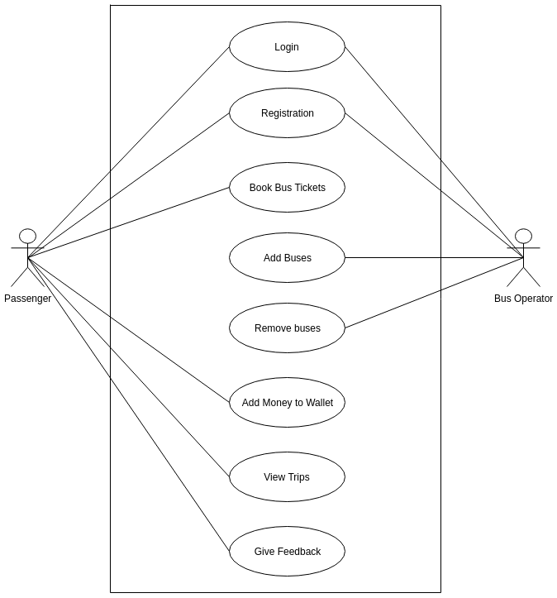

B.2 Sequence Diagram - Passenger

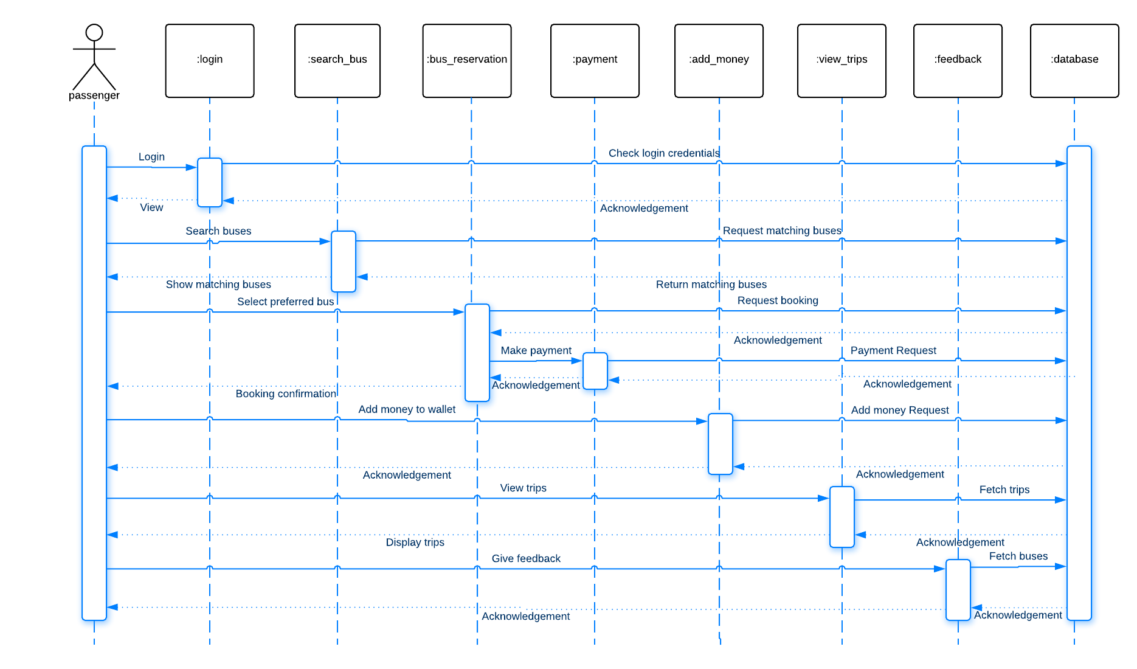

B.3 Sequence Diagram – Bus Operator
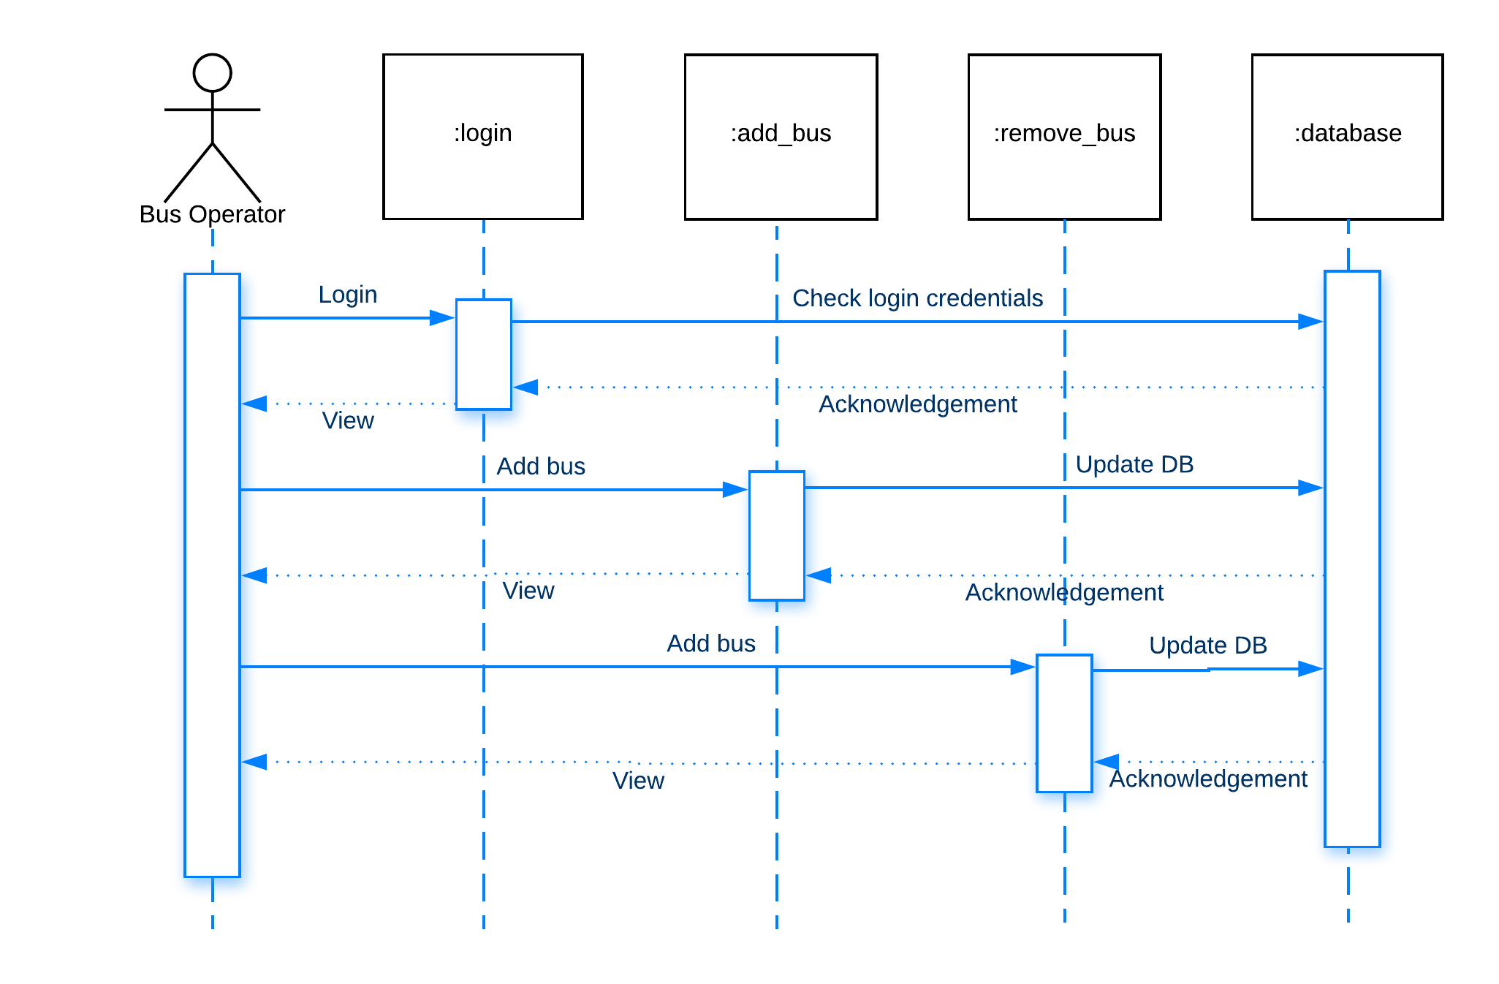

B.4 Activity Diagram – Passenger
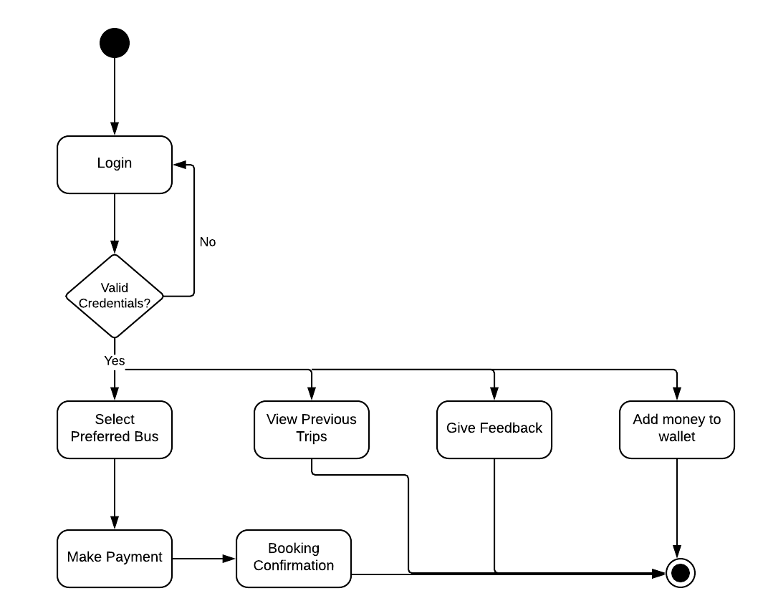

B.5 Activity Diagram - Bus Operator
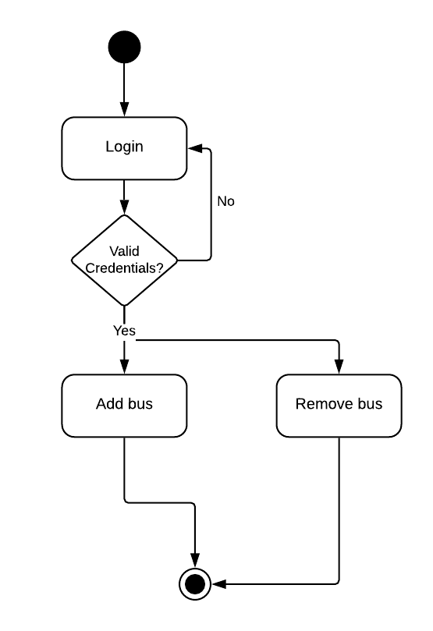

B.6 Navigation Diagram - Passenger
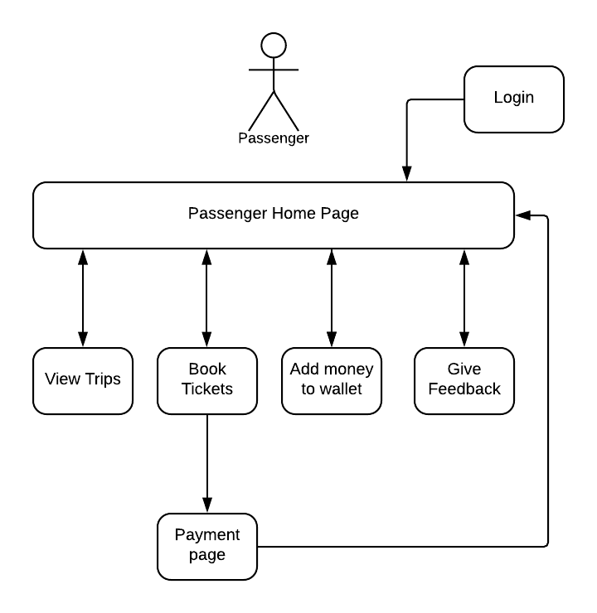

B.7 Navigation Diagram - Bus Operator
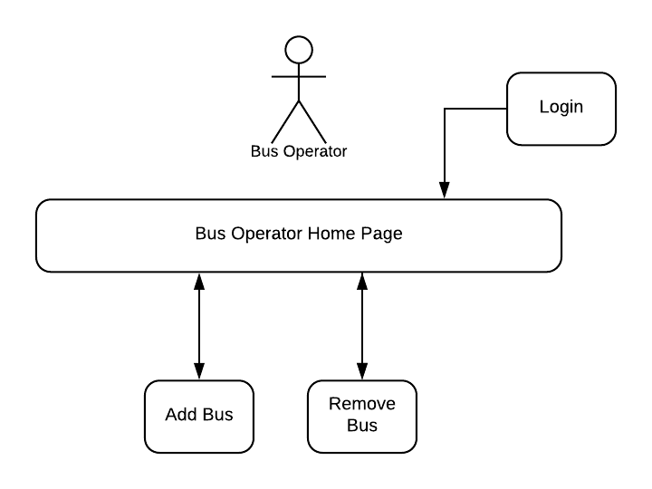

B.8 Swimlane Diagram
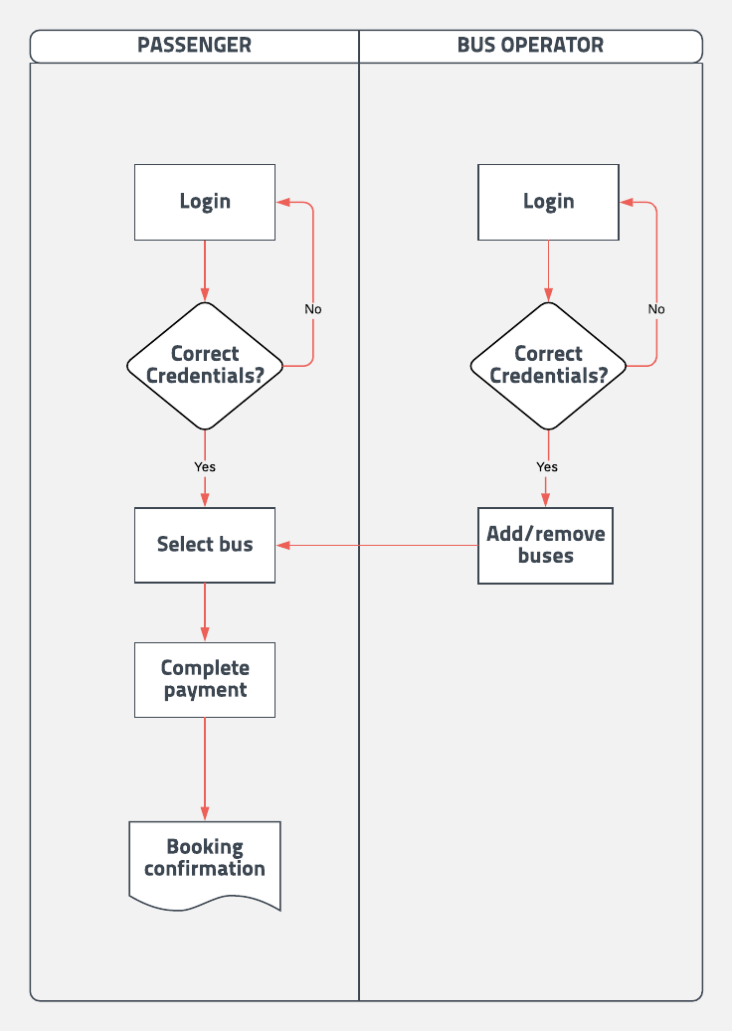

B.9 ER Diagram
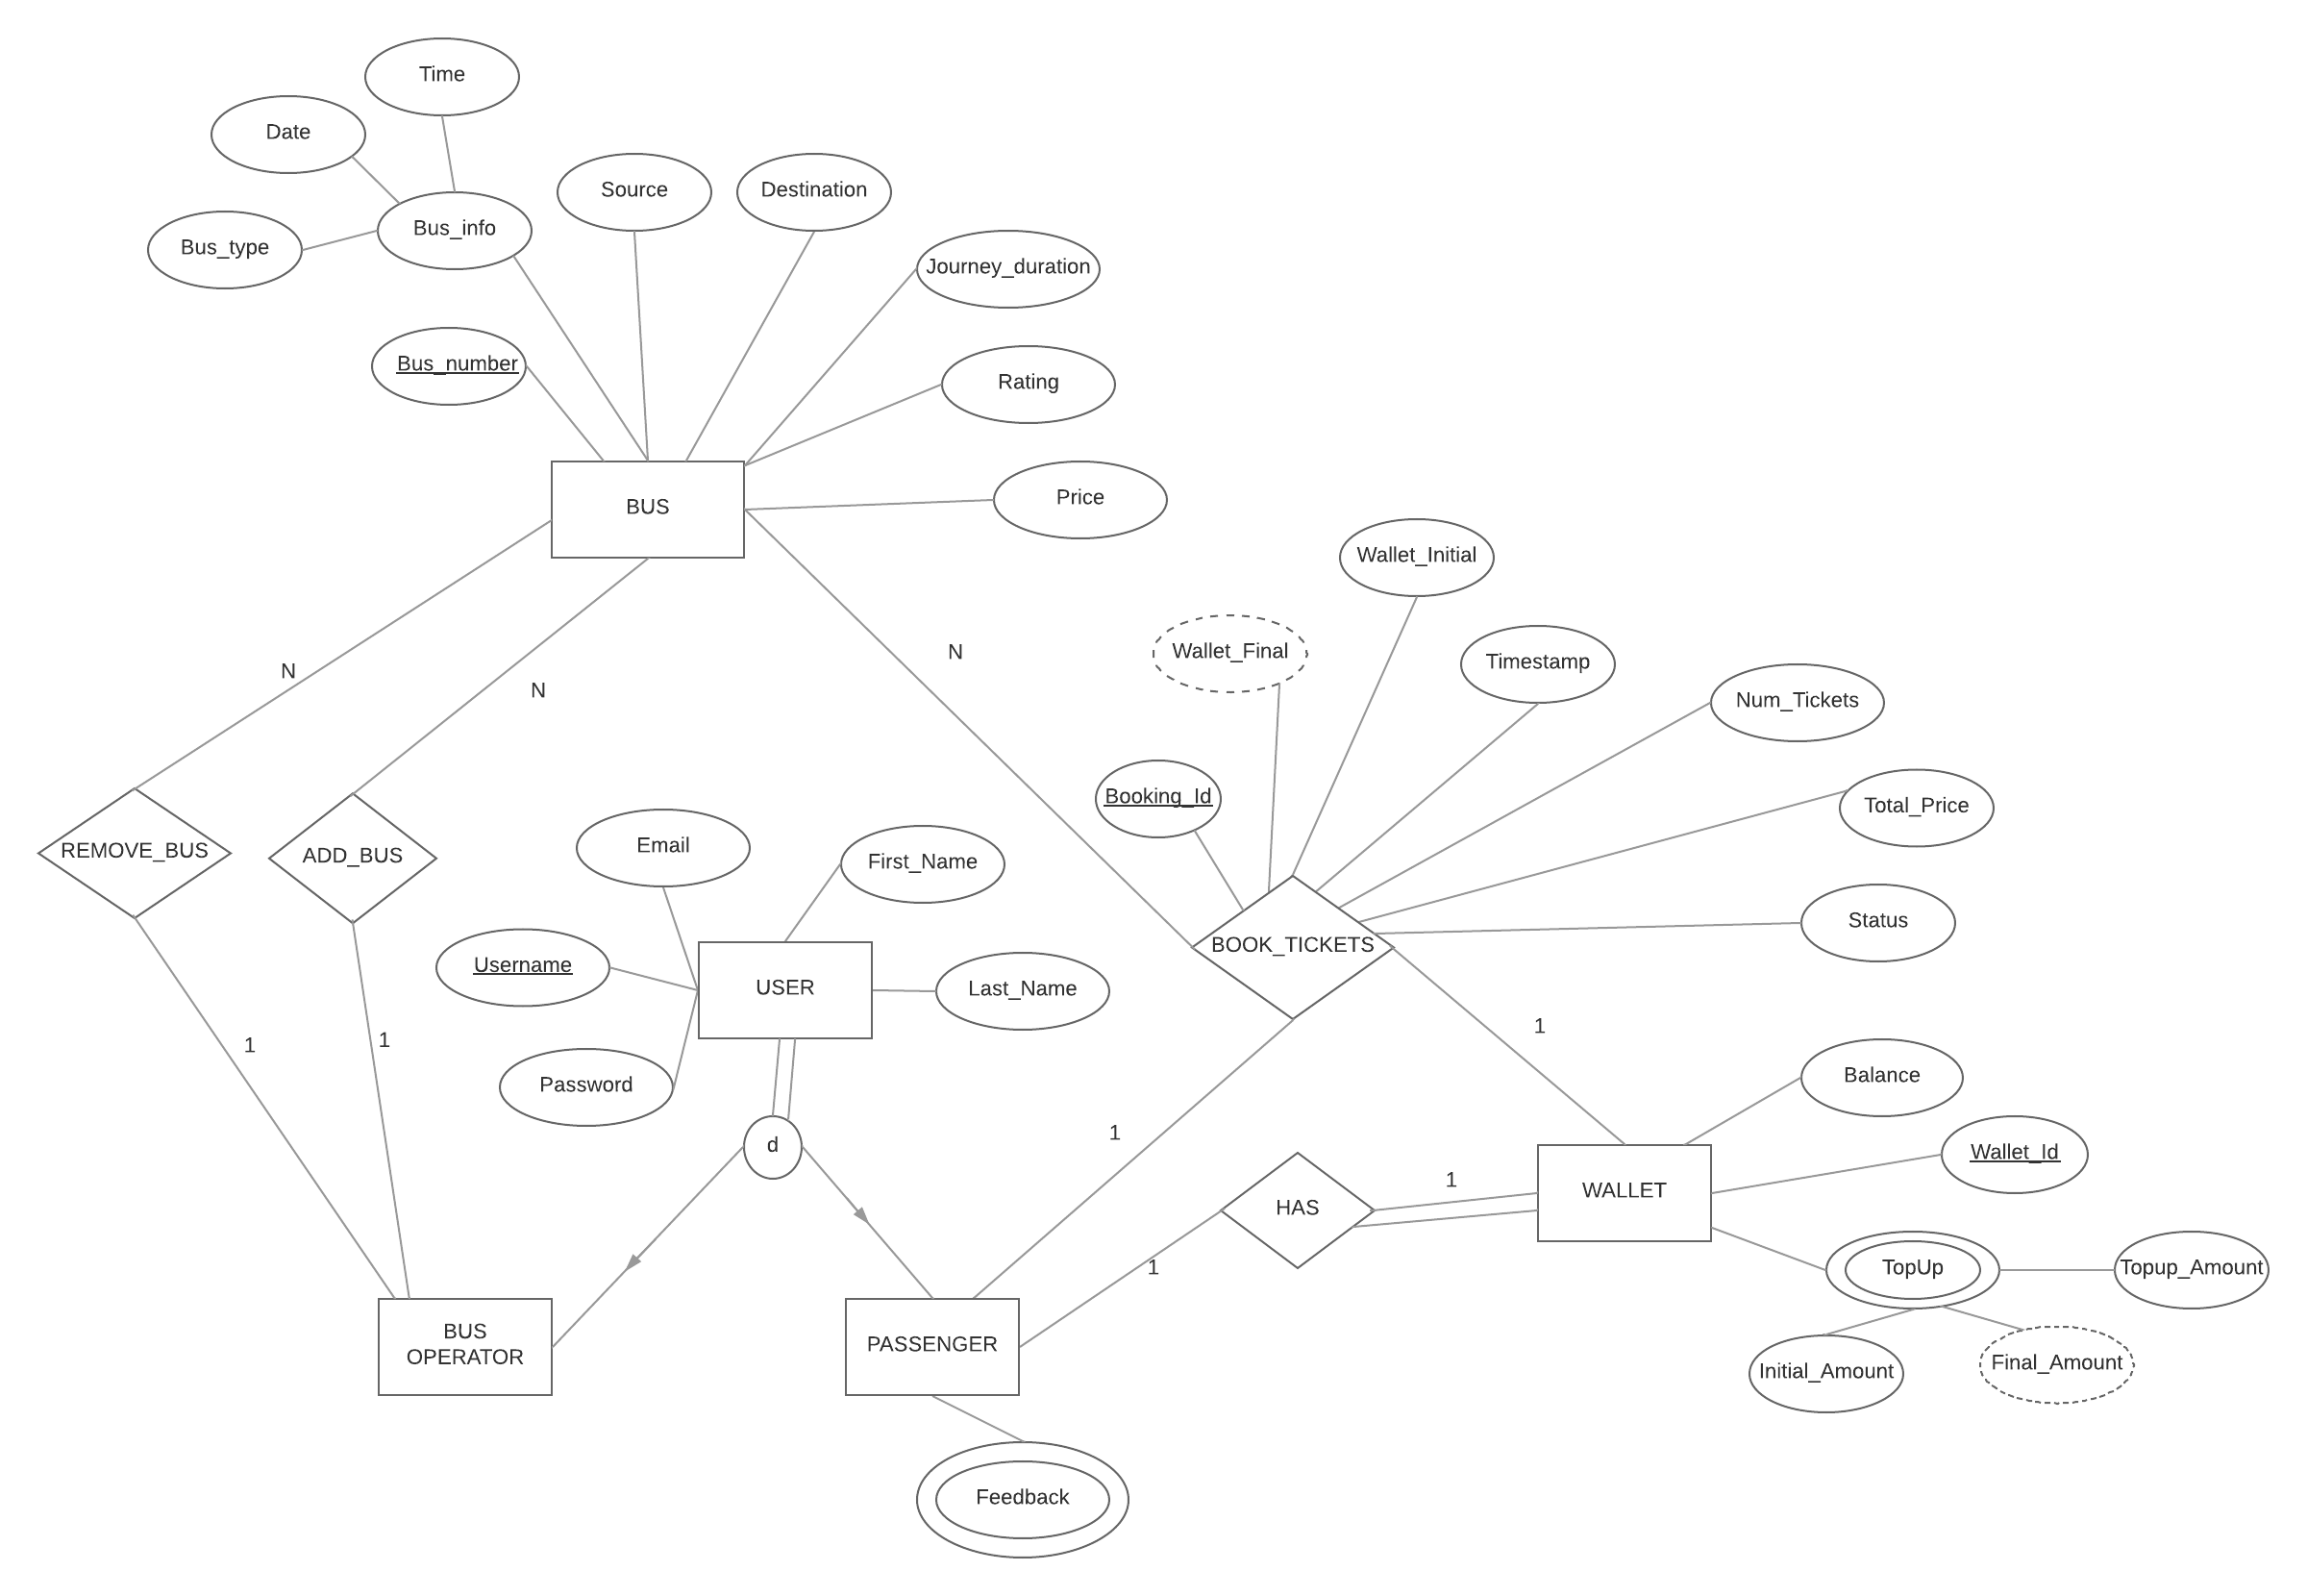
Appendix C: To Be Determined List
- 3.1 - User Interfaces
- 3.2 - Hardware Interfaces
- 3.4 - Communication Interfaces
- 6 - Other Requirements

