NASSAU CANDY
DISTRIBUTOR ANALYTICS

Product Line Profitability & Margin Performance Analysis for Nassau Candy Distributor
Data cleaning, exploratory analysis, profit concentration, and decision support

Research paper | Prepared 21 October 2026 | Academic and business decision-support submission

Prepared from the supplied Nassau Candy Distributor CSV and project brief.

Abstract
This project evaluates product-line profitability for Nassau Candy Distributor using 10,194 usable records from 02 January 2024 to 31 December 2025. The CSV contains 15 products in three divisions, with sales, cost, gross profit, units, dates, and customer geography. The analysis validates financial identities, computes aggregated profitability KPIs, ranks products and divisions, evaluates revenue and positive-profit concentration, examines monthly and geographic patterns, and attaches the brief's product-to-factory mapping. Total sales were $141,783.63, gross profit was $93,442.80, and weighted gross margin was 65.91%. Chocolate accounted for 92.88% of revenue and 95.06% of gross profit. The top five products represented 92.88% of revenue and 95.06% of positive gross profit. One major quality caveat is that every observed Ship Date is 904–1,642 days after its Order Date, so shipment timing is treated as anomalous rather than interpreted as delivery performance. Recommendations emphasize product-specific pricing/cost reviews, portfolio concentration monitoring, and source-date verification.
Keywords: gross margin, product profitability, Pareto analysis, cost diagnostics, Streamlit, distribution analytics

1. Introduction
Sales growth is not synonymous with profit performance. Product profitability analysis compares revenue with associated costs and gross profit so management can prioritize products and divisions using more than sales volume alone. This paper applies descriptive and diagnostic analysis to the supplied distributor records and turns the findings into recommendations for pricing, cost management, promotions, and portfolio review.

2. Background and business context
The project brief frames Nassau Candy as a distributor with product divisions Chocolate, Sugar, and Other. It asks for a common view of product revenue, gross profit, gross margin, regional performance, cost exposure, profit concentration, and factory-associated product summaries. The supplied table is transaction-row data; it does not include list prices, promotion reasons, supplier contracts, detailed manufacturing cost components, delivery dates, or route-level telemetry.

3. Problem statement
The primary analytical problem is limited visibility into whether revenue is translating into gross profit and whether profit depends disproportionately on a narrow product set. Secondary questions cover division efficiency, cost-heavy low-margin products, geographical concentration, monthly trends, and mapping product profitability to the factories specified by the project brief.

4. Project objectives and research questions
1. Measure total sales, gross profit, cost, weighted gross margin, cost ratio, profit per unit, and monthly margin variability.
2. Rank products by revenue, gross profit, margin, and contribution; segment products with transparent relative thresholds.
3. Compare division-level revenue share, profit share, weighted margin, and average product margin.
4. Quantify the product counts required to reach at least 80% of revenue and positive gross profit.
5. Identify rule-based margin risks and separate observed signals from causal claims.
6. Summarize performance by region, state/province, country, and supplied product-to-factory mapping.
7. Provide a reproducible Streamlit dashboard and technical artifacts.

5. Dataset description
The primary source is the supplied file Nassau Candy Distributor.csv. It has 10,194 rows and 18 source columns. The source includes 8,549 distinct provided Order IDs, 5,044 customers, 15 products, 3 divisions, 4 customer regions, 59 states/provinces, and 2 country labels. The Order Date coverage is 02 January 2024 through 31 December 2025. Postal codes were loaded as text to preserve formatting.
Attribute | Value
Rows | 10,194
Source columns | 18
Final usable records | 10,194
Distinct products | 15
Divisions | Chocolate, Other, Sugar
Countries | Canada, United States
Order dates | 2024-01-02 to 2025-12-31

6. Data cleaning and validation
All 10,194 raw rows passed the core financial usability rules; 10,194 records remain in the analysis. The source has 0 exact duplicate rows and 0 duplicate Row IDs. No raw source column has missing values, and all supplied numeric columns parse without missing/nonnumeric values. No negative or zero Sales values, negative Cost values, negative Units, or zero Units rows were found. The largest absolute difference in Sales - Cost - Gross Profit is 7.11e-15, far below the chosen $0.01 tolerance; no financial identity discrepancy exceeded that tolerance.
Step | Rows Before | Rows Removed | Rows After | Rule / Notes
Raw input records | 10194 | 0 | 10194 | Loaded from supplied CSV.
Exact duplicate rows | 10194 | 0 | 10194 | Remove exact duplicates only; repeated Order IDs alone are not duplicates.
Duplicate Row IDs | 10194 | 0 | 10194 | 0 duplicate Row ID(s) flagged, not auto-removed.
Invalid core financial records | 10194 | 0 | 10194 | Exclude missing core financials, Sales <= 0, or Cost < 0.
Missing Units | 10194 | 0 | 10194 | 0 missing Units retained; no zero imputation.
Final usable analysis records | 10194 | 0 | 10194 | No financial imputation; negative Gross Profit remains valid.

The dominant concern is date consistency. Order Date runs from 2024-01-02 to 2025-12-31, but Ship Date runs from 2026-06-30 to 2030-06-28. All 10,194 records have an order-to-ship gap above 90 days; the observed range is 904 to 1642 days, with median 1274 days. Because these dates are implausibly distant, the elapsed gap is retained as a flagged data-quality diagnostic and is not treated as operational shipping time. Repeated Order IDs are retained because repeated IDs alone do not prove duplicate records. Product labels are whitespace-normalized, and supplied source data remains available in the raw-data folder.

7. Exploratory data analysis methodology
EDA used counts, descriptive statistics, aggregated product/division/geography summaries, monthly aggregates, and charts. Potential distributional outliers were flagged using the 1.5 × IQR rule for review, but records were not removed on outlier status alone. Summary calculations use pandas aggregation; plots were generated with Matplotlib and the interactive dashboard uses Plotly inside Streamlit (pandas development team, n.d.; Plotly Technologies Inc., n.d.; Streamlit, n.d.).

8. KPI definitions and formulas
KPI | Formula | Interpretation
Total Sales | Sum(Sales) | Total recorded revenue in the selected records.
Total Gross Profit | Sum(Gross Profit) | Total supplied gross profit; retains supplied values after validation.
Total Cost | Sum(Cost) | Total supplied cost.
Weighted gross margin | Sum(Gross Profit) / Sum(Sales) × 100 | Aggregate profitability; not a simple mean of row-level margins.
Cost ratio | Sum(Cost) / Sum(Sales) × 100 | Share of sales absorbed by supplied cost.
Product gross margin | Product Sum(Gross Profit) / Product Sum(Sales) × 100 | Aggregate product margin, weighted by its sales.
Profit per unit | Sum(Gross Profit) / Sum(Units) | Calculated only where units are available and positive.
Revenue contribution | Product Sales / Total Sales × 100 | Product share of current analysis sales.
Profit contribution | Product Gross Profit / Total Gross Profit × 100 | Displayed where total gross profit is positive.
Monthly margin volatility | Sample SD of monthly weighted margins (percentage units) | Variation between monthly aggregated margins, not transaction-level standard deviation.
Average value per distinct Order ID | Sum(Sales) / Distinct Order IDs | Descriptive proxy only; source IDs appear product-coded, so it may not be basket-level average order value.

9. Overall profitability results
The dataset records $141,783.63 in sales, $93,442.80 in gross profit, and $48,340.83 in cost, with 38,654 units reported. The weighted gross margin is 65.91% and cost ratio is 34.09%. Aggregate gross profit per unit is $2.42. There are 0 rows and 0 product aggregates with negative gross profit in this source. The sample standard deviation of the 24 monthly weighted gross margins is 0.525 percentage points, with monthly margin ranging from 64.54% (2024-03) to 66.75% (2025-01).
Measure | Value
Sales | $141,783.63
Gross profit | $93,442.80
Cost | $48,340.83
Weighted gross margin | 65.91%
Cost ratio | 34.09%
Profit per unit | $2.42
Reported units | 38,654
Margin volatility, monthly SD | 0.525 percentage points

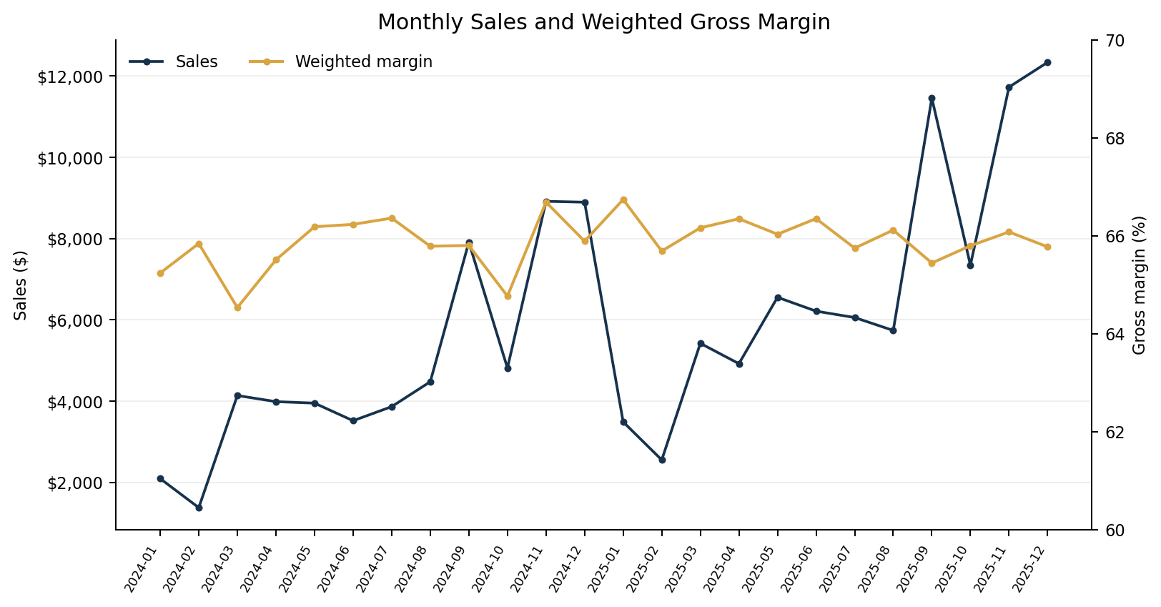
Figure 1. Monthly sales and monthly weighted gross margin. Sales rise in the second year while aggregate margins remain relatively stable.

10. Product-level profitability analysis
The highest gross-profit product is Wonka Bar - Scrumdiddlyumptious at $19,357.50; its aggregate gross margin is 69.44%. The highest-sales product is Wonka Bar - Triple Dazzle Caramel with $28,485.00 in sales. The highest aggregate margin is Everlasting Gobstopper at 80.00%, but it has only $130.00 sales and 3 rows, so it should not be prioritized on margin percentage alone. The lowest-margin product is Kazookles with 7.69% margin and 92.31% cost ratio.
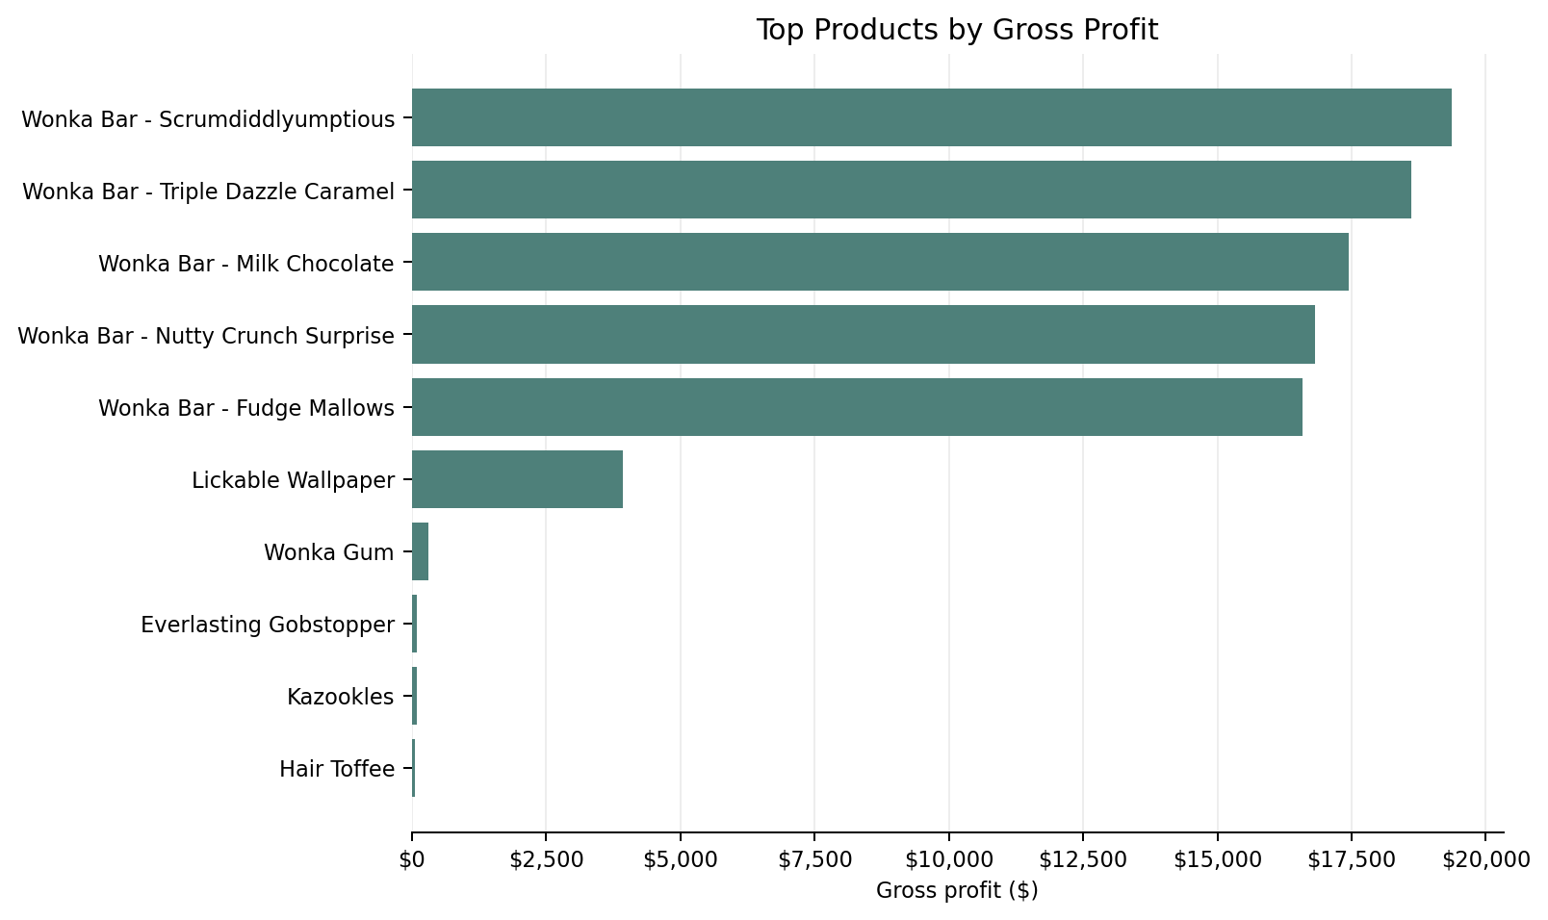
Figure 2. Top products ranked by total gross profit.
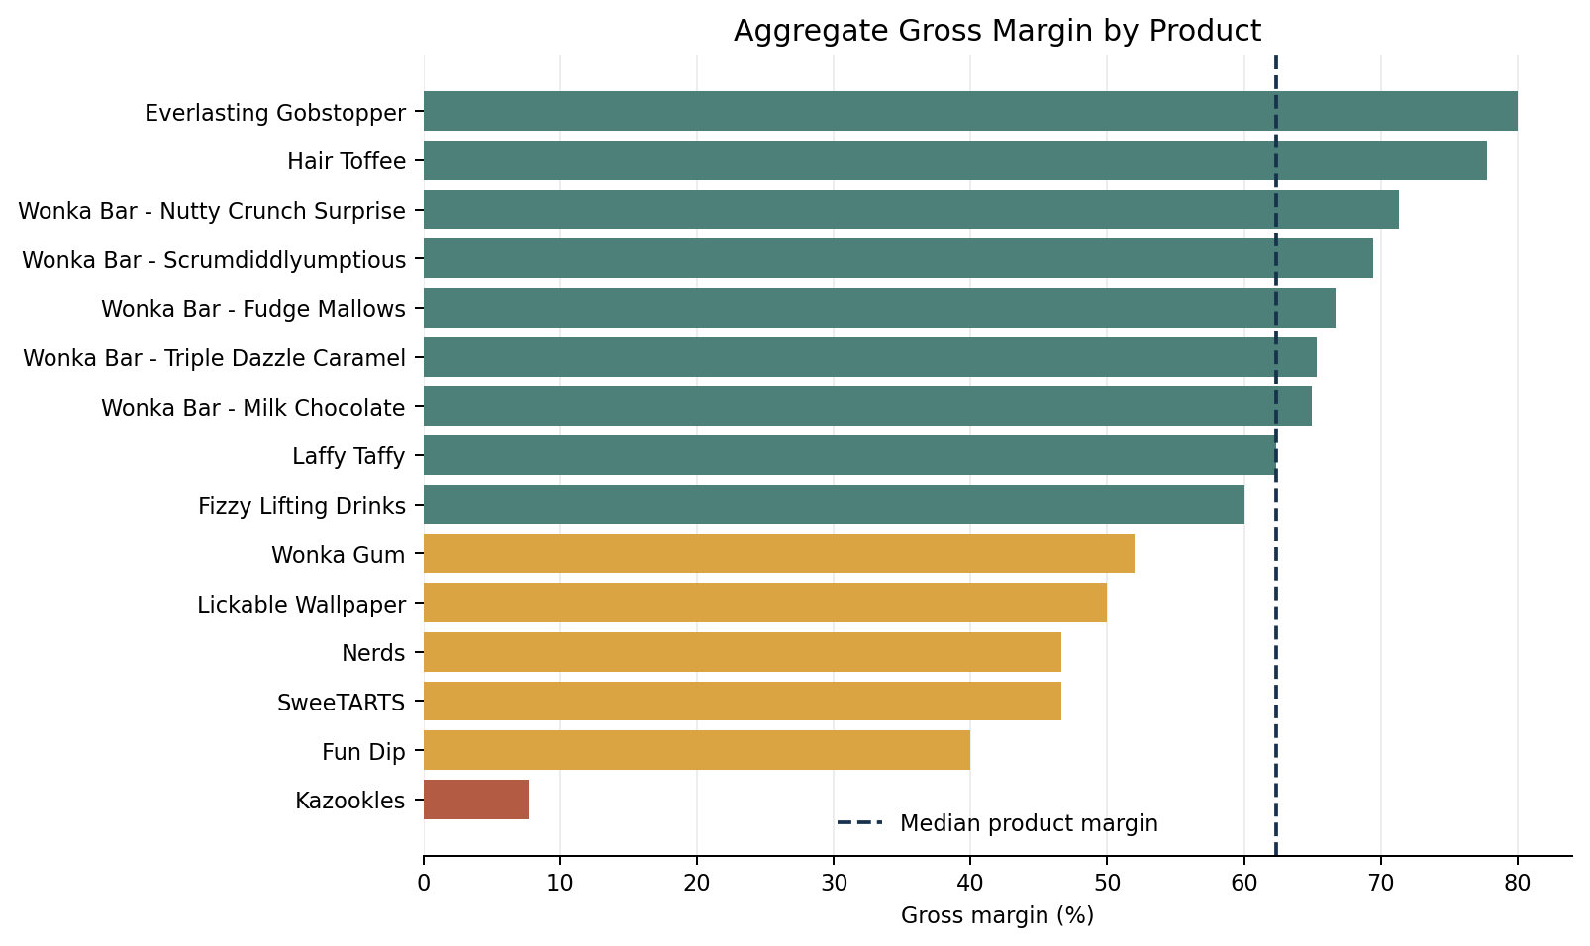
Figure 3. Product aggregate margins, with median-product-margin reference.

Product Name | Division | Sales | Gross Profit | Gross Margin | Revenue Contribution (%) | Profit Contribution (%)
Wonka Bar - Scrumdiddlyumptious | Chocolate | $27,874.80 | $19,357.50 | 69.44% | 19.66% | 20.72%
Wonka Bar - Triple Dazzle Caramel | Chocolate | $28,485.00 | $18,610.20 | 65.33% | 20.09% | 19.92%
Wonka Bar - Milk Chocolate | Chocolate | $26,867.75 | $17,443.37 | 64.92% | 18.95% | 18.67%
Wonka Bar - Nutty Crunch Surprise | Chocolate | $23,574.95 | $16,819.95 | 71.35% | 16.63% | 18.00%
Wonka Bar - Fudge Mallows | Chocolate | $24,890.40 | $16,593.60 | 66.67% | 17.56% | 17.76%
Lickable Wallpaper | Other | $7,860.00 | $3,930.00 | 50.00% | 5.54% | 4.21%
Wonka Gum | Other | $597.50 | $310.70 | 52.00% | 0.42% | 0.33%
Everlasting Gobstopper | Sugar | $130.00 | $104.00 | 80.00% | 0.09% | 0.11%
Kazookles | Other | $1,205.75 | $92.75 | 7.69% | 0.85% | 0.10%
Hair Toffee | Sugar | $76.50 | $59.50 | 77.78% | 0.05% | 0.06%

A distribution-based product matrix uses median aggregate sales and median aggregate product margin as quadrant thresholds. The five Chocolate products sit in the high-sales/high-margin group by these relative cutoffs. Lickable Wallpaper and Wonka Gum have meaningful margins but fall below the median product margin; Kazookles is the clearest numerical margin risk at 7.69%. Very-low-sales products with margins above 75% have tiny samples and are not evidence of scalable demand or stable unit economics.

11. Division-level performance
Chocolate recorded $131,692.90 in sales and $88,824.62 in gross profit, for 67.45% weighted margin. It contributed 92.88% of revenue and 95.06% of gross profit. Other recorded $9,663.25 in sales and $4,333.45 in gross profit; its weighted margin was 44.84%, with cost ratio 55.16%. Sugar recorded $427.48 in sales across seven products but only 40 rows; its apparent 66.61% weighted margin should be read as low-volume evidence rather than as a robust division benchmark.
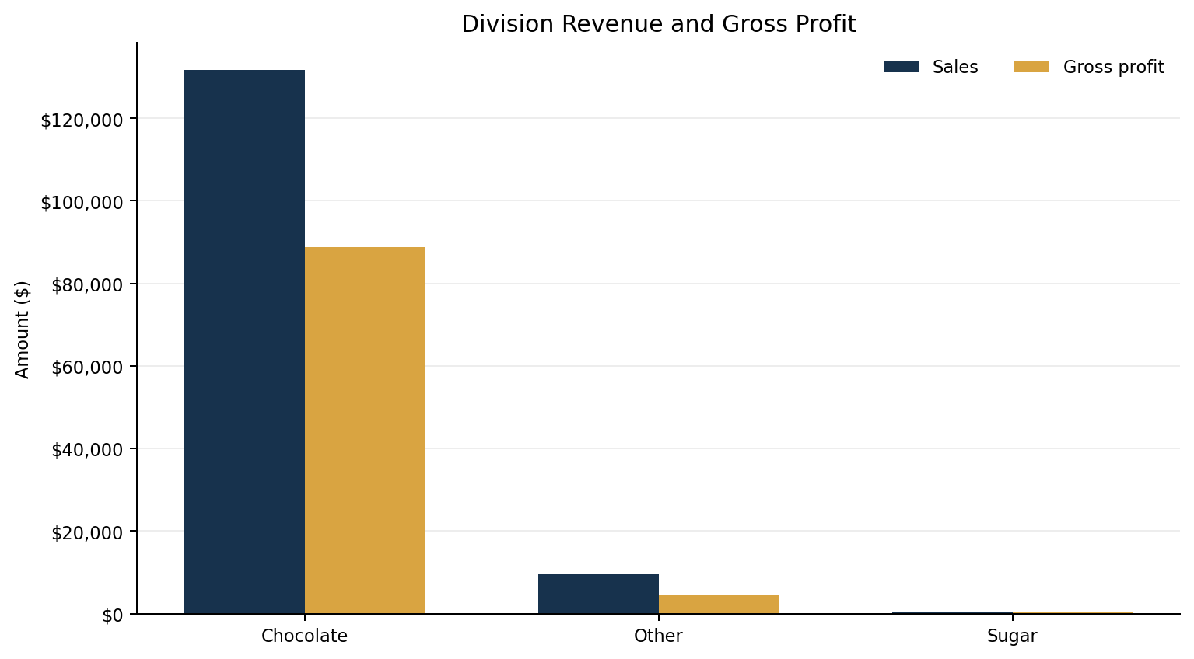
Figure 4. Division-level revenue compared with gross profit.
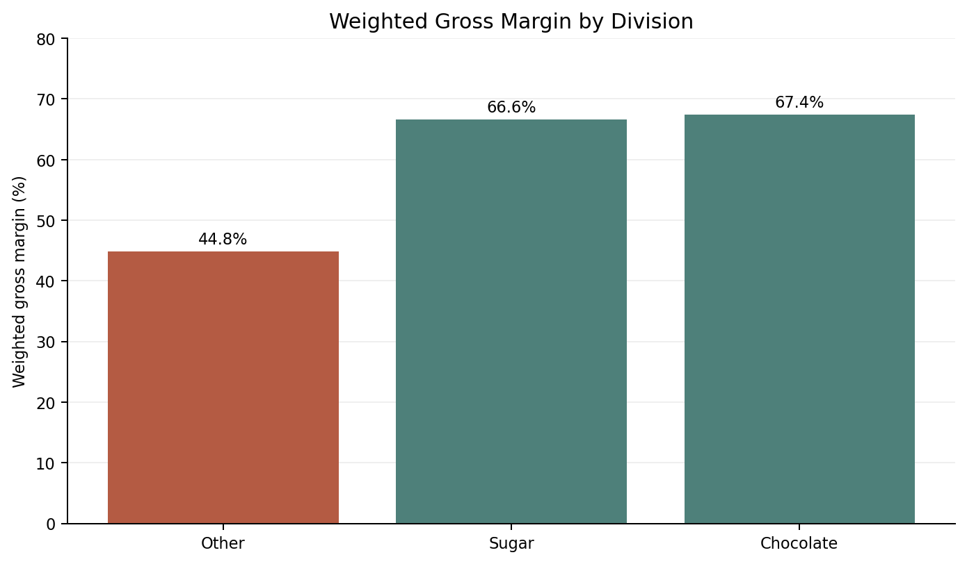
Figure 5. Weighted margin by division.
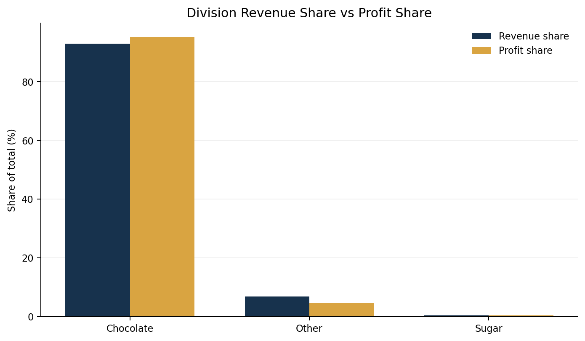
Figure 6. Revenue share versus profit share. Chocolate over-indexes on profit contribution; Other under-indexes.

Division | Sales | Gross Profit | Cost | Units | Products | Rows | Gross Margin (%) | Revenue Contribution (%) | Profit Contribution (%) | Average Product Margin (%)
Chocolate | $131,692.90 | $88,824.62 | $42,868.28 | 37275 | 5 | 9844 | 67.45% | 92.88% | 95.06% | 67.54%
Other | $9,663.25 | $4,333.45 | $5,329.80 | 1242 | 3 | 310 | 44.84% | 6.82% | 4.64% | 36.56%
Sugar | $427.48 | $284.73 | $142.75 | 137 | 7 | 40 | 66.61% | 0.30% | 0.30% | 59.06%

Weighted division margin differs from average product margin because weighted margin gives greater influence to high-revenue products, while average product margin gives each product equal weight. Other has the lowest weighted margin and a profit-share deficit relative to sales share, indicating the first place for a targeted product/cost review. Chocolate is both the largest and most profitable division, but that dominance creates portfolio dependency risk.

12. Pareto and profit concentration analysis
The smallest number of products reaching at least 80% of revenue is 5 of 15 products (33.3%); the top five reach 92.88% of revenue. For positive gross profit, 5 of 15 products (33.3%) reach at least 80%; the top five generate 95.06% of positive gross profit. Four products reach 76.26% of revenue and 77.30% of gross profit; the fifth product lifts both totals beyond 80%. This means product-level disruption in one of the leading five Chocolate products could materially affect revenue and profit, even though all products are currently profitable in gross terms.
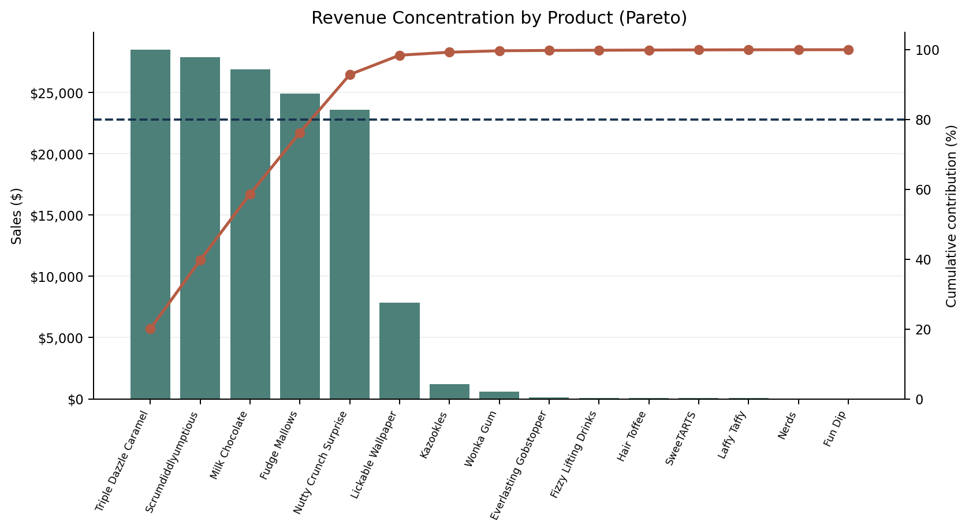
Figure 7. Product revenue concentration; cumulative contribution crosses the 80% threshold with the fifth product.
Metric | Products to >=80% | Share of product set | Top-five cumulative share
Revenue | 5 | 33.3% | 92.88%
Positive gross profit | 5 | 33.3% | 95.06%

13. Cost structure and margin diagnostics
Across all product aggregates, Kazookles has $1,113.00 cost on $1,205.75 sales and $92.75 gross profit. Its 92.31% cost ratio leaves a 7.69% gross margin. This is an observed arithmetic relationship rather than proof of mispricing or manufacturing inefficiency. Lickable Wallpaper shows 50.00% margin and $3,930.00 gross profit; because its sales are much greater than the long tail but margin is below the product median, it merits a price/cost decomposition review. No product has negative gross profit in the supplied records.
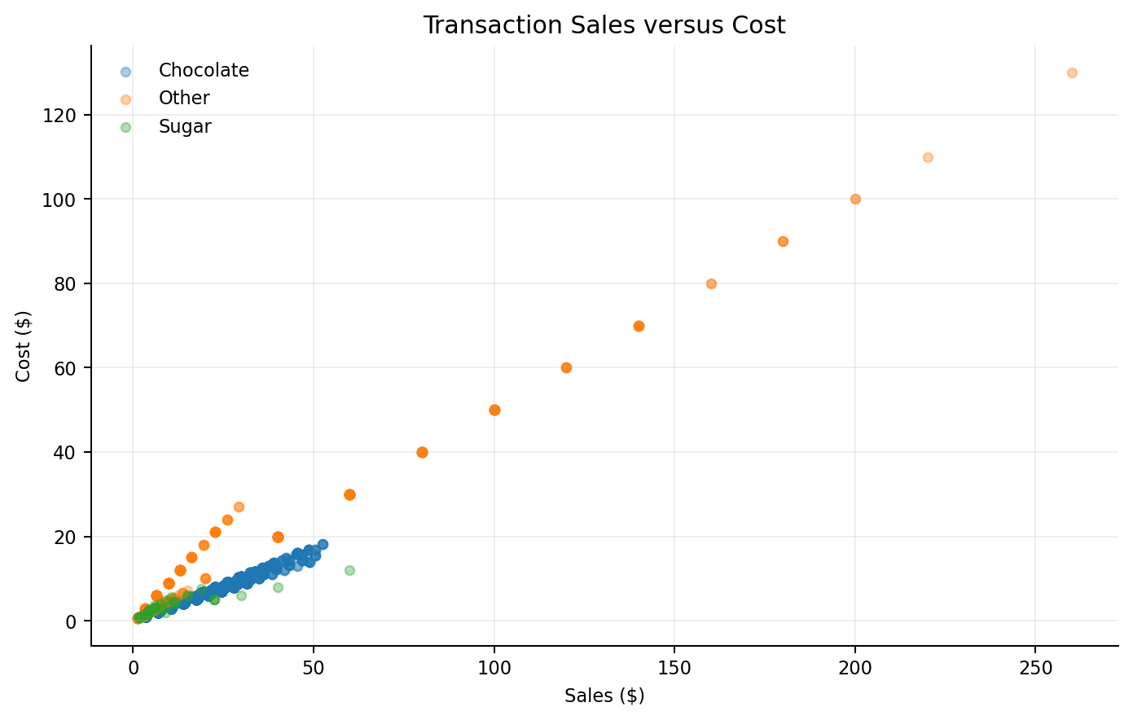
Figure 8. Transaction sales versus supplied cost. Relationships are descriptive and do not establish causal production cost drivers.
- Kazookles: review the product cost basis, discounts, and realized selling price; cost is 92.31% of sales.
- Lickable Wallpaper: evaluate price realization and cost terms because its volume is material but margin sits below the median product margin.
- Wonka Gum: margin is 52.00%; check whether its role is strategic, complementary, or promotion-led before changing the portfolio.
- Use product pricing, discount, supplier, labor, packaging, and detailed bill-of-material data to confirm root causes before repricing or rationalization.

14. Geographic and regional analysis
Pacific is the largest customer region with $46,301.53 sales (32.66% of sales) and 65.84% gross margin. California leads state/province revenue at $27,917.40, or 19.69% of total sales; New York and Texas follow. The top three states together account for 40.11% of revenue. The United States contributes $138,830.34 in sales while Canada contributes $2,953.29. This is geographic commercial concentration, not evidence of traffic congestion or shipping delays.
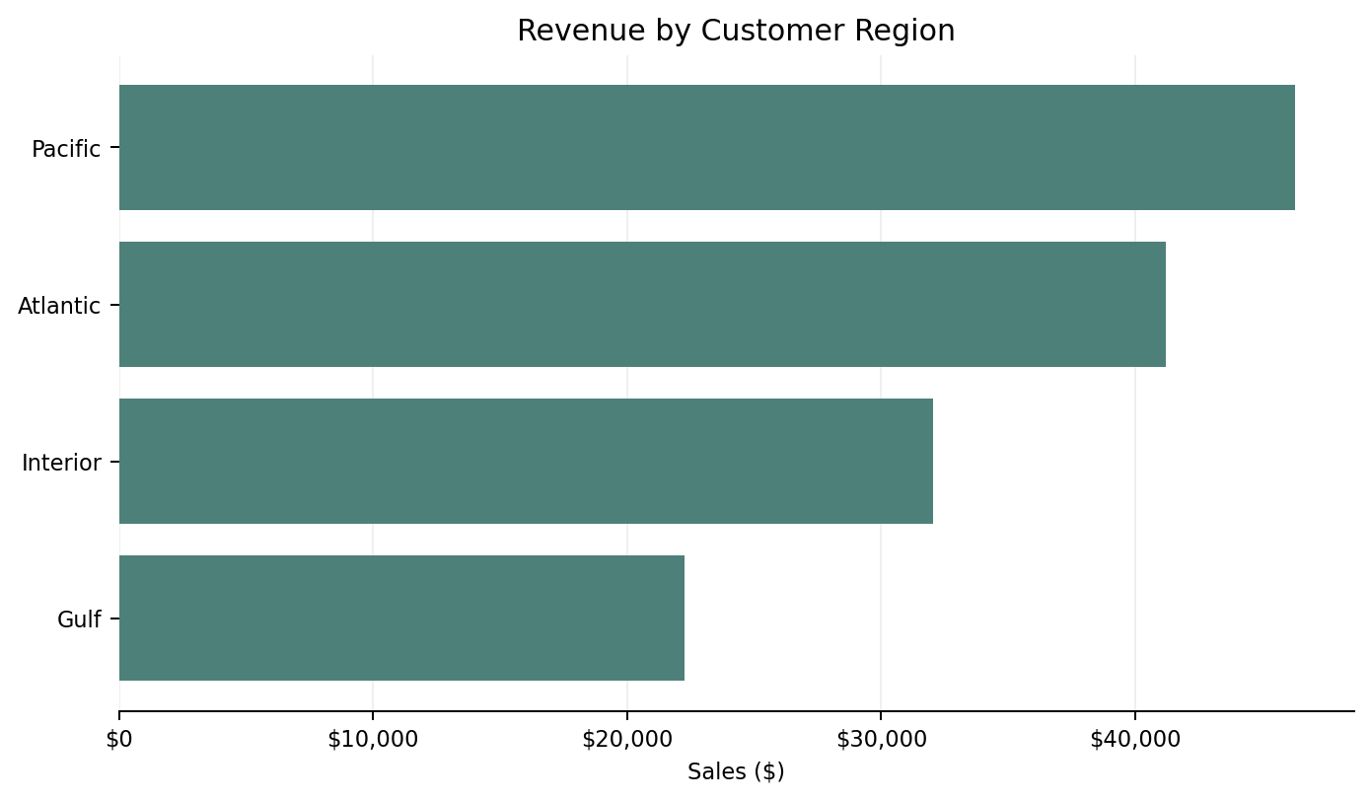
Figure 9. Sales by customer region.
Region | Sales | Gross Profit | Gross Margin (%) | Revenue Contribution (%) | Profit Contribution (%)
Pacific | $46,301.53 | $30,485.94 | 65.84% | 32.66% | 32.63%
Atlantic | $41,197.24 | $26,973.70 | 65.47% | 29.06% | 28.87%
Interior | $32,037.60 | $21,282.49 | 66.43% | 22.60% | 22.78%
Gulf | $22,247.26 | $14,700.67 | 66.08% | 15.69% | 15.73%

15. Factory mapping and factory-associated summaries
All 15 distinct products in the supplied dataset match one of the 15 supplied product-to-factory mappings after case and whitespace normalization. One mapping has a division-label mismatch: the project brief assigns Fizzy Lifting Drinks to the Other division, but the dataset labels it Sugar. Factory-associated results are product aggregates grouped using the supplied mapping, not proof of factory-level manufacturing efficiency, capacity, travel route, delivery timing, or operating cost causality.
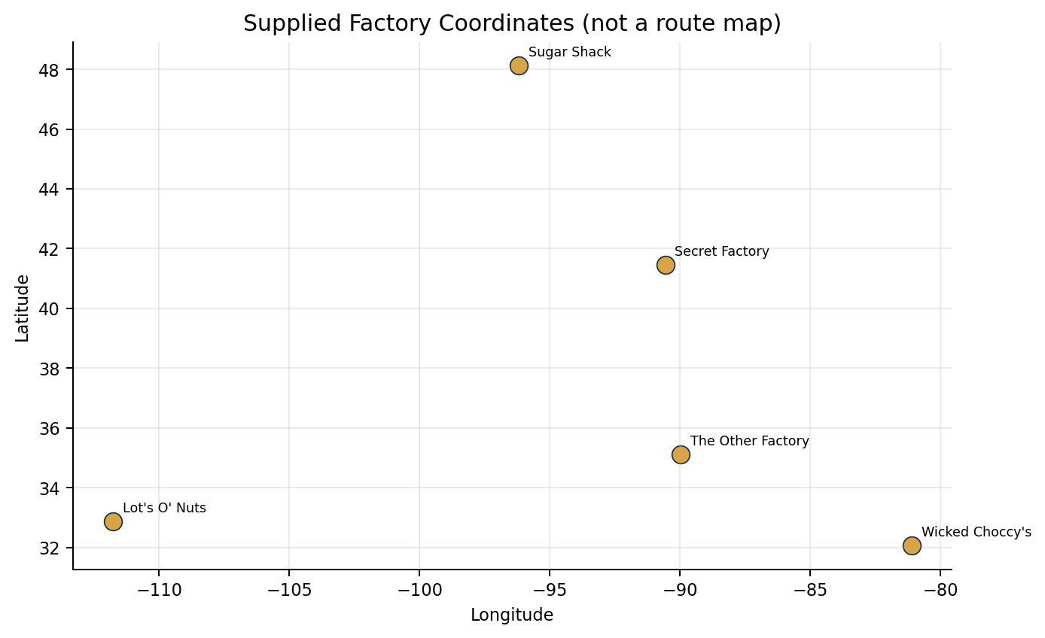
Figure 10. Supplied factory coordinates. The plot is coordinate-based only and is not a routing or service-level map.
Factory | Sales | Gross Profit | Cost | Products | Gross Margin (%) | Revenue Contribution (%) | Mapped Division Mismatches
Lot's O' Nuts | $76,340.15 | $52,771.05 | $23,569.10 | 3 | 69.13% | 53.84% | 0
Wicked Choccy's | $55,352.75 | $36,053.57 | $19,299.18 | 2 | 65.13% | 39.04% | 0
Sugar Shack | $220.98 | $121.23 | $99.75 | 5 | 54.86% | 0.16% | 1
Secret Factory | $8,587.50 | $4,344.70 | $4,242.80 | 3 | 50.59% | 6.06% | 0
The Other Factory | $1,282.25 | $152.25 | $1,130.00 | 2 | 11.87% | 0.90% | 0

16. Time-series analysis
Order Date provides 24 months between January 2024 and December 2025. Revenue rose from $57,956.20 in 2024 to $83,827.43 in 2025, a 44.64% increase. Gross profit rose from $38,151.43 to $55,291.37. The increase is an observed year-over-year comparison; no causal interpretation is made because seasonality, price, distribution, and data generation effects are not separately identified. Monthly gross margin was comparatively stable, with a standard deviation of 0.525 percentage points. Ship Date is excluded from delivery-performance interpretation because of the extreme date gap described above.

17. Dashboard design and implementation
The Streamlit dashboard is implemented in app.py and uses shared functions from analysis.py so tables and KPIs follow common definitions. It provides six modules: Product Overview; Division Performance; Cost & Margin Diagnostics; Profit Concentration; Geography & Factories; and Data Quality & Export. Sidebar controls include order-date range, division, region, state/province, minimum product gross-margin threshold, and product search. An optional uploader accepts a replacement CSV. Interactive charts use Plotly; data tables and exports reflect active filters (Streamlit, n.d.; Plotly Technologies Inc., n.d.).

18. Results and key findings
1. Portfolio profitability: weighted gross margin is 65.91% on $141,783.63 in sales; all observed products have positive aggregate gross profit.
2. Product leaders: Wonka Bar - Scrumdiddlyumptious leads gross profit at $19,357.50; the top five products account for about 95.06% of positive gross profit.
3. Division imbalance: Chocolate contributes 92.88% of revenue and 95.06% of gross profit; Other contributes 6.82% of revenue but only 4.64% of gross profit.
4. Margin risk: Kazookles margin is 7.69% with 92.31% cost ratio.
5. Geographic concentration: California produces 19.69% of sales; the top three states generate 40.11%.
6. Data reliability: financial identities are consistent, but all 10,194 order-to-ship elapsed-time records exceed 90 days.

19. Business recommendations
1. Prioritize a focused cost-and-pricing review for Kazookles. Reconcile its realized price and cost build; validate whether the low margin is recurring before changing price or product status.
2. Run a product-level price realization and supplier-cost review on Lickable Wallpaper and Wonka Gum, with emphasis on discount history, cost components, and volume response.
3. Protect and monitor the top five Chocolate products with availability and margin dashboards. Consider diversification opportunities, but do not pursue a broad portfolio expansion without demand and contribution economics.
4. Set explicit review gates for low-volume high-margin products. Tiny sales bases should not be treated as evidence of scalable profitability; test demand through controlled distribution or promotions.
5. Investigate Other division cost structure and item mix because its weighted margin is only 44.84% and profit contribution is below revenue contribution.
6. Verify source Ship Date semantics and refresh dates from the system of record before using shipment KPIs. Do not infer congestion or delivery delays from this file.
7. Use monthly margin and profit-contribution monitoring as a recurring process. Investigate changes, rather than reacting to gross margin in isolation.

20. Limitations and assumptions
- Gross Profit is accepted as supplied after validation against Sales - Cost; Cost is interpreted as manufacturing cost because the brief describes it that way, but no cost-component breakdown is provided.
- Order ID appears to contain product-specific elements. The descriptive average value per distinct provided Order ID may not equal true basket-level average order value.
- Shipment dates are anomalous: 100% of records have a gap greater than 90 days. Shipping efficiency, delivery delays, and route congestion cannot be inferred.
- Factory figures are product-associated aggregates based on the brief mapping and coordinates; they do not prove factory-level performance or actual production origin.
- Only 15 distinct product names are present, with 98% of records in Chocolate; the Sugar division has only 40 rows and seven products, so product/division comparisons are imbalanced.
- Gross margin does not include selling, marketing, distribution, inventory carrying, returns, overhead allocation, or demand elasticity unless already embedded in the supplied Cost field.
- The 80% Pareto threshold is a descriptive concentration rule, not an optimal product assortment target.

21. Conclusion
The supplied data supports a consistent gross-profit view: $141,783.63 sales and $93,442.80 gross profit at 65.91% weighted gross margin. The main commercial finding is dependency: the five Chocolate products represent most revenue and profit. The main product-level review item is Kazookles due to a 7.69% gross margin; Other division's 44.84% weighted margin also merits structured cost and price investigation. The supplied data does not justify immediate discontinuations or claims of manufacturing inefficiency. The source's anomalous Ship Date values need correction before any logistics-performance conclusion. The original brief ends with a conclusion about shipping-route efficiency; that topic does not match the stated product-profitability project and is therefore not used as the principal conclusion here.

22. References
Nassau Candy Distributor. (n.d.). Nassau Candy Distributor dataset [Data set]. Google Drive. https://drive.google.com/file/d/1c4VDb0Pf7RCgps4aLMiSuLtdaUpU_X49/view?pli=1
pandas development team. (n.d.). User guide. https://pandas.pydata.org/docs/user_guide/
Plotly Technologies Inc. (n.d.). Plotly Python graphing library. https://plotly.com/python/
Python Software Foundation. (n.d.). datetime - Basic date and time types. https://docs.python.org/3/library/datetime.html
Streamlit. (n.d.). Input widgets. https://docs.streamlit.io/develop/api-reference/widgets
Unified Mentor. (n.d.). Product line profitability & margin performance analysis for Nassau Candy Distributor [Project brief].

23. Appendix A: data dictionary and audit outputs
The package contains data_dictionary.csv, data_quality_report.csv, cleaning_summary.csv, outlier_diagnostics.csv, annual_summary.csv, product_summary.csv, division_summary.csv, geographic summaries, monthly_summary.csv, Pareto calculations, product-factory review, and factory-associated summaries. Values in the dashboard and report are generated through the same reusable calculation module.

24. Appendix B: recommended reproducibility steps
1. Install dependencies listed in requirements.txt.
2. Run pytest -q from the project directory.
3. Run python build_outputs.py to regenerate static outputs and report documents.
4. Run streamlit run app.py to launch the dashboard.
5. When using a replacement CSV, confirm the required 18 source columns and inspect the updated data-quality panel before interpreting results.

