1. Subordinates

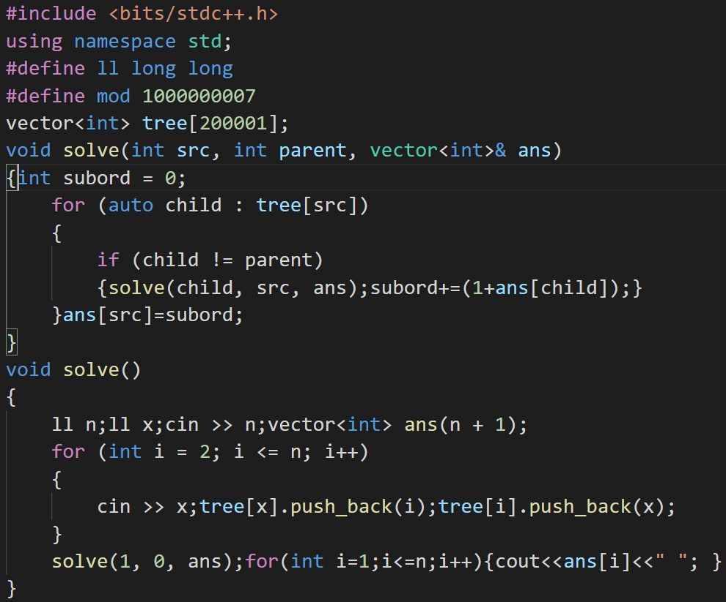

//applying dfs important