1. Subarray with given xor

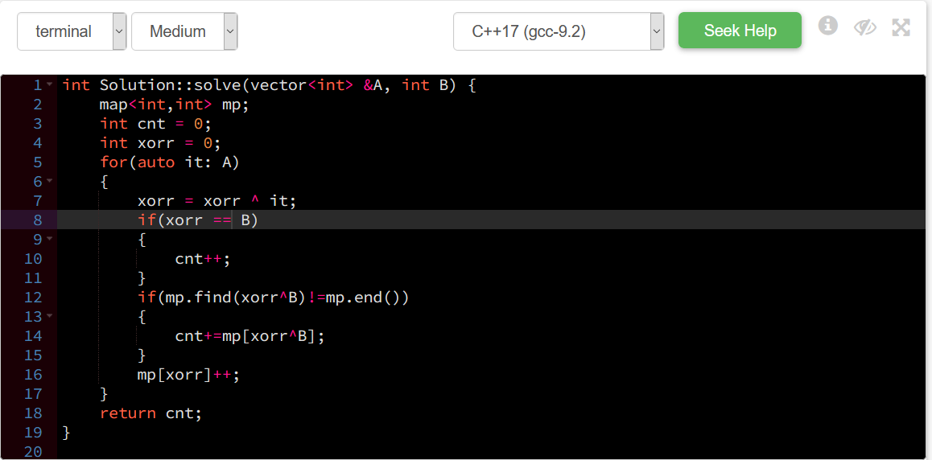

1. Longest length of subarray having count of one, one more than the count of zero.

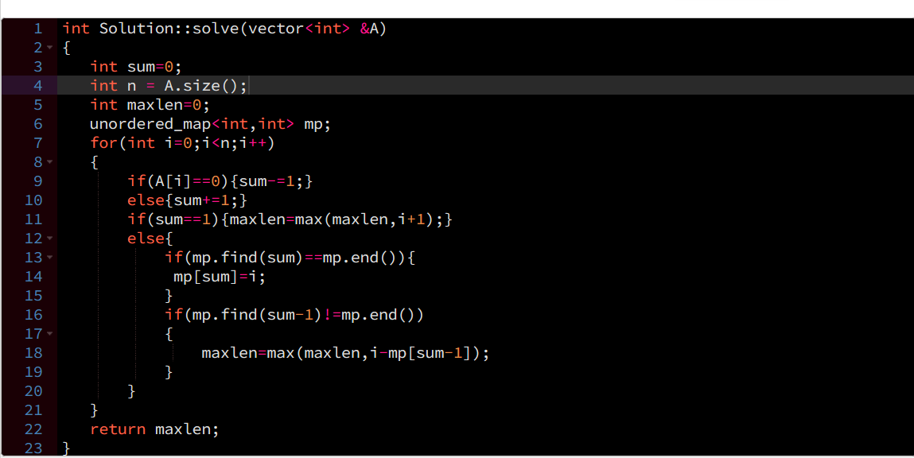

1. Increment problem

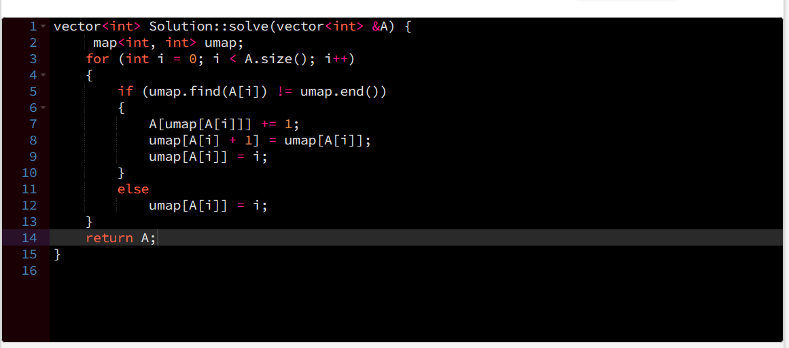

1. Calculate the number of points which are present in a straight line

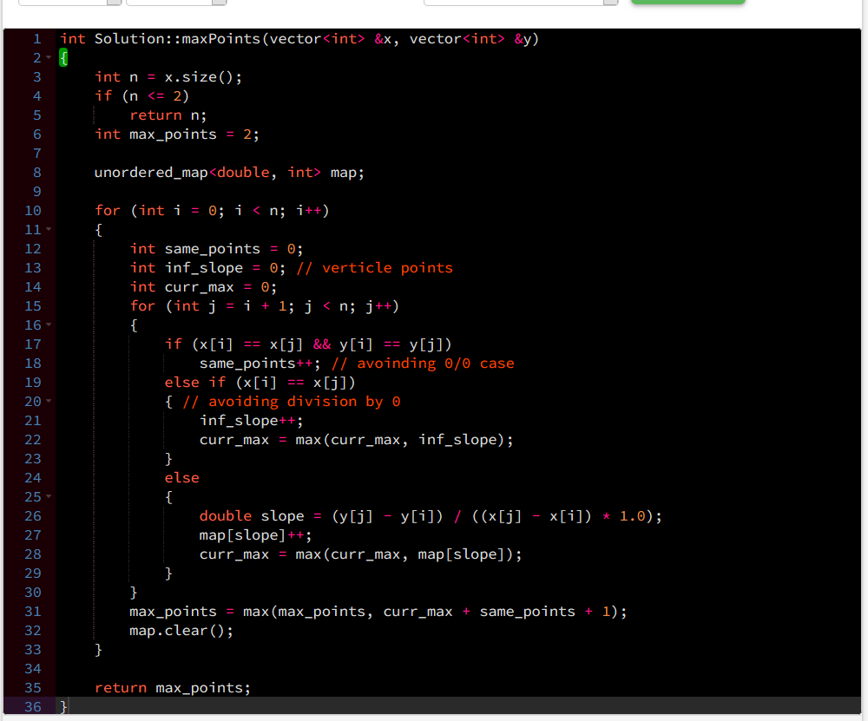

1. Equal (A+B==C+D) return the index of values

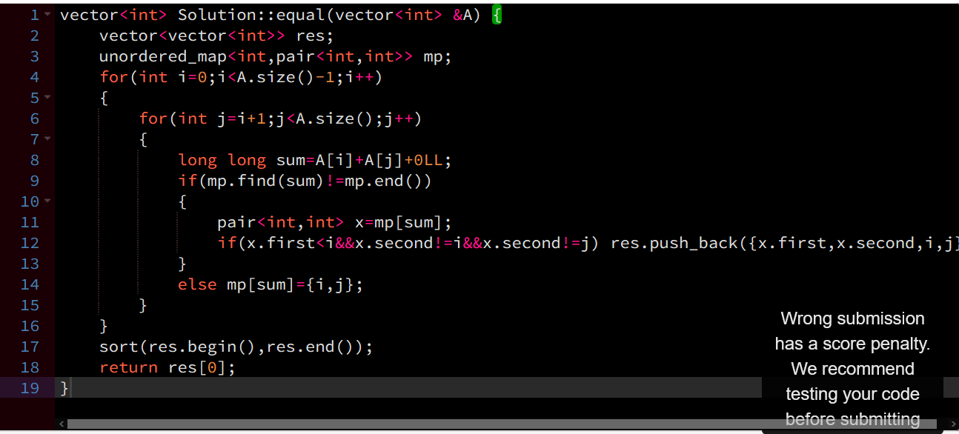

1. Substring concatenation

