1. No of islands

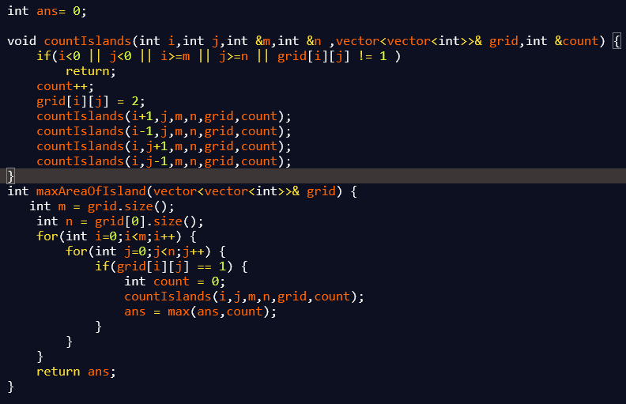

1. Interleaving string

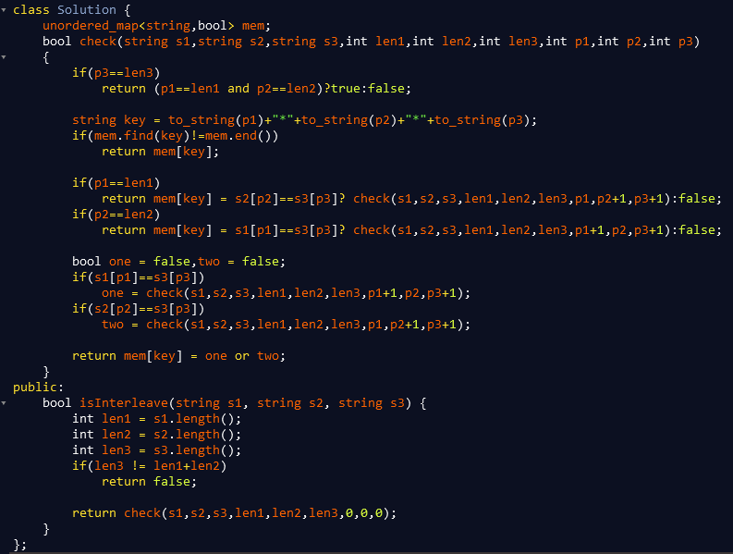

1. Open the lock

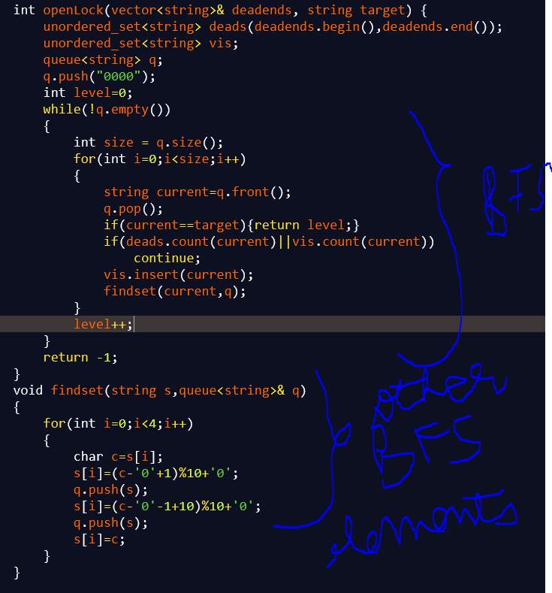

1. Maximum performance of a team

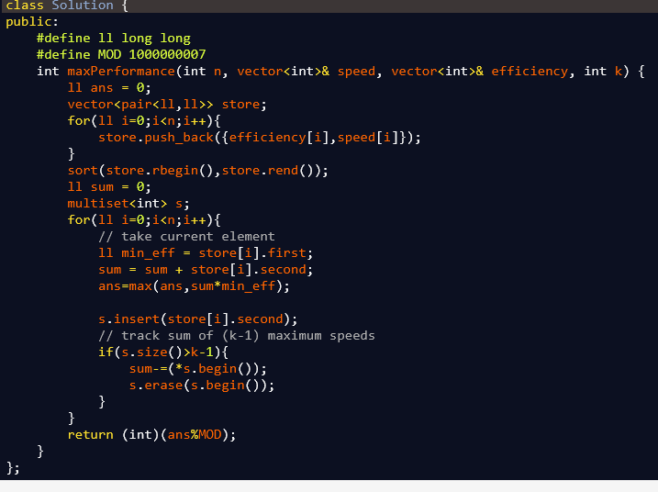

1. Longest consecutive sequence

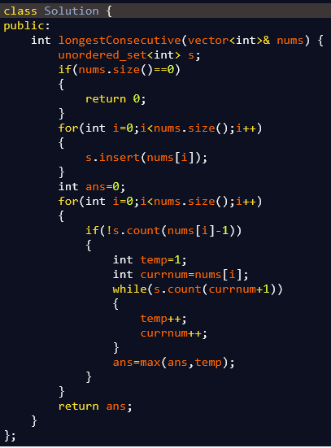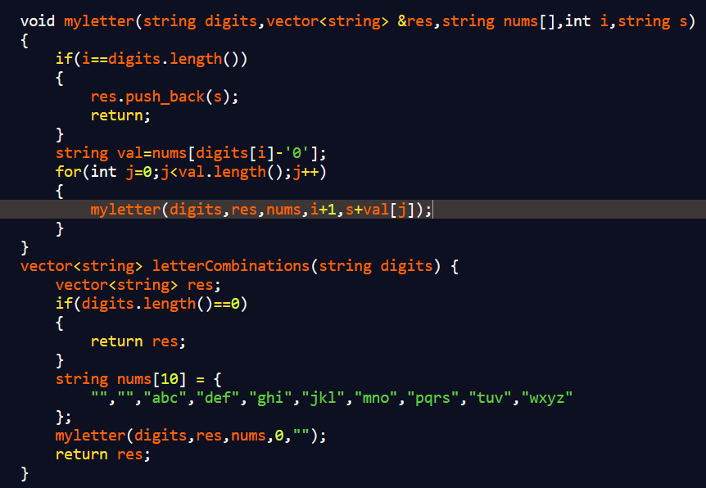

1. Keypad number of possible combinations
2. Top k numbers in terms of frequency
3. Construct binary tree using inorder and preorder trvaersal

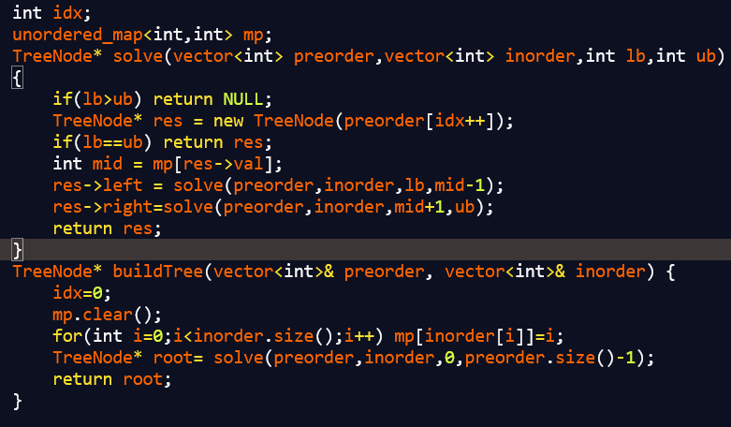



1. Jump number VI

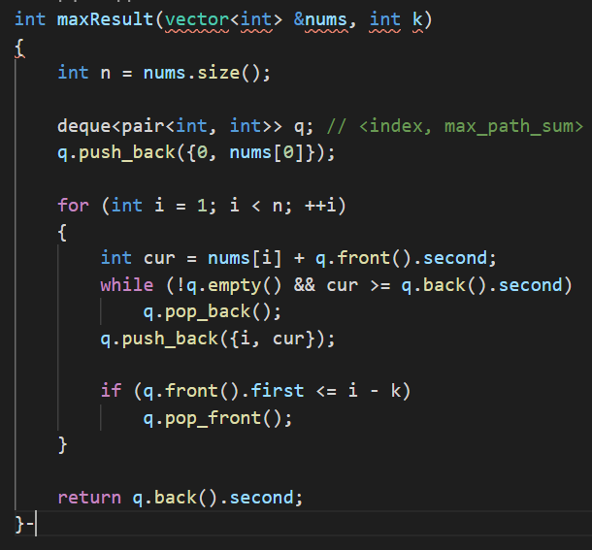

1. Minimum number of refuelling stops

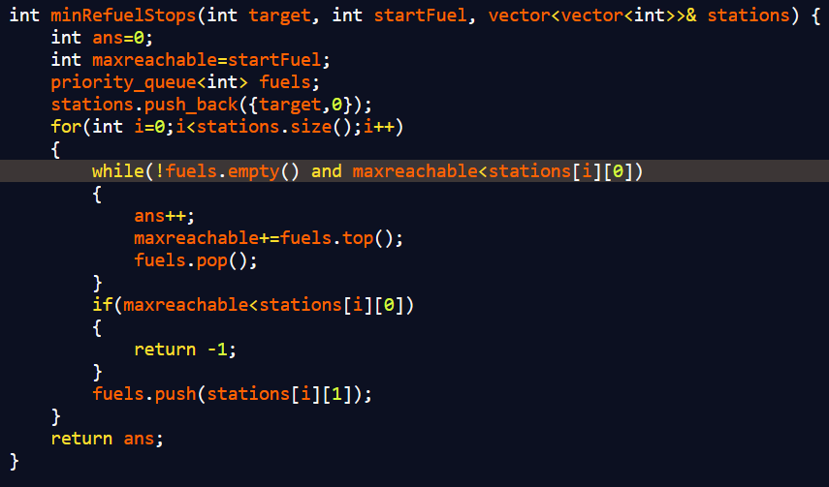

QUES 11) palindrome pairs

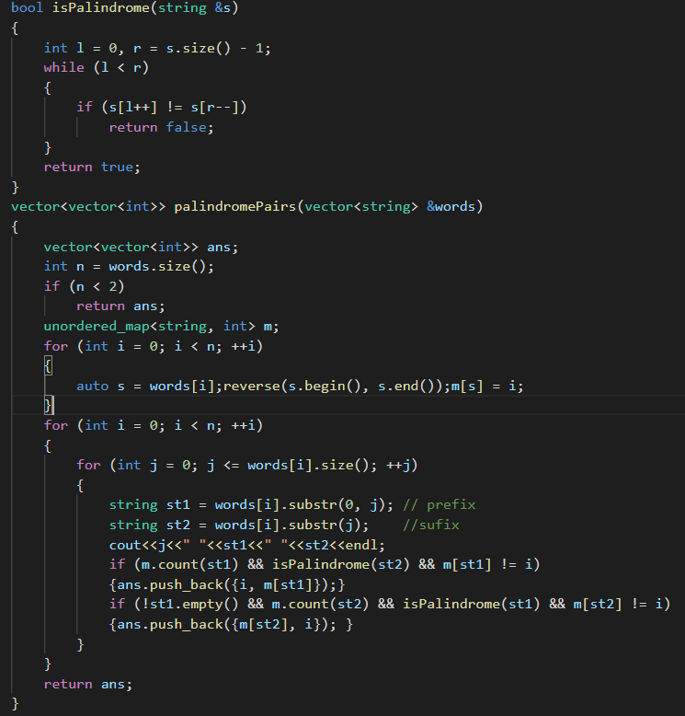

Ques 12) Maximum units of truck

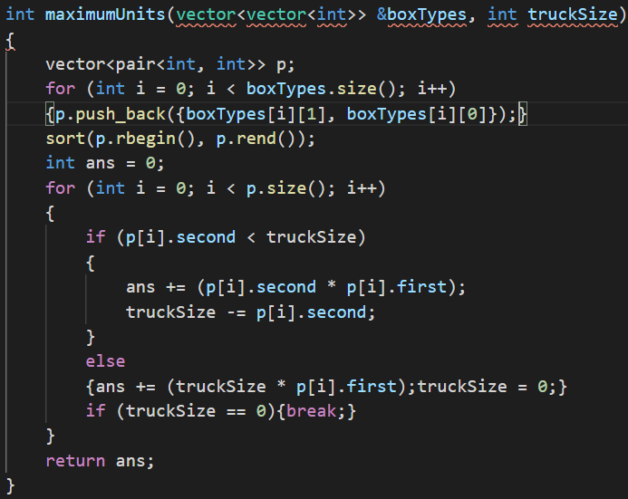

Ques 13) matchsticks to square

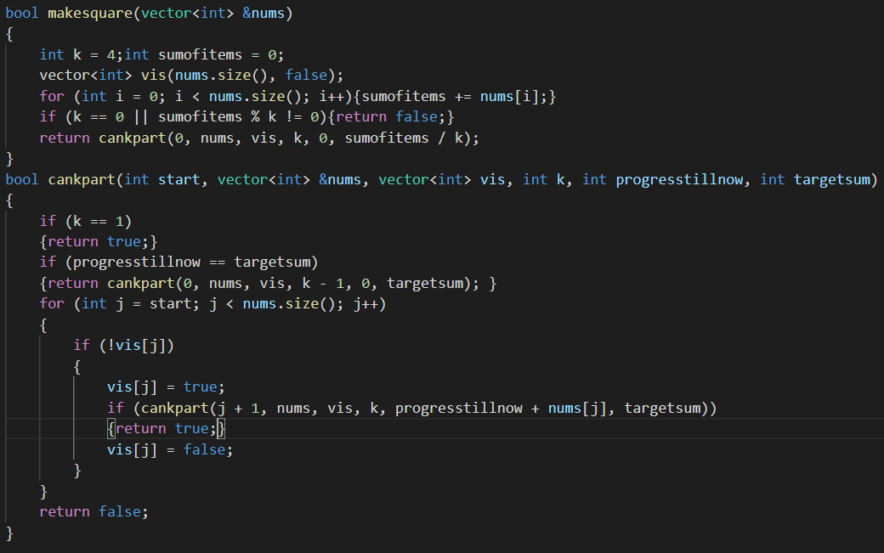

Ques 14) number of subarrays with bounded maximum

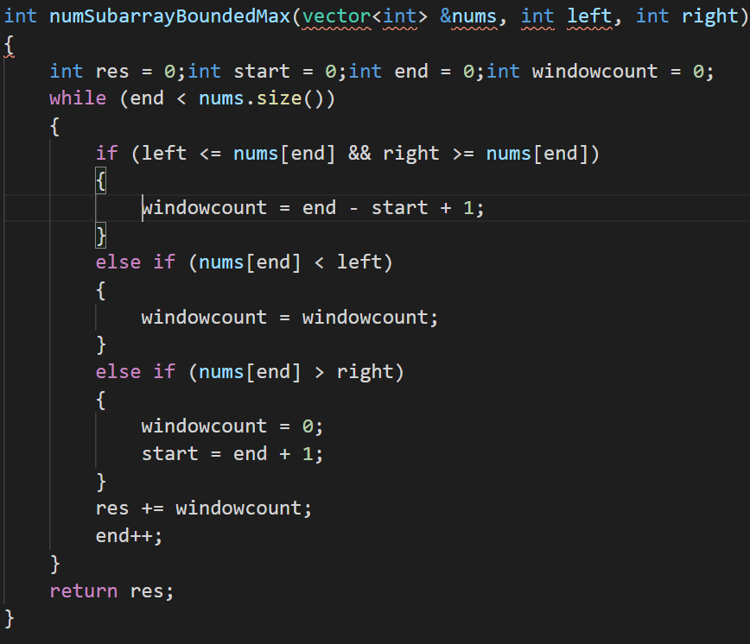

Ques 15) DFS standard island problems

<https://leetcode.com/contest/weekly-contest-246/problems/count-sub-islands/>

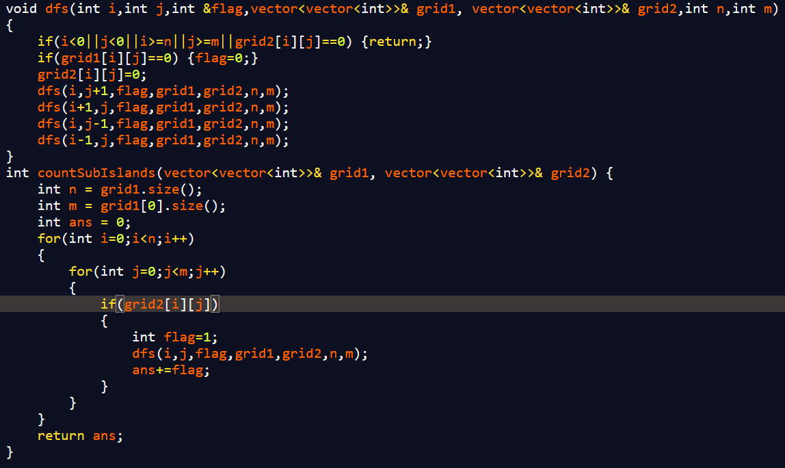

Ques 16) Clock and time problem

\* Convert problem into minutes

\* if(starttime>endtime) then starttime+=24\*60;

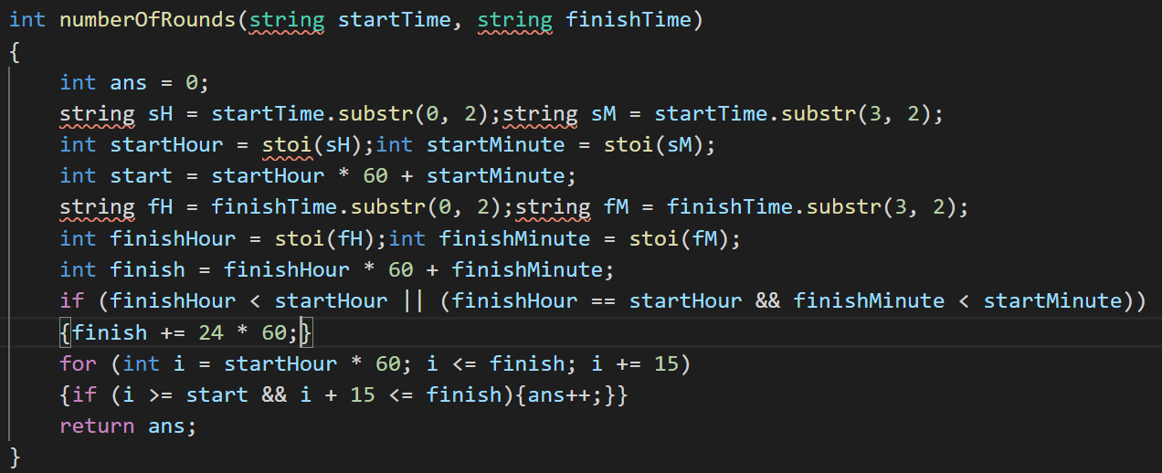

<https://leetcode.com/contest/weekly-contest-246/problems/the-number-of-full-rounds-you-have-played/>

Ques 17) DFS+Binary search on answer rain water

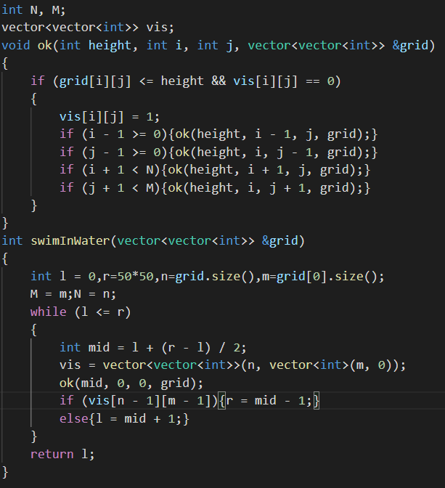

<https://leetcode.com/explore/featured/card/june-leetcoding-challenge-2021/605/week-3-june-15th-june-21st/3785/>

Ques 18) Pascal’s triangle

