**Object detector and Image similarity search engine:**

**Architecture :**

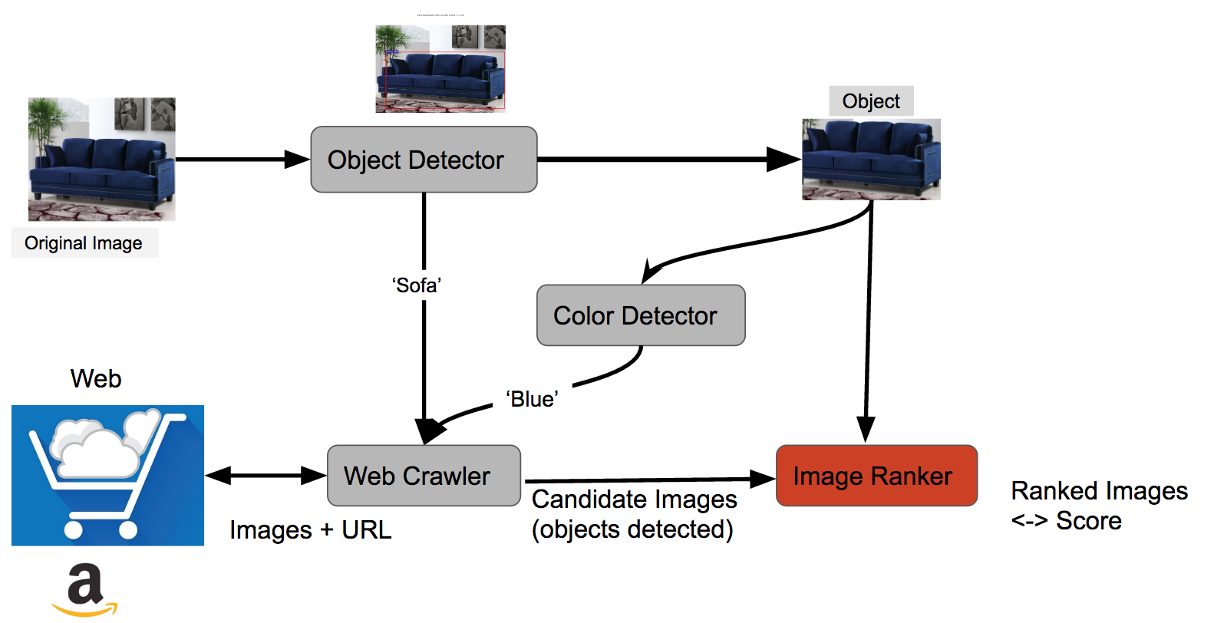

Input Image

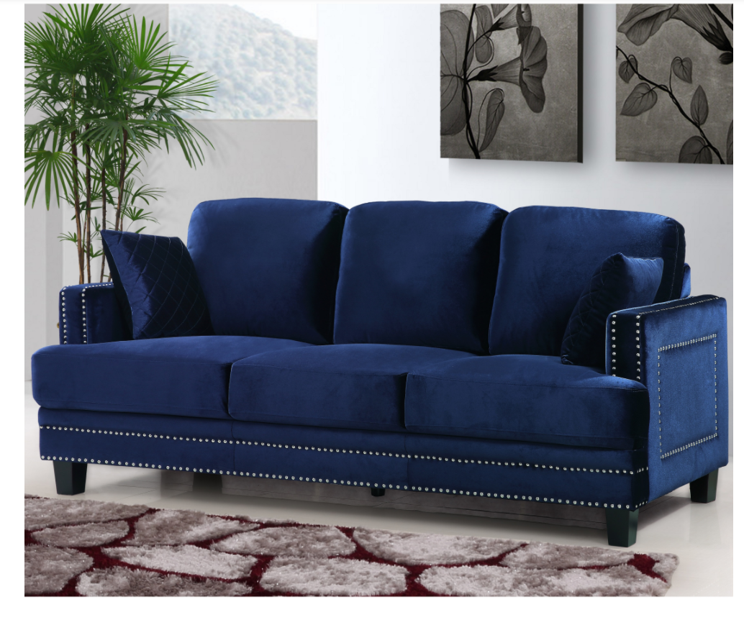

Object detection : through faster RCNN :

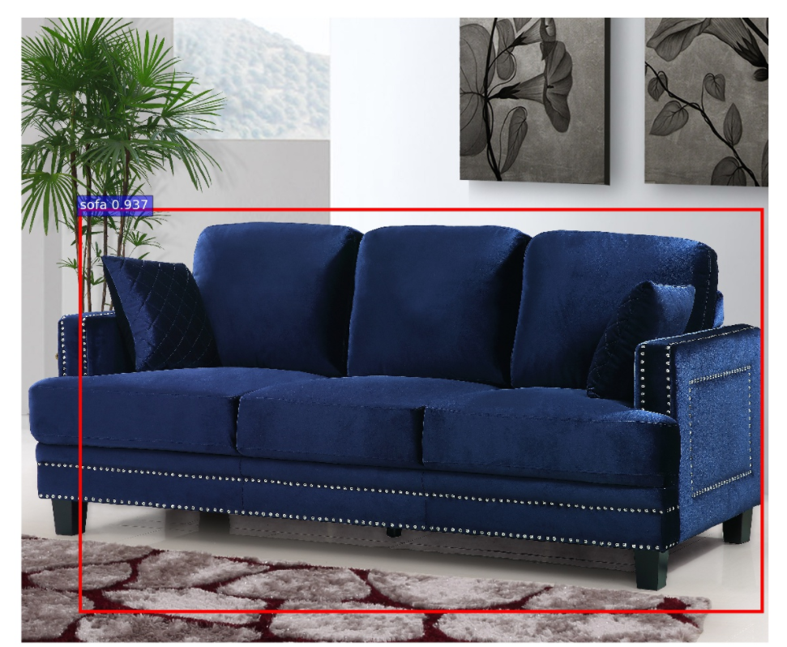

Color detection through : Greyscale -> smoothing -> foreground segregation -> histogram analysis

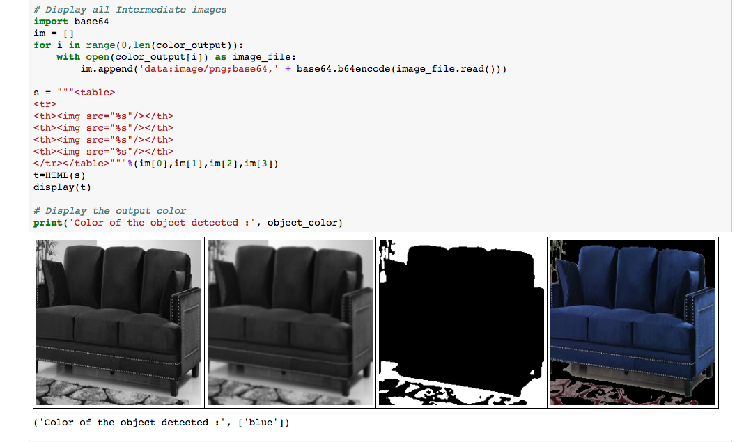

Web crawler results from amazon : ‘Blue sofa’ :

Just search ‘blue sofa’ on amazon -> Candidate images which will be ranked with the base image

**Image Similarity engine result :** CNN with my own architecture. Trained it on chairs/sofa images. Inputs about similarity from hidden layer by Shourabh.

