**Machine learning- Aditya Gautam(agautam1@andrew.cmu.edu)**

**3 g)**

**Test data errors :**

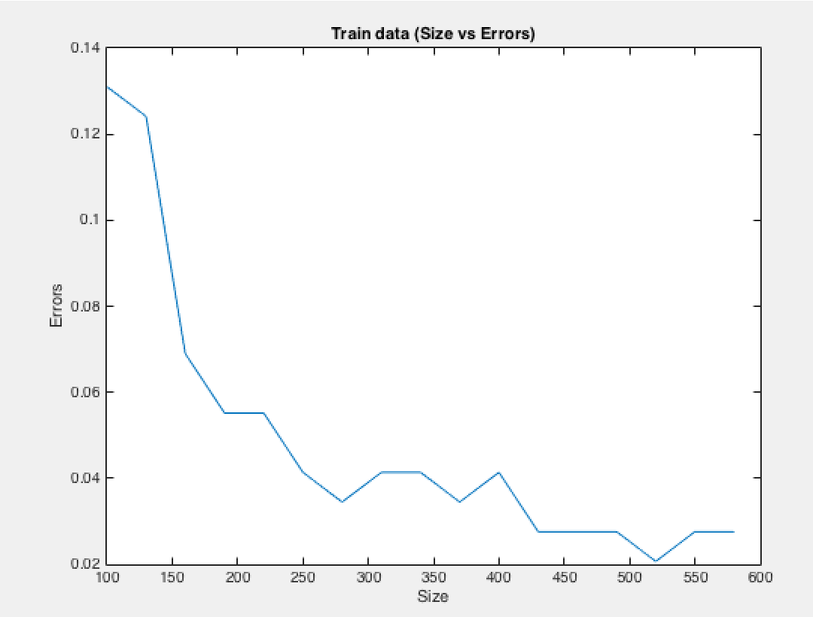

**Training Data Error:**

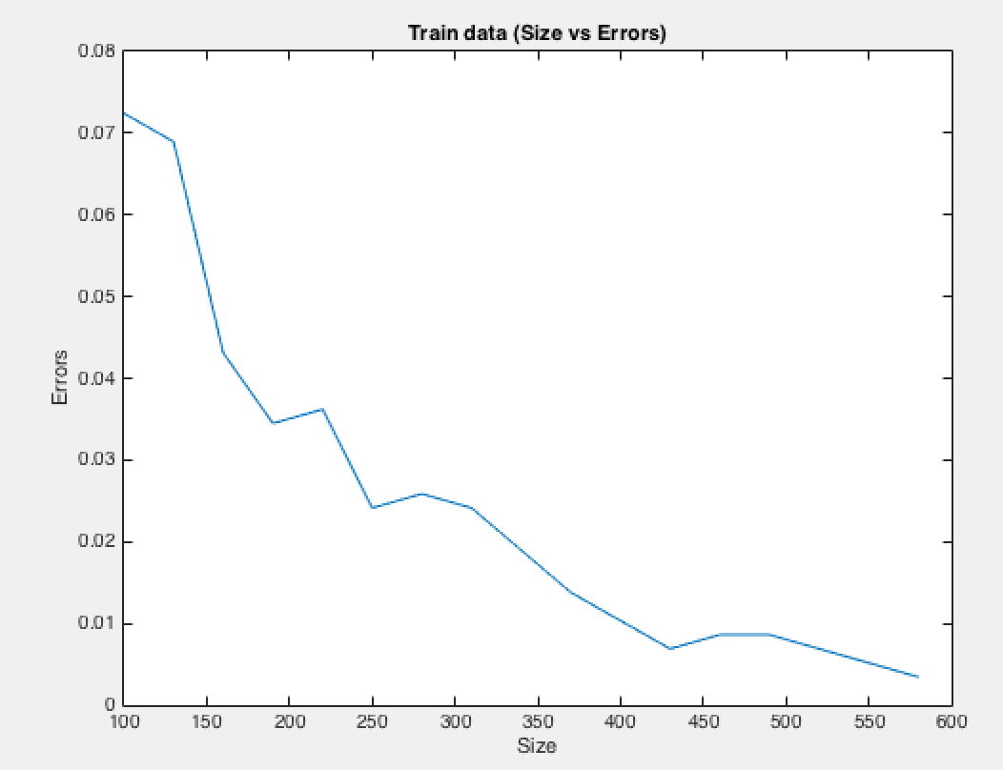

**Ques 2) Part b):**

**Matlab Code**

function [ ] = logMLE()

theta = 0.01:.01:0.5;

x = [1 0 3 5 18 14 5 7 13 9 0 17 4 24 3];

y5= sum(x(1:5))*log(1-theta) + 5*log(theta);

y10 = sum(x(1:10))*log(1-theta) + 10*log(theta);

y15 = sum(x(1:15))*log(1-theta) + 15*log(theta);

figure

plot(theta,y5)

xlabel('theta');

ylabel('y(log MLE)');

title('Log MLE (5 points)');

figure

plot(theta,y10)

xlabel('theta');

ylabel('y(log MLE)');

title('Log MLE (10 points)');

figure

plot(theta,y15)

xlabel('theta');

ylabel('y(log MLE)');

title('Log MLE (15 points)');

end

**Graphs : ( 2b)**

**5 Points**

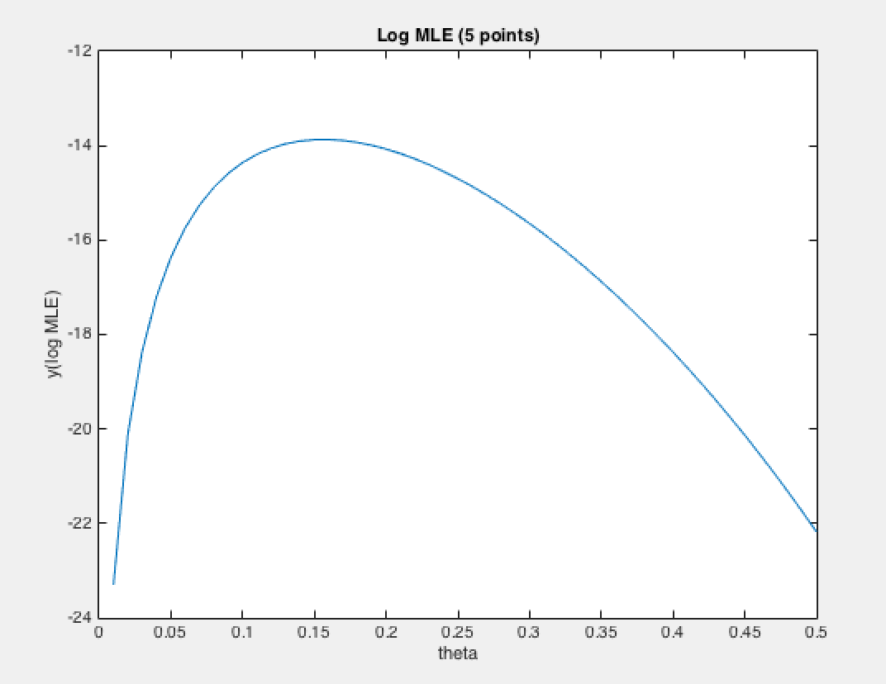

**10 points**

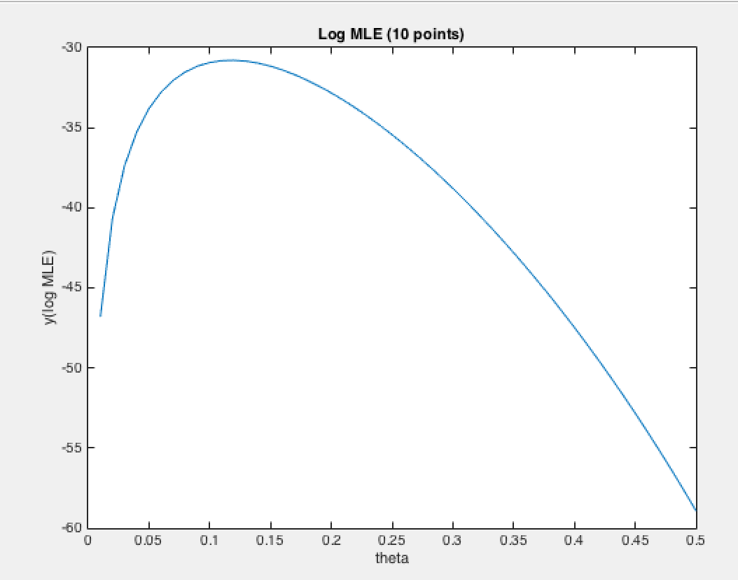

**15 points**

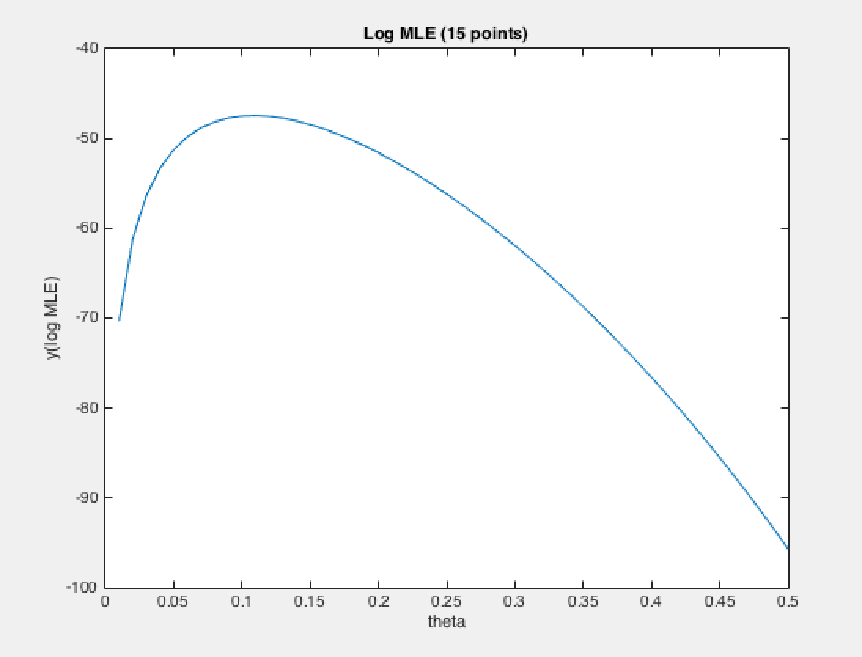

**Code for 3(g) :**

function [] = NB_Size_Error(XTest,yTest,XTrain,yTrain)

load('HW2Data.mat');

error = zeros([1 length(100:30:580)]);

count =1 ;

for m= 100:30:580

D = NB_XGivenY_Size(XTrain,yTrain,m);

p = sum(yTrain(1:m)==1)/length(yTrain);

fprintf('p = %d \n',p);

[yHat] = NB_Classify(D,p,XTest);

error(count)=sum((yTest~=yHat))/length(yTest);

fprintf('size = %d, error = %d \n',m,error(count));

count = count+1;

end

data_size = 100:30:580;

figure

plot(data_size,error)

xlabel('Size');

ylabel('Errors');

title('Train data (Size vs Errors)');

end

**Code for 3(h):**

function [] = NB_FreqWords(XTrain,yTrain)

load('HW2Data.mat');

[n, v] = size(XTrain);

D = zeros([2 v]);

word_count = zeros([2 v]);

[rows,col,value]= find(XTrain);

num_eco_docs = sum(yTrain==1);

num_oni_docs = sum(yTrain==2);

length_spare_matrix = length(rows);

for i = 1:length_spare_matrix

if yTrain(rows(i),1)==1

word_count(1,col(i)) = word_count(1,col(i))+1;

else

word_count(2,col(i)) = word_count(2,col(i))+1;

end

end

D(1,:) = (word_count(1,:) + .001)/(num_eco_docs + .901);

D(2,:) = (word_count(2,:) + .001)/(num_oni_docs + .901);

B = D(1,:);

for i=1:5

[M,I] = max(B);

fprintf(' Economist : val = %d, idx = %d \n',M,I);

B(1,I)=0;

end

B = D(2,:);

for i=1:5

[M,I] = max(B);

fprintf(' Onion : val = %d, idx = %d \n',M,I);

B(1,I)=0;

end

B = D(1,:) ./ D(2,:);

for i=1:5

[M,I] = max(B);

fprintf(' Eco/Onion : val = %d, idx = %d \n',M,I);

B(1,I)=0;

end

B = D(2,:) ./ D(1,:);

for i=1:5

[M,I] = max(B);

fprintf(' Onion/Eco : val = %d, idx = %d \n',M,I);

B(1,I)=0;

end

end