An optimised machine learning approach for detecting a network attack in an Intrusion detection system

ADITYA YADAV
Under the Supervision of
PANKAJ KUMAR KESERWANI



PROJECT REPORT
Submitted to
NATIONAL INSTITUTE OF TECHNOLOGY SIKKIM

for the award of the Degree of
Bachelor of Technology
in
Computer Science and Engineering
June 2021

Certificate by Supervisors

This is to certify that the project report entitled “An optimised machine learning approach for detecting a network attack in an Intrusion detection system” is being submitted by Mr. Aditya Yadav (Roll No. B170071CS), a student in the Department of Computer Science and Engineering, National Institute of Technology Sikkim, for the award of the degree of Bachelor of Technology (B.Tech). It is an original work carried out by him under my supervision and guidance. The results embodied in this report have not been submitted to any other University or Institute for the award of any degree or diploma.

Mr. Pankaj Kumar Keserwani

Certificate by Student

I hereby declare that the work presented in the report entitled “An optimised machine learning approach for detecting a network attack in an Intrusion detection system” is a bonafide record of the work done by me under the supervision of Asst. Prof. Pankaj Kumar Keserwani, Department of Computer Science and Engineering, and that no part thereof has been presented for the award of any other degree.

- I have followed the guidelines provided by the institute in writing the report.
- The report does not contain any classified information.
- Whenever I have used materials from other sources, I have given due credits to those by citing them in the text of the report and giving the details in the references.
- Whenever I have quoted written materials from other sources, I have put them under quotation marks and given due credits to the sources by citing them in the text of the report and giving their details in the references.

Dated: 28-06-2021 Mr. Aditya Yadav
Place: NIT SIKKIM Roll No.: B170071CS

Acknowledgment

I wholeheartedly thank our Project Guide Asst. Prof. Pankaj Kumar Keserwani, Department of Computer Science and Engineering, National Institute of Technology Sikkim for his extreme support and guidance throughout the project work.

My special thanks to our head of department Dr. Pratyay Kuila, Department of Computer Science and Engineering, National Institute of Technology Sikkim, who allowed me to carry out this project work and provided his guidance whenever necessary.

I am grateful to my parents who gave me persistent encouragement and inspiration throughout my being.

Finally, I would like to thank everyone who has directly or indirectly helped me in the successful completion of this project and throughout.

Aditya Yadav

Contents
Page no.
- Chapter:1 Introduction
  - Abstract ……………………………………………………... 8
  - Introduction …………………………………………………. 9
  - Background Study & Motivation ……………………........... 12
  - Problem Statement ………………………………………… 18
  - Objectives ……………………………………………......... 19
  - Summary of Chapter …………………………………......... 20

- Chapter:2 Literature Survey
  - Related Tools & Technologies …………………………….. 21
  - Related Work …………………………………………….. 24
  - Summary Of Chapter ………………………………………. 34

- Chapter:3 Proposed Work
  - Proposed work ……………………………………………. 35
  - Implementation Results ………………………………....... 40
  - Summary Of Chapter ………………………………………. 52

- Chapter:4 Conclusions and Future Works
  - Conclusions ………………………………………………… 53
  - Future works ……………………………………………….. 53

References

List of Tables
Page no.
- Different attack in each category in the training set. …….......... 17
- Different attack in each category in the testing set. …………… 17
- Description of all features in the dataset. ……………………… 41
- Optimal subset of features selected by the RFE algorithm. …… 44
- Performance evaluation on the selected subset of features. …… 45
- Performance evaluation on all 41 features of the dataset. …....... 45
- Accuracy measures on k-fold cross-validations. ………………. 48
- Confusion matrix of proposed classification. ………….………. 49
- Comparison with other methods in various researches .……...... 51

List of figures
Page no.
- Cyber-attacks growth in recent years. ………………………… 9
- Network Intrusion detection systems. …………………………. 13
- Host-based intrusion detection systems. ………………………. 13
- Proposed Approach flow diagram. ……………………….......... 35
- The framework of subset feature elimination. ………………… 37
- Confusion Matrix …………………………………………….... 38
- Process flow of an implementation of proposed work. ………... 40
- DOS recursive feature elimination ROC Curve………………... 46
- Probe recursive feature elimination ROC Curve………………. 47
- R2L recursive feature elimination ROC Curve. ………… 47
- U2R recursive feature elimination ROC Curve. ………… 48

Chapter 1
Introduction

  - Abstract
With increasing day-to-day emerging technologies, IoT, cloud computing, artificial intelligence, edge computing, quantum computing the network security is degraded because of the continuous increase in the number of cyber-attacks. However, at the same time, security has become a major concern due to increased attack scenarios and varied threats to the genuine user community. A recent trend in the number of increasing cyber-attacks is shown in Fig1. The traditional solutions are inefficient and ineffective in providing desired protection against continuously advancing cyberattacks such as ad click fraud, Denial of Service(DoS) attacks, IP flooding, malware, illegal access, altering of data, forgery, interrupting the normal behavior of the system and so on. Varied cyberattacks are not only resulting in massive financial losses but have other serious consequences. An intrusion detection system is proposed based on chi-square feature selection algorithm and tuned hyper-parameters using randomized search cv in random forest algorithm to classify the attack category with a reduced set of features by eliminating less relevant features using proposed feature selection methods to detect malicious attacks in computer networks by experimenting on the CICIDS 2017 dataset. Most researchers stated that by choosing the optimal segment of features for an intrusion detection system, it is quite possible to slowly improve the accuracy of attack detection and model performance. In the present era where there is the rapid emergence of the latest technologies like Cloud Computing, IoT, etc. leading to a continuous increase in network traffic logs, so there is an urgent need for intrusion detection systems should be improved by collecting and analyzing the information of incoming network traffic data. There are some very massive popularly known datasets in which full features set are not contributing to the network logs traffic, thus to turn down and choose the only optimal variety of features could improve the performance, precision, speed, and correctness of the intrusion detection system. For this sci-kit learn library was utilized in this study. With this approach, optimal features were known within the dataset, and therefore the accuracy rate is enhanced. The outcomes are studied showing the concept that selected features improve the classifier performance.

  - Introduction
The recent increase in day-to-day usage of the number of network devices, advancement in existing and new technologies and services leading to a steady increase in cyber-attacks by hackers performing malicious attacks to modify or steal the data from victim systems. To overcome these all cybersecurity network-related attacks there is an increasing demand for protective measures like Intrusion Detection System (IDS) which is one of the essential elements of network security that helps to detect the attacks by analyzing network traffic packets or operating system network logs. In Fig1.showing continuous increase in cyber-attacks count over past years and this is increased about 200%. Therefore current scenario needs faster development in the field of cybersecurity, especially in network intrusion detection and prevention systems.
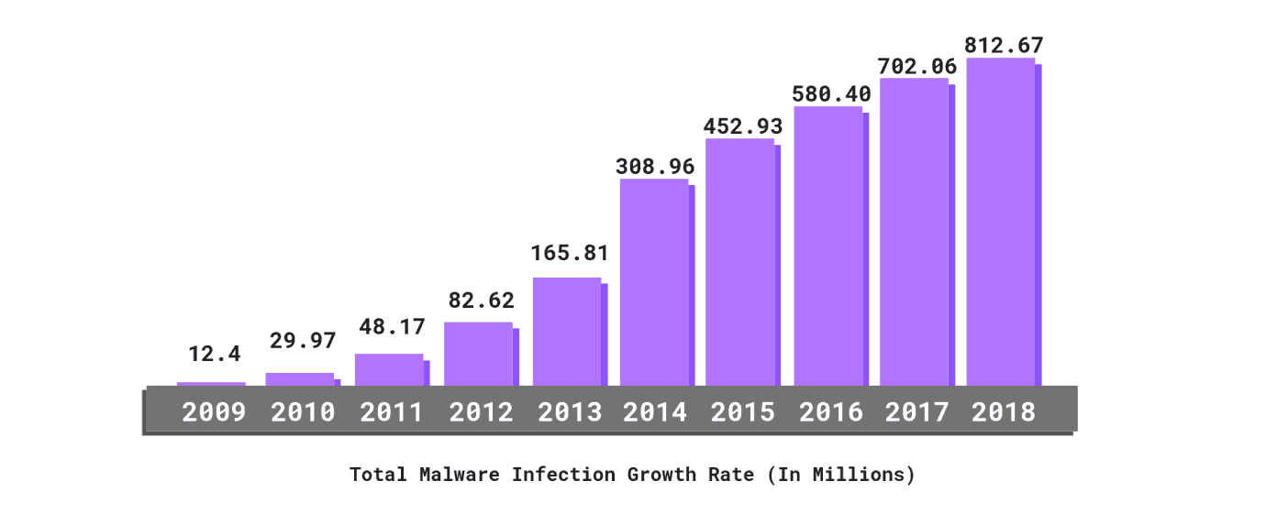
Figure 1 Cyber-attacks growth in recent years

To mitigate the risk of cyber-attacks IDS is one effective solution. Intrusion detection is a process of detecting and preventing intrusions activity on any network or system. It is one of the significant ways of preventing the computer system from intrusions. In general intrusion detection systems are software applications or hardware security programs that verify that anything occurring in the system over a network is malicious or normal in behavior [1]. There are five types of intrusion detection systems: 1) Host-based intrusion detection system 2) Network-based intrusion detection system 3) Protocol-based intrusion detection system 4) Application protocol-based intrusion detection system 5) Hybrid intrusion detection system. Each of the above-mentioned intrusion detection systems has a varied procedure in detection and providing security to the data, and each of them has its pros and cons [2]. Initiating alert to organizations when any malicious or intrusive activity is detected within network or system devices so network and host-based intrusion detection system play a vital role in cybersecurity. One of the most common problems of these intrusion detection systems is handling the large amounts of attack alerts and the way how to handle them. Another major problem that arises due to the recent emerging of new technologies is the upcoming issues of “Big Data”, “IoT”, “Fog & Edge Computing”, “Cloud Computing” is their large network data logs. These emerging technologies produce a large amount of data that is multidimensional with numerous features is needed to be reduced to get an efficient intrusion detection system [3]. It is now very surged need to implement these enormous data to be considered not because of the increasing number of tuples, but also for the number of features in each tuple that may lead to generate more false positives so redundancy of dataset classification will increase.
For any intrusion detection system, selecting a subset of features to reduce the set of non-contributing features in classification is called the pillar of an intrusion detection system. The efficiency and accuracy of a dataset have a major dependency on the performance of the classifier model on that dataset. If the dataset split into training components is less redundant and has more accurate logs then the testing component will have more improvised model performance [4]. Therefore, it is one of the most inevitable steps to get better accuracy performance choosing a less redundant dataset for testing and training components of the system model, and gathering the network logs dataset is a big quandary as a dataset that is publicly available for use is very diverted from real scenario. There are some well-known available datasets on network attacks mostly used by the researchers are such as NSL KDD, UNSW NB-15, CICIDS 2017 datasets.
In our implementing CICDS dataset, there are a set total of 79 features. To make our dataset fit for applying machine learning classification algorithms for gaining high accuracy dataset needs to be first pre-processed, cleaning of redundant data, encoding of categorical features, scaling of features with very huge values, feature reduction should be performed first to increase the efficiency and get training time reduced.
Machine learning approaches helped us to analyze learn from very huge datasets and make correct predictions overtime on continuous learning from each outcome feature has now reduced human intervention to a greater extent in the real-time data science world.
To get the proper intrusion detection system it involves feature elimination and classification of attack category for enhancing the performance of the model to get better metric value on accuracy, precision [7].
The rest of the study is organized as follows. In Chapter II, the related survey of works done by various researchers is discussed briefly. In Chapter III, the proposed model is discussed and analyzed in-depth for algorithms implemented from dataset selection to performance evaluation. Different phases of intrusion detection systems are described in detail with a detailed analysis of the performance evaluation of our proposed model. In Chapter IV Conclusion and future work are briefly mentioned.

  - Background Study & Motivation
Motivation to perform a detailed study in network security topic of intrusion detection systems is:
- Continuously developing IoT networks, cloud computing have become an increasingly valuable target of malicious attacks due to the increased amount of valuable user data they contain. In response, network intrusion detection systems have been developed to detect suspicious network activity with more accuracy.

- Traditional network security solutions may not be directly applicable due to the differences in the advancement of IoT structure and behavior in recent times.

- Healthy class discussions with our project supervisor about recent issues, challenges, and solutions by machine learning and deep learning methods to solve the problem arouse interests in the field and motivated to do some contribution.

- During this project, I have read many research and journal papers related to intrusion detection systems on various methods to solve this problem each having its pros and cons led me to work in this field more efficiently.

Detection of intruders is the detection and prevention of intrusive activity on any network or system. These intrusion attacks may lead to serious damage to networks and systems. The intrusion detection system keeps an eye on network systems to alert the admin if any malicious or intrusive activity is noticed. It is a radar-like software application continuously searching for fraud or intrusive activity or policy violations.

Types of Intrusion Detection System:
The intrusion detection system is of 5 types:
- Network Intrusion Detection System:
A network intrusion detection system is a hardware or software-based system that detects malicious traffic on the network. In a network intrusion detection system, there are some points on the network which inspect the congestion from incoming packets to all network devices. It checks the packets for if there is an attack by the pre-determined or known existing database. If it matches to attack an alert is sent to the administrator [8].
Figure 2 Network Intrusion Detection System

- Host Intrusion Detection System:
A host-based intrusion detection system is an application that inspects for any malicious activity on a network and reports to the administrator if any suspicious activity is detected by operating through data on individual computers on the whole network system. Host-based IDS analyses the network by capturing screenshots of individual hosts information logs [9].
Figure 3 Host-based Intrusion Detection system
- Protocol-based Intrusion Detection System:
A protocol-based intrusion detection system is installed on the front end of the webserver which performs its operation by analyzing the protocol system used between the host network device and the webserver. Protocol-based IDS keeps an eye on the front end of a web server HTTP, HTTPS protocol stream [10].
- Application Protocol-based Intrusion Detection System:
Application Protocol-based Intrusion Detection System also monitors and analyses the dynamic network behavior from server installed application. But it typically performs its operation from the application protocol of a group of servers [11].
- Hybrid Intrusion Detection System :
If any intrusion detection system has two or more machine learning approaches are combined to perform as a single algorithm for classification then it is called a hybrid intrusion detection system. In this individual system, data is mixed with the data on the network system to get full network logs of the system [12].

Detection methods of IDS:
- Signature-based Method:
A signature-based intrusion detection system is based on detecting the attack or any malicious activity by matching the known attack pattern from existing data of pre-defined attacks. These attack patterns which are known in the database are called signatures. When any network behavior is matched with these known signatures then the intrusion detection system issues an alert alarm to the administrator that a malicious attack is happening over a network [13].
- Anomaly-based Method:
An anomaly-based intrusion detection system is based on detecting any unknown attack or malicious activity which is not known or its behavior is not in the existing database of the intrusion detection system. In an anomaly-based intrusion detection system, machine learning models are trained based on existing attack behavior and identifies for the attacks based on that available information and predictions [14].

Comparison of IDS with Firewalls:
Intrusion detection system it monitors and issues only alert if any malicious activity is detected however in firewalls it blocks any unauthorized access and also disables users to access any malicious content on the system. The major difference is that firewall can protect if any intrusive activity is happening inside the system but an intrusion detection system can alert only over a network.
- A firewall does not restrict or alerts for permitted network traffic areas while an intrusion detection system keeps an eye over the complete network.

- To function a firewall no human intervention is required but for an intrusion detection system, an administrator is required to handle the attacks when alerted by the system.

Machine learning solves many different types of problems; we can group these problems
into the following tasks:

- Classification outputs a predicted label from some predefined set.
- Regression outputs a predicted real-valued numerical result.
- Clustering groups objects such that objects within the same cluster have similar
properties compared to that of other clusters. There may or may not be a predefined
number of clusters to fit the training data to.

Both classification and clustering are types of approaches which are suitable for this project. Classification aims to predict a category and assign the labels benign or attack. While clustering aims to divide the data into groups that are similar to each other. Here, we cluster the data into normal and anomalous cases.

  - Problem Statement

For high-dimensional data spaces, the machine learning-based intrusion detection systems have decreased their performance and a very large increase in execution time of the model as compared to low dimensional data spaces in which it has higher accuracy and efficiency in detecting network attack. Therefore it is an urgent need for implementing an appropriate feature reduction method with proper classification methods but some of the features which have a lesser dependency on target outcome variable can be eliminated so that it does not possess a great impact on the classification process and results in reducing time. There are many network intrusions dataset that works upon any network attacks-related datasets like UNSW-NB15, NSL KDD, CICIDS, etc. which includes many irrelevant features or features having very very least dependency on outcome variable so it drastically decreasing the rate of intrusion detection and increasing false alarm rate. Here the aim is to propose a relevant feature extraction technique to obtain more accurate and decrease false alarm rate. Apply a proper classification algorithm to train a model which detects the attacks in a network by following network log data. Compare with other feature extraction and classifier algorithms of previously done researches with your proposed method.

  - Objectives

- To identify the most significant features extraction mechanism of Intrusion detection on any network attacks dataset.

- To achieve this objective a statistical-based feature selection algorithm is applied which selects the features having a correlation coefficient value greater than 0.5. this method is called Pearson’s correlation coefficient.

- Comparing Machine learning-based approaches with the reduced feature set and all features by measuring respective performance metric score.

- To achieve this objective after feature extraction binary classification and multi-class classification is performed on the dataset. Linear support vector classifier, Quadratic support vector classifier, K-nearest neighbor, Linear discriminant analysis classifier, Quadratic discriminant analysis classifier is applied and compared the performance of each model.

- Obtain better accuracy and decreased false alarm rate with strongest and reduced features by RFE algorithm proposed.

- To achieve this objective by our trained model and used feature elimination algorithm has shown approx. 98% accuracy in overall attack categories and has decreased the false alarm rate which results in a better intrusion detection system based on features
selected.

  - Summary of Chapter

In this chapter, a discussion to introduction of Intrusion detection is done. It is a process of detecting and preventing intrusions activity on any network or system. The intrusion detection system is of five types NIDS, HIDS, Hybrid IDS, Protocol IDS, Application protocol IDS. There are two types of detection methods of IDS signature-based and anomaly-based detection. Signature-based detection can detect only pre-known attacks in the database while an anomaly-based intrusion detection system is capable of handling the unknown attacks on basis of information or trend learn from the huge network attacks log data. Due to continuous growth in network devices, IoT, cloud computing data files, and information security a primary-concern. In some recent reports of increasing cyber-attacks continuously as shown in Figure 1, there is a need for improvement in this field. Apart from seeing these incidents news in-class discussion with our project supervisor motivated me to give some contribution in this field. Machine Learning (ML), Deep Learning (DL), and nature-inspired approaches are applied to design and develop more efficient and intelligent security solutions to fight against fraudsters or attackers. Cloud computing has become popular among the business community due to its cost effectiveness and other advantages. Security is also one of the paramount in the cloud environment, and hence efforts are made to propose enhanced NIDS. My problem is to find the best minimal subset of features to get better accuracy on the classification of attacks category. For this problem some objectives are defined to achieve that are selecting relevant features subset, applying proper classification model, comparing the metric score such as accuracy precision-recall f score with that of previously done researches. To perform this work CICIDS 2017 dataset is chosen for our works. CICIDS 2017 dataset has 80 features and 12 types of attacks mainly listed into 7 categories DOS, Probe, DDoS, Brute force, Benign, Botnet, Web attack. Each attack category has some attacks from the dataset which is properly listed in Table @ for the CICIDS dataset. DoS is the attack blocking computer networks or resources. The probe is the attack where the intruder scans information from the network and uses it later to launch the attacks.

Chapter 2
Literature Survey

  - Related Tools & Technologies

Technology and tools used for this study are:

- Python 3.8.5: Python is one of the most powerful dynamic programming languages. Python is also called an interpreted scripting language.The programming language in our implementation of machine learning algorithms is python’s 3.8.5 version.

- Anaconda Software: Anaconda is software used for machine learning, deep learning, data science for python and R programming languages. It has a collection of individual software packages named Jupyter, Spyder, Anaconda navigator, etc.

- Jupyter Notebook: Jupyter Notebook is an open-source software also known as a python notebook included in Anaconda software which is capable of creating python notebooks mostly used for data science machine learning, deep learning. Jupyter notebook has filed with the extension “.ipynb”.

- Machine Learning: Machine Learning is the field of study in which machines are trained on basis of known patterns and are made able to think like humans. Machine learning is now used up in almost all fields to reduce human intervention and a better way of prediction and analysis.

- Python Libraries: Some most common python libraries used in machine learning are used such as Pandas, numpy, sci-kit learn, matplotlib, etc.

  - Related Works

  - Summary

Chapter 3
Proposed Work and Implementation

- Proposed Work
In this section, a framework to solve the problem statement a work is proposed to achieve all the goals and objectives is depicted in following flow-diagram Figure @ and brief later.
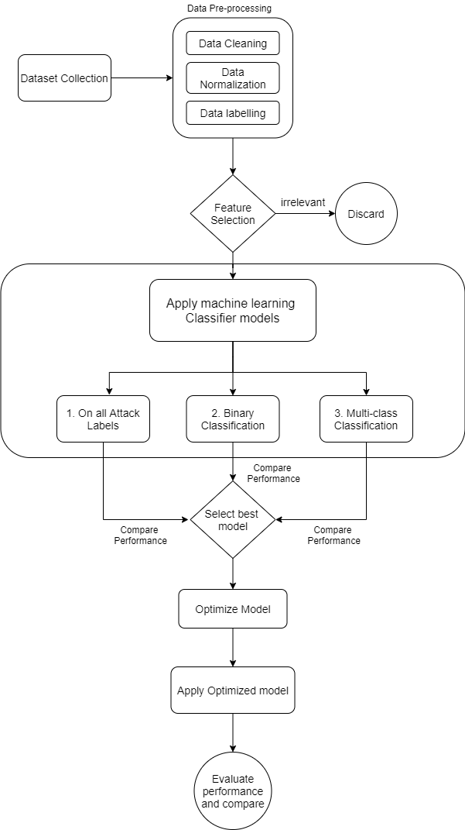

    - Data Collection and cleaning
The first process to build a network intrusion detection system is to collect a dataset to experiment. Collected data may have some missing values, infinite values, duplicate columns, redundant attributes, etc. these all are termed as noise in the dataset so, the dataset is required to be cleaned for such noises if present any with suitable methods like replacing NaN values with mean, median values or dropping the columns redundant. In this, data cleaning step all inconsistencies in the dataset are removed to get a cleaned dataset. Data cleaning is performed within the Python environment.
    - Data Pre-processing
Data Pre-processing is another important step to improve the quality of data which gives an enhancement in results of our experimented proposed approach. Data Pre-processing involves analyzing the dataset attributes, removing and selecting proper attributes, labeling outcome attributes for better visualization, data normalization, encoding, feature scaling, splitting into training and testing set, etc.
Data Normalization
Normalization of a feature or attributes in data is a step to control the upper and lower limits of numerical values in data to a smaller range generally in [-1,1] or [0,1] without losing the actual information values. Normalization is required to perform because generally, high variances in different attributes of data may induce some problems while applying classification models. Normalization helps in the generation of new values within the specified range without affecting the general distribution and results. For example, if attributes have values -10, 234, -657, 987, 213 then to normalize this data, first check for the largest digit value and then divide each by the largest number of that digits for this example largest is 987 so divide by 1000 each then, normalized data will be -0.01, 0.234, -0.657, 0.987, 0.213. This method is called decimal standard scaling.
Data Encoding
In most of the datasets, some categorical features have their values in form of strings that are difficult to interpret by machines. To get better classification relevancy of these features should be included so these types of data features are first converted into numerical data types by several encoding methods. There are various encoding techniques such as one-hot encoder, label encoder, binary encoding, etc. are available. One-Hot-Encoding is a binary representation in which all are zero except one whose value is set to 1. This method of encoding variables is used to get binary features from the input of all categorical features. If any categorical feature has ‘n’ distinct values then one hot encoding makes ‘n’ columns with binary datatype for each distinct value of features.

Attack Labelling
Attack labelling is a step to be performed in any network intrusion detection dataset to perform experiment as label attribute present in dataset has many attack classes. To perform binary classification labelling is to be done as two category one is normal and other is attack all the attack classes except normal i.e. benign in our dataset are clumped in a single label called attack. For performing multi-class classification labelling is done in groups. For example: a highly benchmarked dataset NSL KDD has 22 attacks categorized in 4 different attack categories similarly CICIDS 2017 dataset has 12 attack classes categorized into 7 attack categories.

    - Feature Extraction
Feature Selection is the process of selecting the features which show the greatest contribution in finding the correct class prediction to target variable outcome. If there are some irrelevant features with no or least dependency on the target variable then it decreases the accuracy of classification.
For example, if there are 10 features with their different ratio of contribution to target variable outcome as 0.92, 0.2, 0.11, 0.84, 0.97, 0.05, 0.79, 0.123, 0.976, 0.01 so the feature with very low contribution can be removed from the dataset for classification here only 5 features can be taken into consideration which has their dependency score above 0.7, as it has multiple benefits for improvement in model performance. The use of an optimized feature selection technique reduces data size, training time, and detection time and safeguards against overfitting, leading to overall better performance enhancement of the network intrusion detection system.
There are many feature extraction algorithms like chi-square, recursive feature elimination, Pearson's correlation coefficient, ANOVA F-test, etc. In this work, chi-square method in select k best feature technique for extracting relevant features is used.

    - Classification algorithms
Support Vector Machine
A SVM uses an optimal hyperplane for classification, which is a line for 2D space, a plane for 3D space, and so on. In other words, the SVM maximizes the margins between classes during its training phase by creating the hyperplanes.

Decision Tree
This classifier follows the flowchart-like structure to build a tree from top to down. The internal node in the tree is equivalent to a "test" on an attribute, and the branch is equivalent to the outcome for the test. The leaf node is equivalent to a class label or decision as an outcome after computing all attributes.

Naïve Bayes
This classifier is based on the Bayes’ Theorem, where many algorithms are used from a family by sharing a common principle. Here, each pair of classified features are independent of each other. This classifier is simple and effective. It can build an ML model and predict quickly. It is also known as a probabilistic classifier as it predicts using probability. In supervised learning, every classifier has to undergo the training phase and testing phase. The dataset is prepared after optimization of the feature set, which selects the relevant set. The data of selected features is divided into two subsets - training and testing.

KNN
k-NN is a supervised learning approach that is simple and gets trained fairly well on large training sets. It follows the assumption that data points with similar characteristics reflect similar outcomes. k-NN method predicts an unknown data sample based on majority neighbors among k neighbors. It is robust to noisy training data and is effective in case of a large number of training examples. It requires more time to compute the distance from each instance to all training data samples.

K-means clustering
K means cluster is an unsupervised clustering algorithm that groups objects based on their feature values into K disjoint clusters (where K is a positive integer specifying the number of clusters). It clusters data based on the Euclidean distance between the data, classifying objects into the same cluster if they have similar feature values.

Random Forest
RF makes multiple decision trees during its training from the dataset given as input to work upon the unknown data. For unknown input, each decision tree votes for a specific class as per its training, and finally, the majority vote decides the class of unknown data. It is able to work upon the massive and multidimensional dataset effectively that makes it appropriate for an IoT network.

Proposed Randomized Random Forest Algorithm

    - Performance evaluation
The test dataset is now used to predict our model and for evaluation, on basis of various performance metric values such as the accuracy score, precision, recall, f-1 score, and a confusion matrix.

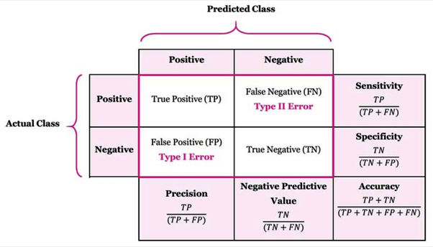
Figure 4 Performance evaluation by Confusion Matrix

True positives are when the prediction of a result attacks and in reality, it is also an attack that means positive predicted for positive. True negatives are when the prediction of result is normal and in reality, it is normal means negative is predicted for negative. False positives are when the prediction of a result is normal but in reality, it is attack means negative predicted for positive. False negatives are when the prediction of result is attack but in reality, it is normal. All above performance metric bases are calculated from the confusion matrix.

- Accuracy is defined as the percentage of true predictions calculated by dividing true predictions by total predictions.
- Precision is defined as the fractions of that are attack and predicted true with all attacks in reality.
- The recall is defined as the fractions of prediction that attack and in reality, is also an attack with total attack predicted.
- F1 Score is calculated from the values of Precision and Recall. F1 score, in general, has more importance in the metric score for comparison. F1 score is calculated by finding the harmonic mean of precision and recall.

Overfitting is another prominent issue in machine learning; it occurs when your model does not generalise well to new data. It can appear when you refine your model too much that it also has learnt all of the noise in the dataset, meaning that although the performances seem to be making improvements, it performs worse when you come to test it on new data.

- Implementation & Results
Implementation of proposed work is done on CICIDS 2017 dataset read using panda’s python library in jupyter notebook. After the dataset is loaded in the jupyter notebook the process flow of an implementation of the proposed approach is shown by the figure @ below:

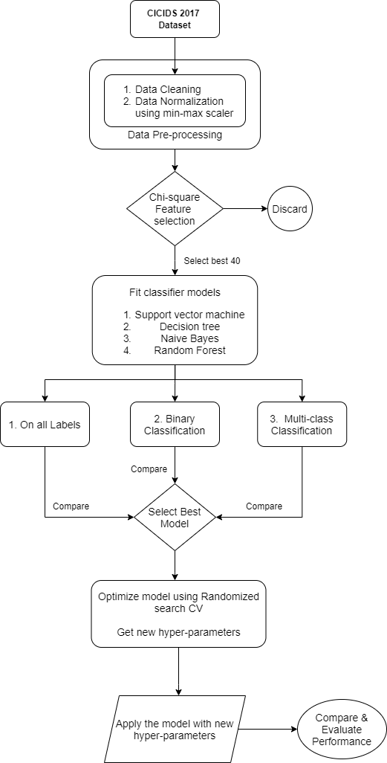

Dataset Collection & Analyzing
To make a network intrusion detection system a benchmark network data should be used to prove the effectiveness and superior performance of our work. In this work, for detecting the network attack a network intrusion detection systems dataset CICIDS 2017 is used.
Analyzing CICIDS-2017 dataset
This dataset contains the realistic background of network traffic events generated by twenty-five users. The profiles of users were detailed, including specific purpose protocols such as Secure Shell (SSH), HTTP, HTTPS, email, and FTP. This dataset covers different types of common attack scenarios. It is publicly accessible in Packet Capture (PCAP) format and CSV files format. There are eight CSV files to perform our work all these files were clumped into a single csv file cicids.csv.
The CICIDS-2017 was created with the actual traces of benign and fourteen types of attacks from the network traffic data, where 2,830,108 records are available in the dataset. 2,358,036 records belong to the benign traffic, and 471,454 records belong to attack records. The CICIDS-2017 dataset contains 84 features, where the last column represents the traffic status or target attribute. This dataset is one of the popular datasets which includes new attacks as its uniqueness. Table @ depicts the distribution of fifteen class labels in the CICIDS2017 dataset.

Attack labels in CICIDS 2017 dataset | Attack Count
Benign | 2,273,097
DoS Hulk | 231,073
Port Scan | 158,930
DDoS | 128,027
DoS Golden Eye | 10,293
FTP Patator | 7,938
SSH Patator | 5,987
DoS Slowloris | 5,796
DoS Slowhttptest | 5,499
Bot | 1,966
Web attack: Brute Force | 1,507
Web attack: XSS | 652
Infiltration | 36
Web attack: SQL Injection | 21
Heartbleed | 11
These above 15 categories of attacks are classified further into 7 different attack categories as shown in below Table @ is:

Attack Categories | All Attack labels
Benign | Benign
DoS | DoS Golden eye, DoS Slowloris, DoS Slowhttpptest, DoS Hulk
Probe | Port scan
DDoS | DDoS
Brute force | FTP patator, SSH Patator
Botnet | Bot
Web attack | Web attack: Brute Force, Web attack: XSS

Different types of attacks in the CICIDS-2017 dataset are briefed below as:

- DoS Hulk: In this HULK tool is used by the attacker to carry out DoS attack on a
web server.
- Port Scan: In this, an attacker attempts to collect information such as OS and active
service on the targeted machine by hitting packets of changing destination ports.
- DDoS: In this, the attacker performs a distributed DoS attack on the victim machine
through multiple machines under the control of a server machine.
- DoS GoldenEye: In this GoldenEye tool is used by the attacker to carry out DoS
attack.
- FTP Patator: In this the attacker performs brute force attack using FTP Patator for
guessing File Transfer Protocol (FTP) login password.
- SSH Patator: In this the attacker perform the brute force attack using SSH Patator
to guess Secure Shell (SSH) login Password.
- DoS Slow Loris: In this, the Slow Loris tool is used by the attacker to carry out a
DoS attack.
- DoS Slow HTTP Test: In this HTTP request is exploited by the attacker to conduct
HTTP flooding on a server.
- Botnet: In this trojans are rooted by the attacker to take control of victim machines
for making a network to conduct desired attacks remotely. The hampered machine
is known as Bot.

- Web Attack: Brute Force: In this trial and error approach is adopted by the attacker
to get privilege of user personal data like password, Personal Identification
Number (PIN), etc.
- Web Attack: XSS: In this, the attacker targets the trusted websites to carry out the
attack by sending malicious scripts.
- Infiltration: In this infiltration, techniques are used by the attacker to infiltrate and
get unlawful access inside the system within a network.
- Web Attack: SQL Injection: In this, the attacker tries to insert SQL queries in an
entry field on the data-driven applications to obtain or update the confidential data.
- Heart Bleed: In this OpenSSL protocol is exploited by the attacker to root malicious
data in OpenSSL memory to obtain unauthorized access to the confidential information.

Dataset Cleaning & Pre-processing
After this loading and analyzing dataset it is checked that dataset has any Null, Nan values so that it should be replace with mean, median, etc. In this work, Dataset is very large so that it may contain redundant and duplicate data which has no contribution toward the targeted outcome. Removal of these redundancies is data cleaning, In our work, CICIDS 2017 dataset has Fwd_header_length column repeated twice hence its redundant so one is removed. Another there are 6 attributes which have single unique values which also has no contribution to the outcome. Hence this is also removed, now dataset is cleaned, For preprocessing it involves Data normalization and Data encoding , Data splitting are performed.
Data Normalization
The normalization of feature or attribute is done to limit the numerical values of data in a range (usually 0 -1) without affecting range differences of actual values or loosing the information. For example, if the first column values range from 0 to 1, and the other column values range from 10,000 to 10,00,000, the variance in the two columns can lead to problems in modeling and analysis. Normalization helps in the generation of new values within the specified range without affecting the general distribution and results. Eq. (1) is used to normalize the values of various attributes present in the datasets [264]
below:

Data Encoding
Dataset is checked for if any categorical data type is present or not if present then before proceeding too classifier algorithms it must be encoded. Here in this work CICIDS 2017 dataset ha no categorical data type hence there is no requirement for applying Machine learning classifier algorithms.
Feature Selection
Extracting the appropriate network feature set is referred to as feature selection and is a challenging task. The use of an optimized feature selection technique reduces data size, training time, and detection time and safeguards against overfitting, leading to overall performance enhancement of the NIDS system. Various optimization techniques can be used for feature selection but for feature selection in this work on CICIDS 2017 dataset chi-square scoring function in select k best algorithm is used.
Chi-square Feature selection method
A chi-square test is used in statistics to test the independence of two events. Chi-square test is used for categorical features in a dataset. We calculate Chi-square between each feature and the target and select the desired number of features with best Chi-square scores. It determines if the association between two categorical variables of the sample would reflect their real association in the population.
Chi square scores is calculated as :
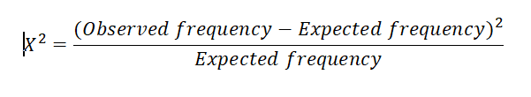
In our work total 40 most relevant features were selected for building model and evaluation by above mentioned method and feature selected are shown in snapshot of code below:
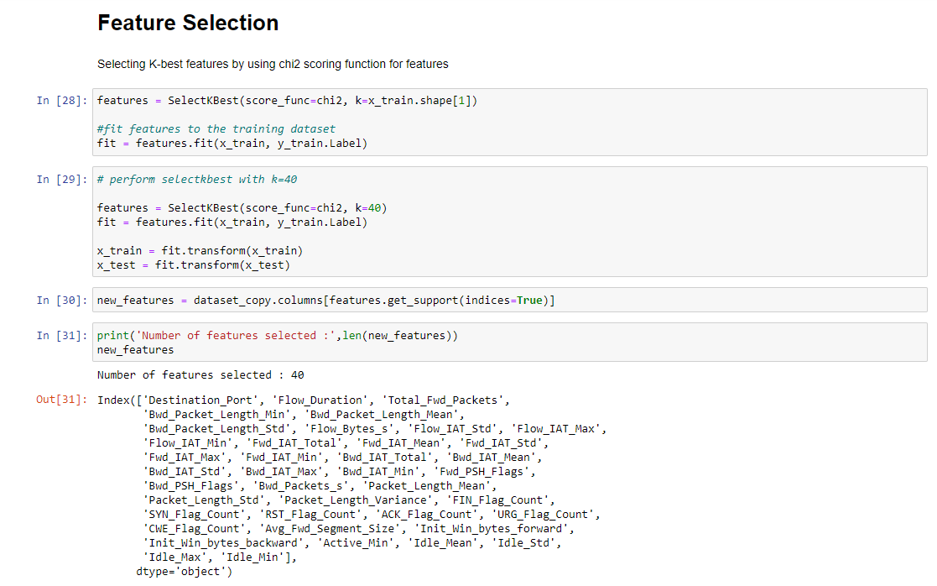
Applying Classification algorithms
Now on preprocessed data feature selection is also applied and is reduced to 40 attributes one by one machine learning algorithm is applied and analyzed the results.
For each machine learning algorithm it is applied in 3 different categories :
- For all Attack labels : In this category there are total 12 attack labels.

- Binary Classification : In this category there is only two label normal and attack.

- Multi-class classification : Here 7 different attack categories are there.

- Support vector machine classifier (SVM)

Support Vector machine classifier is applied first with kernel parameter as linear.

- On all Labels

On all Label model training time is approx. 462 seconds for SVM classifier while testing time is 0.144 seconds. SVM model showed an accuracy of 94.83%.

Confusion matrix for SVM on all Labels is shown below:

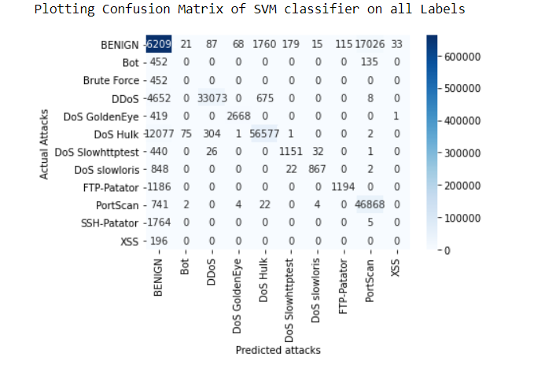

- Binary Classification

In Binary Classification model training time was 158 seconds and testing time being 0.72 seconds. In this model showed an accuracy of 92.72%.

Confusion matrix for SVM on binary label is shown below:

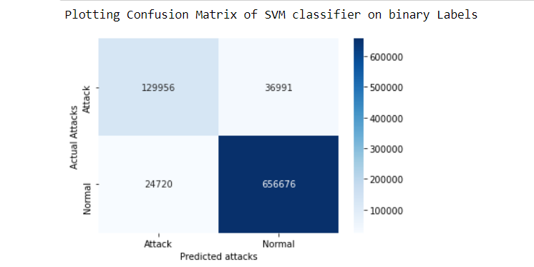

- Multi-class classification

In Multi-class Classification model training time was 340 seconds and testing time being 0.89 seconds. In this model showed an accuracy of 94.43%.

Confusion matrix for SVM on multi-class label is shown below:
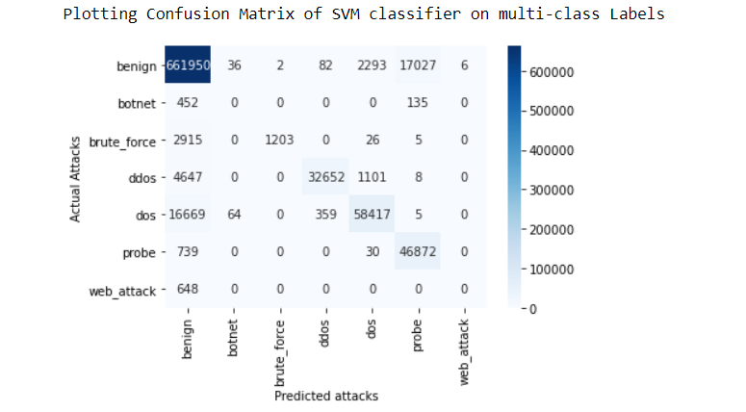

- Decision Tree

- On all Labels

On all Label model training time is approx. 112.453 seconds for Decision Tree classifier while testing time is 0.239 seconds. Decision tree model showed an accuracy of 99.97%.

Confusion matrix for Decision tree classifier on all Labels is shown below:

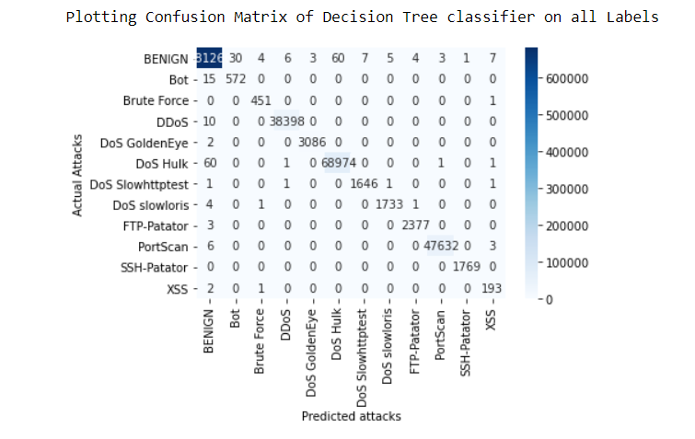

- Binary Classification

In Binary Classification model training time was 113 seconds and testing time being 0.19 seconds. In this model showed an accuracy of 99.97%.

Confusion matrix for Decision tree classifier on binary label is shown below:

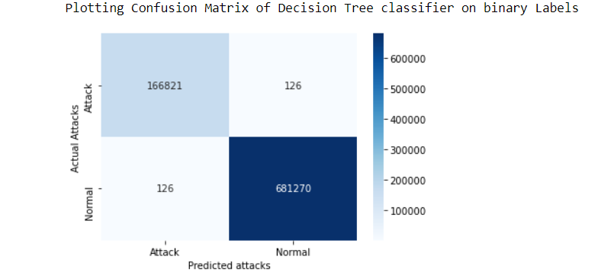

- Multi-class classification

In Multi-class Classification model training time was 113.71 seconds and testing time being 0.22 seconds. In this model showed an accuracy of 99.97%.

Confusion matrix for Decision tree classifier on multi-class label is shown below:

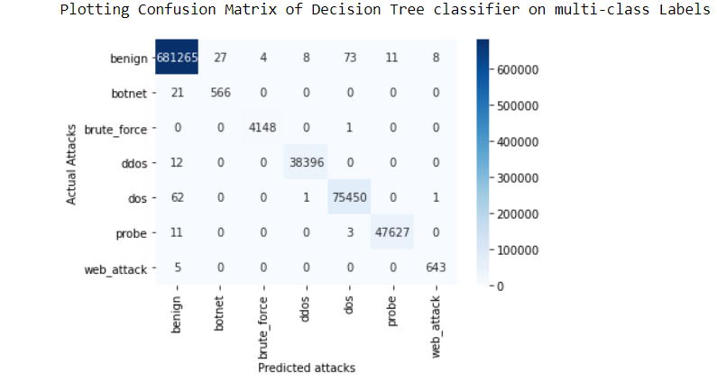

- Naïve Bayes

  - On all Labels

On all Label model training time is approx. 462 seconds for Naïve bayes classifier while testing time is 0.144 seconds. Naïve bayes model showed an accuracy of 94.83%.

Confusion matrix for Naïve bayes on all Labels is shown below:

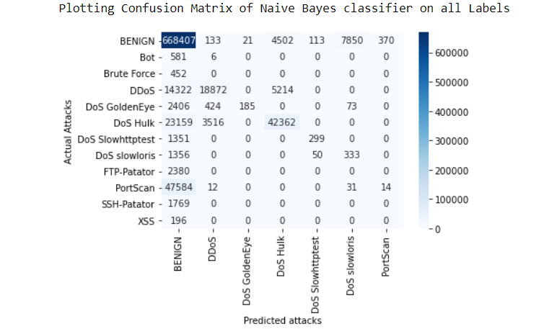
  - Binary Classification

In Binary Classification model training time was 158 seconds and testing time being 0.72 seconds. In this model showed an accuracy of 92.72%.

Confusion matrix for Naïve bayes on binary label is shown below:

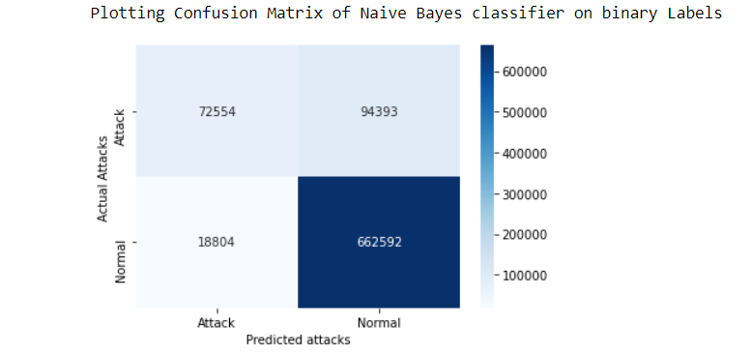

  - Multi-class classification

In Multi-class Classification model training time was 340 seconds and testing time being 0.89 seconds. In this model showed an accuracy of 94.43%.

Confusion matrix for Naïve bayes on multi-class label is shown below:

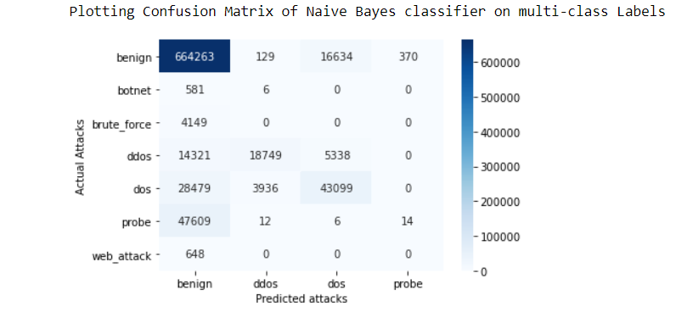

- Random Forest Classifier

- On all Labels

On all Label model training time is approx. 462 seconds for Random Forest classifier while testing time is 0.144 seconds. Random Forest model showed an accuracy of 94.83%.

Confusion matrix for Random Forest on all Labels is shown below:

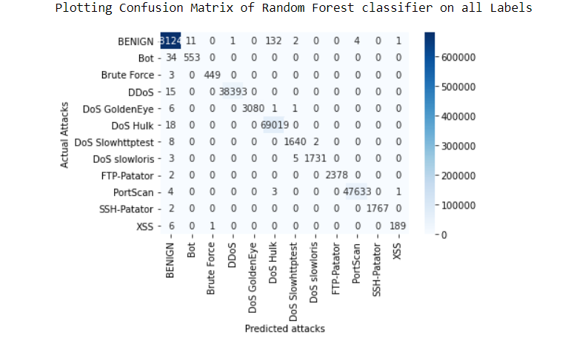

- Binary Classification

In Binary Classification model training time was 158 seconds and testing time being 0.72 seconds. In this model showed an accuracy of 92.72%.

Confusion matrix for Random Forest on binary label is shown below:

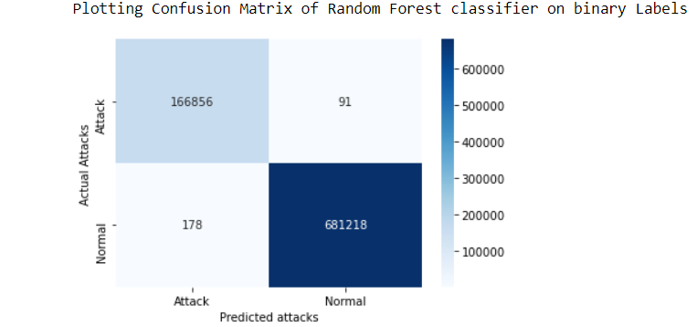

- Multi-class classification

In Multi-class Classification model training time was 340 seconds and testing time being 0.89 seconds. In this model showed an accuracy of 94.43%.

Confusion matrix for Random Forest on multi-class label is shown below:

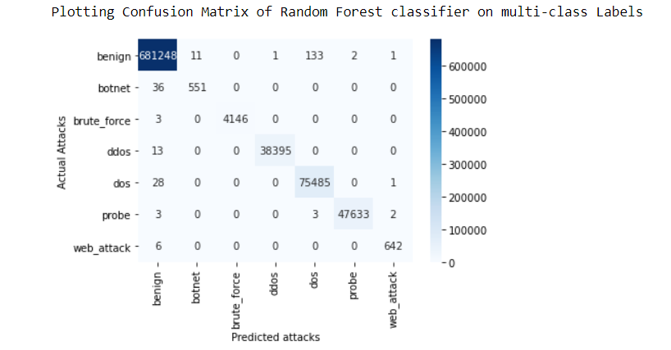

- Proposed Optimized Random Forest Classifier

- On all Labels

On all Label model training time is approx. 462 seconds for optimized random forest classifier while testing time is 0.144 seconds. SVM model showed an accuracy of 94.83%.

Confusion matrix for optimized random forest on all Labels is shown below:

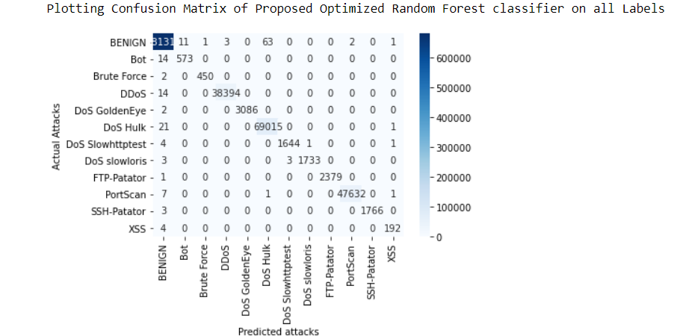

- Binary Classification

In Binary Classification model training time was 158 seconds and testing time being 0.72 seconds. In this model showed an accuracy of 92.72%.

Confusion matrix for optimized random forest on binary label is shown below:

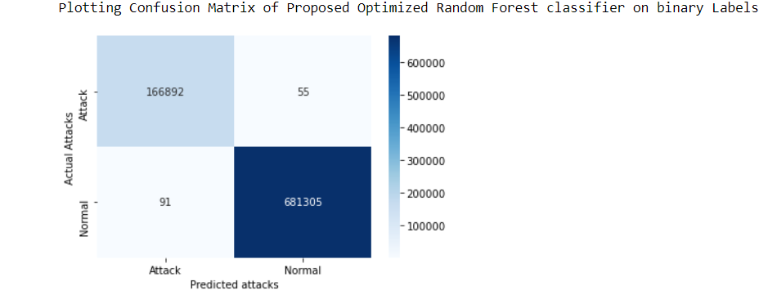

- Multi-class classification

In Multi-class Classification model training time was 340 seconds and testing time being 0.89 seconds. In this model showed an accuracy of 94.43%.

Confusion matrix for optimized random forest on multi-class label is shown below:

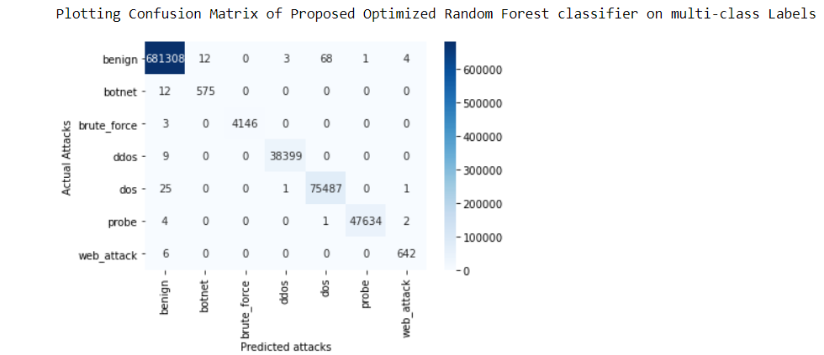

- Summary

