Data-Driven Forecasting and Peak Demand Prediction for Afficionado Coffee Roasters
A time-series study of hourly and daily sales across three stores
Research Paper and Executive Summary
Unified Mentor Project
Author: Aditya Gupta
October 2026

Executive Summary
Purpose. Afficionado Coffee Roasters runs three stores in New York (Astoria, Hell’s Kitchen and Lower Manhattan). This study uses 149,116 sales transactions from January to June 2023 to forecast daily revenue and hourly customer demand, and to flag the busiest hours so that staff and stock can be planned in advance.

Key findings
- Demand is concentrated in the morning. The busiest hours are 8 to 10 AM at all stores. After 11 AM demand falls to roughly half of the morning peak and is very low after 8 PM.
- Sales are growing fast, and coffee and tea earn most of the income. Average daily revenue per store roughly doubled between January and June 2023 (from about 750–1,000 to about 1,750–2,500).
- Stores behave differently. Hell’s Kitchen has the sharpest morning rush, Lower Manhattan opens busy from 6 AM and fades after 5 PM, and Astoria has a smaller peak but steady afternoon demand.

What the forecasts can do
- Daily revenue can be forecast with an average error of about 14%, better than simple rules such as “same as last week” (about 16–20%).
- Hourly customer counts can be forecast about one third more accurately than the “same hour last week” rule.
- The model correctly flagged 91 of every 100 genuinely busy hours in the test week (93 with a slightly more cautious setting), compared with 76 for the simple rule.

Outlook for July 2023
The combined forecast expects about 174,000 in total revenue across the three stores over the next 30 days (about 39,600 in the first 7 days). This is a conservative estimate: it assumes growth levels off, so actual sales may be higher if the June growth continues.

Recommendations
- Schedule the strongest staffing between 7 and 10 AM, especially at Hell’s Kitchen and Lower Manhattan.
- Use the model’s peak alerts for next-day rosters. Accept some extra staffing (about 4 in 10 alerts are false alarms) rather than risk missing a rush.
- Keep strong stock of coffee and tea products, and keep premium items such as Civet Cat beans available at Hell’s Kitchen, where they sell in bulk orders.
Caution. Results rest on only six months of data, so use them as decision support and re-check as more data arrives.

Abstract
Accurate demand forecasts help coffee retailers to staff stores correctly, reduce waste and avoid lost sales during rush hours. This paper studies 149,116 point-of-sale transactions from three stores of Afficionado Coffee Roasters between 1 January and 30 June 2023. After cleaning the data, we aggregated sales into hourly and daily series for each store and engineered lag, rolling-average and calendar features. Seven forecasting approaches were compared on a held-out 28-day test period: Naive, Seasonal Naive, 7-day Moving Average, Exponential Smoothing, SARIMA, Prophet and Gradient Boosting. SARIMA and Prophet performed best for daily revenue (MAPE 14.1% and 14.2% against 16.3% for the best baseline), and the best model differed by store. For hourly demand, Gradient Boosting reduced the weighted absolute percentage error from 45.7% to 30.2% compared with the same-hour-last-week rule. Using a trend-aware definition of peak hours, Gradient Boosting captured 91.1% of true peak hours with a false-alarm share of 37.9%. A 30-day forecast for July 2023 was produced with an ensemble of SARIMA and Prophet. We discuss limitations, notably the short history and narrow Prophet intervals (78.6% observed coverage for a nominal 95%), and give operational recommendations.
Keywords: demand forecasting, peak demand, time series, SARIMA, Prophet, gradient boosting, retail analytics.

1. Introduction
Coffee retail demand changes sharply within a day, with strong morning rushes and quiet afternoons. Fixed staffing and inventory plans therefore either leave customers waiting or waste labour and stock. Afficionado Coffee Roasters wants to move from reactive to forecast-driven planning.
The objectives of this study are to:
- Analyse hourly, daily and store-level sales patterns and identify peak-demand periods.
- Build and compare forecasting models for daily revenue and hourly transaction volume.
- Define and evaluate a peak-hour detection measure, including a Peak Error Rate.
- Produce short-term (1–7 days) and medium-term (8–30 days) forecasts with uncertainty ranges.
- Deliver an interactive dashboard and practical recommendations for staffing and inventory.

2. Dataset and Preparation

2.1 Data description
The dataset contains 149,116 transactions with 11 columns, including transaction date and time, quantity, unit price, store ID and location, and product category and detail. It covers three stores: Astoria, Hell’s Kitchen and Lower Manhattan. The project brief refers to 2025, but the supplied data span 1 January to 30 June 2023 (181 days); all analysis uses the actual dates in the file.

2.2 Cleaning and derived variables
- Quality checks found no missing values and no duplicate rows.
- Date and time columns were combined into a single datetime. Revenue was computed as transaction quantity × unit price.
- Hour of day, day of week and weekend flags were derived.
- Outliers. The largest transactions (revenue 360, quantity 8 at 45 each) were all Civet Cat coffee beans sold at Hell’s Kitchen. They are genuine premium bulk purchases, not errors, so they were kept.

2.3 Building the time series
Transactions were aggregated to hourly and daily totals per store. Observed opening hours were Astoria 7:00–19:59 and Hell’s Kitchen and Lower Manhattan 6:00–20:59. Hours inside opening times with no sales were filled with zero (920 hours), while hours outside opening times were left out so that closed hours are not treated as zero demand. This produced 7,783 hourly rows and 543 daily rows (181 days × 3 stores).

3. Exploratory Analysis
- Hourly pattern. Demand peaks between 8 and 10 AM, with the highest hour (10 AM) at roughly 18,500 transactions across the six months. From 11 AM onwards demand is roughly half of the peak and declines to very little after 8 PM.
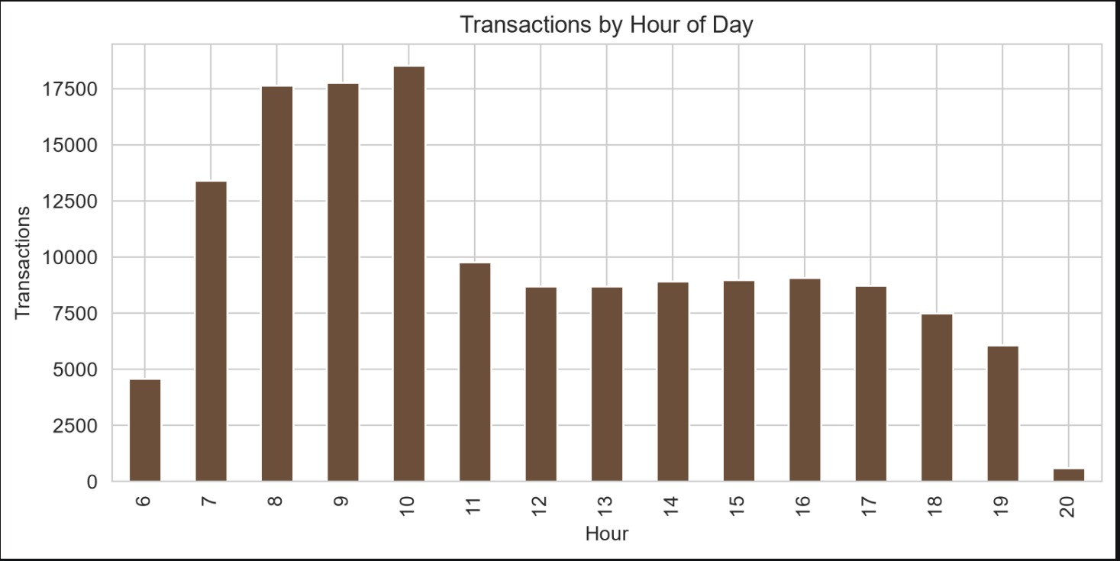
Figure 1. Total transactions by hour of day.
- Store differences. Hell’s Kitchen has the strongest morning peak (around 7,000 transactions at the busiest hour). Lower Manhattan starts at 6 to 7 AM and drops after 5 PM. Astoria has a smaller peak but the most stable afternoon demand.
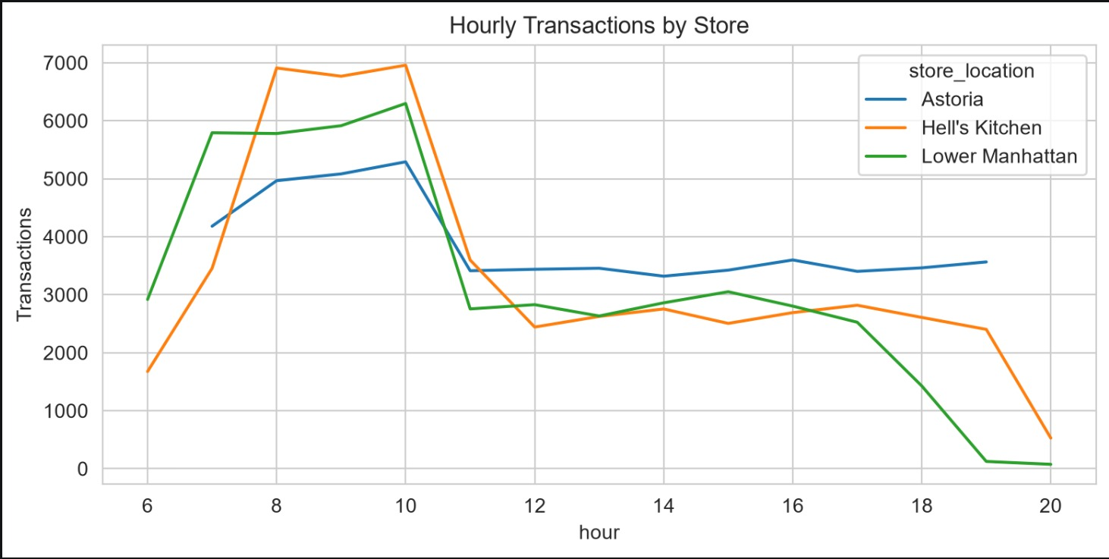
Figure 2. Hourly transactions by store.
- Day of week. Revenue by weekday is almost flat (about 95,000–100,000 per weekday), slightly higher on Monday and lower at weekends. Weekly seasonality is therefore weak compared with hourly seasonality.
- Trend. Daily revenue per store roughly doubled from January to June. This strong upward trend is the most important feature of the data and explains why simple repeat-last-week rules perform poorly.
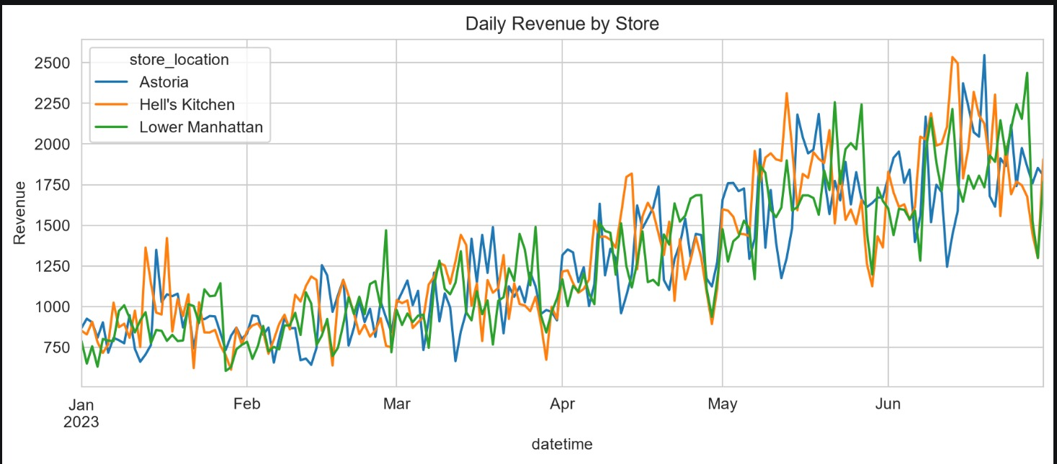
Figure 3. Daily revenue trend by store.
- Product mix. Coffee (about 270,000 in revenue) and Tea (about 195,000) dominate, followed by Bakery (about 80,000) and Drinking Chocolate (about 72,000).
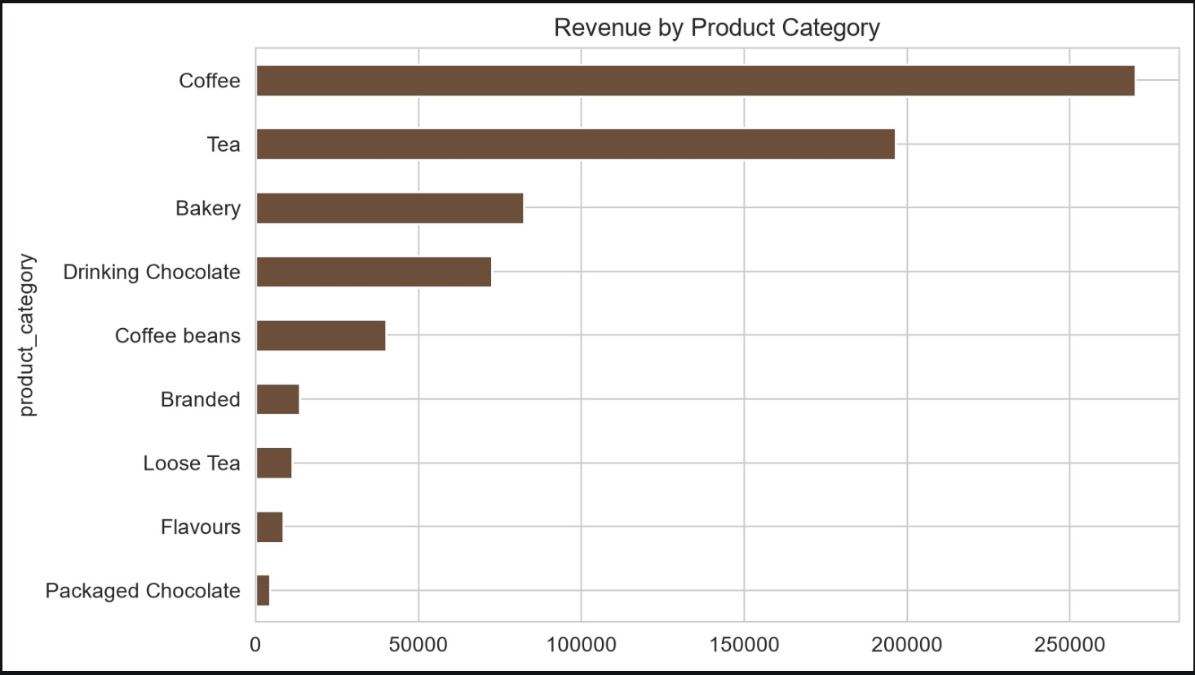
Figure 4. Revenue by product category.

4. Methodology

4.1 Forecasting targets
Two targets were forecast: daily revenue per store, and hourly transactions per store (used for peak detection).

4.2 Feature engineering
- Hourly: lag 1 hour, lag 24 hours (same hour yesterday), lag 168 hours (same hour last week), rolling means over 24 and 168 hours, hour, day of week, weekend flag, day index (for trend) and store indicators. Lags were computed on a full 24-hour grid so that “24 hours back” is exact, and rolling means exclude the current value to prevent leakage.
- Daily: lag 1 and lag 7 days, rolling means over 3 and 7 days, day of week, weekend flag, day index and store indicators.

4.3 Train/test split
A strictly time-based split was used. For daily revenue, data from 1 January to 2 June were used for training and the last 28 days (3–30 June) for testing. For hourly demand, the last 7 days were held out.

4.4 Models
- Baselines: Naive (last value), Seasonal Naive (repeat last week) and 7-day Moving Average.
- Exponential Smoothing with damped additive trend and weekly seasonality.
- SARIMA(1,1,1)(1,0,1)₇ fitted per store.
- Prophet with weekly seasonality; yearly seasonality was switched off because the data cover only six months.
- Gradient Boosting (one global model with store indicators). Daily forecasts were made recursively, with each prediction feeding the next day’s lag features, so that no future actuals are used.

4.5 Evaluation metrics
Daily models are compared using MAE, RMSE and MAPE. For hourly demand, WAPE (sum of absolute errors divided by sum of actuals) is used in place of MAPE because some hours have zero sales. Peak performance is measured by:
- Peak Capture Rate = share of true peak hours that the model also flags as peak.
- Peak Error Rate = 100% − Peak Capture Rate (peaks missed).
- False Alarm Share = share of flagged peak hours that were not truly peak.

5. Results

5.1 Daily revenue forecasting
Table 1 shows average accuracy across the three stores on the 28-day test set.
Model | MAE | RMSE | MAPE % | Rank (MAPE)
SARIMA | 274.0 | 347.8 | 14.08 | 1
Prophet | 252.4 | 307.4 | 14.17 | 2
Exponential Smoothing | 291.1 | 357.4 | 15.39 | 3
Gradient Boosting | 318.7 | 391.9 | 16.23 | 4
Moving Average (7d) | 322.3 | 397.5 | 16.25 | 5
Naive | 318.4 | 384.3 | 16.68 | 6
Seasonal Naive (7d) | 380.3 | 458.3 | 19.69 | 7
Table 1. Average daily-revenue accuracy across stores (28-day test).
SARIMA has the lowest MAPE and Prophet the lowest MAE and RMSE; the two are practically tied and both beat the best baseline by about two percentage points of MAPE. Seasonal Naive is the weakest model, confirming that weekly seasonality is weak and that the trend matters.
Table 2 shows that the best model differs by store.
Model (MAPE %) | Astoria | Hell’s Kitchen | Lower Manhattan
SARIMA | 12.13 | 16.06 | 14.06
Prophet | 15.03 | 14.70 | 12.77
Exponential Smoothing | 16.25 | 15.06 | 14.85
Gradient Boosting | 14.62 | 13.46 | 20.61
Moving Average (7d) | 12.80 | 21.45 | 14.49
Naive | 14.06 | 14.63 | 21.36
Seasonal Naive (7d) | 13.09 | 24.48 | 21.51
Table 2. MAPE by model and store. Best per store: Astoria SARIMA, Hell’s Kitchen Gradient Boosting, Lower Manhattan Prophet.
Gradient Boosting performed best at Hell’s Kitchen but worst of the advanced models at Lower Manhattan, probably because tree-based models cannot extrapolate an upward trend beyond the range seen in training. The improvement over baselines is modest because daily revenue is noisy and the test window is short; differences of one to two points should not be over-interpreted.

5.2 Prophet uncertainty intervals
Prophet’s 95% interval contained 78.6% of actual daily revenues in the test period, well below the nominal level. The interval therefore understates real uncertainty and should be read as a minimum range of variation, not a guaranteed bound.
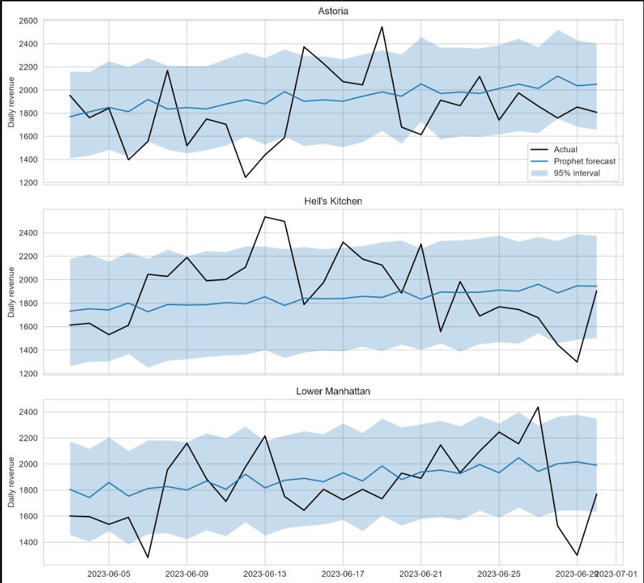
Figure 5. Prophet forecast and 95% interval against actual daily revenue.

5.3 Hourly demand forecasting
Model | MAE | RMSE | WAPE %
Seasonal Naive (lag 168) | 12.21 | 17.74 | 45.7
Gradient Boosting | 8.07 | 11.42 | 30.2
Table 3. Hourly transaction forecasts on the last 7 days (301 store-hours).
Gradient Boosting reduced MAE by about one third compared with the same-hour-last-week rule. Only the 168-hour lag was used as a lag feature because it is the only lag still known when forecasting a full week ahead.

5.4 Peak-hour detection
A peak hour was first defined as an hour in the top 20% of the store’s hourly transactions over the whole training period (thresholds of 32, 28 and 28 transactions for Astoria, Hell’s Kitchen and Lower Manhattan). Under this definition, Gradient Boosting captured only 52.6% of peaks and Seasonal Naive 58.8%. The reason is that sales rose sharply over the six months, so many test-week hours exceeded a threshold built from the lower early-period sales, and regression models tend to under-predict extremes.
The definition was therefore made trend-aware: a peak is an hour in the top 20% of the store’s hourly transactions over the 28 days before the test week (thresholds 45, 37 and 39.2). This gave 45 true peak hours out of 301. Table 4 reports results for different cut-offs, where a peak is flagged when the prediction is at least the cut-off factor times the threshold.
Model | Cut-off factor | Peak Capture % | Peak Error Rate % | False Alarm %
Seasonal Naive | 1.0 | 75.6 | 24.4 | 52.1
Seasonal Naive | 0.9 | 82.2 | 17.8 | 51.9
Seasonal Naive | 0.8 | 86.7 | 13.3 | 56.2
Seasonal Naive | 0.7 | 91.1 | 8.9 | 63.4
Gradient Boosting | 1.0 | 91.1 | 8.9 | 37.9
Gradient Boosting | 0.9 | 93.3 | 6.7 | 44.0
Gradient Boosting | 0.8 | 95.6 | 4.4 | 47.6
Gradient Boosting | 0.7 | 97.8 | 2.2 | 50.0
Table 4. Peak detection by model and cut-off factor (trend-aware peak definition).
Gradient Boosting dominates the baseline at every cut-off: at factor 1.0 it captures 91.1% of peaks with 37.9% false alarms, whereas Seasonal Naive captures 75.6% with 52.1% false alarms. Lowering the cut-off raises capture but also false alarms, which is the practical trade-off between the cost of under-staffing and the cost of over-staffing. Because the test contains only 45 peak hours, these percentages are noisy; each additional missed peak moves the capture rate by about 2.2 points.

5.5 July 2023 forecast
The models were retrained on all six months and the average of SARIMA and Prophet (ensemble) was used to forecast 1–30 July 2023. The first 7 days are the short-term horizon and days 8–30 the medium-term horizon.
Store | Avg. daily revenue | Next 7 days | Next 30 days
Astoria | 1,983 | 13,523 | 59,491
Hell’s Kitchen | 1,856 | 12,652 | 55,695
Lower Manhattan | 1,970 | 13,445 | 59,103
All stores | – | 39,620 | 174,288
Table 5. Ensemble forecast of revenue for July 2023 (model-based estimate).
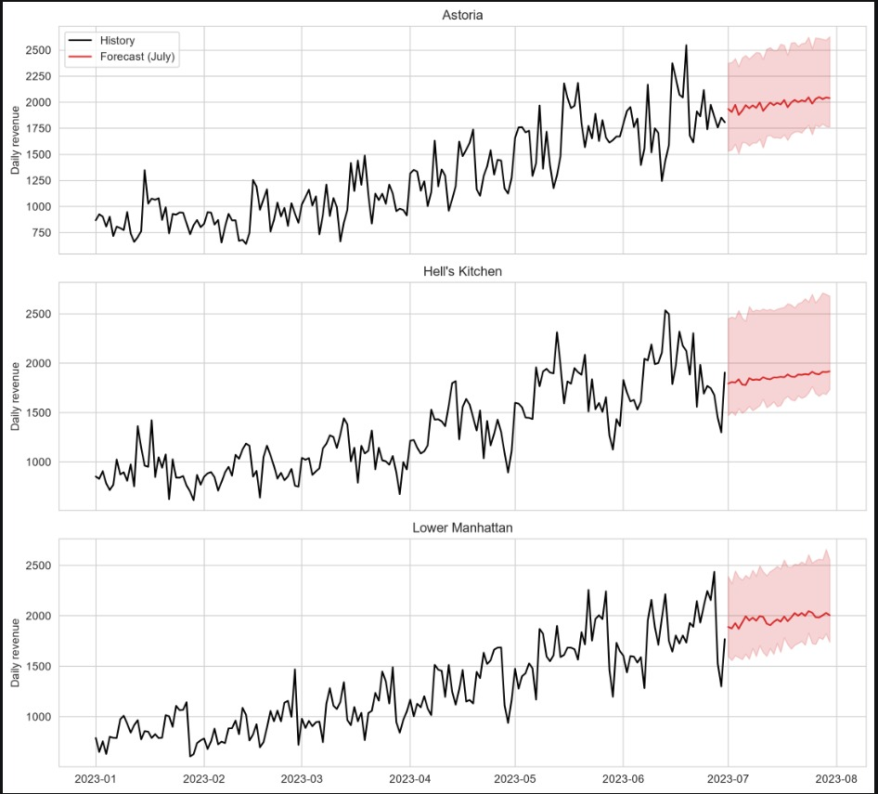
Figure 6. Revenue history and July 2023 forecast.
The forecast is close to a flat continuation of the late-June level, because the models damp the strong January–June growth. If growth continues, actual July sales will exceed these figures, so they should be read as a conservative baseline. As July actuals are not available, the forecast could not be validated.

5.6 Interactive dashboard
A Streamlit dashboard was built with store, horizon, metric (revenue or quantity) and model selectors. It has four views: sales forecast against actuals, model comparison, confidence intervals, and hourly demand heatmaps with predicted peak hours. The quantity view is an approximation that divides revenue forecasts by each store’s average revenue per unit.
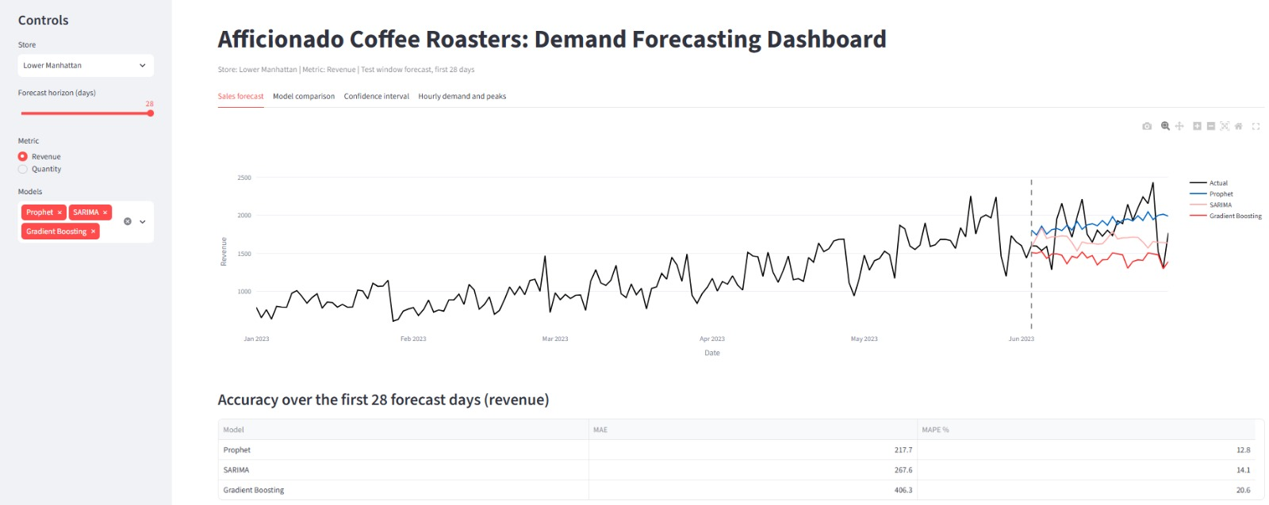
Figure 7. Streamlit dashboard, Sales forecast tab (Lower Manhattan).

6. Business Recommendations
- Staffing. Place the largest shifts between 7 and 10 AM. Hell’s Kitchen needs the strongest morning cover; Lower Manhattan must be ready from 6 AM; Astoria can run a leaner morning with stable afternoon staffing.
- Peak alerts. Use the Gradient Boosting hourly forecast with a cut-off factor of 0.9–1.0 for next-day rosters. At 1.0 roughly 9% of peaks are missed with fewer false alarms; at 0.9 about 7% are missed but more than four in ten alerts are unnecessary. Choose according to whether lost sales or extra labour cost more.
- Inventory. Stock plans should prioritise coffee and tea, then bakery. Premium Civet Cat beans at Hell’s Kitchen sell in bulk orders and cause revenue spikes; keep safety stock but do not use them to set baseline demand.
- Model choice by store. Use SARIMA for Astoria, Gradient Boosting for Hell’s Kitchen and Prophet for Lower Manhattan, or the SARIMA–Prophet ensemble as a robust default.
- Growth tracking. Compare July actuals with the forecast; if actuals are consistently higher, retrain and add a trend term or growth assumption.

7. Limitations
- Only six months of history (181 days). Yearly seasonality, holidays and weather effects cannot be learned, and the date range differs from the year named in the brief.
- The daily test window is 28 days and the hourly test window 7 days, so error estimates are uncertain; small differences between models are not conclusive.
- Prophet intervals are too narrow (78.6% observed coverage for a nominal 95%).
- The peak definition was changed after seeing results on a trend-driven first attempt. The trend-aware version is justified by the growth in sales, but it should be validated on new data.
- Gradient Boosting cannot extrapolate trends, which hurt it at Lower Manhattan.
- Hourly forecasts use only last week’s same-hour value as a lag, trading some accuracy for being usable a full week ahead.

8. Conclusion
Sales at Afficionado Coffee Roasters follow a strong morning-peak pattern and grew rapidly during the first half of 2023. Statistical models (SARIMA, Prophet) forecast daily revenue with about 14% average error, improving on simple baselines, while Gradient Boosting gives the best hourly forecasts and the most reliable peak detection. Together with the dashboard, these models give management a practical way to schedule staff and stock ahead of demand. The main next steps are to gather a full year of data, add holiday and weather features, widen the uncertainty intervals, and validate the July forecast against actual sales.

Appendix: Reproducibility
Analysis was carried out in Python (pandas, statsmodels, Prophet, scikit-learn, Plotly and Streamlit) in the notebook forecasting.ipynb. Intermediate outputs were saved as CSV files (daily_ts, hourly_ts, daily_features, hourly_features, daily_predictions, hourly_predictions, model_results, peak_results, prophet_intervals, future_forecast) and are used by the dashboard app.py.

