

CODEKSHETRA HACKATHON
Round 1: Idea Proposal Document
Track: Software Edition Only

Team Information

No. | Member Name | Institute Name | Role
1 | Aditya Dileep Shintre | DKTE | Team Leader
2 | Rakhi Balchandra Patil | DKTE
3 | Sneha Ravsaheb Patil | DKTE
4 | Utkarsh Uttam Patil | DKTE

Team Size Requirement: Minimum 2 and Maximum 4 Members.
Team Name: THE HOISTERS
Project Name: Claim Sheild – Smart Medical Coding and Denial Prediction System
Selected Theme: Health Tech

ClaimShield AI – Smart Medical Coding & Denial Prediction System

1. Abstract
Healthcare systems worldwide lose billions annually due to inefficient medical coding and high insurance claim denial rates.
Manual claim processing is slow, error-prone, and reactive, resulting in revenue leakage, delayed reimbursements, and administrative burden.
ClaimShield AI is an AI-powered Revenue Cycle Intelligence Engine that automates medical code extraction from clinical notes and predicts
insurance claim denial risk before submission. Using NLP-based diagnosis extraction and machine learning-based denial risk modeling,
the system transforms unstructured clinical documentation into structured claim-ready outputs while proactively flagging high-risk claims.
Unlike traditional billing systems that detect errors after claim rejection, ClaimShield AI introduces a predictive pre-adjudication
layer that reduces denial probability, improves financial efficiency, and accelerates reimbursements.

2. Problem Statement
Healthcare providers face high insurance claim denial rates (5–20%), leading to revenue loss, increased rework costs, delayed cash flow,
and administrative burden. Manual medical coding from unstructured clinical notes is time-consuming and error-prone.
There is a need for an intelligent system that automates clinical-to-code translation, predicts claim denial probability before submission,
and assists billing teams in reducing financial risk proactively.

3. Market Analysis – Pros and Cons
Market Need:
• Healthcare administrative waste costs billions annually.
• Increasing insurance policy complexity.
• Rising denial rates due to documentation errors.
Pros:
• Strong demand from hospitals and RCM companies.
• Scalable across healthcare networks.
• High ROI due to reduced denial rework costs.
Cons:
• Requires regulatory compliance in real deployment.
• Integration with existing hospital systems may be complex.
• Model accuracy depends on quality of training data.

4. Target Users
Primary Users:
• Medical Billing Specialists
• Revenue Cycle Management (RCM) Teams
• Hospital Billing Departments
Secondary Users:
• Hospital Revenue Managers
• Healthcare Financial Analysts

5. Existing Solutions
Current solutions include manual coding workflows, static rule-based claim scrubbers,
and traditional RCM software with limited AI intelligence.
Limitations:
• Reactive denial handling
• Limited predictive capability
• Lack of intelligent pattern learning

6. Competitive Advantage
• AI-driven medical code extraction from unstructured notes
• Predictive denial risk scoring before claim submission
• Intelligent explanation system for risk factors
• Scalable architecture for integration

7. Market Impact
• Reduce claim denial rates (prototype simulation: 40–60% potential reduction)
• Reduce Accounts Receivable cycle time
• Lower administrative rework costs
• Improve hospital revenue efficiency

8. Proposed Solution
Modules:
1. Clinical NLP Engine – Extracts diagnoses and maps to ICD-10 codes.
2. Claim Structuring Module – Combines ICD, CPT, payer, and charges.
3. Denial Prediction Engine – Uses ML (XGBoost) to predict denial probability and assign risk level.
System Flow:
Clinical Note Upload → Diagnosis Extraction → ICD Mapping → User Adds CPT & Payer →
Denial Prediction → Risk Score + Claim Summary Report

9. Technology Stack
Component | Technology Used
Frontend | Streamlit
Backend | FastAPI / Python
Database | SQLite
Cloud / Deployment | Cloud / Localhost
Other Tools / APIs | Scikit-learn, XGBoost, HuggingFace Transformers

Innovativeness
• Predictive denial modeling before submission
• AI-based clinical-to-code automation
• Risk-based claim routing
• Intelligent explanation layer

Show Stoppers and Risk Analysis
Technical Risks:
• Limited dataset for training
• Model accuracy variation
Regulatory Risks:
• Requires compliance in real-world deployment
Scalability Challenges:
• Integration with EHR systems
• Multi-payer policy variations

Use Case / System Flow Diagram
System Workflow Diagram:
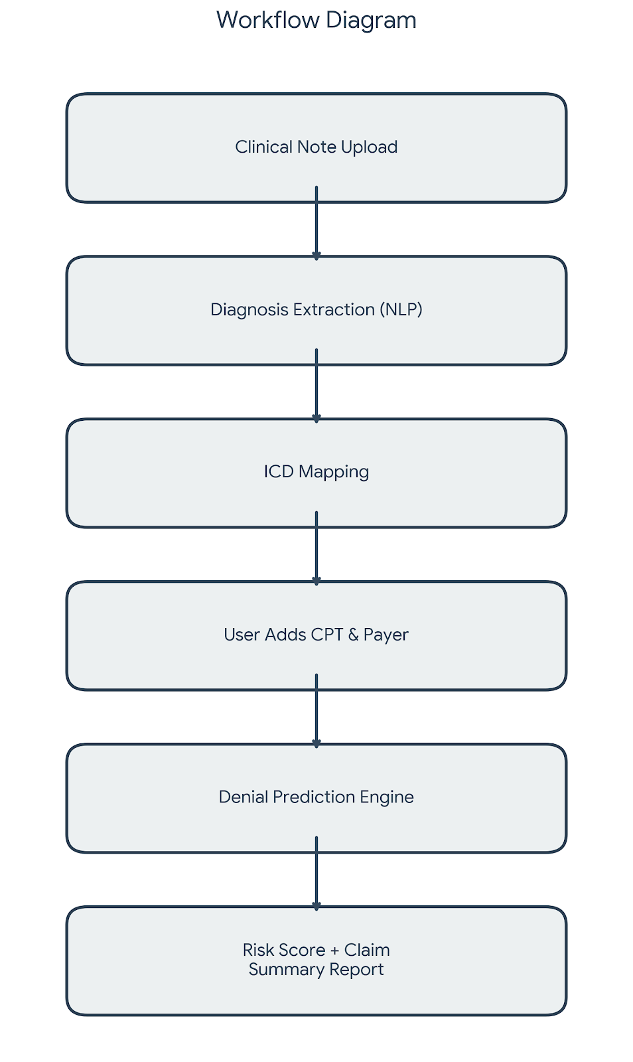

Prototype / Wireframes
Below are the UI Screenshots of ClaimShield AI:
Link - https://github.com/aditya764k/Codeshetra2026
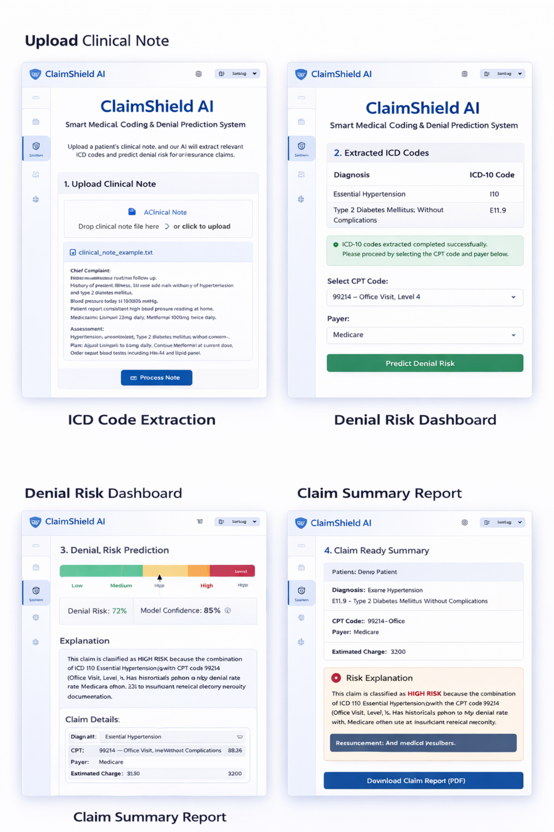

Declaration
We declare that this idea is original and developed for CODEKSHETRA 2026 Hackathon. Any reused components have been properly disclosed.

