Lab1:

Part1(Group):

**Group Members:**

* **Deshpande,Aditya**
* **Meka,Tej Kiran**
* **Jagadish Rao**
* **Mahesh Vemula**

Task1: Android application using TI sensor tag.

Step 1: Exatract the application from download file.

Step 2: Run the application on the device after enbling debugging mode.

Step 3: Observe the output and take the screen shots of result.

First screen of the applciation

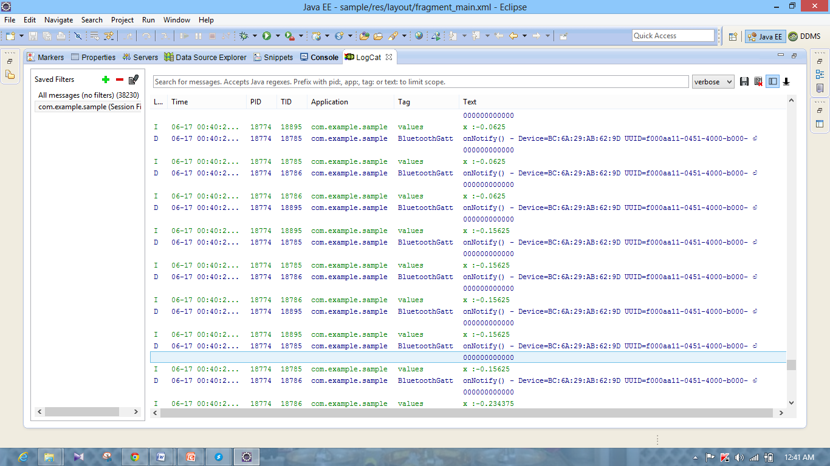

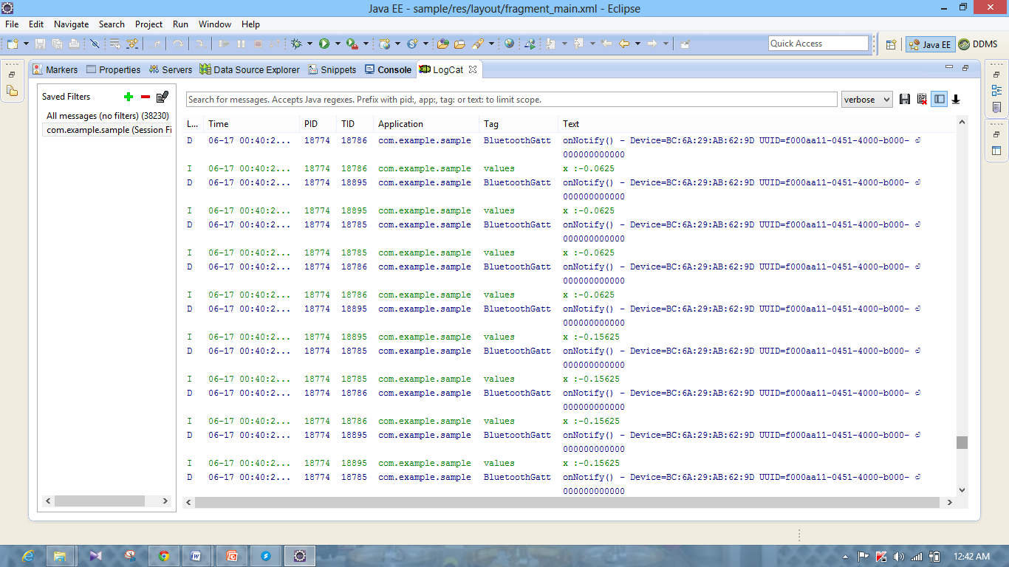

Task 2: Mobile sensor with Android sensor app

Step 1: Exatract and modify the application from blackboard.

Step 2: Run the application on the device after enbling debugging mode.

Step 3: Observe the output and take the screen shots of result.



First screen of the application

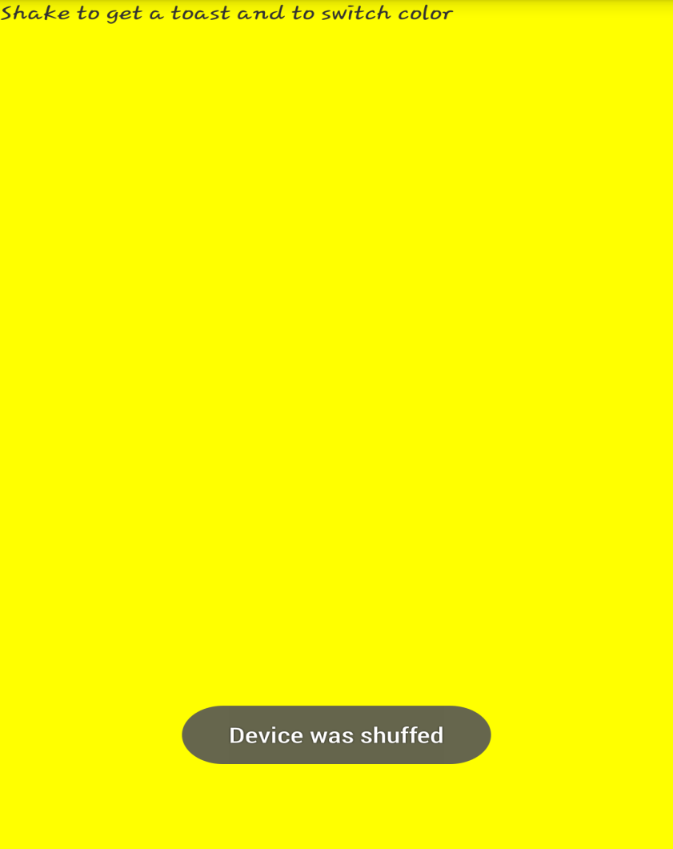

When we shake the device the sensor detects and gives sensor ouput. By detecting output we change the colour of the device.

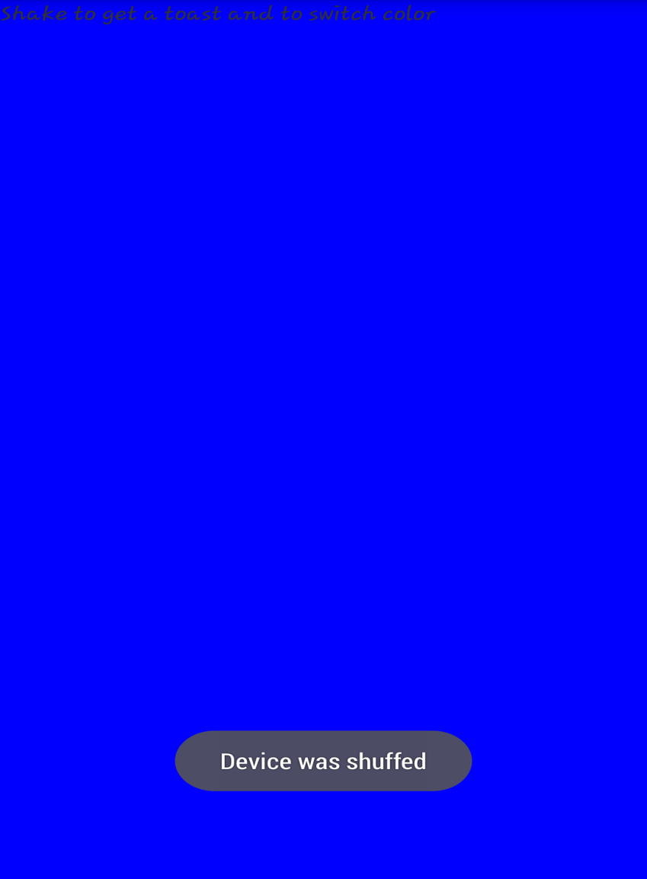

Again when we shake the device the sensor detects and gives sensor ouput. By detecting output we change the colour of the device.

Task3: Geosensing android application

Step 1: Exatract and modify the application and add libraries.

Step 2: Run the application on the device after enbling debugging mode.

Step 3: Observe the output and take the screen shots of result.

First screen detecting the geo loacation and Displaying address using google API service call with geo location coordinates.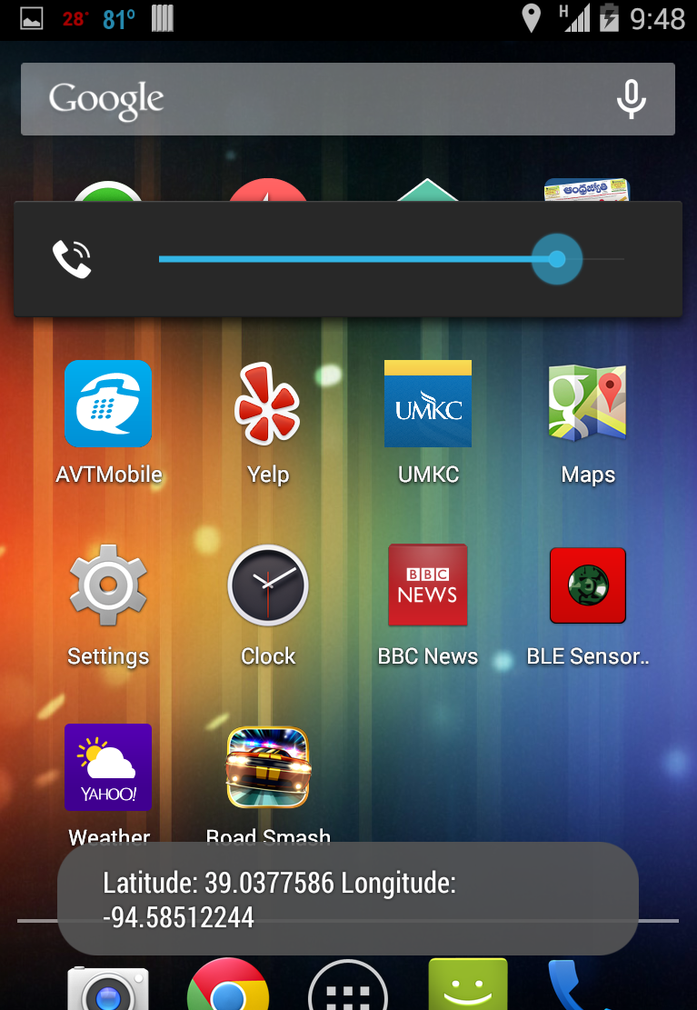

Task4: Wiigee app with Android smartphone

Step 1: Exatract and modify the application. Modify build path.

Step 2: Run the application on the device after enbling debugging mode.

Step 3: Observe the output and take the screen shots of result.

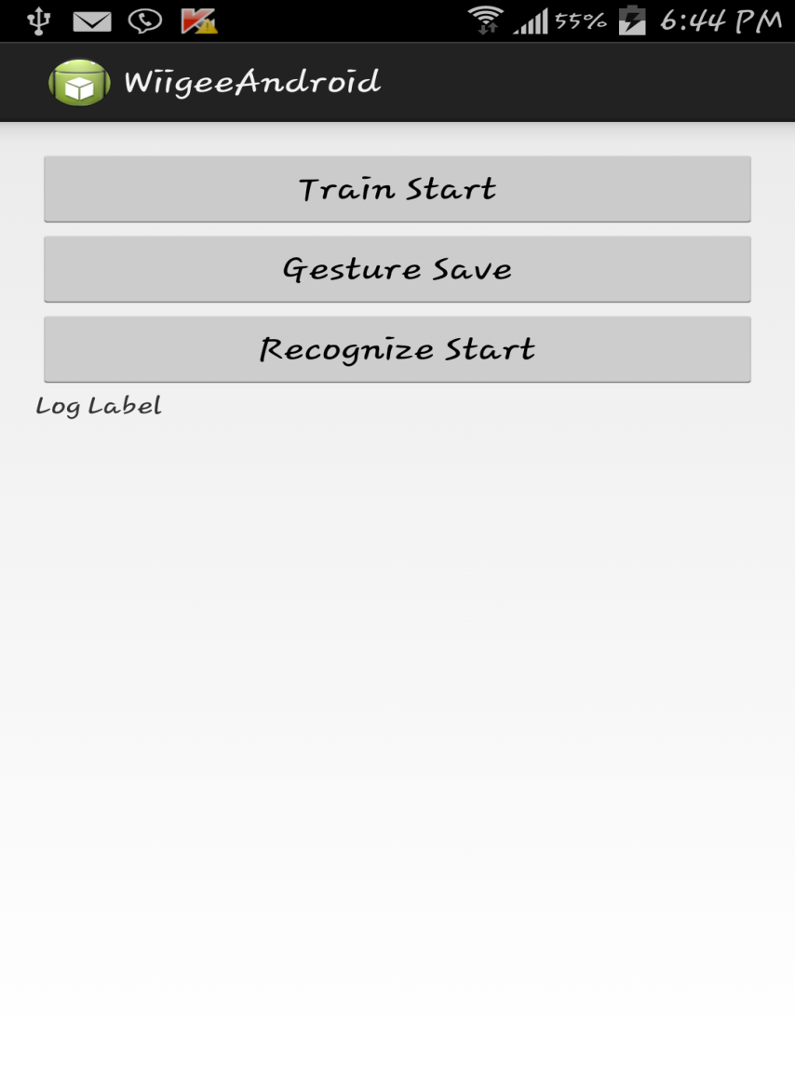

First screen of the application

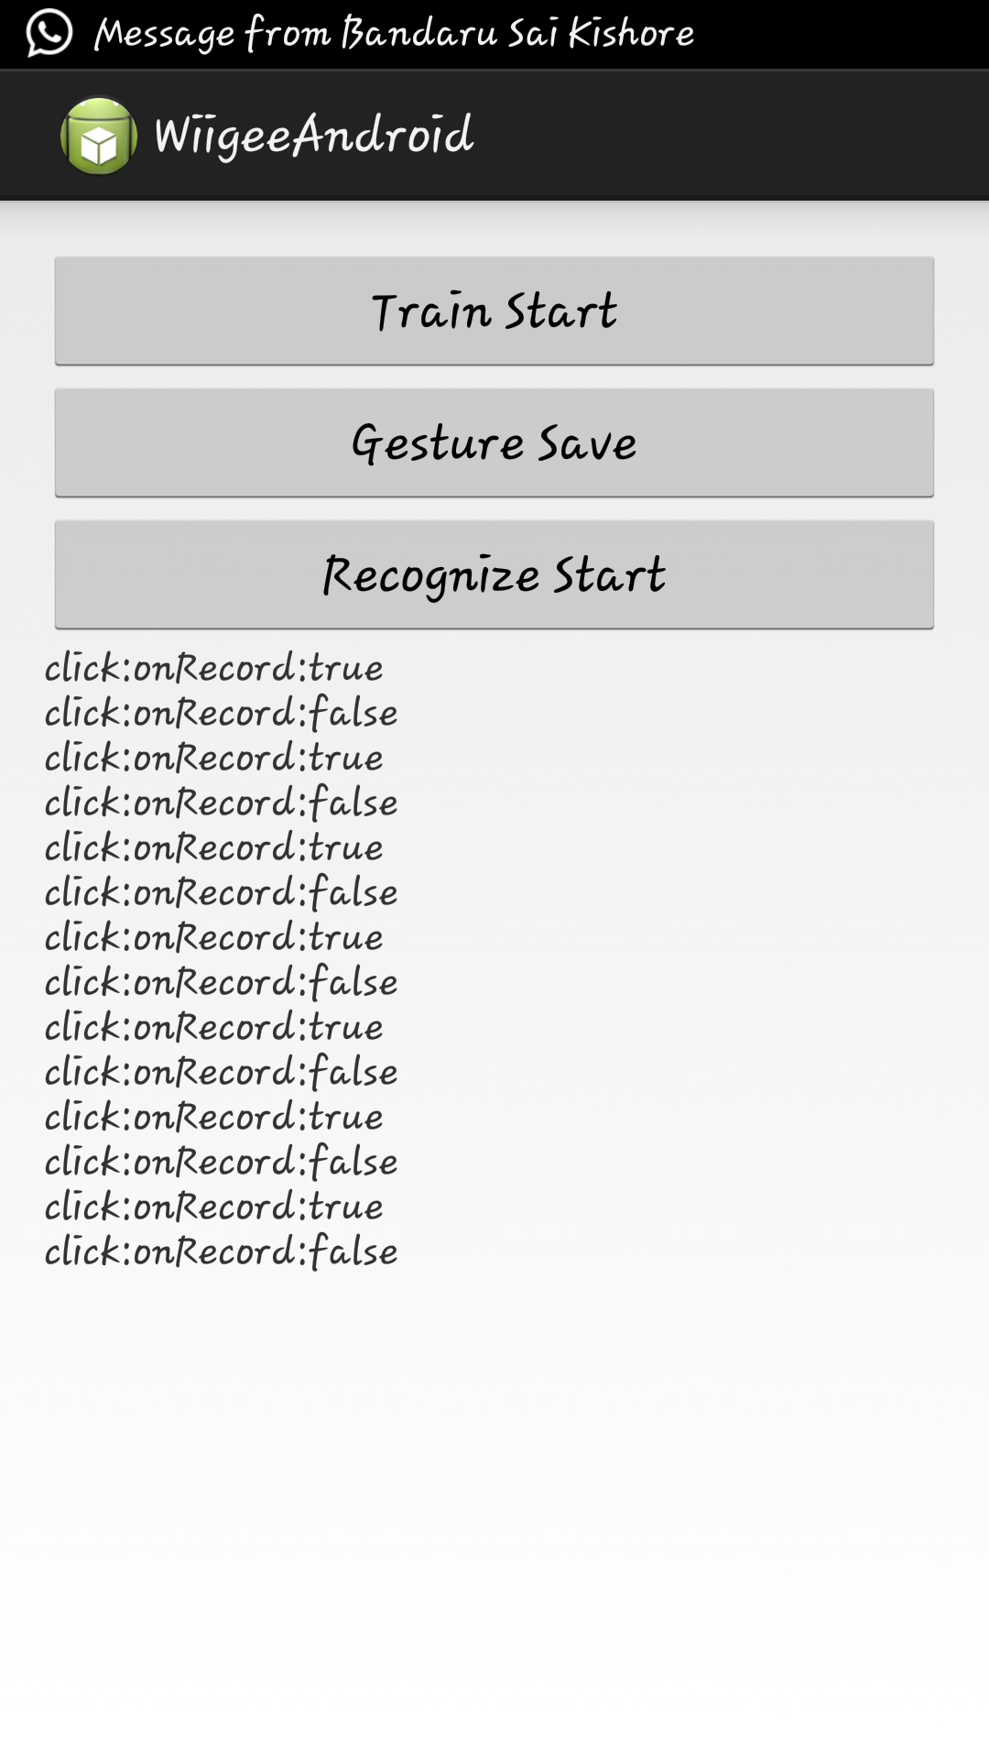

When we capture gesture click on record a gesture and after motion click on stop. After few samples click on save gesture.

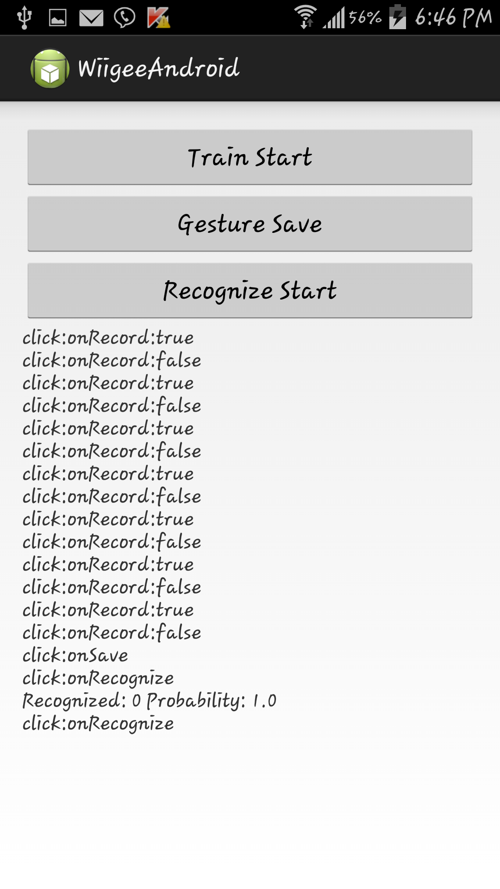

Now to check the gesture we click on recognize and make motion. If motion matches it shows probability of gesture match.

Task5: Application using chronus watch

Step 1: Install the chronus watch drivers.

Step 2: Enable ACC mode on watch.

Step 3: Click start capture on the application.

**NOTE:**

Chronos software did not support Windows8 so we were unable to complete this task and we didn’t have chronos watch with us too.

Part2(Individual):

*Cloudera Installation and MapReduce Application-Word Count*

Installed Cloudera in my PC and Run Mapreduce Wordcount program in HDFS to count number of words.

