**LAB 2 REPORT:**

**Task 1:** **Choose any devices (Android smartphone, Sensor Tag, Chronos Watch). Implement an application to generate a file for your activities**

Modified existing code to include Humidity and temperature parameters.Txt file is generated

Please find below is the screenshot of txt file generated

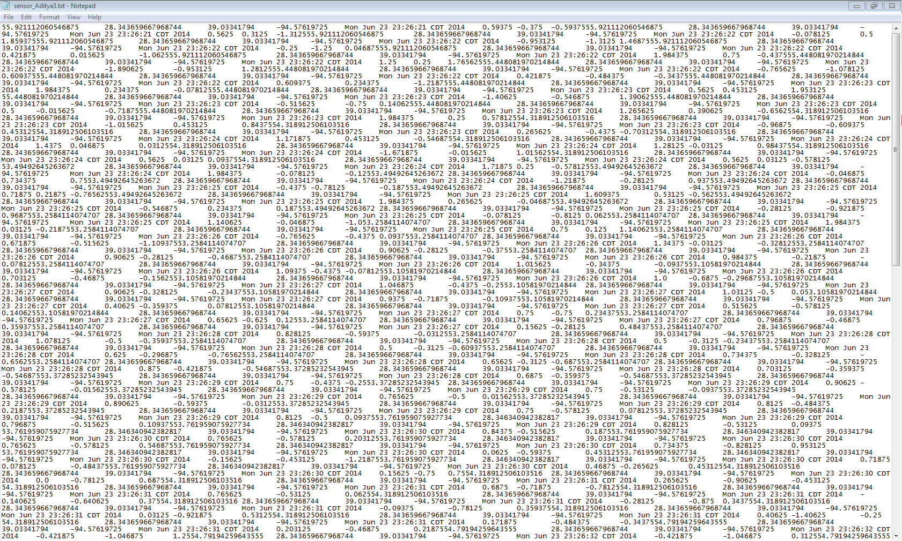

*Uploaded modified source code and txt file generated to github*

**Task2: Implement an HBase client application to insert your data to HBase (either Local Cloudera or UMKC Cloudera servers).**

Made changes to existing HBase table creation to include to Humidity and HumidityTemp column families.

**Table Creation:**

Created table SensorTagTable in my local cloudera server

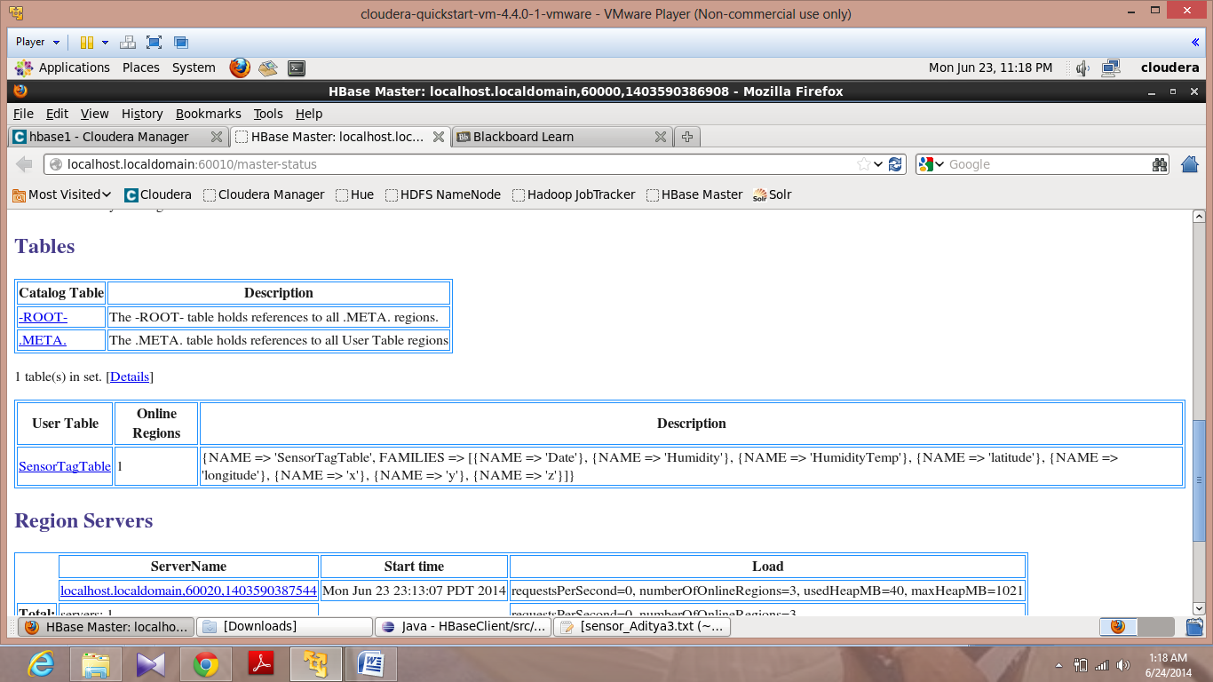

**Insert:**

Inserted data from txt file generated into corresponding column families.

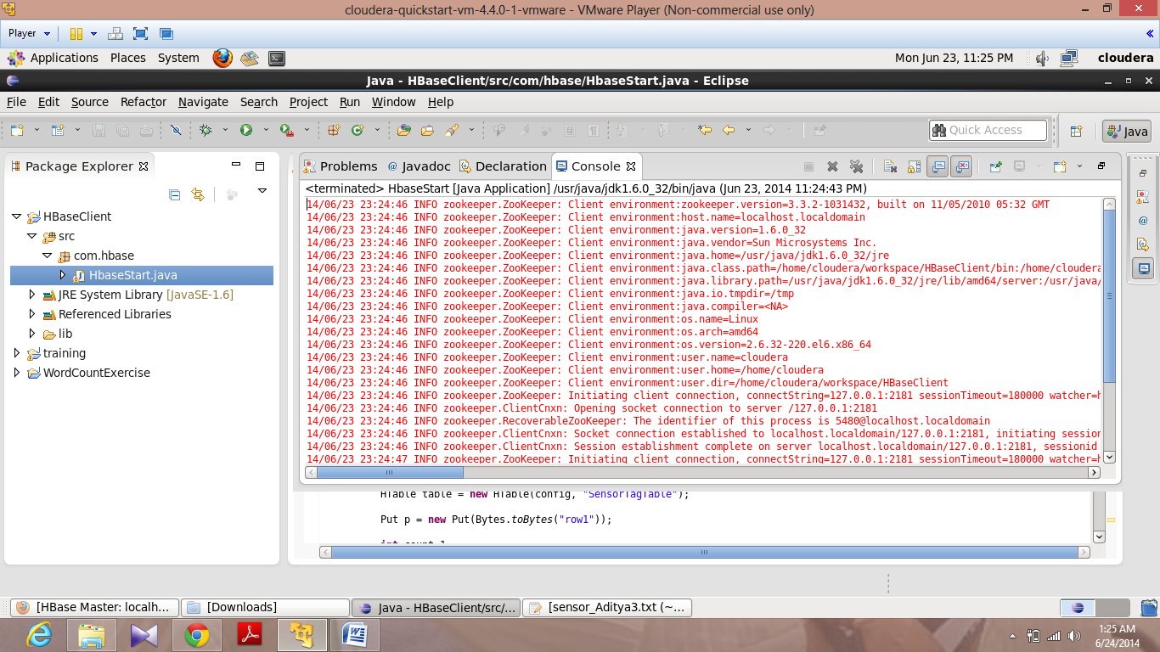

**Retrieve:**

Fetched data from HBase table (only first row)

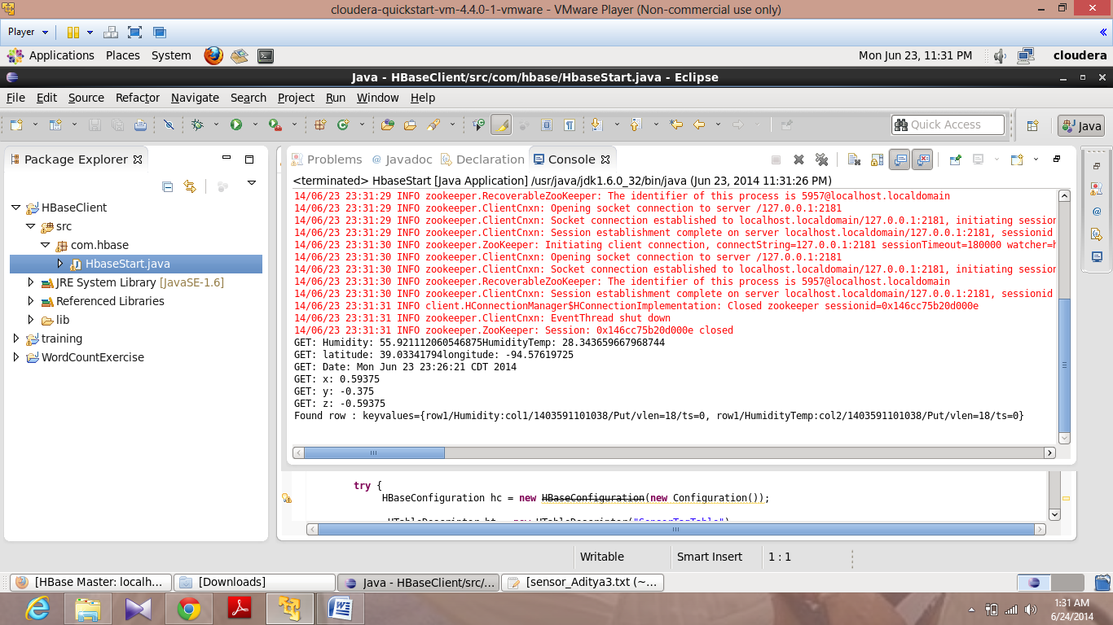

**GetAllRows:**

Retrieved all rows from HBase table.

