**Lab3:**

**Report:**

Collected data from sensor. User needs to click on *Collect data* button in android app.

**Screenshot**

Modified existing HbaseWS file to added extra column families to create RESTful web services for

* Fileupload
* create HBase table
* insert data into table
* retrieve data
* delete table

Exported HbaseWS file as WAR file and deployed it on Glassfish server

(1)User need to click on *Create* button to create HBase table

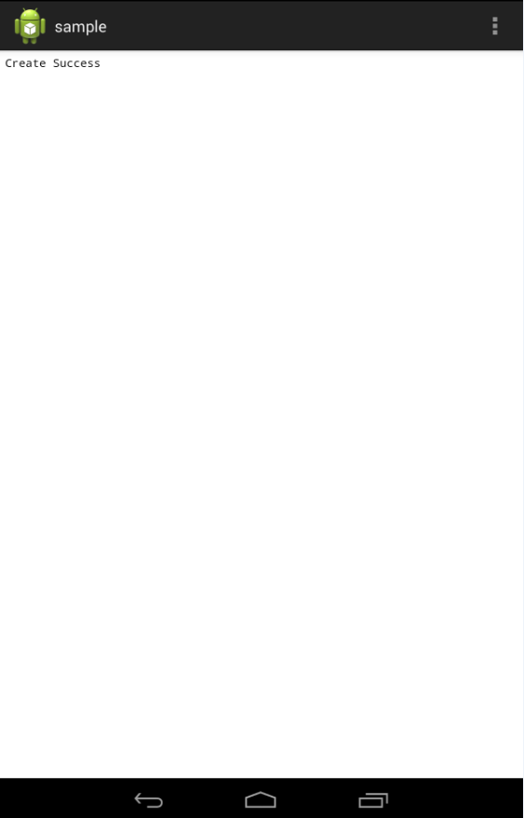

(2) User need to click on *Insert* button to create HBase table

(3) User need to click on *Retrieve* button to retrieve all values from HBase table

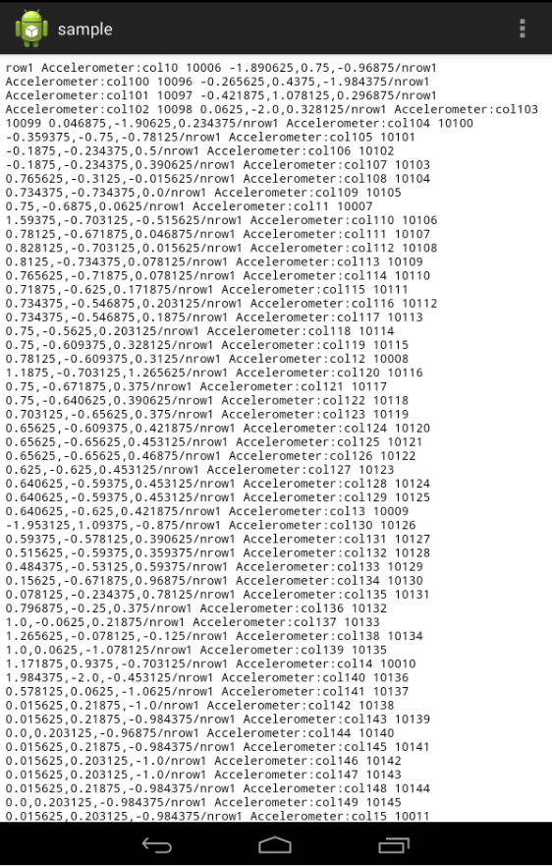

(4) User need to click on *Delete* button to delete all values from HBase table

