**Lab 4:**

**1.Segment and convert to sequence file for Training file**

**input file:**  home/group5/alr.txt

**output file:** home/group5/alr.seq

**REST Service**

http://134.193.136.147:8080/HMMWS/jaxrs/generic/TrainFileOperation/-home-group5-alr.txt/-home-group5-alr.seq

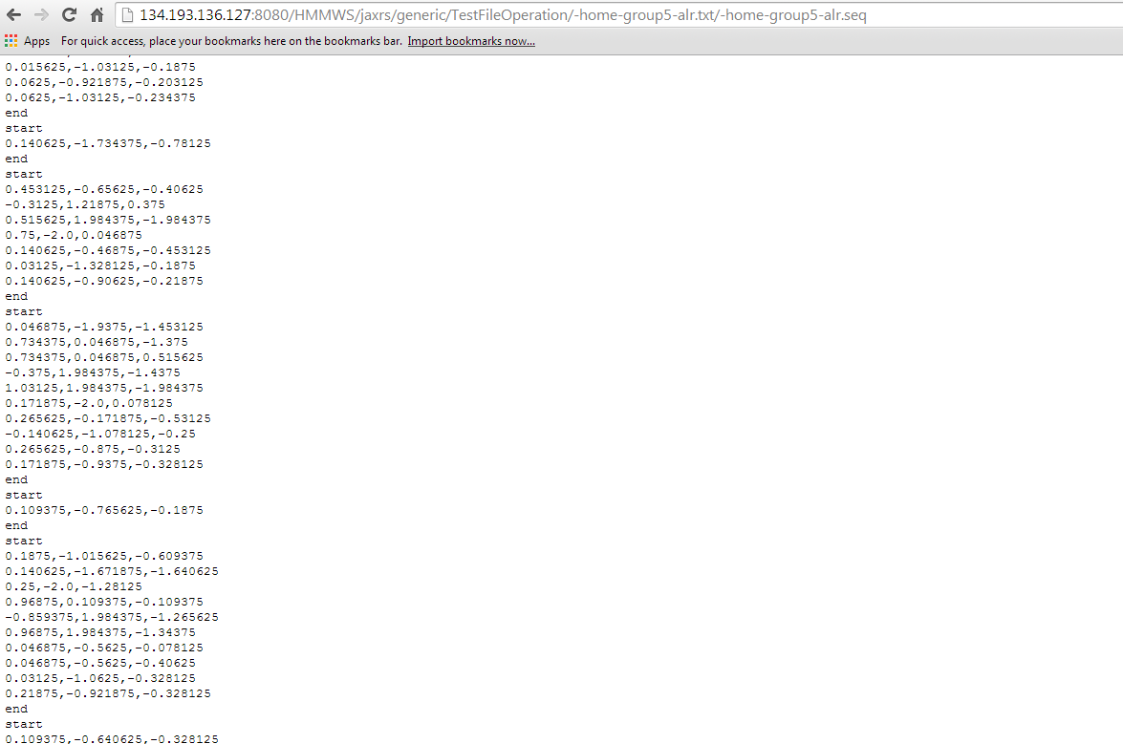

**input file:**  home/group5/arl.txt

**output file:** home/group5/arl.seq

**REST Service**

http://134.193.136.147:8080/HMMWS/jaxrs/generic/TrainFileOperation/-home-group5-arl.txt/-home-group5-arl.seq

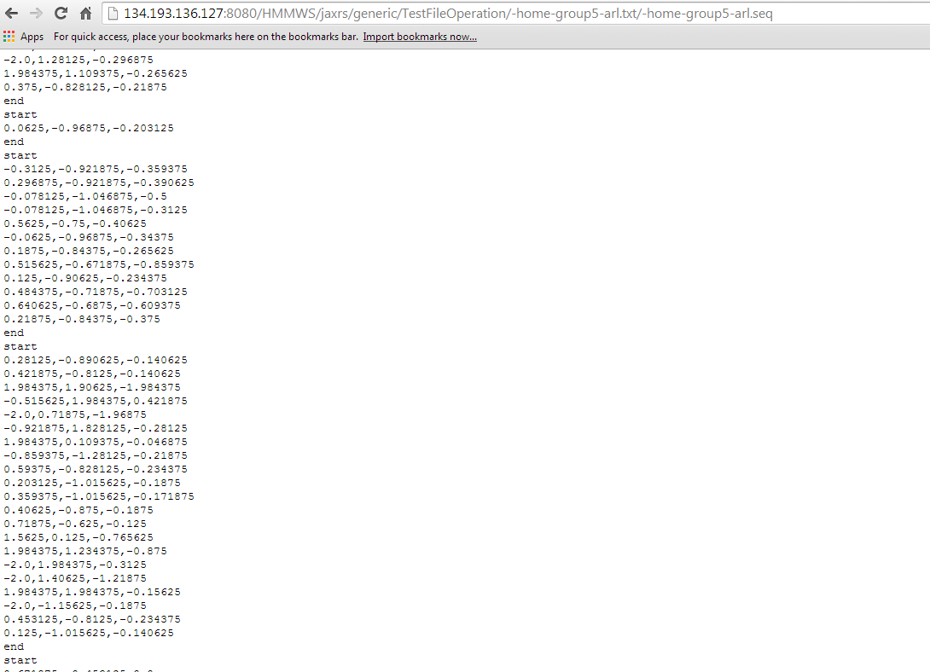

**input file:**  home/group5/abt.txt

**output file:** home/group5/abt.seq

**REST Service**

http://134.193.136.147:8080/HMMWS/jaxrs/generic/TrainFileOperation/-home-group5-abt.txt/-home-group5-abt.seq

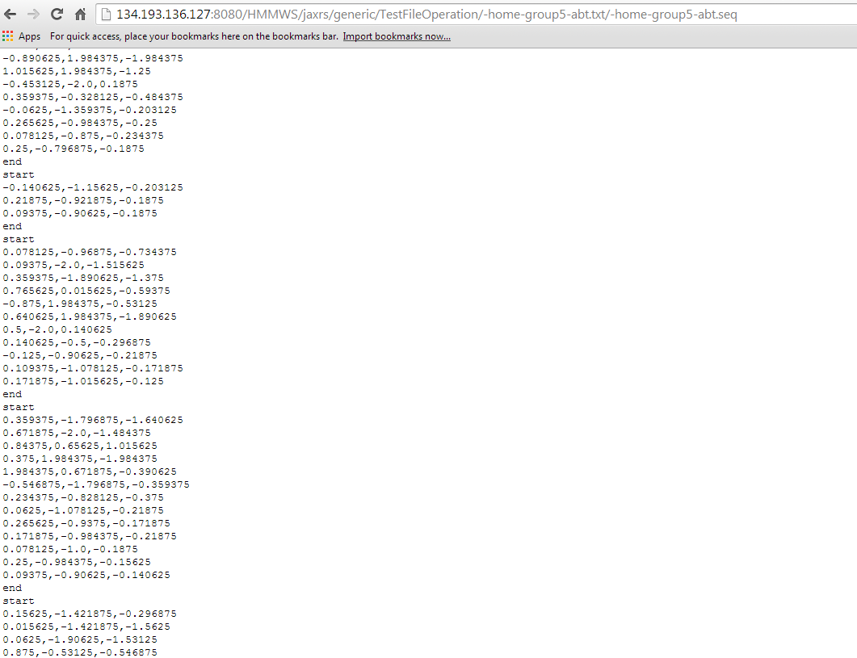

**2.Segment and convert to sequence file for Testing file**

**input file:**  home/group5/combi.txt

**output file:** home/group5/combi.seq

**REST Service**

http://134.193.136.127:8080/HMMWS/jaxrs/generic/TestFileOperation/-home-group-combi.txt/-home-group5-combi.seq

