CS5560- KDM – Lab#1 Assignment

This document consists of following information.

1. **ER Diagram:** For the following Scenario.

Suppose we wish to keep a genealogy. We shall have one entity set, Person. The information we wish to record about persons includes their name (an attribute) and the following relationships: mother, father, and children. Give an E/R diagram involving the Person entity set and all the relationships in which it is involved. Include relationships for mother, father, and children. Extend it with additional relationships such as husband and wife. Do not forget to indicate roles when an entity set is used more than once in a relationship.

1. **Class Diagram:** For the following Scenario

For the given domain (i.e., Family), define UML Class Diagram that specifies classes and their relationships with specific relationships such as inheritance, aggregation, composition, dependence, association, etc.

1. GitHub Account Screenshots(username: davinashreddy)
2. ScrumDo Account Screenshots(link: <https://www.scrumdo.com/organization/umkc32/dashboard>)

* This ER Diagram is created using Microsoft Visio Professional Edition

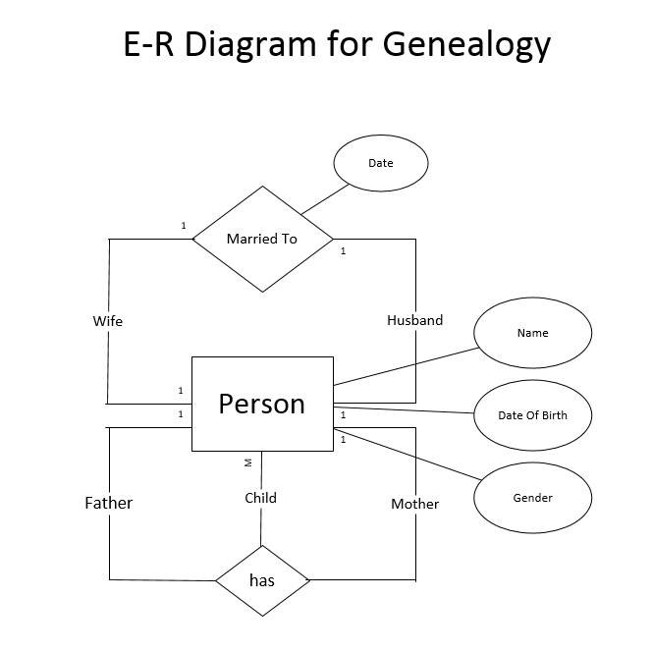

* This Class Diagram is created using Microsoft Visio Professional edition

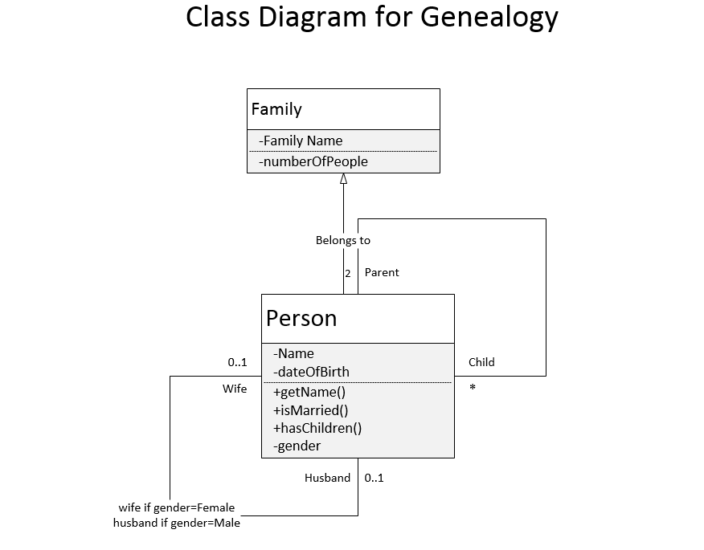

3. GitHub Account Screenshot

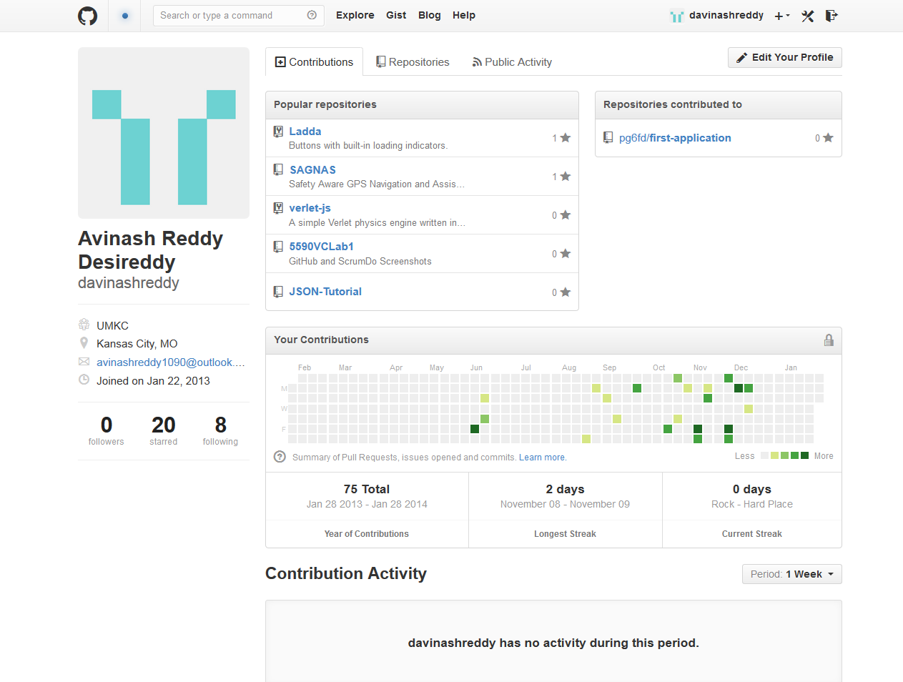

1. ScrumDo Account Screenshot

