Daily Transactions Analysis Project Report

Generated automatically with Python.

# Introduction

This project analyzes a dataset of daily household transactions. The objective is to clean the data, perform exploratory data analysis (EDA), identify spending and income trends, and provide key financial insights.

# Dataset Description

The dataset contains the following fields:  
• Date: Date of transaction  
• Mode: Payment mode  
• Category & Subcategory: Type of transaction  
• Note: Short description  
• Amount: Transaction amount  
• Income/Expense: Income or Expense  
• Currency: INR

# Summary Statistics

Total Income: 3042397.35 INR

Total Expense: 1955380.53 INR

Net Savings: 1087016.82 INR

Top 5 Expense Categories:

* Money transfer: 606528.90 INR
* Investment: 269858.00 INR
* Transportation: 169053.78 INR
* Household: 161645.58 INR
* subscription: 114587.91 INR

Top 5 Income Categories:

* Salary: 2526576.45 INR
* Maturity amount: 382792.00 INR
* Other: 83442.00 INR
* Tax refund: 26130.00 INR
* Petty cash: 13170.00 INR

# Visualizations

Dist

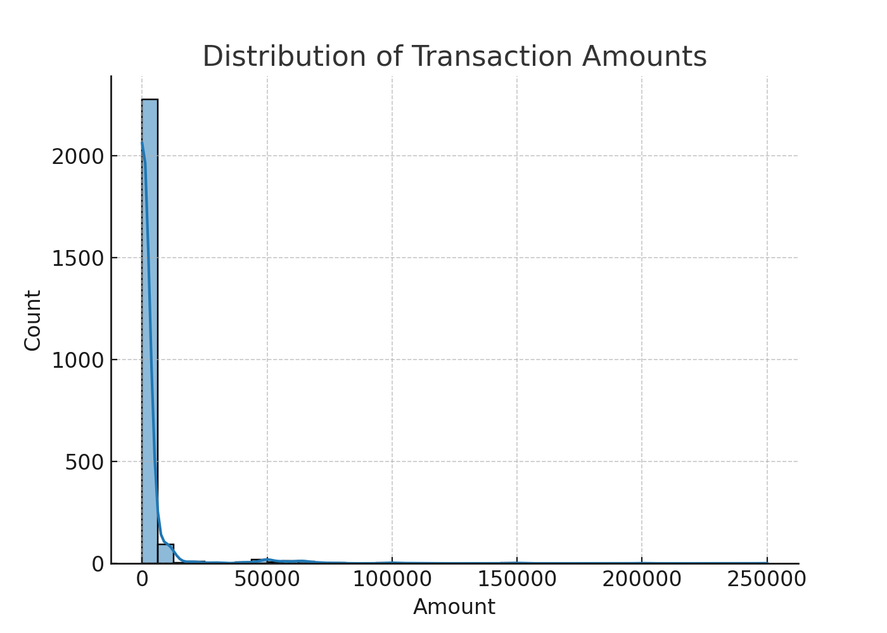

Cat

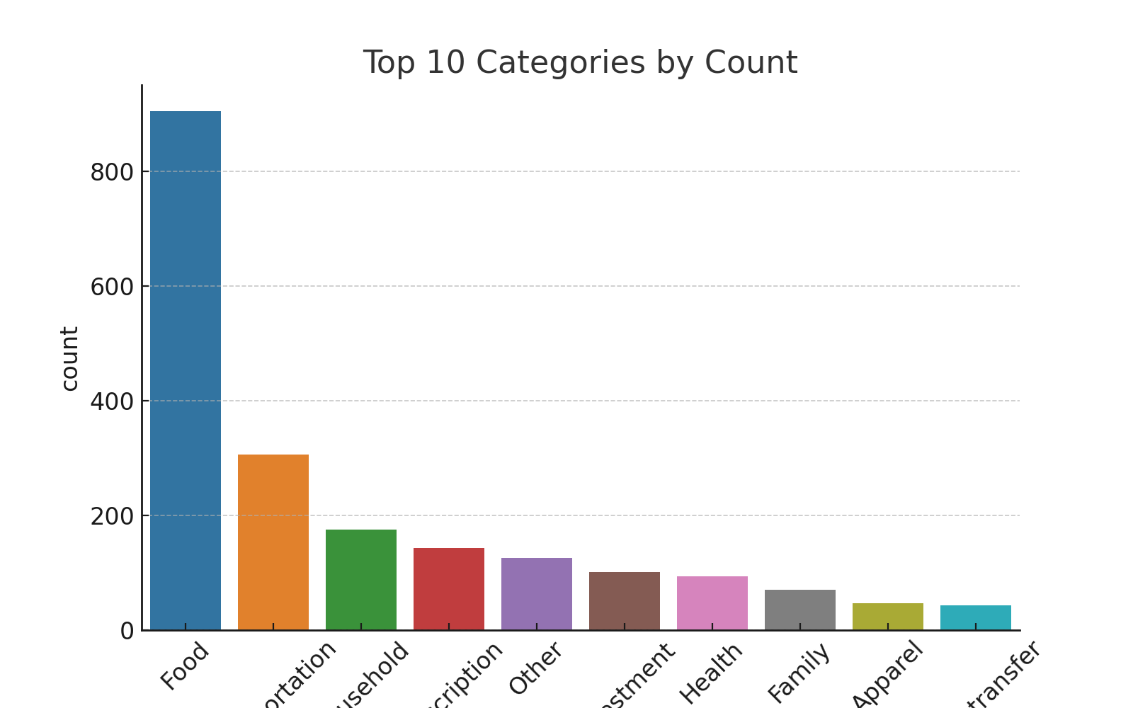

Inex

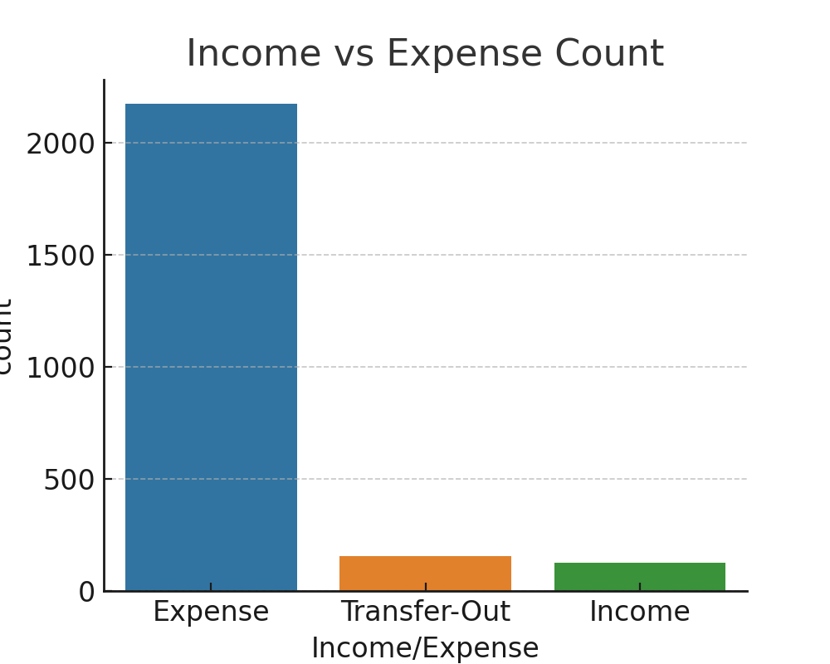

Monthly

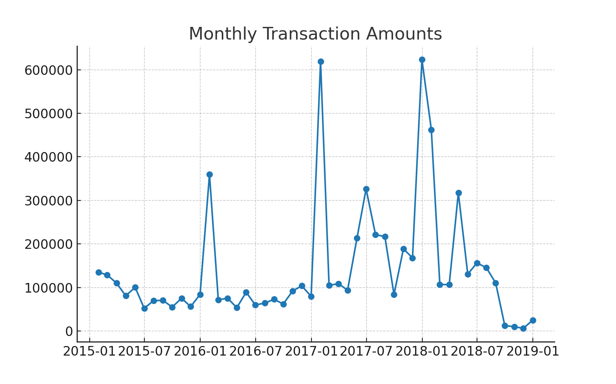

Daily

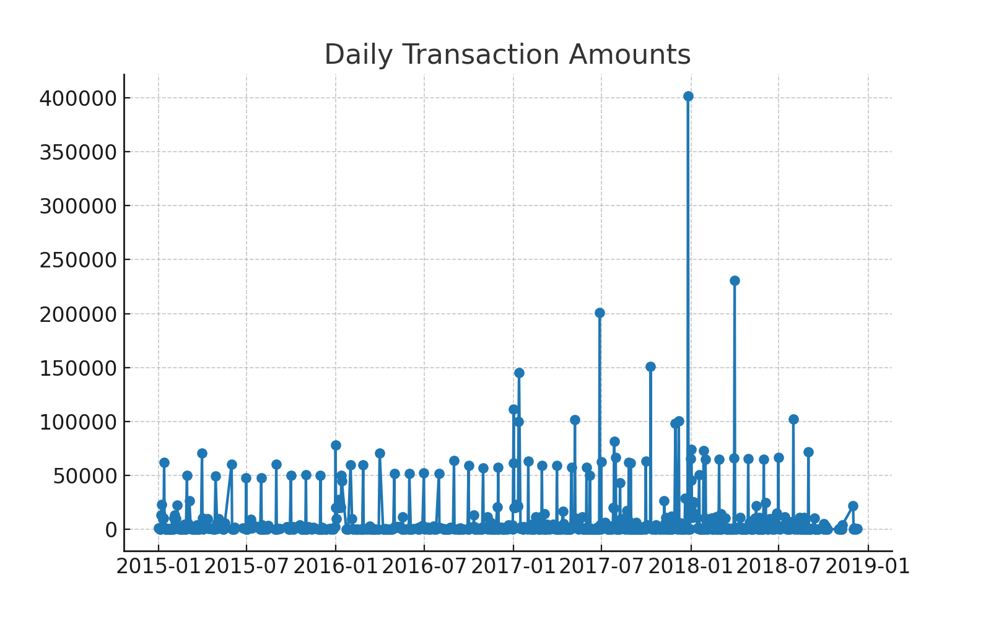

Heatmap

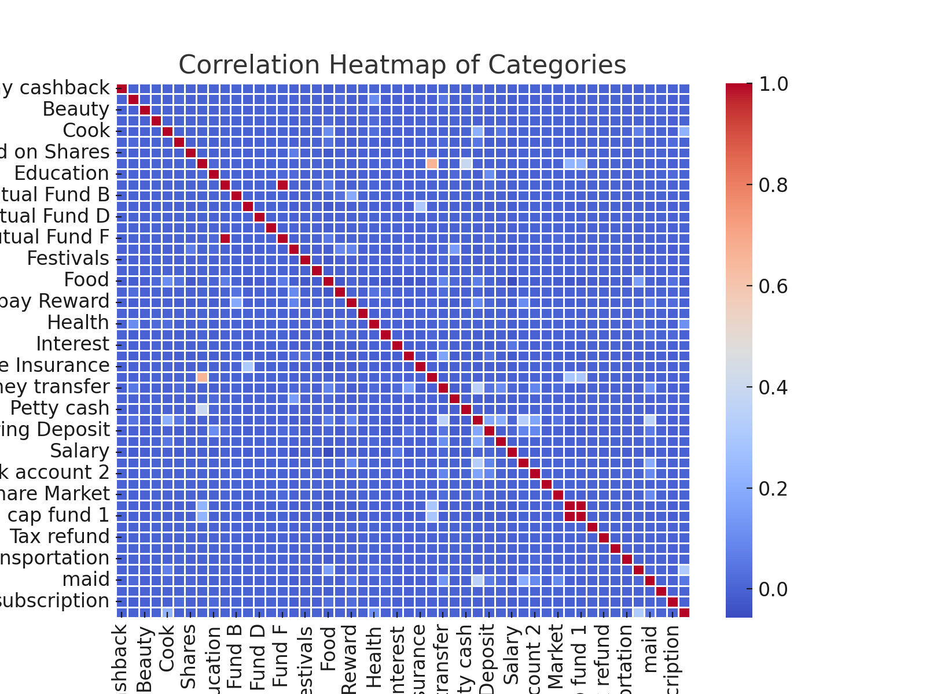

# Key Insights

• Transaction amounts are right-skewed, with many small transactions and few large ones.

• Food and Transportation are among the top spending categories.

• Income transactions are fewer but higher in value compared to expenses.

• Seasonal peaks are visible in monthly expenses.

• Correlation heatmap shows strong relationships between certain categories.

# Conclusion

This project demonstrates how financial transaction data can be analyzed to gain insights into spending behavior, income sources, and savings. These insights can help in better budgeting, forecasting, and financial planning.