ROCKWELL AUTOMATION + NVIDIA INNOVATION LAB | FALL 2026
ADAPTIVEVISION
Intelligent Robotic Grasping and Sorting for High-Mix, Low-Volume Manufacturing
Theme Physical AI for the Factory Floor
Project focus Dataset 3: Robotic Grasping and Sorting
Hackathon duration October 8 to November 5, 2026

Project Overview
AdaptiveVision aims to make an industrial robotic sorting cell more adaptable. Today, many pick-and-place programs assume that every part sits at a known, fixed coordinate. We propose a system that uses RGB cameras and computer vision to find objects wherever they are on the worktable, estimate their position and orientation, choose a suitable grasp for the two-finger gripper, and plan a safe robot motion to the correct sorting location. Development will happen first in the provided digital twin, so ideas can be tested without risk to hardware. The team will start with a simple, measurable baseline and add more advanced Physical AI capabilities only after that baseline works. The goal is to show a practical, measured improvement over fixed-coordinate automation.

How to read this plan. Every important statement is labeled by source:
CONFIRMED stated in the event information supplied to the team. PROPOSED our team's suggested approach. TO BE VERIFIED (TBV) needs confirmation from mentors, Dataset 3 documentation, or the equipment provider.
This is a plan, not a report. Nothing described here has been built, trained, or tested yet, and no results are claimed. Event details were taken from the supplied event information; a public web search on October 9, 2026 did not return a separate official page, so dates should be re-checked on the event portal.
1. Understanding the Innovation Lab
CONFIRMED The Rockwell Automation + NVIDIA Innovation Lab Fall 2026 is a four-week Physical AI hackathon run with MSOE and the University of Wisconsin-Milwaukee's Connected Systems Institute (CSI). Student teams build AI-based solutions to real manufacturing challenges using the CSI testbed. The theme, Physical AI for the Factory Floor, asks teams to move AI out of the screen and into machines that work in the physical world.
Physical AI refers to AI systems that perceive a physical environment, interpret what they see, make decisions, and support or perform physical actions through machines or robots. For an industrial robot, this is a repeating loop:
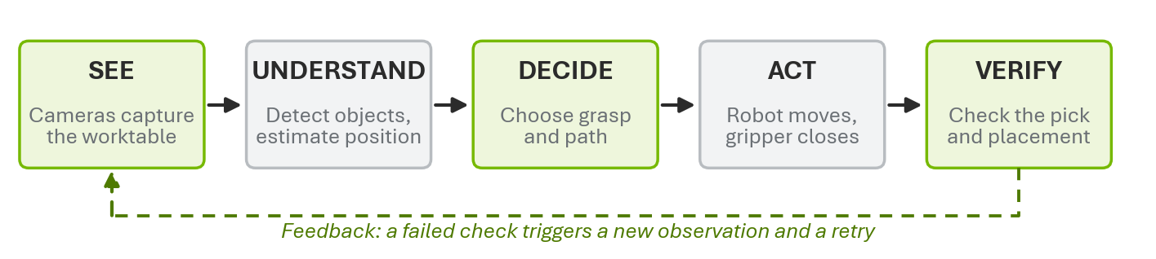
Figure 1. The Physical AI loop applied to a robotic sorting cell (proposed interpretation).
See: cameras capture the worktable. Understand: software detects a cube and estimates where it is. Decide: the system chooses where to grip it and how to move there. Act: the arm moves and the gripper closes. Verify: the cameras confirm the cube left the table and arrived in the right tray. If not, the loop starts again.
2. What Is a Manufacturing Testbed?
A testbed is a controlled environment where engineers can try new technologies before deploying them in real factories. It matters because it allows controlled experiments, safer testing, repeatable evaluation, validation of new technology against real equipment, and lower risk when a solution later moves to production.
3. What Is HMLV Manufacturing?
High-Mix, Low-Volume (HMLV) manufacturing means a factory makes many different product variations (high mix) but small quantities of each (low volume). Between production runs, the type, position, or arrangement of parts can change. Traditional fixed-coordinate robot programs work well when products and positions stay predictable. In HMLV settings, every change may require reprogramming, recalibration, or manual setup, and that time adds up. The opportunity is that AI-based perception and adaptable planning can help robots handle some of these variations automatically, without a new program for each change.
4. Factory Context
CONFIRMED The CSI testbed includes a demonstration vial production line. Its process flow is: liquid tanks, fluid mixing, vial filling, cap placement, inspection, robotic handling, and final placement. This kind of fill-cap-inspect process resembles processes used in several manufacturing industries, such as consumer goods, chemicals, and food and beverage. It is background context only. Dataset 3 uses a separate, standalone FANUC robotic workcell and is not directly connected to the vial production line.
5. Dataset 3: Robotic Grasping and Sorting
CONFIRMED The challenge is to improve a robotic arm's ability to find, grasp, and relocate objects that may appear in unexpected positions. The provided environment includes a FANUC industrial robotic arm, a pneumatic two-finger gripper, multiple RGB cameras, a digital twin of the arm and environment, and objects such as cubes, caps, and vials.
Component | What it is | What it does | Why it matters / status
FANUC robot | Industrial multi-joint robotic arm | Moves the gripper to precise positions | Executes every pick. Provided; exact model TBV
Two-finger gripper | Pneumatic (air-driven) parallel gripper | Opens and closes to hold an object | Grasp must fit its finger width and stroke. Provided
RGB cameras | Standard color cameras, several views | Capture images of the workspace | Only source of object location. Provided; specs TBV
Worktable | Surface where objects are placed | Holds objects in varied positions | Defines the pick area. Assumed present, layout TBV
Sorting area | Target locations (trays or bins) | Receives sorted objects | Defines success. Destinations TBV
Digital twin | Virtual model of arm and cell | Simulates motion, cameras, objects | Safe testing. Provided; format TBV
Robot controller | FANUC control cabinet and software | Runs motion programs, drives joints | Our software must talk to it. Interface TBV
AI perception system | Our vision and planning software | Turns images into pick targets | Core contribution. Proposed
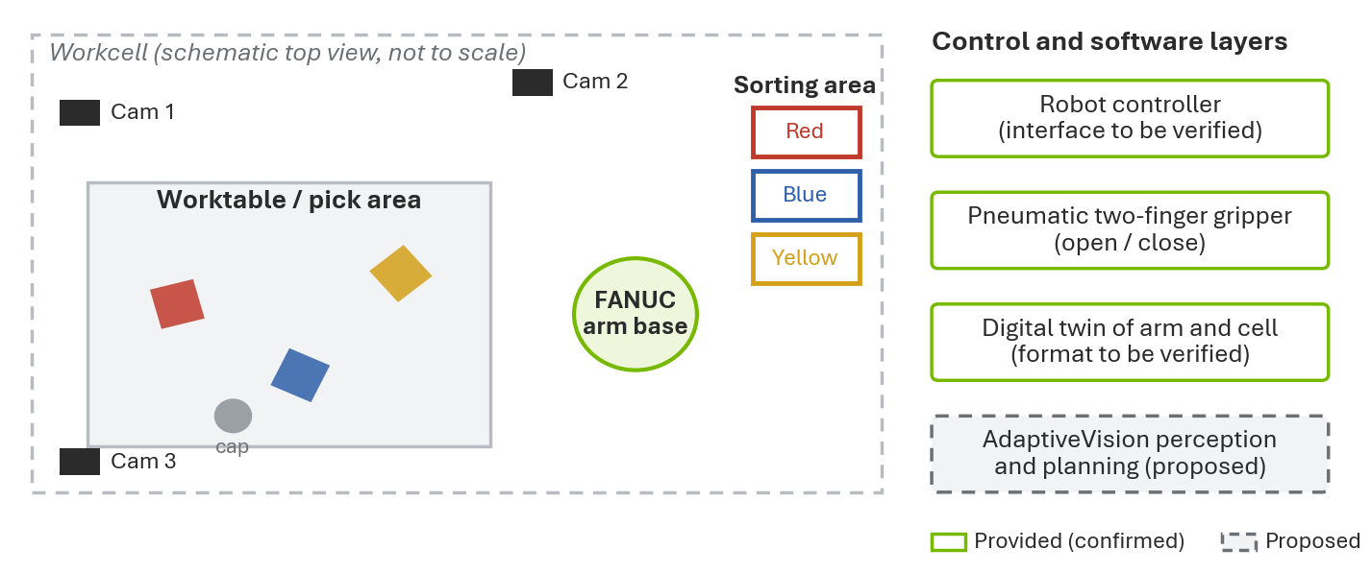
Figure 2. Schematic of the Dataset 3 workcell. Layout, camera placement, and tray positions are illustrative and TBV; this is not a drawing of the real cell.
6. Why Traditional Automation Struggles
A robot is taught to pick a cube from Position A. Someone places the cube at Position B. A fixed-coordinate program still moves to Position A, closes the gripper on nothing, and the task fails until a technician updates the program. An adaptive system closes this gap by looking first: the camera observes the cube, AI detects it, the system estimates its position, a grasp planner chooses a grasp, a motion planner finds a path, the robot attempts the pick, and the system verifies the result.
Aspect | Traditional fixed automation | Vision-guided adaptive automation (proposed)
Object position | Must be exactly where programmed | Measured from camera images every cycle
New part or layout | Reprogram or re-teach points | Update detector classes or sort rules
Failure handling | Often silent; operator notices later | Camera check after each pick, then retry
Setup effort | Low for one fixed job | Higher at first: calibration and model training
Best fit | High-volume, unchanging production | HMLV production with frequent change
7. Project Problem Statement
How can a vision-guided robotic system improve the reliability of grasping and sorting objects placed in varying positions and orientations within a high-mix, low-volume manufacturing workcell, compared with a fixed-coordinate pick-and-place program?
8. Project Objectives
Primary objective: develop and evaluate a vision-guided pick-and-place system that adapts to changes in object position. Secondary objectives: detect objects in camera images; estimate object positions; generate suitable grasp targets; plan feasible robot movements; sort objects into assigned destinations; verify task completion; and evaluate performance under varied conditions.
9. How the Proposed System Works
For every object: (1) it is placed on the worktable; (2) the RGB cameras capture the workspace; (3) the vision system identifies it; (4) the system estimates its location and orientation; (5) a grasp planner picks a gripping position; (6) a motion planner calculates a collision-free path; (7) the robot controller executes the movement; (8) the gripper attempts the grasp; (9) the robot carries the object to its tray; (10) the system checks whether the task succeeded.
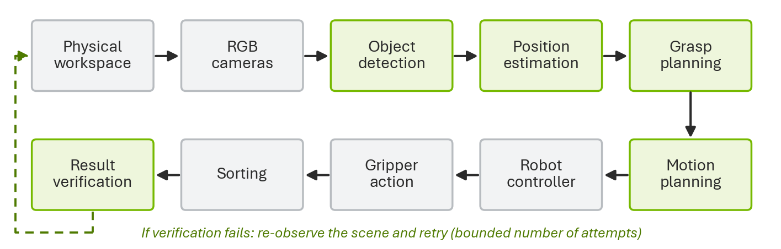
Figure 3. Proposed end-to-end pipeline. Green stages are the main software contributions.
If the object moves before the pick, the plan is based on stale data, so the system re-captures images just before the approach and re-plans if the position changed by more than a set tolerance. If detection fails (no object found or low confidence), the robot does not move; the system logs the event and requests a new image or operator help. If a grasp fails, the verification check sees the object still on the table and triggers a retry, up to a fixed limit, before flagging the object for an operator.
Concept | Question it answers | Example output
Object detection | What is in the image, and where in pixels? | "Red cube" in a box at pixels (412, 230)
Object localization | Where is it in the real workspace? | x = 0.42 m, y = 0.15 m on the table
Pose estimation | Where is it and how is it rotated? | Position plus a 35 degree rotation
Grasp planning | Where should the fingers close? | Grasp centered on the cube, fingers across its faces
Motion planning | How does the arm get there safely? | A collision-free series of joint positions
Robot control | How is the motion executed? | Controller drives the motors along the path
Task verification | Did it work? | Cube detected in red tray: success
10. Example Scenario (Proposed Demonstration)
Three cubes are sorted by color: red to the red tray, blue to the blue tray, yellow to the yellow tray.
Scenario | Situation | Expected response of the proposed system
A: Expected positions | Cubes sit where a fixed program expects them | Detects all three, confirms positions, sorts them. Both fixed and adaptive systems should succeed; this is the control case.
B: Unexpected positions | Cubes are moved and rotated | Re-detects each cube, computes new positions and grasp angles, sorts correctly. A fixed program would miss.
C: Failed grasp | Blue cube slips out of the gripper | Verification sees the blue cube still on the table, logs a failure, re-plans, and retries within the attempt limit.
11. Technical Terminology Explained
Terms marked (adv.) are optional research topics. All other terms are needed to understand or build the baseline.
Term | Meaning, and use in Dataset 3 | Term | Meaning, and use in Dataset 3
Physical AI | AI that perceives, decides, and acts in the physical world. Here: The whole see-to-verify loop. | Forward kinematics | Joint angles in, gripper position out. Here: Check where a planned pose puts the gripper.
Industrial automation | Machines and control systems doing production tasks. Here: The FANUC cell is an automated system. | Inverse kinematics | Desired gripper position in, joint angles out. Here: Turn a grasp pose into arm joint angles.
HMLV | Many product types, few of each. Here: Why positions and parts change often. | Grasp planning | Choosing where and how to hold an object. Here: Pick finger placement on a cube or cap.
Manufacturing testbed | Controlled environment for trying new technology. Here: The CSI facility. | Grasp pose | Gripper position and orientation at closing. Here: Above the cube, rotated to match its faces.
Digital twin | Virtual model linked to a real system and its data. Here: Test picks before touching hardware. | Motion planning | Finding a path that avoids collisions. Here: Route from home to cube to tray.
Simulation | Running a model to predict behavior. Here: Rehearse thousands of picks quickly. | Collision detection | Checking whether geometry overlaps. Here: Avoid hitting the table, trays, other parts.
Sim-to-real | Moving results from simulation to real hardware. Here: Final, supervised validation step. | Trajectory | A path with timing (positions over time). Here: What the controller actually executes.
Synthetic data | Computer-generated, auto-labeled training data. Here: Rendered images of cubes for the detector. | Robot controller | Computer that runs programs and drives motors. Here: FANUC controller; interface TBV.
Domain randomization | Randomly varying lighting, color, pose in simulation. Here: Helps the detector work on real images. | End effector | Tool at the end of the arm. Here: The two-finger gripper.
Computer vision | Software that extracts information from images. Here: Finding objects on the table. | Pneumatic gripper | Gripper powered by compressed air. Here: Mostly open/close; force set by air pressure.
RGB camera | Camera recording red, green, blue color (no depth). Here: Main sensor; depth must be inferred. | Open-loop control | Acting without checking the result. Here: Fixed-coordinate picking.
Multi-view vision | Combining images from several cameras. Here: Better position estimate, fewer blind spots. | Closed-loop control | Acting, measuring, then correcting. Here: Pick, verify, retry.
Camera calibration | Measuring lens properties and camera placement. Here: Needed to turn pixels into meters. | Feedback | Measured information used to adjust actions. Here: Camera check after each pick.
Object detection | Finding and labeling objects in an image. Here: "Yellow cube at these pixels". | Reinforcement learning (adv.) | Learning by trial, error, and reward. Here: Possible grasp-policy research in simulation.
Object localization | Finding an object's position in the world. Here: Table coordinates of the cube. | Imitation learning (adv.) | Learning by copying demonstrations. Here: Learn picks from recorded examples.
Object pose | Position plus orientation. Here: Where the cube is and how it is turned. | Robot policy (adv.) | Function mapping observations to actions. Here: Output of RL or imitation learning.
6D pose estimation (adv.) | Estimating 3 position and 3 rotation values. Here: Needed for vials lying at odd angles. | Foundation model (adv.) | Large model pre-trained on broad data. Here: Used as-is or adapted, never trained here.
Coordinate frame | A reference point and set of axes. Here: Camera frame, robot base frame, table frame. | Vision-language model (VLM) (adv.) | Model that reads images and text together. Here: Describe scene or check result in words.
Coordinate transformation | Converting a point from one frame to another. Here: Camera coordinates to robot coordinates. | Vision-language-action (VLA) (adv.) | Model that outputs robot actions from images and text. Here: Research comparison only.
Robot kinematics | Math linking joint angles to gripper position. Here: Basis of all arm motion. | In-context learning (adv.) | Model adapts from examples in its prompt, no retraining. Here: Show example images of a new object type.
12. Proposed Technology Stack
Not every technology below is necessary. The team will use the smallest stack that delivers a working, measurable baseline. Status refers to whether the event provides it, not whether the team has used it.
Technology | Purpose | How we would use it | Priority | Status
Python | Main language | Glue code, vision, planning, scripts | Essential | Proposed
OpenCV | Classic computer vision | Calibration, color filtering, geometry | Essential | Proposed
YOLO (Ultralytics) | Fast object detector | Detect cubes, caps, vials in images | Essential | Proposed
PyTorch | Deep learning framework | Train or fine-tune the detector | Essential | Proposed
NVIDIA Isaac Sim | Robot simulation | Run the digital twin, render images | Essential | TBV
OpenUSD | 3D scene description format | Read and edit the twin's scene files | Useful | TBV
Motion planning (e.g., MoveIt 2 or Isaac Sim tools) | Collision-free paths | Plan approach, grasp, place moves | Essential | TBV
ROS 2 | Robot messaging middleware | Only if the twin or robot uses it | Useful | TBV
NVIDIA Isaac Lab | Robot learning on Isaac Sim | Only for RL extension | Optional | Proposed
GitHub | Version control | Code, issues, final submission | Essential | Proposed
Docker | Reproducible environment | Same setup on every machine | Useful | Proposed
Experiment tracking | Record runs and metrics | Spreadsheet or tool such as MLflow | Useful | Proposed
NVIDIA Cosmos | World foundation models | Possibly augment synthetic images | Optional | Proposed
VLMs | Image plus text reasoning | In-context checks of new objects | Optional | Proposed
VLAs | End-to-end action models | Literature comparison only | Optional | Proposed
Reinforcement / imitation learning | Learned grasp policies | Research extension in simulation | Optional | Proposed
13. Recommended Baseline Stack
The first version links proven, well-documented tools: RGB images, then Python + OpenCV, then an object detector, then calibration and position estimation, then grasp target generation, then motion planning, then the digital twin robot, then pick-and-place evaluation. This is a good first version because every step can be tested on its own, failures are easy to locate, and it produces measurable numbers early. For objects lying flat on a table, the baseline uses top-down grasps: the gripper approaches vertically and only needs an x, y position, a fixed height, and one rotation angle. Because the cameras are RGB only, the table height acts as the known depth, so a calibrated camera can convert a pixel into a table position.
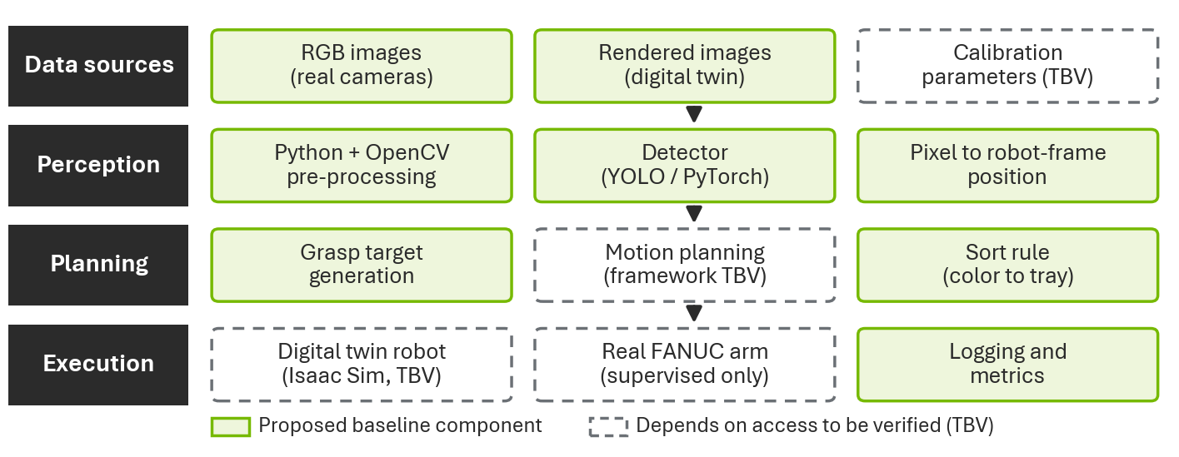
Figure 4. Proposed layered architecture. Dashed boxes depend on interfaces or files still to be verified.
14. Advanced Research Extensions
Extension | What and why | How it could work | Added complexity | Success measure
1. Multi-view localization | Combine cameras to reduce position error and occlusion | Triangulate the same object seen from two or more calibrated cameras | Medium: multi-camera calibration and matching | Lower localization error (mm) than one camera
2. Failure detection and recovery | Catch missed grasps instead of failing silently | Compare before and after images; re-plan and retry | Low to medium | Recovery success rate; fewer unrecovered failures
3. Adaptive grasp selection | Pick the best grasp when objects are rotated, crowded, or a new type | Score candidate grasps by clearance and stability; optional VLM check with example images | Medium to high | Grasp success rate under varied conditions vs. baseline
Training a large robotics foundation model from scratch is out of scope for a four-week hackathon. Any foundation model would be used pre-trained, through prompting or light adaptation.
15. Role of the Digital Twin
A digital twin is a virtual model of a real system that mirrors its geometry, behavior, and, ideally, its live data. A static 3D model only shows shape; it cannot move or react. A simulation runs a model to predict behavior, but it may represent any machine. A digital twin is a simulation tied to one specific real system. For robotics, it lets the team place objects in hundreds of positions, test reachability, generate labeled camera images, and catch collisions or unreachable poses before any real motion. CONFIRMED a twin of the arm and environment is provided; TBV whether it has a working Isaac Sim control interface.
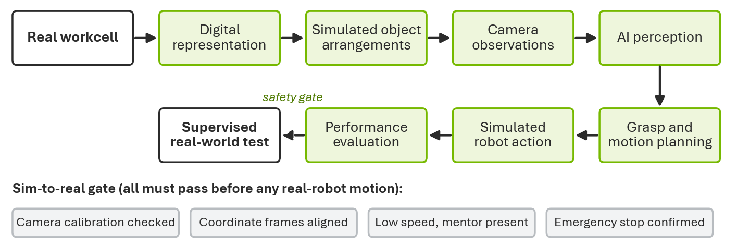
Figure 5. Proposed digital twin to real robot workflow with a sim-to-real safety gate.
16. Synthetic Data Generation
Instead of collecting hundreds of real photographs and labeling each by hand, the digital twin can render images of objects at different positions and record the exact label for each one automatically. Useful variations include object positions, rotations, lighting, camera viewpoints, object combinations, and partial occlusions. These images can train the detector and create test sets with known ground truth. Limitation: synthetic images do not perfectly match real lighting, textures, reflections, or physics, so the detector must also be checked on real camera images.
17. Sim-to-Real
Sim-to-real means taking a result that works in simulation and making it work on the physical robot. The main issues are: camera calibration (real lens distortion and camera positions must be measured); robot coordinate frames (the twin's frames must line up with the real robot base and table); gripper geometry (real finger width, stroke, and friction); simulation fidelity (how closely simulated physics matches reality); and the domain gap (differences between simulated and real images). Real-robot tests will happen only if permitted, at reduced speed, with a mentor present and the emergency stop confirmed.
18. Project Development Plan
CONFIRMED Key dates: October 8 kickoff; October 14, 11:59 PM Central Time team plan deadline; November 1 final submission deadline; November 5 final presentations.
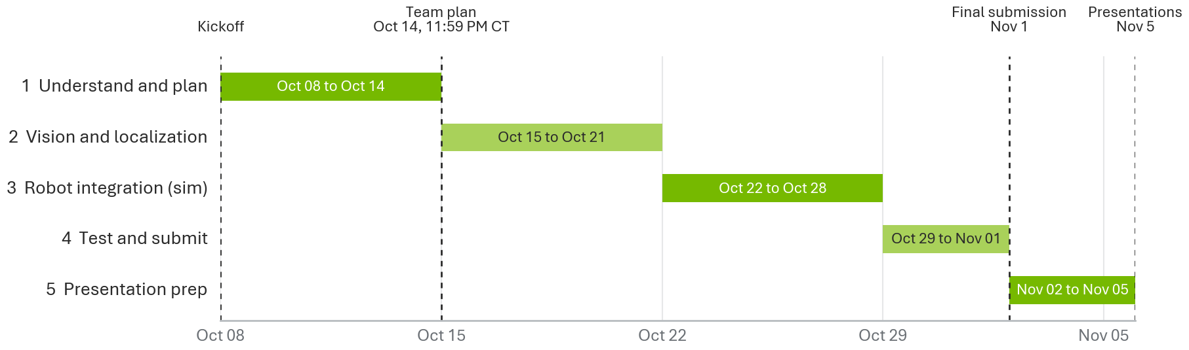
Figure 6. Proposed four-week roadmap with official milestones.
Phase | Main tasks | Deliverable
1. Understand and plan  Oct 8 to 14 | Review Dataset 3 documentation; access the digital twin; inspect camera data; identify robot control interfaces; define scope; select a baseline; prepare the team plan | Project plan and initial architecture
2. Vision and localization  Oct 15 to 21 | Set up environment; inspect images; build a basic detector; study camera calibration; estimate object locations; validate detections | Detection and localization prototype
3. Robot integration  Oct 22 to 28 | Connect perception to the virtual robot; generate grasp targets; integrate motion planning; test pick-and-place; measure grasps; improve reliability | Working simulation prototype
4. Test and submit  Oct 29 to Nov 1 | Test unexpected positions; compare baseline and improved system; measure performance; record video; write one-page summary; organize GitHub; add references; submit | Complete hackathon submission
5. Presentation  Nov 2 to 5 | Refine slides; practice the demo; prepare technical and business explanations; rehearse judge questions | Final presentation on Nov 5
19. Project Evaluation Plan
All tests below are planned. Each will run on both the fixed-coordinate baseline and the adaptive system, with the same object layouts, so the comparison is fair: A expected positions; B unexpected positions; C different orientations; D multiple objects at once; E partially occluded objects; F grasp failure and recovery (for example, an object nudged during the approach).
Metric | Meaning | How it will be measured
Object detection accuracy | How often objects are correctly found and labeled | Precision and recall against labeled test images (real and synthetic)
Localization error | Distance between estimated and true position | Millimeters, against twin ground truth or measured real positions
Grasp success rate | Share of grasps that lift and hold the object | Count over all attempts (formula below)
Sorting accuracy | Share of objects placed in the correct tray | Correct placements divided by objects sorted
Task completion time | Time per object, image capture to release | Timestamps in the system log
Collision-free planning rate | Share of planned paths with no collision | Collision checks in simulation
Recovery success rate | Share of failed grasps fixed by a retry | Recovered failures divided by detected failures
Grasp Success Rate = (Successful Grasps / Total Grasp Attempts) x 100. Illustrative example only, not a result: if a future test had 46 successful grasps out of 50 attempts, the rate would be (46 / 50) x 100 = 92%.
20. Judging and Award Categories
CONFIRMED Judges represent Rockwell Automation, NVIDIA, MSOE, and UWM. The publicly described expectations are: a solution relevant to the CSI line or robot; a clearly defined manufacturing problem; a working demonstration; measured results; and a business case applicable to manufacturers. The announced award categories, and how this project could address each, are:
- Most Impactful: reduce manual reprogramming when parts or positions change, and show the gain with before-and-after measurements.
- Most Innovative: a closed loop that sees, verifies, and recovers, unlike a basic fixed-coordinate robot; possibly multi-view localization.
- Best Use of In-Context Learning: in-context learning means a model adapts from examples placed in its input, such as a few labeled images of a new part, without changing its weights. Fine-tuning, by contrast, retrains the weights. An optional approach is to give a VLM example images of a new object and ask it to identify or check that object. The project will claim this only if it is actually implemented.
- Most Scalable: new objects need new detector classes or examples, not a new robot program; the same pipeline could serve other cells.
- Best Presentation: a clear problem, a live or recorded demo, honest metrics, and a simple business story.
Detailed judging weights and final award categories were not confirmed in the supplied event materials.
21. Business Impact
Manufacturers might care because a working version of this approach could potentially reduce manual reprogramming, improve production flexibility, handle variable object positions better, reduce downtime caused by missed picks, make sorting more consistent, and simplify adaptation to new product variations. These are potential benefits only; the project will not estimate financial savings without measured data.
22. Official Hackathon Deliverables
Deliverable | Deadline | What it should contain
Team plan | Oct 14, 2026, 11:59 PM CT | Project plan submitted through the event's team plan submission process (form requirements TBV)
Demo video (about 5 minutes) | Nov 1, 2026 | Problem, environment, AI architecture, working demo, measured results, business value
One-page summary | Nov 1, 2026 | Title, problem, solution, stack, implementation, results, business relevance, limitations
GitHub repository | Nov 1, 2026 | README, setup steps, source code, dependencies, architecture, test instructions, results, references, known limitations
References | Nov 1, 2026 | Official documentation and papers for the frameworks actually used
Proposed video structure (not an official format): 0:00 to 0:30 problem; 0:30 to 1:15 environment; 1:15 to 2:15 AI architecture; 2:15 to 3:45 live demo; 3:45 to 4:30 measured results; 4:30 to 5:00 business value and next steps.
23. Immediate Action Checklist
[ ] Register for the Innovation Lab  [ ] Confirm team membership  [ ] Connect GitHub to the event workspace  [ ] Access Dataset 3 materials  [ ] Download or open the digital twin  [ ] Identify the available camera files  [ ] Verify the robot controller interface | [ ] Select the proposed technical approach  [ ] Discuss feasibility with mentors  [ ] Submit the team plan before October 14  [ ] Build the initial baseline  [ ] Measure results  [ ] Prepare the final submission  [ ] Practice the final presentation
24. Questions for Mentors
- What exact FANUC robot model and controller are provided?  - What format is the digital twin supplied in (USD, URDF, other)?  - Is the robot controllable through Isaac Sim?  - Are camera calibration parameters available?  - What robot control interfaces are supported (for example, PLC, socket, or ROS 2 driver)? | - Can teams run supervised real-robot tests?  - Which objects must the system handle?  - Are sorting destinations predefined?  - Are there restrictions on external or pre-trained AI models?  - What are the exact team plan form requirements?

