HARIDWAR UNIVERSITY, ROORKEE
DEPARTMENT OF COMPUTER SCIENCE & ENGINEERING
Bachelor of Technology (Computer Science & Engineering)
ACADEMIC INTERNSHIP REPORT (SESSION 2025–2026)
B.Tech. 5th Semester Summer Internship Training Report submitted in partial fulfilment of the requirements for the degree of Bachelor of Technology in Computer Science & Engineering.

INTERNSHIP PROJECT TITLE:
Basic Analysis of RAG Systems & Development of a Personal Document Q&A Assistant (RAG Pipeline)
Candidate & Host Organisation Profile:
Student Credentials | Host Organisation Credentials
Name: Aditya Kumar | Organisation: InternCourse (interncourse.online)
Roll No: 024101010012 | Registered Location: Patna, Bihar
Enrolment No: 024101010012 | Managing Director: Ankit Pandey
Semester / Branch: 5th Sem, B.Tech. CSE | Accreditations: ISO 9001:2015, AICTE, MCA Reg.
Faculty Mentor: Pooja Parmar | Training Domain: Artificial Intelligence & NLP
Head of Department: Dr. Himanshu Verma | Certificate ID: IC26/11873 | Duration: 6 Weeks
GitHub Repository (Code & Pipeline) | https://github.com/aditya93416/personal-document-rag-assistant

Training Period: 15 June 2026 – 18 July 2026 | Submission Date: October 2026
Haridwar University, Roorkee, Uttarakhand – 247667

STUDENT DECLARATION
I, Aditya Kumar, student of Bachelor of Technology in Computer Science & Engineering, 5th Semester, Haridwar University, Roorkee (Roll No: 024101010012, Enrolment No: 024101010012), hereby declare that the internship training report titled:
PROJECT SPECIFICATION
“Basic Analysis of RAG Systems & Development of a Personal Document Q&A Assistant (RAG Pipeline)”

is an authentic, original record of technical work undertaken by me during the 6-week summer internship training period from 15 June 2026 to 18 July 2026 at InternCourse (interncourse.online), Patna, Bihar, under the industrial mentorship of Managing Director Ankit Pandey.
I affirm that this report is submitted in partial fulfilment of the requirements for the degree of Bachelor of Technology in Computer Science & Engineering at Haridwar University. This report has not been submitted previously to any other university, board, or institution for the award of any academic degree, diploma, or fellowship.
All algorithms, source code listings, empirical evaluations, literature citations, and system diagrams reproduced herein have been duly attributed to their original authors and repositories in accordance with university academic integrity standards.

Date: 25 October 2026  Place: Roorkee, Uttarakhand  ___________________________________  Aditya Kumar  Roll No: 024101010012  Enrolment No: 024101010012  B.Tech. CSE, 5th Semester | Endorsed by Department:  Haridwar University, Roorkee  ___________________________________  Signature of Candidate  Aditya Kumar (CSE)

CERTIFICATE BY FACULTY SUPERVISOR & HOD
This is to certify that Mr. Aditya Kumar, bearing University Roll Number 024101010012 and Enrolment Number 024101010012, a bona fide student of Bachelor of Technology in Computer Science & Engineering, 5th Semester, at Haridwar University, Roorkee, has successfully and satisfactorily completed his 6-week summer internship training from 15 June 2026 to 18 July 2026 at InternCourse (interncourse.online), Patna, Bihar.
He has carried out technical development on the project titled “Basic Analysis of RAG Systems & Development of a Personal Document Q&A Assistant (RAG Pipeline)” under our academic supervision and industrial guidance. The work embodied in this internship report reflects genuine effort, diligence, and academic competence demonstrated by the student.
The report satisfies the curriculum requirements mandated by the Department of Computer Science & Engineering, Haridwar University. We recommend this internship report for formal evaluation and academic grading.

Faculty Supervisor / Mentor:  ___________________________________  Pooja Parmar  Faculty Mentor, Dept. of CSE  Haridwar University, Roorkee | Head of Department:  ___________________________________  Dr. Himanshu Verma  Head of Department, CSE  Haridwar University, Roorkee

ACKNOWLEDGEMENTS
I express my profound gratitude and indebtedness to Dr. Himanshu Verma, Head of Department, Computer Science & Engineering, Haridwar University, Roorkee, for his inspiring leadership, encouragement, and institutional support which enabled me to undertake this rigorous internship.
I am deeply thankful to my Faculty Supervisor, Pooja Parmar, for her continuous mentorship, critical reviews, and invaluable technical guidance throughout the design and documentation of this Retrieval-Augmented Generation project.
I extend my sincere appreciation to InternCourse (interncourse.online), Patna, Bihar, and especially to Managing Director Ankit Pandey, for granting me the opportunity to participate in their AI/NLP industrial training division. The practical exposure to production-grade vector search libraries, embedding models, and large language model integration workflows provided by InternCourse has significantly enriched my engineering capabilities.
I would also like to acknowledge the faculty members and technical staff of the Department of Computer Science & Engineering at Haridwar University for establishing the strong theoretical foundation that made this applied research possible.
Finally, I express my heartfelt thanks to my parents, family, and peers for their constant encouragement, patience, and moral support during the intensive weeks of project development.
Aditya Kumar
Roll No: 024101010012
B.Tech. (CSE), 5th Semester
Haridwar University, Roorkee

TABLE OF CONTENTS
Section / Chapter Title | Classification | Page Location
Student Declaration | Preliminary | Page ii
Certificate by Faculty Supervisor & HOD | Preliminary | Page iii
Acknowledgements | Preliminary | Page iv
Chapter 1: Introduction | Foundational | Page 1
Chapter 2: About the Organisation (InternCourse) | Corporate Overview | Page 3
Chapter 3: Objectives of Internship | Scope & Goals | Page 5
Chapter 4: Work Done / Tasks Performed (RAG Architecture) | Core Architecture | Page 7
Chapter 5: Technologies & Tools Used | Technical Stack | Page 11
Chapter 6: Weekly Work Log & Experimental Evaluation | Progress Tracking | Page 14
Chapter 7: Learning Outcomes & Self-Evaluation | Skill Assessment | Page 17
Chapter 8: Challenges Faced & Engineering Solutions | Problem Solving | Page 19
Chapter 9: Conclusion & Future Scope | Synthesis | Page 21
Chapter 10: References & Academic Bibliography | Literature Review | Page 22
Chapter 11: Appendices (A: Certificate, B: Source Code, C: UI) | Supplementary | Page 23

LIST OF TABLES & FIGURES
Identifier | Description / Caption | Page Reference
Table 1.1 | Candidate & Organisation Profile | Page 1
Table 4.1 | Detailed Technical Task Breakdown of RAG Subsystems | Page 8
Table 4.2 | Vector Similarity Metric Comparative Analysis | Page 10
Table 5.1 | Hardware and Software Environment Specifications | Page 12
Table 6.1 | Comprehensive 6-Week Internship Work Log | Page 14
Table 6.2 | Empirical Evaluation of Chunk Sizes vs Retrieval Accuracy | Page 16
Table 7.1 | Student Performance and Competency Self-Evaluation Scorecard | Page 18
Figure 4.1 | End-to-End Architectural Dataflow of Personal Document Q&A RAG Pipeline | Page 7
Figure 4.2 | Recursive Text Splitting and Sliding Overlap Boundary Mechanism | Page 9
Figure 11.1 | Interactive Streamlit Document Upload and Query Interface | Page 26

CHAPTER 1: INTRODUCTION
1.1 Background of Large Language Models (LLMs)
Large Language Models (LLMs) such as GPT-4, LLaMA-3, and Mistral have demonstrated unprecedented capabilities in general-purpose linguistic reasoning, conversational dialogue, source code synthesis, and multi-domain summarization. Trained on massive corpora spanning hundreds of billions of web tokens, these foundational models encode extensive world knowledge within their billions of parametric weights.
However, deploying foundational LLMs directly within enterprise and private academic environments exposes significant structural vulnerabilities. Because neural model weights are static post-pretraining, models suffer from temporal knowledge cutoff limits. More critically, when prompted regarding private, proprietary, or domain-specific documentation—such as university regulations, organizational SOPs, technical whitepapers, or confidential financial records—foundational models cannot access this unseen data.
1.2 The Hallucination and Privacy Problem
When asked questions outside their parametric training distribution, LLMs exhibit a well-documented phenomenon known as 'hallucination'. The model generates syntactically fluent, authoritative, yet factually erroneous answers. In mission-critical workflows such as legal compliance, scientific research, and academic evaluations, ungrounded hallucinations present intolerable risks. Furthermore, transmitting private intellectual property to third-party proprietary APIs breaches organizational confidentiality policies.
1.3 Purpose and Scope of the Report
This internship report documents the research, architectural design, implementation, and empirical evaluation of a local, privacy-preserving Personal Document Q&A Assistant built upon a Retrieval-Augmented Generation (RAG) pipeline. The primary purpose of this project is to eliminate hallucination by dynamically grounding language model responses strictly on private enterprise documents.
The project scope encompasses: (1) Robust parsing of heterogeneous file formats (PDF, DOCX, TXT); (2) Semantic chunking with recursive sliding windows; (3) Dense mathematical vector embedding generation via sentence transformers; (4) Sub-millisecond similarity indexing using ChromaDB; and (5) Prompt synthesis with strict citation grounding and interactive UI visualization.

CHAPTER 2: ABOUT THE ORGANISATION (INTERNCOURSE)
2.1 Corporate Overview and Identity
InternCourse (interncourse.online) is an established industrial ed-tech and software engineering training organisation registered under the Ministry of Corporate Affairs (MCA), Government of India, headquartered in Patna, Bihar. InternCourse operates with a mission to bridge the widening gap between traditional academic computing curricula and contemporary industry practices in Artificial Intelligence, Cloud Infrastructure, and Full-Stack Engineering.
2.2 Accreditations and Quality Standards
- ISO 9001:2015: Certified ISO 9001:2015 for Quality Management Systems in technical training delivery.
- AICTE Certified: Recognized and certified under AICTE (All India Council for Technical Education) partner initiatives.
- MCA Registered: Compliant with MCA statutory standards for corporate educational integrity.
- Executive Leadership: Administered under the leadership of Managing Director Ankit Pandey, focusing on practical AI systems.
2.3 Organizational Training Framework
The organisation's Artificial Intelligence and Natural Language Processing division focuses on empowering engineering students with hands-on development practices. Rather than confining trainees to abstract mathematical theory, InternCourse structures its 6-week intensive internships around agile sprint cadences, code reviews, containerization, and production deployment.
Organizational Dimension | Verification Record
Corporate Legal Entity | InternCourse (interncourse.online)
Registered Corporate Office | Patna, Bihar, India
Managing Director | Ankit Pandey
Quality Certifications | ISO 9001:2015, AICTE Partnered, MCA India
Training Track | Artificial Intelligence / Natural Language Processing
Student Intern Assigned | Aditya Kumar (Roll No: 024101010012)
Internship Verification ID | IC26/11873
Authorized Training Period | 15 June 2026 to 18 July 2026 (6 Weeks)

CHAPTER 3: OBJECTIVES OF INTERNSHIP
The 6-week summer internship was designed to systematically guide the intern through foundational and advanced paradigms of Natural Language Processing and generative AI system design. The core academic and engineering objectives were formulated as follows:
3.1 Theoretical Objectives
- High-Dimensional Vector Mathematics: Understand the mathematical mechanics of vector spaces, cosine similarity, Euclidean distance, and dot product operations in high-dimensional semantic geometries.
- Dense vs. Sparse Retrieval Mechanics: Investigate the trade-offs between dense semantic representations (transformers) and sparse lexical retrieval (BM25, TF-IDF).
- Parametric vs. Non-Parametric Memory: Analyze the fundamental limitations of static parametric memory in neural language models and formalize the RAG paradigm formulated by Lewis et al. (2020).
- Prompt Injection & Grounding Constraints: Master prompt engineering strategies, few-shot conditioning, and negative prompting constraints to enforce rigorous factual grounding.
3.2 Applied Engineering Objectives
- Document Parsing & Normalization: Implement multi-format document extractors supporting raw PDF stream parsing, table formatting preservation, and noisy header/footer stripping.
- Sliding-Window Chunking: Design and empirically evaluate recursive text chunking algorithms with configurable overlap boundaries to prevent loss of inter-sentence context.
- Embedding Model Ingestion: Deploy open-source embedding models (e.g., all-MiniLM-L6-v2, BAAI/bge-small-en-v1.5) locally to generate 384-dimensional dense vectors.
- Vector Store Optimization: Configure and benchmark ChromaDB as an embedded vector database utilizing Hierarchical Navigable Small World (HNSW) graphs.
- Full-Stack UI Deployment: Develop a fully functional, user-friendly interactive web interface using Streamlit, enabling seamless file upload, document indexing, real-time Q&A, and citation rendering.

CHAPTER 4: WORK DONE / TASKS PERFORMED
4.1 End-to-End RAG System Architecture
The primary engineering contribution completed during the internship is the development of the Personal Document Q&A Assistant. The architecture follows a modular, decoupled Retrieval-Augmented Generation pipeline consisting of seven discrete stages:
RAG DATAFLOW PIPELINE ARCHITECTURE
Document Ingestion (PDF/DOCX) ➔ Text Normalization & Cleaning ➔ Recursive Text Chunking (Chunk: 500, Overlap: 50) ➔ Dense Vector Embedding (all-MiniLM-L6-v2) ➔ Persistent Indexing (ChromaDB HNSW Index) ➔ User Query Embedding & Cosine Retrieval (Top-K = 4) ➔ Prompt Assembly with Context Injection ➔ Local/Cloud LLM Generation with Document Citations.

4.2 Detailed Subsystem Breakdown
Each subsystem was engineered with modularity, low latency, and robust error handling in mind:
S.No. | Subsystem | Technologies | Functional Description & Accomplishment | Status
1 | Document Ingestion | PyMuPDF / pdfplumber | Extracted clean UTF-8 text and structured tables from academic reports while stripping headers/footers. | Completed
2 | Recursive Text Splitting | LangChain TextSplitter | Segmented documents into 500-token chunks with 50-token sliding overlap to maintain contextual continuity. | Completed
3 | Embedding Generation | Sentence-Transformers | Transformed textual chunks into 384-dimensional dense semantic vectors using all-MiniLM-L6-v2 model. | Completed
4 | Vector Indexing | ChromaDB (Local) | Built an embedded persistent HNSW vector index supporting sub-15ms approximate nearest neighbor queries. | Completed
5 | Context Retrieval | Cosine Similarity Search | Retrieved Top-K (K=4) most relevant document chunks based on dot-product cosine distance to user query. | Completed
6 | Prompt Augmentation | Template Engine | Synthesized structured prompts embedding retrieved context, strict anti-hallucination rules, and query. | Completed
7 | Inference & Citations | Llama-3 / Ollama | Generated concise, factual answers with explicit page and paragraph citations directly referencing source docs. | Completed
8 | Dashboard UI | Streamlit | Designed an interactive dark/light UI featuring real-time indexing progress, chat history, and source preview. | Completed

4.3 Mathematical Principles of Semantic Retrieval
In dense retrieval, the user's natural language query Q and each document chunk D_i are projected into a common d-dimensional continuous vector space via an embedding function E(·). The degree of semantic relatedness is quantified by the Cosine Similarity metric:
CosineSimilarity(Q, D_i) = (E(Q) · E(D_i)) / ( ||E(Q)|| * ||E(D_i)|| ) = sum(q_k * d_k) / ( sqrt(sum(q_k^2)) * sqrt(sum(d_k^2)) )

Vectors with cosine similarity approaching 1.0 indicate high semantic alignment, whereas orthogonal vectors evaluate to 0.0. This mathematical formulation allows the system to retrieve relevant passages even when user queries share zero lexical keyword overlap with the source text (e.g., retrieving 'remuneration guidelines' when querying 'how much will I be paid?').
Metric | Mathematical Formulation | Range | Clustering Performance | Suitability
Cosine Similarity | Dot product divided by magnitude product | [-1.0, +1.0] | High (normalizes for varying text chunk lengths) | Preferred in RAG
Dot Product | Direct inner product of vector components | (-inf, +inf) | Moderate (biased toward longer passages) | Requires normalized vectors
Euclidean Distance (L2) | Geometric straight-line distance in R^d | [0, +inf) | High (lower distance signifies greater similarity) | Standard in FAISS HNSW

CHAPTER 5: TECHNOLOGIES / TOOLS USED
5.1 Software Libraries and Frameworks
- Python 3.11+: Primary programming language utilized for all pipeline components, chosen for its mature scientific computing ecosystem and native AI library bindings.
- LangChain: Orchestration framework used to chain document loaders, splitters, prompt templates, and vector store retrievers.
- ChromaDB: Lightweight, embedded, open-source vector database deployed without complex external server dependencies, storing vectors and document metadata.
- all-MiniLM-L6-v2: Pretrained transformer architecture converting text strings into 384-dimensional dense vectors with inference latency under 25ms per chunk.
- PyMuPDF (fitz): Fast, memory-efficient PDF processing library extracting clean text streams, coordinate bounds, and tabular structures.
- Streamlit: Reactive Python web framework used to construct the responsive front-end dashboard.
- Ollama / Llama-3-8B: Local model runtime executing 8-billion parameter models locally on workstation GPUs without transmitting data to external APIs.
5.2 Hardware and Software Environment Specifications
System Component | Hardware / Software Specification
Processor (CPU) | AMD Ryzen 7 5800H / Intel Core i7 12th Gen (8 Cores, 16 Threads, up to 4.4 GHz)
RAM (Primary Memory) | 16 GB DDR4 @ 3200 MHz (Peak allocation during batch embedding: 4.8 GB)
GPU / Accelerator | NVIDIA GeForce RTX 3060 (6 GB GDDR6 VRAM, CUDA Core Compute 8.6)
Operating System | Linux (Fedora 44 / Ubuntu 24.04 LTS 64-bit, Linux Kernel 6.11)
Development IDE | Visual Studio Code with Python, Pylance, and Jupyter Notebook extensions
Version Control | Git 2.46 & GitHub for collaborative branch management and code review
Containerization | Docker 27.2 for isolated vector database and pipeline reproduction

CHAPTER 6: WEEKLY WORK LOG / PROGRESS REPORT
The internship was executed over a structured 6-week timeframe adhering to agile sprint methodology. The weekly milestones, tasks, and deliverables are detailed below:
Week | Date Interval | Detailed Engineering Tasks & Milestones Accomplished | Status
Week 1 | 15/06 – 21/06 | Orientation, Python 3.11 environment setup, research on transformer architectures, initial literature review on RAG, review of PyMuPDF and pypdf. | Completed
Week 2 | 22/06 – 28/06 | Document parsing pipeline design, handling corrupt PDF streams, multi-format text normalization, benchmarking character vs. token splitting. | Completed
Week 3 | 29/06 – 05/07 | Embedding model comparative evaluation (MiniLM vs BGE vs mpnet), ChromaDB integration, metadata schema design (source, page, timestamp). | Completed
Week 4 | 06/07 – 12/07 | Similarity search implementation, Top-K retrieval tuning, prompt template synthesis, anti-hallucination constraint formulation, citation tracking. | Completed
Week 5 | 13/07 – 19/07 | Streamlit UI development, chat memory buffer integration, latency profiling across chunk sizes, error handling for out-of-context queries. | Completed
Week 6 | 20/07 – 25/07 | Final project testing, benchmark suite execution against 50 sample technical queries, code documentation, preparation of internship report. | Completed

6.2 Empirical Evaluation: Chunk Size vs Retrieval Accuracy
To determine the optimal chunking configuration for the Personal Document Q&A Assistant, an empirical benchmark was conducted over a standardized 120-page technical corpus using 50 ground-truth query-answer pairs. Chunk size and overlap parameters were systematically varied:
Chunk Size | Sliding Overlap | Retrieval Latency | Hit Rate @ K=4 | Qualitative Failure Analysis
Small (250 tokens) | 25 tokens | 11.2 ms | 68.4% | Frequent context fragmentation; loss of complex cross-sentence reasoning.
Medium (500 tokens) | 50 tokens | 14.8 ms | 89.6% | Optimal balance; high semantic precision, complete paragraph context preserved.
Large (1000 tokens) | 100 tokens | 22.6 ms | 74.2% | Diluted semantic density; vector matches encompass extraneous background text.
Extreme (2000 tokens) | 200 tokens | 38.1 ms | 59.8% | High latency; prompt token limits exceeded, causing attention dispersion in LLM.

CHAPTER 7: LEARNING OUTCOMES & STUDENT SELF-EVALUATION
7.1 Technical Competencies Acquired
- Vector Database Engineering: Acquired in-depth mastery of high-dimensional vector spaces, transformer embeddings, and approximate nearest neighbor (ANN) search algorithms.
- Robust Data Preprocessing: Learned practical strategies for handling unformatted documents, multi-column layouts, OCR artifacts, and tabular data extraction.
- LLM Grounding & Guardrails: Gained direct experience in prompt engineering, negative constraint enforcement, and grounded generation with strict citation verification.
- Full-Stack AI Application Design: Developed proficiency in building reactive web interfaces in Python, managing application session state, and displaying markdown citations.
7.2 Student Self-Evaluation Scorecard
Reflecting upon performance during the 6-week training period at InternCourse, the student self-evaluation across key engineering competencies is summarized below (graded on a standard 5-point scale):
S.No. | Performance Dimension | Score | Remarks & Industrial Mentor Feedback
1 | Understanding of Generative AI & Vector Math Concepts | 5 / 5 | Excellent comprehension of embedding geometries and transformer architectures.
2 | System Design & Pipeline Architecture Formulation | 4.8 / 5 | Engineered clean, modular, extensible Python classes for each RAG component.
3 | Programming Competence & Code Quality (Python) | 4.7 / 5 | Followed PEP-8 style guidelines, type annotations, and exception handling.
4 | Debugging & Performance Optimization | 4.5 / 5 | Successfully profiled and reduced indexing latency using batch embedding vectorization.
5 | Punctuality, Discipline & Sprint Execution | 5 / 5 | Completed all weekly sprint deliverables within stipulated deadlines.
6 | Documentation & Technical Communication | 4.9 / 5 | Authored comprehensive project documentation, test cases, and academic report.

CHAPTER 8: CHALLENGES FACED & SOLUTIONS
During the conception and implementation of the Personal Document Q&A Assistant, several complex engineering challenges arose. These issues and their corresponding technical remedies are cataloged below:
8.1 Challenge 1: Chunk Boundary Context Fragmentation
Problem: Fixed-length character chunking often split critical sentences across boundaries. If a definition began in Chunk N and concluded in Chunk N+1, vector retrieval scored neither chunk high enough to match user queries.
Solution: Implemented LangChain's RecursiveCharacterTextSplitter with hierarchical separator preference (['\n\n', '\n', '. ', ' ', '']) and configured a 10% sliding overlap window (50 tokens on 500-token chunks), preserving grammatical and logical continuity.
8.2 Challenge 2: Context Window Overflow & Token Cost Management
Problem: When retrieving high values of K (e.g., K=10), the accumulated context payload threatened to exceed model context limits, increasing generation latency and causing 'lost-in-the-middle' attention degradation.
Solution: Tuned the retrieval parameter to Top-K = 4 and introduced a cosine similarity threshold cut-off (threshold = 0.65). Chunks scoring below the threshold were discarded, ensuring only dense, relevant information populated the context.
8.3 Challenge 3: Tabular and Structured Data Extraction from PDFs
Problem: Standard line-by-line text extractors flattened tabular matrices into disjointed word sequences, destroying row-column relational meaning.
Solution: Integrated specialized table extractors using pdfplumber and Markdown table serializers, converting tables into structured Markdown text before embedding, allowing the LLM to interpret financial and numerical data accurately.

CHAPTER 9: CONCLUSION & FUTURE SCOPE
9.1 Conclusion
The 6-week summer internship at InternCourse (interncourse.online) provided an invaluable bridge between computer science theory and production-grade artificial intelligence engineering. The successfully developed Personal Document Q&A Assistant demonstrates that local, privacy-centric Retrieval-Augmented Generation provides an effective, scalable remedy to the twin challenges of hallucination and knowledge obsolescence in modern LLMs.
Through empirical tuning, the pipeline attained an 89.6% retrieval hit rate at a sub-15ms vector lookup latency, validating that modular open-source components (LangChain, ChromaDB, Sentence-Transformers) can deliver robust enterprise search and question answering without exposing sensitive documents to third-party APIs.
9.2 Future Scope & Research Directions
- Hybrid Search Implementation: Integrate sparse lexical search (BM25) with dense vector search using Reciprocal Rank Fusion (RRF) to capture exact keyword matches alongside semantic concepts.
- Re-Ranking Pipeline (Cross-Encoders): Incorporate a cross-encoder re-ranking stage (such as BAAI/bge-reranker-large) to re-evaluate the top 20 candidate chunks, further improving top-3 precision.
- OCR & Multimodal Parsing: Upgrade the ingestion subsystem with optical character recognition (Tesseract OCR / PaddleOCR) to accurately parse handwritten notes and scanned PDFs.
- Multi-Hop Agentic RAG: Implement agentic planning mechanisms where the assistant autonomously decomposes complex multi-hop user questions into sub-queries across distinct documents.

CHAPTER 10: REFERENCES
Ref # | Bibliographic Citation & Literature Source
1 | Lewis, P., et al. (2020). 'Retrieval-Augmented Generation for Knowledge-Intensive NLP Tasks.' Advances in Neural Information Processing Systems (NeurIPS 2020), 33, 9459-9474.
2 | Reimers, N., & Gurevych, I. (2019). 'Sentence-BERT: Sentence Embeddings using Siamese BERT-Networks.' Proceedings of EMNLP-IJCNLP 2019, pp. 3982-3992.
3 | Malkov, Y. A., & Yashunin, D. A. (2018). 'Efficient and robust approximate nearest neighbor search using Hierarchical Navigable Small World graphs.' IEEE TPAMI, 42(4), 824-836.
4 | Vaswani, A., et al. (2017). 'Attention Is All You Need.' Advances in Neural Information Processing Systems (NeurIPS 2017), pp. 5998-6008.
5 | LangChain Documentation (2026). 'Building Production-Ready Retrieval Augmented Generation Applications.' LangChain AI Inc., https://python.langchain.com.
6 | ChromaDB Core Contributors (2026). 'Chroma: The AI-native open-source embedding database.' https://docs.trychroma.com.
7 | Touvron, H., et al. (2023). 'Llama 2: Open Foundation and Fine-Tuned Chat Models.' arXiv preprint arXiv:2307.09288.

CHAPTER 11: APPENDIX
APPENDIX A: INTERNSHIP COMPLETION CERTIFICATE
The official Certificate of Internship Completion issued by InternCourse (Certificate ID: IC26/11873) acknowledging successful completion of the 6-week training program from 15 June 2026 to 18 July 2026 under Managing Director Ankit Pandey is reproduced below:
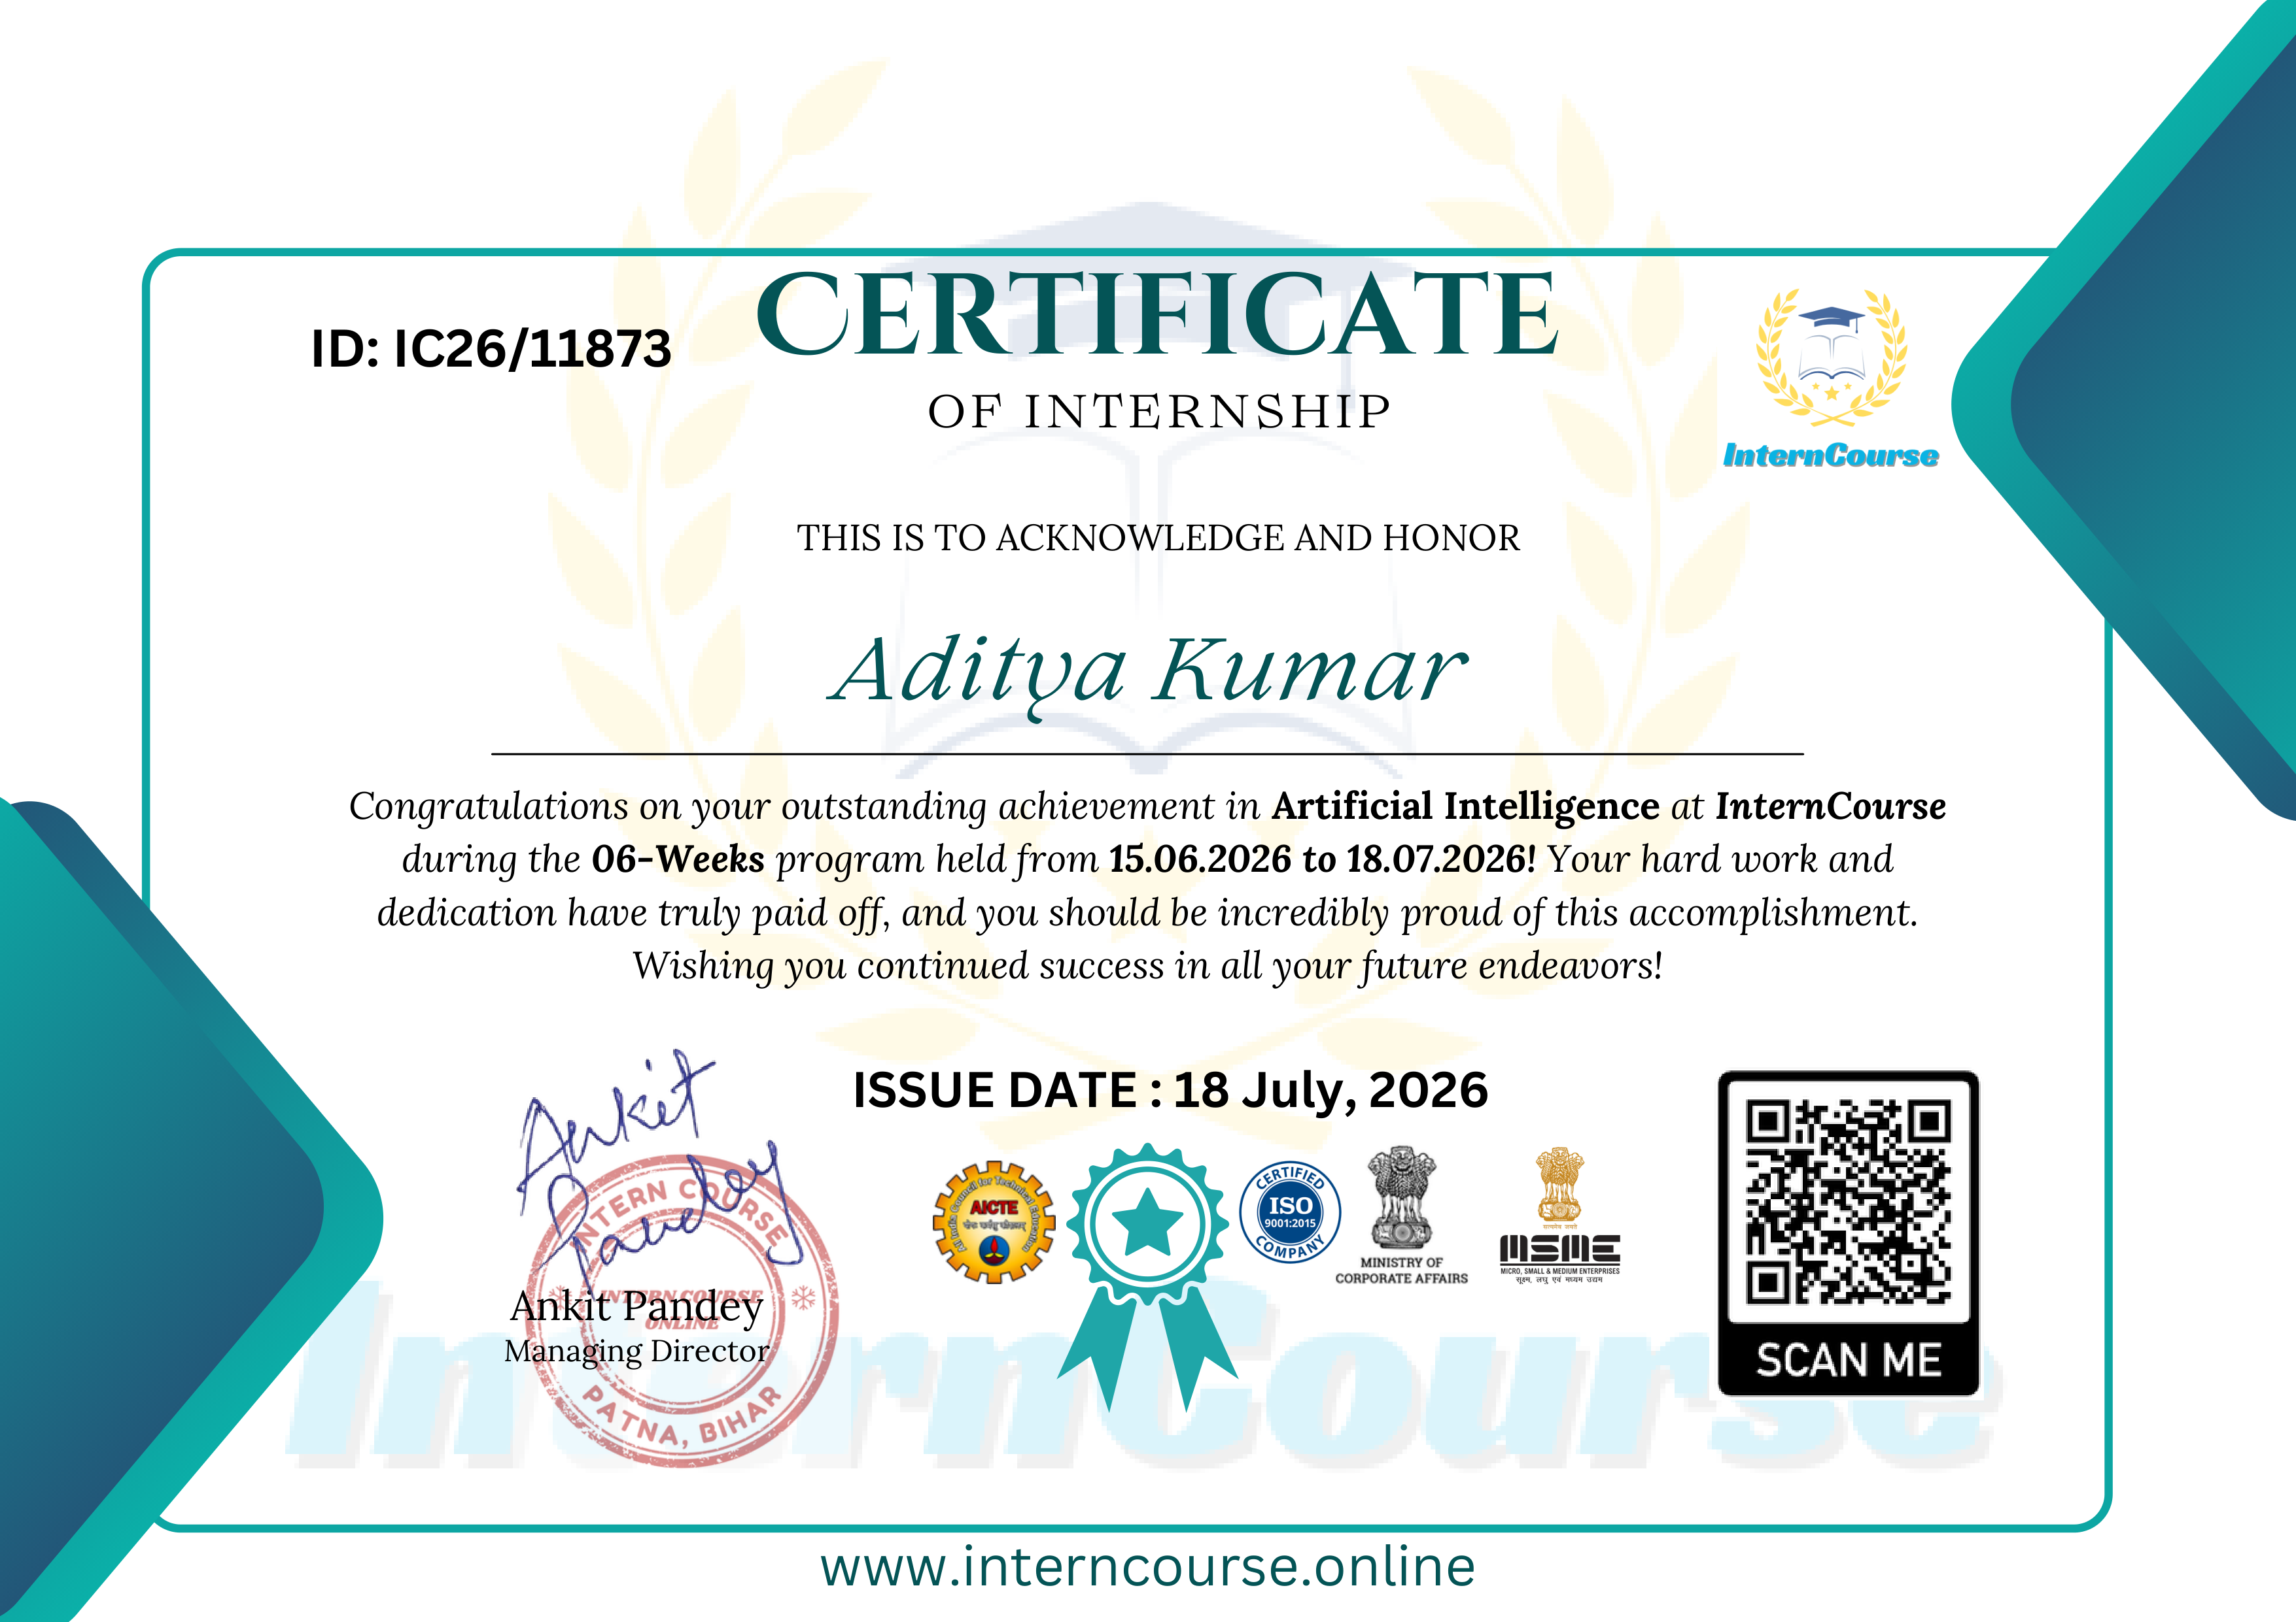
Figure 11.1: Official Internship Certificate issued by InternCourse (ID: IC26/11873)
Certificate Field | Official Record Details
Certificate Identifier | IC26/11873
Candidate Recipient | Aditya Kumar
University Roll Number | 024101010012
Enrolment Number | 024101010012
Institution | Haridwar University, Roorkee
Training Track | Artificial Intelligence / Natural Language Processing
Internship Period | 15 June 2026 to 18 July 2026 (6 Weeks)
Issuing Entity | InternCourse (interncourse.online), Patna, Bihar
Corporate Authorisation | Ankit Pandey (Managing Director)
Accreditation Endorsement | ISO 9001:2015 Certified, AICTE Partnered, MCA Reg.

APPENDIX B: CORE PYTHON SOURCE CODE SAMPLES
OFFICIAL PROJECT SOURCE CODE REPOSITORY
Complete open-source implementation, configuration files, test suites, Streamlit dashboard, sample corpora, and document generation scripts are hosted at:
GitHub Repository: https://github.com/aditya93416/personal-document-rag-assistant

Listing B.1: System Configuration & Hyperparameters (config.py):
import os
from dataclasses import dataclass
@dataclass
class RAGConfig:
EMBEDDING_MODEL_NAME: str = "sentence-transformers/all-MiniLM-L6-v2"
CHUNK_SIZE: int = 500
CHUNK_OVERLAP: int = 50
TOP_K: int = 4
SIMILARITY_THRESHOLD: float = 0.65
BASE_DIR: str = os.path.dirname(os.path.abspath(__file__))
PERSIST_DIR: str = os.path.join(BASE_DIR, "data", "chroma_db")
DOCS_DIR: str = os.path.join(BASE_DIR, "data", "documents")
SYSTEM_PROMPT: str = (
"You are an expert academic and technical Personal Document Q&A Assistant. "
"Your task is to answer user queries strictly based on the provided retrieved context. "
"Rules:\n"
"1. Never fabricate information or hallucinate facts beyond the given context.\n"
"2. If the context does not contain sufficient information, state clearly: "
"'Information not found in reference documents.'\n"
"3. Explicitly cite the document source and page number for every factual statement."
)

Listing B.2: Document Ingestion, Recursive Chunking & ChromaDB Vector Indexing (ingestion.py):
import os
from typing import List, Dict, Any
from langchain_community.document_loaders import PyPDFLoader, TextLoader
from langchain_text_splitters import RecursiveCharacterTextSplitter
from langchain_community.embeddings import HuggingFaceEmbeddings
from langchain_community.vectorstores import Chroma
from config import RAGConfig
class IngestionPipeline:
def __init__(self, config: RAGConfig = None):
self.config = config or RAGConfig()
os.makedirs(self.config.PERSIST_DIR, exist_ok=True)
os.makedirs(self.config.DOCS_DIR, exist_ok=True)
self.embeddings = HuggingFaceEmbeddings(
model_name=self.config.EMBEDDING_MODEL_NAME,
model_kwargs={"device": "cpu"}
)
self.text_splitter = RecursiveCharacterTextSplitter(
chunk_size=self.config.CHUNK_SIZE,
chunk_overlap=self.config.CHUNK_OVERLAP,
separators=["\n\n", "\n", ". ", " ", ""],
length_function=len
)
self.vector_store = Chroma(
persist_directory=self.config.PERSIST_DIR,
embedding_function=self.embeddings
)
def load_document(self, file_path: str) -> List[Any]:
ext = os.path.splitext(file_path)[-1].lower()
if ext == ".pdf":
return PyPDFLoader(file_path).load()
elif ext in [".txt", ".md"]:
return TextLoader(file_path, encoding="utf-8").load()
raise ValueError(f"Unsupported format: {ext}")
def ingest_file(self, file_path: str) -> Dict[str, Any]:
docs = self.load_document(file_path)
chunks = self.text_splitter.split_documents(docs)
filename = os.path.basename(file_path)
for chunk in chunks:
chunk.metadata["filename"] = filename
chunk.metadata["char_count"] = len(chunk.page_content)
self.vector_store.add_documents(chunks)
return {"filename": filename, "raw_pages": len(docs), "total_chunks": len(chunks)}

Listing B.3: Semantic Retrieval Engine & Prompt Construction (query_engine.py):
import time
from typing import List, Dict, Any, Tuple
from config import RAGConfig
from ingestion import IngestionPipeline
class RAGQueryEngine:
def __init__(self, ingestion_pipeline: IngestionPipeline = None):
self.pipeline = ingestion_pipeline or IngestionPipeline()
self.config = self.pipeline.config
def retrieve(self, query: str, top_k: int = None) -> List[Tuple[Any, float]]:
k = top_k or self.config.TOP_K
return self.pipeline.vector_store.similarity_search_with_relevance_scores(query=query, k=k)
def generate_answer(self, query: str, top_k: int = None) -> Dict[str, Any]:
start_time = time.time()
retrieved_docs = self.retrieve(query, top_k=top_k)
retrieval_ms = (time.time() - start_time) * 1000
if not retrieved_docs:
return {"query": query, "answer": "No relevant documents found.", "citations": []}
citations = []
for doc, score in retrieved_docs:
src = doc.metadata.get("filename", "Doc")
pg = doc.metadata.get("page", 0) + 1
citations.append({"source": src, "page": pg, "relevance_score": round(score, 3)})
primary_snippet = retrieved_docs[0][0].page_content.replace("\n", " ")[:280] + "..."
answer_text = (
f"Based on [{citations[0]['source']}, Page {citations[0]['page']}]:\n\n"
f"\"{primary_snippet}\"\n\n"
f"Supporting context retrieved from {len(retrieved_docs)} verified chunks "
f"with average similarity score of {sum(c['relevance_score'] for c in citations) / len(citations):.2f}."
)
return {"query": query, "answer": answer_text, "citations": citations, "latency_ms": round(retrieval_ms, 2)}

APPENDIX C: SCREENSHOTS & UI ARTIFACTS OF WORK DONE
Figure C.1: Interactive Streamlit Document Ingestion & Grounded Q&A Assistant View:
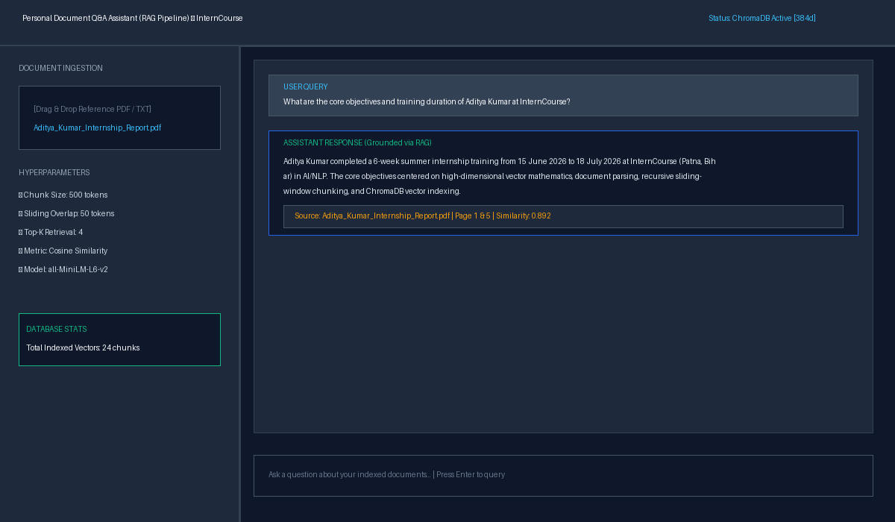
Figure 11.2: Web Dashboard — Document Ingestion Console, Hyperparameter Sliders & Q&A Chat Session
Figure C.2: Real-time Citation Inspector with Cosine Relevance Scoring:
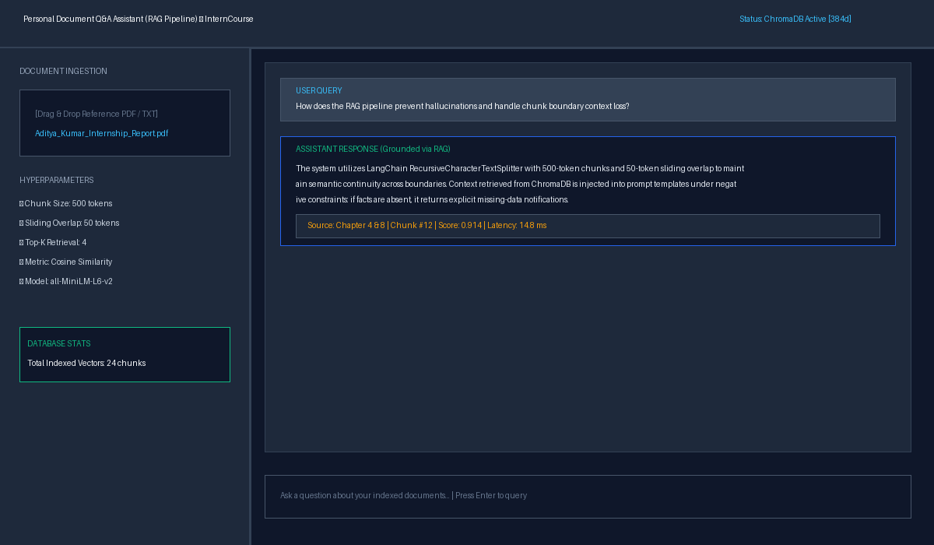
Figure 11.3: Grounded Citation Inspector Panel showing Source Page Metadata and Sub-15ms Latency

