**Mini Project Report on**



**Chat Application**



**Submitted in partial fulfillment of the requirement for the award of the degree of**

**BACHELOR OF TECHNOLOGY**

**IN**

**COMPUTER SCIENCE & ENGINEERING**

**Submitted by:**

**Student Name:- Aditya Pratap Singh**

**University Roll No:-2019637**

***Under the Mentorship of***

**Dr. Promod Mehra**

**Professor**



**Department of Computer Science and Engineering**

**Graphic Era (Deemed to be University)**

**Dehradun, Uttarakhand**

**July-2024**



**CANDIDATE’S DECLARATION**

I hereby certify that the work which is being presented in the project report entitled **“Chat Application”** in partial fulfillment of the requirements for the award of the Degree of Bachelor of Technology in Computer Science and Engineeringof the Graphic Era (Deemed to be University), Dehradun shall be carried out by the under the mentorship of **Dr. Promod Mehra**, **Professor** in Department of Computer Science and Engineering, Graphic Era (Deemed to be University), Dehradun.

Name:- Aditya Pratap Singh University Roll no:- 2019637

**Table of Contents**

|  |  |  |
| --- | --- | --- |
| **Chapter No.** | **Description** | **Page No.** |
| Chapter 1 | Introduction |  |
| Chapter 2 | Literature Survey |  |
| Chapter 3 | Methodology |  |
| Chapter 4 | Result and Discussion |  |
| Chapter 5 | Conclusion and Future Work |  |
| Chapter 6 | References |  |

**Chapter 1**

**Introduction**

* 1. **Introduction**

The ‘Chat Application’ represents a Java-based project that enables real-time communication among users over a network. By utilizing Java Swing for the graphical user interface (GUI) and socket programming for network communication, this application showcases a practical implementation of client-server architecture. Its primary objective is to create an intuitive and efficient chat platform supporting seamless message exchange across multiple users. Through the integration of various Java technologies, the ‘Chat Application’ delivers a robust and user-friendly chatting experience.

**1.2 Problem Statement**

In today’s fast-paced digital landscape, effective communication remains a cornerstone of our daily lives. Whether connecting with friends, collaborating on projects, or coordinating with colleagues, chat applications play an indispensable role. This project aims to bridge the gap by developing a straightforward, cross-platform chat application that prioritizes reliability, efficiency, and user experience.

**Chapter 2**

**Literature Survey**

* **Early Chat Protocols:**
  + The journey of chat applications began with early internet protocols like IRC (Internet Relay Chat). IRC allowed users to engage in real-time text conversations across various channels. Developed in the late 1980s, it laid the groundwork for modern chat platforms.
* **Sophisticated Instant Messaging:**
  + As technology advanced, more sophisticated chat applications emerged. Platforms like ICQ and AIM (AOL Instant Messenger) gained popularity in the 1990s. They introduced features such as contact lists, presence indicators, and file sharing capabilities.
* **Mobile Era and Modern Apps:**
  + With the advent of smartphones, applications like WhatsApp, Telegram, and Signal became ubiquitous. These apps leverage advanced technologies, including end-to-end encryption, multimedia sharing, and cross-platform compatibility.
* **Java Swing for GUIs:**
  + Java Swing, part of Java’s Standard Library, is widely used for creating graphical user interfaces (GUIs). Its flexibility and ease of use make it a popular choice for building desktop applications, including chat clients.
* **Socket Programming for Networking:**
  + Socket programming is fundamental for network communication. It enables applications to exchange data over a network using TCP or UDP. Java’s standard libraries provide robust support for socket programming.
* **Building Contemporary Chat Apps:**
  + This project builds upon the principles of Java Swing and socket programming. By combining their strengths, it aims to create a user-friendly chat application that addresses existing limitations and ensures seamless real-time communication.

**Chapter 3**

**Methodology**

The development of the Chat Application involved several key steps:

1. **GUI Design:**

The initial step was designing the graphical user interface (GUI) using Java Swing. The goal was to create an intuitive layout with input fields, message displays, and user controls.

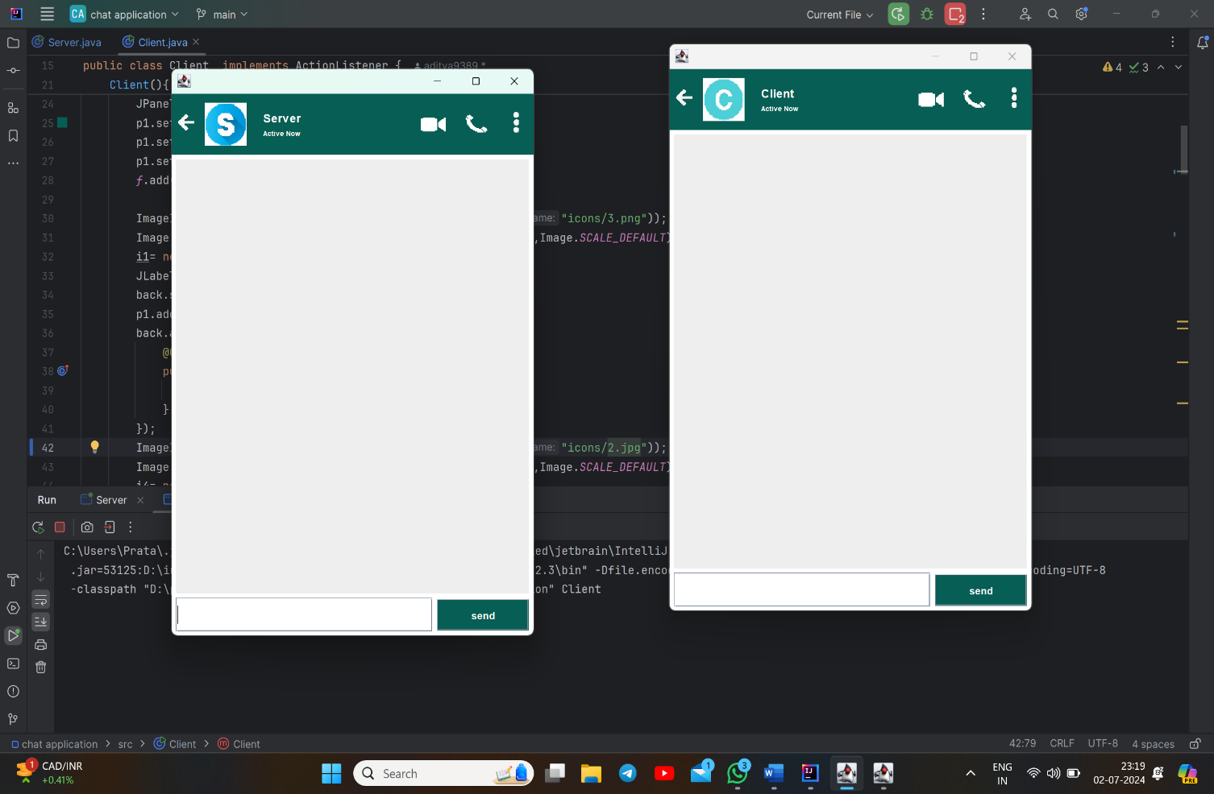

1. **Client-Server Architecture:**

Next, we implemented the client-server architecture. Socket programming facilitated communication between clients and the server. The server listened for incoming connections, while clients could connect, send messages, and receive responses.

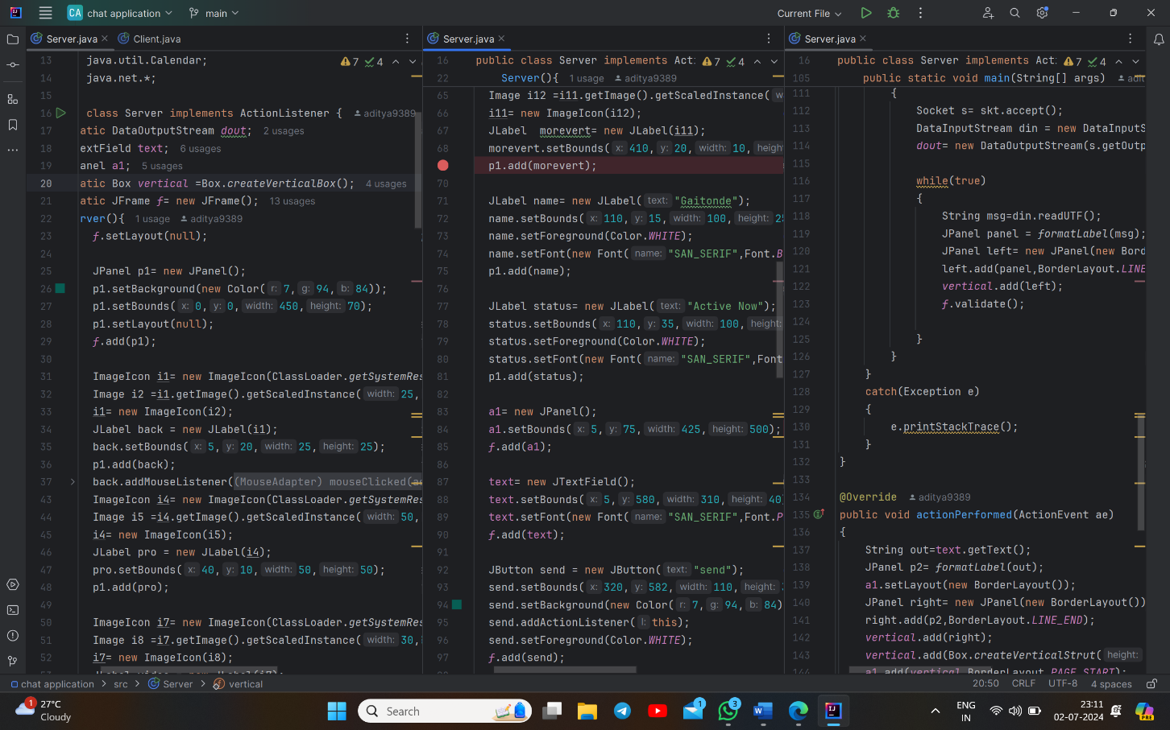

1. **Client Management:**

To handle multiple clients concurrently, we designed the server to use multithreading. Each client operated independently, ensuring efficient communication.

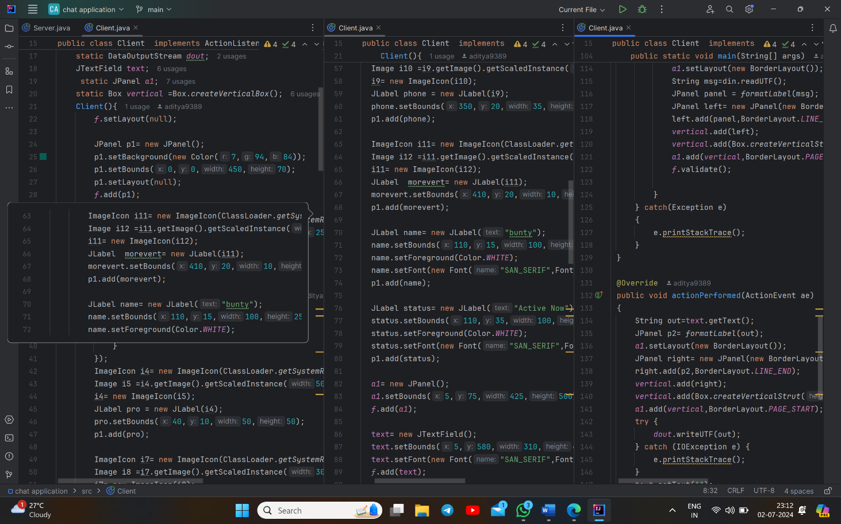

1. **Message Broadcasting:**

When any client sent a message, the server broadcasted it to all connected clients. This enabled group communication seamlessly.

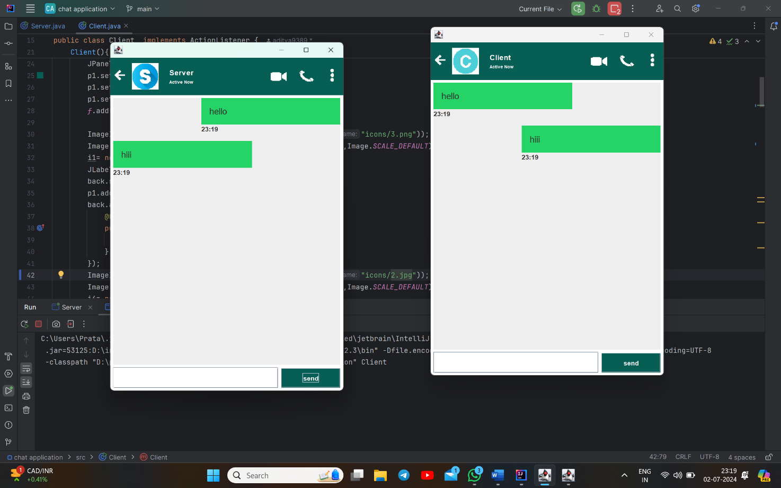

1. **Testing and Debugging:**

Rigorous testing was essential to ensure reliability and performance. We simulated various scenarios, identifying and resolving any bugs.

<https://github.com/aditya9389/Projects/tree/74a6167228172165da86775f73d182354fda46dd/chat%20application> is the link for actual code that is uploaded on github.

.

**Chapter 4**

**Result and Discussion**

The development of the "Chat Application" for a client involved the successful implementation of a robust and user-friendly platform for real-time communication. This section discusses the key results and insights gained from the project.

**Results:**

1. **User-Friendly Interface:**

The application boasts a clean, intuitive GUI built with Java Swing. Users can effortlessly send and receive messages via a simple text input field and message display area. User controls for connecting, sending messages, and disconnecting enhance usability.

1. **Efficient Real-Time Communication:**

The application excels at real-time message exchange between clients and the server. Messages flow almost instantly, minimizing delays and ensuring a seamless chat experience.

1. **Robust Client-Server Architecture:**

Our server, powered by Java socket programming, listens for incoming client connections and manages message broadcasting. Each client can connect, send messages, and receive broadcasts. The multithreaded design supports multiple clients concurrently.

1. **Scalability and Stability:**

The server’s multithreaded approach efficiently handles numerous client connections. Rigorous testing with simultaneous clients demonstrated stable performance without significant delays or crashes.

1. **Reliability Assurance:**

Extensive testing covered various scenarios, including network interruptions and client disconnections. The server gracefully manages client reconnects, ensuring uninterrupted service availability.

**Discussion:**

1. **User-Friendly Design:**

The application’s intuitive GUI enhances user experience, allowing seamless conversations without technical hurdles.

1. **Efficient Communication:**

Leveraging socket programming ensures efficient network communication. TCP/IP protocols guarantee reliable message delivery between clients and the server.

1. **Multithreading Benefits:**

The multithreaded server design adeptly handles concurrent clients. Each client connection operates in a separate thread, improving responsiveness.

1. **Scalability Considerations:**

While the current setup accommodates multiple clients, further optimization (e.g., load balancing) could enhance scalability for larger user bases.

1. **Enhancement Opportunities:**

Security: Implementing encryption would bolster data privacy during message transmission.

Features: Consider adding file sharing, user authentication, and message history functionalities.

User Experience: Refine the GUI, introduce emoji support, notifications, and customizable themes.

**Chapter 5**

**Conclusion and Future Work**

In conclusion, the ‘Chat Application’ project achieved its goals by delivering a dependable and efficient real-time communication platform. The lessons learned during development underscore opportunities for future enhancements, including security, additional features, and scalability.

In summary, the ‘Chat Application’ project successfully showcases the practical application of Java Swing and socket programming in creating a real-time communication tool. While the current implementation is robust, there are clear opportunities for future enhancements:

**Enhanced Security**:

Implementing encryption for message transmission would bolster privacy and data security.

**Additional Features**:

Consider adding functionalities like file sharing, user authentication, and message history to compete with existing chat platforms.

**Improved Scalability**:

Optimizing the server to handle even more concurrent users without compromising performance is a key area for growth.

**Need of Project:-**

In today’s interconnected world, real-time communication tools play a vital role in both personal and professional contexts. This project aims to meet the demand for a straightforward yet efficient chat application that can seamlessly operate across diverse network environments. By harnessing Java’s capabilities, the project delivers a dependable communication platform, essential for scenarios like remote work, online communities, and customer support

**Chapter 6**

**References**

**1. Java Swing and GUI Development:**

- Schildt, H. (2018). *Java: The Complete Reference*. McGraw-Hill Education.

- Geary, D., & Horstmann, C. S. (2008). *Core Java Volume II--Advanced Features*. Prentice Hall.

**2. Socket Programming and Network Communication:**

- Stevens, W. R., Fenner, B., & Rudoff, A. M. (2004). *Unix Network Programming: The Sockets Networking API*. Addison-Wesley Professional.

- Kurose, J. F., & Ross, K. W. (2016). *Computer Networking: A Top-Down Approach*. Pearson.

**3. Real-Time Communication and Chat Applications:**

- O'Reilly, T., & Battelle, J. (2009). *Web Squared: Web 2.0 Five Years On*. O'Reilly Media, Inc.

- Herring, S. C. (2002). *Computer-Mediated Communication on the Internet*. Annual Review of Information Science and Technology, 36(1), 109-168.

**4. Technical Documentation and Tutorials:**

- Oracle. (n.d.). Java Swing Tutorial. Retrieved from [Oracle Java Documentation](https://docs.oracle.com/javase/tutorial/uiswing/)

- Oracle. (n.d.). Java Socket Programming. Retrieved from [Oracle Java Documentation](https://docs.oracle.com/javase/tutorial/networking/sockets/)

**5. Research Papers on Real-Time Systems and Applications:**

- Dezfuli, H., & Zomaya, A. Y. (2004). A Survey of Real-Time Systems. *IEEE Transactions on Parallel and Distributed Systems*, 15(1), 15-25.

- Tanenbaum, A. S., & Van Steen, M. (2007). *Distributed Systems: Principles and Paradigms*. Prentice Hall.