MINI PROJECT-II REPORT

**On**

**Website Development**

**Submitted by**

**Aditya Anal (171500018)**

**Abhishek Kumar(171500009)**

**AAYUSHMAAN RAO (171500001)**

**Submitted to**

**Mr. VINAY AGARWAL SIR**

**(MENTOR)**

Department of Computer Engineering & Applications

**Institute of Engineering & Technology**



**GLA University**

**Mathura- 281406, INDIA**

**2019**

**Department of computer Engineering and Applications**

**GLA University, Mathura**

**17 km. Stone NH#2, Mathura-Delhi Road, P.O. – Chaumuha,**

**Mathura – 281406**



**Declaration**

I hereby declare that the work which is being presented in the Mini project -II “Website Development**”,**in partial fulfillment of the requirements for Mini Project-II viva voce, is an authentic record of my own work carried under the supervision of Mr. Vinay Agarwal Sir,Mentor,GLAU.

Signature Of Candidate:

Name of Candidate: ADITYA ANAL(171500018)

ABHISHEK KUMAR (171500009)

AAYUSHMAAN RAO(171500001)

Course: B.Tech

Year : 3rd

Semester: 6th

**CERTIFICATE**

This is to certify that the mini project report entitled "Website development" submitted by Aditya Anal , Abhishek Kumar and Aayushmaan Rao has been carried out under the guidance of Mr.Vinay Agarwal Sir, Mentor, Department of Computer

Engineering & Applications ,GLA University, Mathura.

**ACKNOWLEDGEMENT**

The project work in this report is an outcome of continuous work over a period and drew intellectual support from various sources. We would like to articulate our profound gratitude to all those people who extended their wholehearted co-operation and have helped me in completing this project successfully.

We are thankful to Mr.Vinay Agarwal Sir for teaching and assisting us in making the project successful. We would also like to thank other fellow mates for guiding and encouraging me throughout the duration of the project.

**ABSTRACT**

The aim of our mini project is to represent our project i.e Website of a Restaurant which permits the clients globally to reserve the room in the hotel at any time. It will provide a unique search and book functionally for the customers anywhere in the world. This project can be used by the clients and the travel agencies who will help them to party in the hotel. The user interface is simple and easy to understand even by the common man. The Project is developed using HTML, CSS, JAVASCRIPT and BOOTSTRAP. The client can do karaoke party and they can also visit our menu section. The project can be reached at any time and anywhere from the world with great efficiency. The main aim of developing this project is to create a static website of the Restaurant.

**TABLE OF CONTENTS**

**CHAPTER 1:- INTRODUCTION**

**1.1 Overview**

**1.2 Objective**

**1.3 Motivation**

**CHAPTER 2:- DESIGN AND APPROACH**

**2.1 Design And Approach**

**2.3 Project Detail**

**2.3.1 Description**

**2.3.2 Language used**

**CHAPTER 3:- PROJECT SPECIFICATION**

**3.1 Hardware specification**

**3.2 Software specification**

**3.2.1 Features**

**3.3 Project details**

**3.3.1 description**

**CHAPTER 4:- SYSTEM DESIGN**

**4.1 Development Environment**

**4.2 Function and Structure Design**

**4.3 Feasibility Analysis**

**4.4 Introduction to website**

**CHAPTER 5:- SOURCE CODE**

**5.1 Index.html**

**5.2 Menu.html**

**5.3 Karaoke.html**

**5.4 Promotion.html**

**5.5 Contacts.html**

**CHAPTER 6:- CONCLUSION**

**6.1 Conclusion**

**6.2 Future Scope**

**CHAPTER 7:-REFRENCES**

|  |  |
| --- | --- |
|  |  |
|  |  |
|  |  |
|  |  |

**CHAPTER 1**

**INTRODUCTION**

**1.1 OVERVIEW:-**

Web programming, also known as web development, is the creation of static web applications. There are two broad divisions of web development – front-end development (also called client-side development) and back-end development (also called server-side development).

Front-end development refers to constructing what a user sees when they load a web application the content, design and how you interact with it. This is done with three codes – HTML, CSS and JavaScript.

HTML, short for [**Hyper Text Markup Language**](https://www.codeconquest.com/tutorials/html/), is a special code for ‘marking up’ text in order to turn it into a web page. Every web page on the net is written in HTML, and it will form the backbone of any web application. CSS, short for [**Cascading Style Sheets**](https://www.codeconquest.com/tutorials/css/), is a code for setting style rules for the appearance of web pages. CSS handles the cosmetic side of the web. Finally, [**JavaScript**](https://www.codeconquest.com/tutorials/javascript/) is a scripting language that’s widely used to add functionality and interactivity to web pages.

Back-end development controls what goes on behind the scenes of a web application. A back-end often uses a database to generate the front-end.

**2.1 OBJECTIVE:-**

The main objective is providing quality content on your **website**, regularly adding new information, establishing trust, marketing your site on other websites and social media. Goal: Improve interaction with existing and potential customers. It also improve customer satisfaction through user experience, then you should consider qualitative research in the form of surveying your customers before and after a redesign.

**2.2** MOTIVATION**:-**

This project will give us hands on practice on Website development. It will also help in understanding HTML, CSS and JAVASCRIPT concepts better and provide us the experience of developing the website.

**Chapter 2**

**DESIGN AND APPROACH**

The new technologies have completely changed the dynamics of the web-designing. The desktop-only approach got morphed into the desktop-first approach and has finally got transformed into the mobile-first approach.

The rapid increase in the number of web users on mobile applications calls for an overhaul of the way websites are designed thus making space for new models to take centre-stage. Any website which is not equally accessible on the mobile interface is all set to be phased out.

The new techniques and approaches to web-designing not only factor in the current sensitivities but also the changes which are likely to happen in foreseeable future. The most promising trends in the web-designing arena which are likely to sustain in 2019 are the ones which will continue to innovate and embrace the latest breakthroughs with ease.

This Website of hotel will play an important part in keeping overall web developing experience Consistent and enjoyable .

**2.1 LANGUAGE USED:-**

**a. HTML** :-

Hypertext Markup Language (HTML) is the standard markup language for documents designed to be displayed in a web browser. It can be assisted by technologies such as Cascading Style Sheets (CSS) and scripting languages such as JavaScript. HTML elements are the building blocks of HTML pages. With HTML constructs, images and other objects such as interactive forms may be embedded into the rendered page. HTML provides a means to create structured documents by denoting structural semantics for text such as headings, paragraphs, lists, links, quotes and other items. HTML elements are delineated by tags, written using angle brackets. Tags such as <img /> and <input /> directly introduce content into the page. Other tags such as <p> surround and provide information about document text and may include other tags as sub-elements. Browsers do not display the HTML tags, but use them to interpret the content of the page.

**b. CSS :-**

Cascading Style Sheets (CSS) is a style sheet language used for describing the presentation of a document written in a markup language like HTML.CSS is a cornerstone technology of the World Wide Web, alongside HTML and JavaScript. CSS is designed to enable the separation of presentation and content, including layout, colors, and fonts.[3] This separation can improve content accessibility, provide more flexibility and control in the specification of presentation characteristics, enable multiple web pages to share formatting by specifying the relevant CSS in a separate .css file, and reduce complexity and repetition in the structural content. Separation of formatting and content also makes it feasible to present the same markup page in different styles for different rendering methods, such as on-screen, in print, by voice (via speech-based browser or screen reader), and on Braille-based tactile devices. CSS also has rules for alternate formatting if the content is accessed on a mobile device.The name cascading comes from the specified priority scheme to determine which style rule applies if more than one rule matches a particular element.

**c. JAVASCRIPT:-**

JavaScript often abbreviated as JS, is a programming language that conforms to the ECMA Script specification. JavaScript is high-level, often just-in-time compiled, and multi-paradigm. It has curly-bracket syntax, dynamic typing, prototype-based object-orientation, and first-class functions. Alongside HTML and CSS, JavaScript is one of the core technologies of the World Wide Web.[8] JavaScript enables interactive web pages and is an essential part of web applications. The vast majority of websites use it for client-side page behaviour, and all major web browsers have a dedicated JavaScript engine to execute it.

As a multi-paradigm language, JavaScript supports event-driven, functional, and imperative programming styles. It has application programming interfaces (APIs) for working with text, dates, regular expressions, standard data structures, and the Document Object Model (DOM). However, the language itself does not include any input/output (I/O), such as networking, storage, or graphics facilities, as the host environment (usually a web browser) provides those APIs.JavaScript engines were originally used only in web browsers, but they are now embedded in server-side website deployments, usually via Node.js. They are also embedded in a variety of applications created with frameworks such as Electron and Cordova. Although there are similarities between JavaScript and Java, including language name, syntax, and respective standard libraries, the two languages are distinct and differ greatly in design.

**Chapter 3**

**Project Specification**

**3.1 Hardware Specification:-**

* CPU Speed : 2GHz recommended or higher
* Processor : Pentium Processor or above
* Memory/RAM : 1GB minimum,2GB recommended or higher
* Display Properties : Greater than 256 color depth
* Size of Hard Disk : 60GBminimum
* NIC Card : NIC Card

**3.2 Software Specification:-**

* Software Used : Bootstrap
* Operating System : Windows XP(and above)

**3.2.1 Bootstrap:-**

Bootstrap  Is a  free and open-source  CSS framework  directed at responsive,  mobile-first front-end web development. It contains  CSS - and (optionally)  JavaScript - based design templates for  typography,  forms,  buttons,  navigation, and other interface components. Mark Otto announced Bootstrap 4 on October 29, 2014. The first alpha version of Bootstrap 4 was released on August 19, 2015.The first beta version was released on 10 August 2017. Mark suspended work on Bootstrap 3 on September 6, 2016, to free up time to work on Bootstrap 4. Bootstrap 4 was finalized on January 18, 2018. Bootstrap is a web framework that focuses on simplifying the development of informative web pages (as opposed to web apps). The primary purpose of adding it to a web project is to apply Bootstrap's choices of color, size, font and layout to that project. As such, the primary factor is whether the developers in charge find those choices to their liking. Once added to a project, Bootstrap provides basic style definitions for all HTML elements. The result is a uniform appearance for prose, tables and form elements across web browsers. In addition, developers can take advantage of CSS classes defined in Bootstrap to further customize the appearance of their contents. For example, Bootstrap has provisioned for light- and dark-colored tables, page headings, more prominent pull quotes, and text with a highlight.

**3.2.2 Features:-**

Bootstrap is a web framework that focuses on simplifying the development of informative web pages (as opposed to web apps). The primary purpose of adding it to a web project is to apply Bootstrap's choices of color, size, font and layout to that project. As such, the primary factor is whether the developers in charge find those choices to their liking. Once added to a project, Bootstrap provides basic style definitions for all HTML elements. The result is a uniform appearance for prose, tables and form elements across web browsers. In addition, developers can take advantage of CSS classes defined in Bootstrap to further customize the appearance of their contents. For example, Bootstrap has provisioned for light- and dark-colored tables, page headings, more prominent pull quotes, and text with a highlight.

Bootstrap also comes with several JavaScript components in the form of jQuery plugins. They provide additional user interface elements such as dialog boxes, tooltips, and carousels. Each Bootstrap component consists of an HTML structure, CSS declarations, and in some cases accompanying JavaScript code. They also extend the functionality of some existing interface elements, including for example an auto-complete function for input fields.

A precompiled version of Bootstrap is available in the form of one CSS file and three JavaScript files that can be readily added to any project. The raw form of Bootstrap, however, enables developers to implement further customization and size optimizations. This raw form is modular, meaning that the developer can remove unneeded components, apply a theme and modify the uncompiled Sass files.

**3.3 PROJECT DETAIL**

**3.3.1 Description:**

This is a website of a restaurant where the customer can see the menu of the restaurant online and can also do karaoke party. The user interface of the website is very simple and can be used by anyone.

It is simple to use and not at all complex like other website.

**3.3.2 DEVISE USED**

1. LAPTOP
2. ANDROID SMARTPHONE
3. DATA CABLE

**Chapter 4**

**SYSTEM DESIGN**

**4.1 DEVELOPMENT ENVIROMENT**

The keyword environment usually refers to a number of things, rather than just a single one. I mentioned a word about all this stuff in one of my previous articles. IMHO, we can safely differentiate at least 4 groups in our dev-env:

1. Operating System - the most general part of our env, can greatly impact the availability of our other tools.
2. Code editor / IDE - essential for every programmer, with a number of additional functionalities, it can both boost, but also decrease one's productivity if not chosen correctly.
3. Browser - the most important part of web development workflow, useful for accessing knowledge, testing and having fun
4. Other tools - there's definitely plenty more tools, which can differ because of the developer's preference. Every additional piece of software, browser extensions, GIT-tools, services, and standard/often-used libraries find their place here.
   * 1. OPERATING SYSTEM

An **Operating System** (OS) is an interface between a computer user and computer hardware. An **operating system** is a software which performs all the basic tasks like file management, memory management, process management, handling input and output, and controlling peripheral devices such as disk drives and printers.

* + - 1. WINDOWS

Microsoft Windows, commonly referred to as Windows, is a group of several proprietary graphical operating system families, all of which are developed and marketed by Microsoft. Each family caters to a certain sector of the computing industry. Active Microsoft Windows families include  Windows NT and  Windows IoT; these may encompass subfamilies, e.g. Windows Server or Windows Embedded Compact (Windows CE).

* + - 1. MacOs

MacOS is an operating system designed by Apple. The operating system is what allows you to use a computer. macOS comes preloaded on all new Apple Macintosh computers (commonly known as Macs).macOS makes it possible to complete all kinds of everyday tasks on your computer. For example, you can use it to browse the Internet, check your email, edit digital photos, listen to music, and play games.

* + 1. CODE EDITOR

A source-code editor is a text editor program designed specifically for editing source code of computer programs. Source-code editors are a fundamental programming tool, as the fundamental job of programmers is to write and edit source code.

* + - 1. WEB STORM

WebStorm is a powerful IDE for modern JavaScript development. WebStorm provides full support for JavaScript, TypeScript, HTML, CSS as well as for frameworks such as React, Angular, and Vue.js right out of the box, no additional plugins are required.Besides client-side applications, WebStorm helps you develop server-side applications with Node.js, mobile apps with React Native or Cordova, and desktop apps with Electron. Note that having Node.js is highly recommended although the core WebStorm features are still at your disposal without it.

* + - 1. NOTEPAD++

Notepad++ is a free (as in “free speech” and also as in “free beer”) source code editor and Notepad replacement that supports several languages. Running in the MS Windows environment, its use is governed by GPL License. Based on the powerful editing component Scintilla, Notepad++ is written in C++ and uses pure Win32 API and STL which ensures a higher execution speed and smaller program size. By optimizing as many routines as possible without losing user friendliness, Notepad++ is trying to reduce the world carbon dioxide emissions. When using less CPU power, the PC can throttle down and reduce power consumption, resulting in a greener environment.

**4.3 FEASIBILITY ANALYSIS**

This section verified that it is feasible to add the website over the internet from the aspects of economic, technical and social feasibility.

**Economic feasibility**

Recently, Web-based Project Management (WPM) systems attracted a significant number of construction industry applications worldwide. These implementations, actual and potential, pushed many construction companies to the front of WPM investment decision-making. This paper reviews IT investment evaluation methods and concludes that a single economic analytical method or a simple combination thereof is insufficient to justify or decline an

investment in WPM. To fulfil the practical need of many construction companies to implement WPM systems, the paper puts forward a multidimensional decision-making approach that the authors believe is closer to the style of decision-making in the construction business world.

**Technical feasibility**

Technical feasibility To design a web-based project which meets the basic requirements, a deep understand of HTML, CSS and JAVASCRIPT language the ATOM development tools, SQLlite databases, application of framework and other technical knowledge are needed.(framework is the core of the application, and rules that all the programmers participating in the development must abide by). Based on the related technology information and resources for website on the market, and equipped with technical personnel of technology and the spirit of willing to learn, the technology is feasible.

**Social feasibility**

An appraisal exercise intimately connected with the evaluation of environmental feasibility is the assessment of the project’s impact on the lives of people that live and work in the project’s area of influence. The social impact analysis (or social feasibility assessment) can be a very important part of the general appraisal of PPP projects, since many infrastructure initiatives cause severe adverse impacts on communities surrounding the site on which they are implemented. Social impact analysis is an exercise aimed at identifying and analyzing such impacts in order to understand the scale and reach of the project’s social impacts. It also ensures that these impacts are mitigated, to the extent possible, and fully considered in the green light decision. Social impact analysis greatly reduces the overall risks of the project, as it helps to reduce resistance, strengthens general support, and allows for a more comprehensive understanding of the costs and benefits of the project.

However, social impact analysis can be expensive and time consuming, so the full analysis process cannot be justified for all projects. At a minimum, all projects demand a review of project data at the Appraisal Phase, so as to identify if material social impacts exist. If they do, a full social impact analysis should be conducted.

**4.5 INTRODUCTION TO WEBSITE OF A RESTAURANT**

In this section, the Starting module of the website in the project is introduced, as well as the Website engineering program structure, etc. Creating a website that revolves around a particular restaurant would be very interesting. Often times the website contains more than just information, it contains very appealing pictures of food. Many restaurants include their menus online to attract more customers. In order to place their menus online a website designer is required many times. Designing a website in the food business can be lots of fun, however it will require maintenance. As the food prices and menu change so will the website. Many restaurants even allow the customers to place orders online to allow easy access and boost their sales. According to Derek Gehl, the CEO of the Internet Marketing Center, “Instead of trying to please everyone who visits your site by offering a large range of products with minimal detail about each one, if you offer just one product-or one set of related products-you can really focus on one key set of benefits and answer all the possible questions and doubts your visitors might have about your product.”

**The project mainly contain of 5 section:-**

1. **INDEX PAGE** :-

In this section complete information about the restaurant is given i.e what are the specialities of the restaurant. They are:-

1. Known For Service - We are committed to provide you with an exceptional dining experience every time you walk through our door.
2. Modern Asian Dining - We offer authentic Chinese and Asian cuisine from the different parts of China and the Far East.
3. A Harmonious Taste - Our chefs understand that the secret of good taste lies largely in the freshness of the ingredients and creating a harmionious combination of tastes.
4. **MENU PAGE :-**

In this section complete information about the menu of the restaurant is given.It is a list of food and beverages offered to customers and the prices. It  may be à la carte – which presents a list of options from which customers choose – or table d'hôte, in which case a pre-established sequence of courses is offered. Customer can visit this page and can check the item available in the restaurant and also their price.

1. **KARAOKE/PARTY PAGE:-**

Zaika restaurant offer several Karaoke rooms which can be adequately accommodate 10 to 45 people. And a lavish set menu is on offer, items for which are chosen by our accomplished chef for both dine in and outdoor catering. Here the customer can visit the photo section where they can see the photos of the previous guest having fun in the karaoke/party organized by our team.

1. **PROMOTIONS/EVENTS :-**

In this section customer can book the restaurant for promotions/events if they want to organized and they can accordingly contact with our team. All complete information regarding the promotion/event booking is available in this section.

1. **CONTACT PAGE:-**

In this section customer can contact us for any purpose through contact number or email or they can simply leave their detail i.e name, contact number, address and our team will contact them as soon as possible for their help and clearing all their doubt. Here the customer can also see a map which points towards the exact location of our restaurant in case if they are new to the place.

**CHAPTER-5**

**SOURCE CODE**

**1.INDEX.HTML:-**

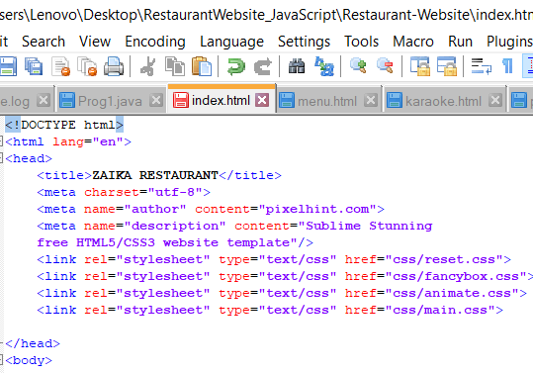

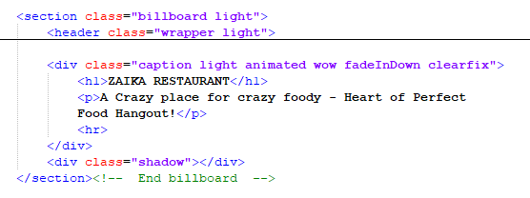

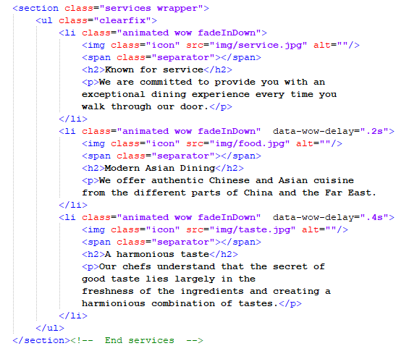

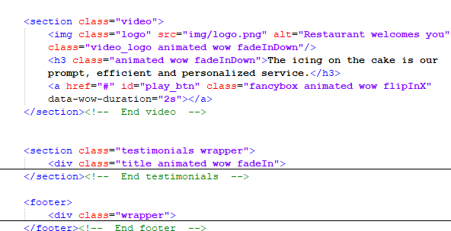

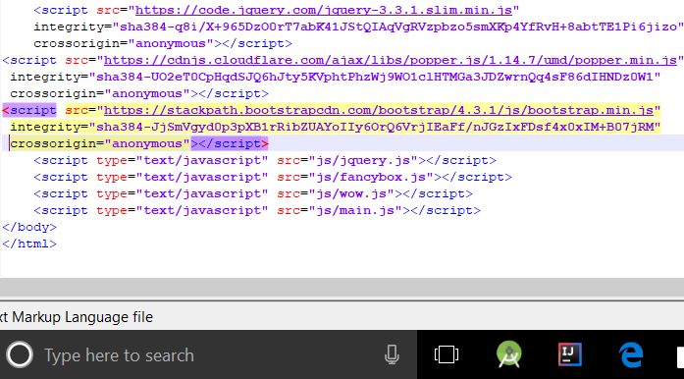

2. MENU.HTML:-

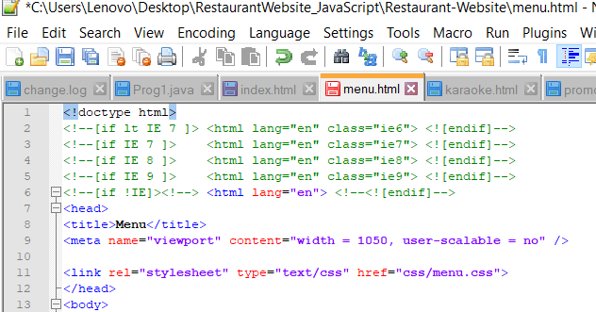

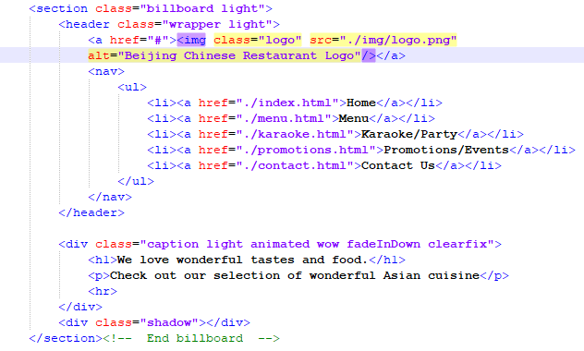

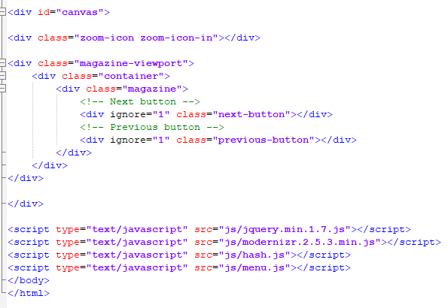

3.KARAOKE.HTML:-

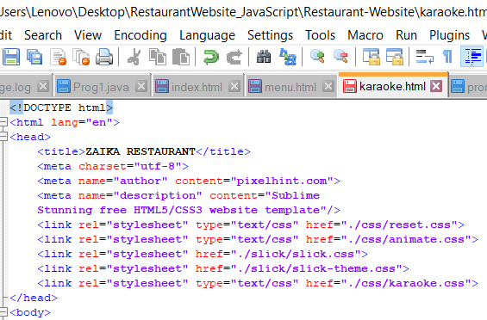

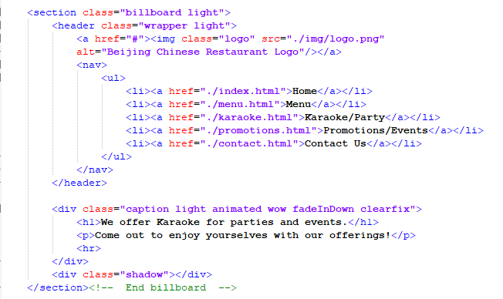

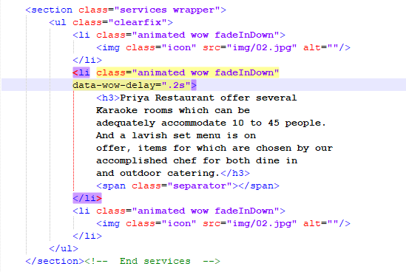

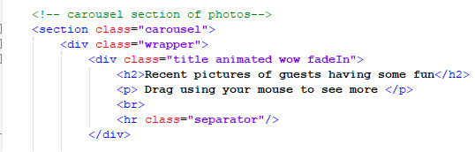

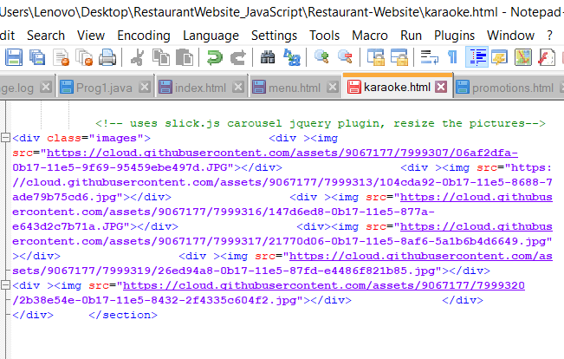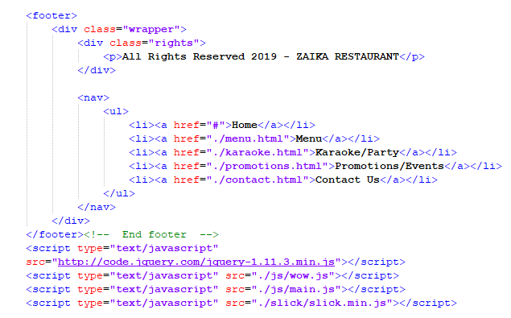

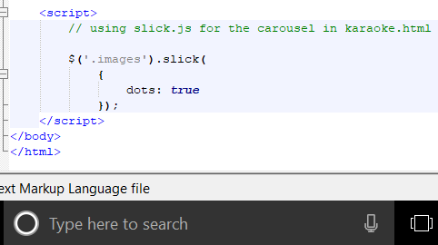

4.PROMOTIONS.HTML:-

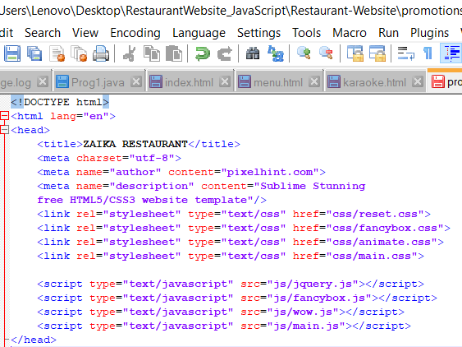

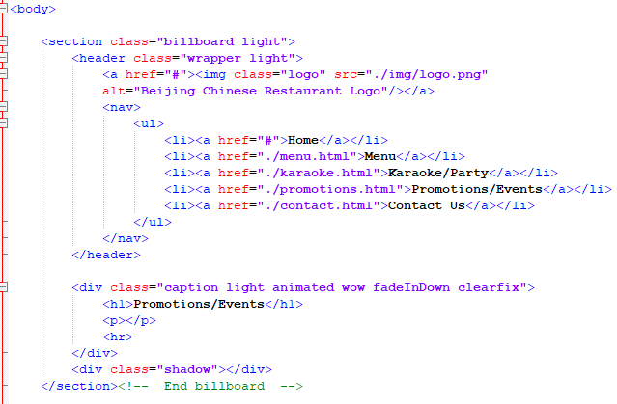

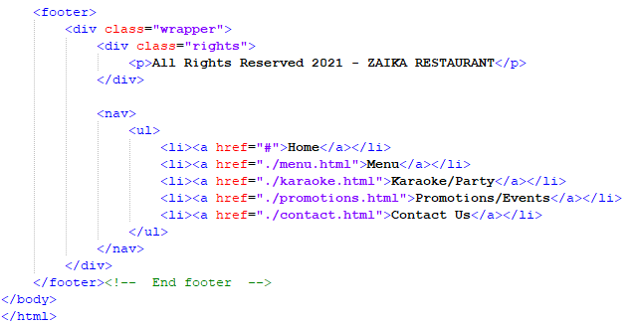

5.CONTACT.HTML:-

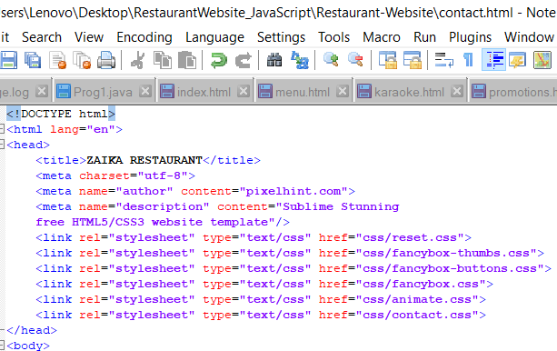

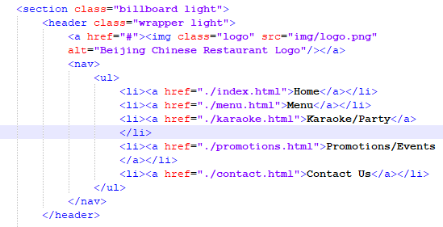

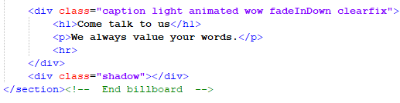

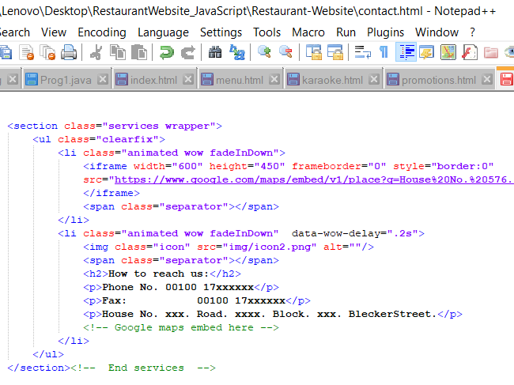

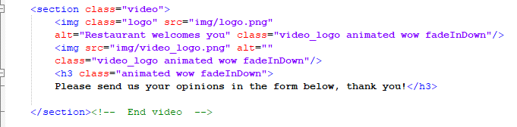

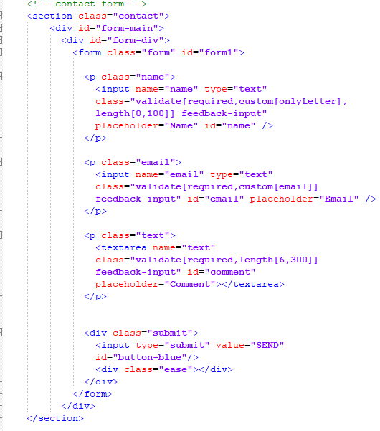

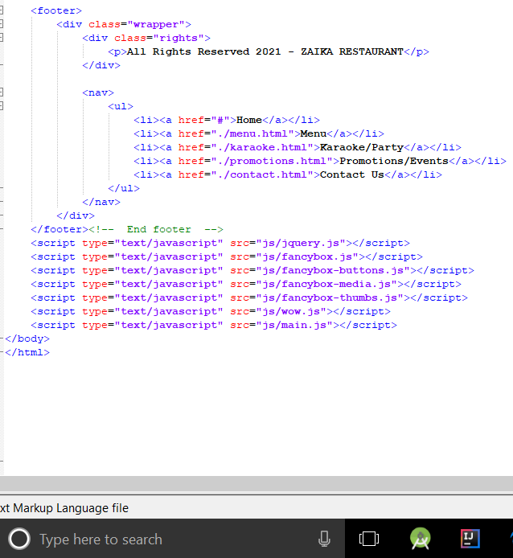

**CHAPTER-6**

**Conclusion**

Through this hands-on project was able to see how well we understood the material presented, and our critical thinking as you developed the restaurant site. We were also able to learn our creative side, through the layout and design of your project. As a team we were able to use your problem-solving skills to troubleshoot errors when something did not work the way you intended. Knowing basic HTML is a skill that will help you with blogging, working with Wiki's, Facebook, and much more.

Websites are playing important part in improvement of business. 70% of the population is using dynamic and interactive websites because of their eye capturing visual effects. Static websites also have their own place for the platform where there is specific information required.

Not only we have learned the design aspects of web development, but we have also learned how to program in HTML, CSS and JAVASCRIPT. Through evaluating many different web sites, we are aware of what is effective and ineffective to viewers when designing a website too.

**FUTURE SCOPE:-**

For any business, a website matters more than anything, when it comes to reaching out to customers online. A website is the representation of the business online. These days, every business realizes the need for having a website and are putting in efforts to design and develop the best site for taking their products or services online. This is where we can see a great deal of scope for web development and design.

With the tremendous progress in the launch of websites, people who can create exemplary designs and platforms for their online presence is what businesses are searching for. Web developers and designers are bringing in all the best of their technical expertise and skills to develop and unique design websites that are and capable of pulling the crowd.

**CHAPTER 7**

**REFERENCES**

**1.www.youtube.com**

**2.www.internshala.com**

**3.www.udemy.com**

**4. www.stackoverflow.com**