|  |
| --- |
|  |

**Kinematics**

In this section the kinematics representation used for the simulation will be briefly descripted. The quaternions method has been chosen to describe the kinematics of this model, they represent a way to parametrize the attitude of a rigid body in space. They are commonly used for control purpose due to the fact that they don't have kinematics singularities.

A quaternion is a four-component vector with some additional operations defined on it. A quaternion has a three-vector part and a scalar part. The kinematic equation for the quaternion can be written as :

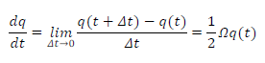

where OM is defined as

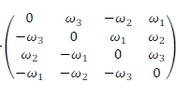

By integrating this equation, knowing the angular velocities, it is possible to achieve the full attitude at every iteration in terms of quaternion. The initial condition is a direction cosine matrix expressed as:

A_BN_0 = [1/3, 2/3, 2/3;

2/3, 1/3, -2/3;

-2/3, 2/3, -1/3];

This matrix represents an initial random orientation of the spacecraft.

In the kinematics it has also been computed the orbit propagation, in particular the evolution of three values during time:

1) r_B: vector pointing the spacecraft during the orbit, expressed in body frame.

2) n: mean angular velocity of the spacecraft during orbit.

3) theta: true anomaly of the spacecraft.

Finally, the kinematics block has also as output the matrices A_LN and A_BL, representing respectively the orientation between Local-Vertical-Local-Horizontal frame and Inertial frame and the orientation between body frame and Local-Vertical-Local-Horizontal frame. These two matrices will be used later.

**Dynamics**

The dynamics of a rigid body which is tumbling into space can be modelled by mean of the well-known Euler equations, referring to the body frame:



where om is the angular velocity vector of the spacecraft in body frame, I is the inertia tensor of the spacecraft in body frame and M are the external torques acting on the spacecraft due to external disturbances and control torques. On a satellite there are torques that directly influence the dynamics (Euler equations) and induce changes in the components of angular velocity. Adopting one attitude parameterization it is possible, by knowing the angular velocity, to calculate the attitude parameters that indicate the orientation of the satellite in space and that allow to evaluate the position-dependent torques.

**Gravity Gradient**

The gravity field is not uniform, therefore there could be a torque acting on the satellite. This is mainly true for large satellites, and even if the resulting torque is small the effect can be considerable due to the long-time of action. Furthermore, the spacecraft has one side closer to the Earth than the other side. If we consider a rigid spacecraft, the torque due to the gravity gradient about the spacecraft's center of mass can be modelled, in the body frame, as:

where mu is the Earth's gravitational constant, R is the radius vector from the center of the Earth, [Ix, Iy, Iz] are the principal inertia moments of the spacecraft and [c1, c2, c2] are direction cosines of the radial direction in the principal axes

**Magnetometer**

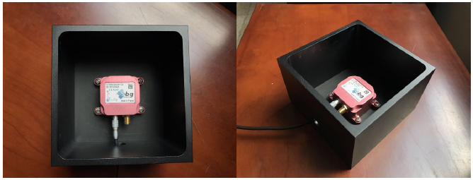

Magnetometers can provide the measurement of the direction of the magnetic field in the body frame, they have no moving parts and do not require a clear field of view. They measure the sum of the ambient field that is of interest and any local fields produced by the spacecraft. Local fields can be produced by ferromagnetic materials or by current loops in solar arrays, electric motors, payload instruments, or most especially attitude control torquers. If the local fields are known, they can be compensated for. If they are not known, the magnetometers can be located far from the sources of magnetic contamination, on a deployable boom. They do require a well-modelled magnetic field if they are to be used as attitude sensors. The magnetometer chosen for this report is an IG-500N with the following specifications:

Measurement Range: ± 1.2 Gauss

Non Linearity Error: 0.2%

Noise Density: 0.01 mG/√ Hz

Sampling Rate: 18Hz

Pointing Accuracy: 0.5°

Power: 750 mW

Weight: 85 g

Dimensions: 94 x 15 x 13 mm

The equation of the magnetometer output in the body frame is given by : b_B = A_BN* * b_N. The magnetometer has been modelled considering a small error to take into account the possible misalignment between the true principal axis of the spacecraft and the mounting axis of the magnetometer itself, plus a withe gaussian noise to take into account the noise present on a real magnetometer, and a scale factor error to consider an overestimation of the characteristic of the model.

A_BN* = A_BN*A_eps*A_no*A_noise

where :

A_scalefactor =

A_nonorto =

A_noise =

Finally it has been chosen an RC low pass filter, in order to filtered the highest frequency and to give a smooth signal to the onboard computer.

**Target Tracking**

The mission required from the customer is to perform Earth pointing. By defining a desired pointing vector 𝛤𝑑 expressed in the inertial reference frame, and calling 𝛤̱ the same vector expressed with respect to the body frame, it is possible to compute the control action as:



This control asymptotically converges to the desired pointing direction 𝛤𝑑.

References:

-note Bernelli part 1, 2,3

-http://www.seismic.com.au/assets/pdf/SBG_Systems-IG_500N_Brochure.pdf

-https://www.mdpi.com/1424-8220/17/6/1223