Customer Loan Approval Prediction

Abstract
This report evaluates Machine Learning models for predicting loan approval based on customer profiles. Using Random Forest, SVM, Logistic Regression, and Gradient Boosting, we aimed to accurately classify potential loan defaults vs approvals.

Dataset Overview
Total samples: 2000
Number of features: 7
Target variable distribution:
Loan_Approved
0 1658
1 342

Data Preprocessing
Missing values were handled via median/mode imputation. Categorical features were encoded using Label Encoding. Feature scaling was performed using StandardScaler. SMOTE was applied to address class imbalance in the training data.

Model Comparison and Evaluation Metrics
Rank | Model | Accuracy | Precision | Recall | F1 Score
1 | Random Forest | 1.000 | 1.000 | 1.000 | 1.000
1 | Gradient Boosting | 1.000 | 1.000 | 1.000 | 1.000
3 | SVM | 0.975 | 0.939 | 0.912 | 0.925
4 | Logistic Regression | 0.880 | 0.591 | 0.956 | 0.730

Visualizations
Metrics Comparison:
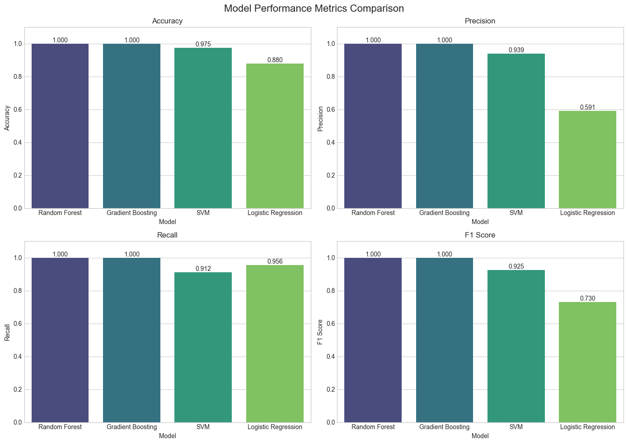
ROC Curves:
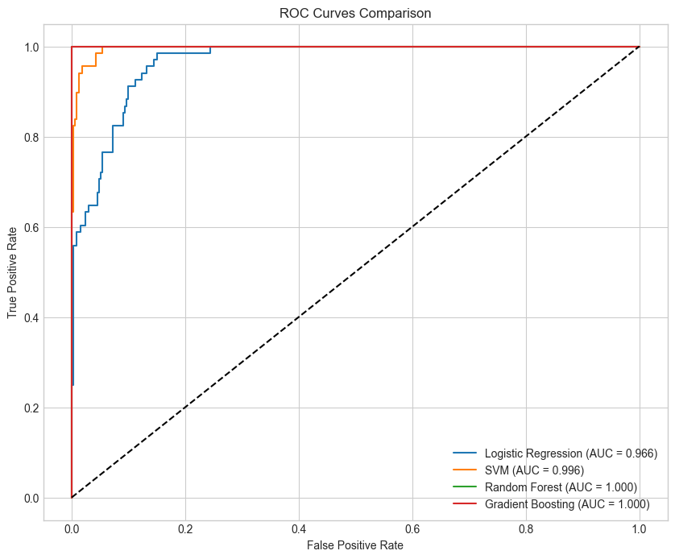
Confusion Matrices:
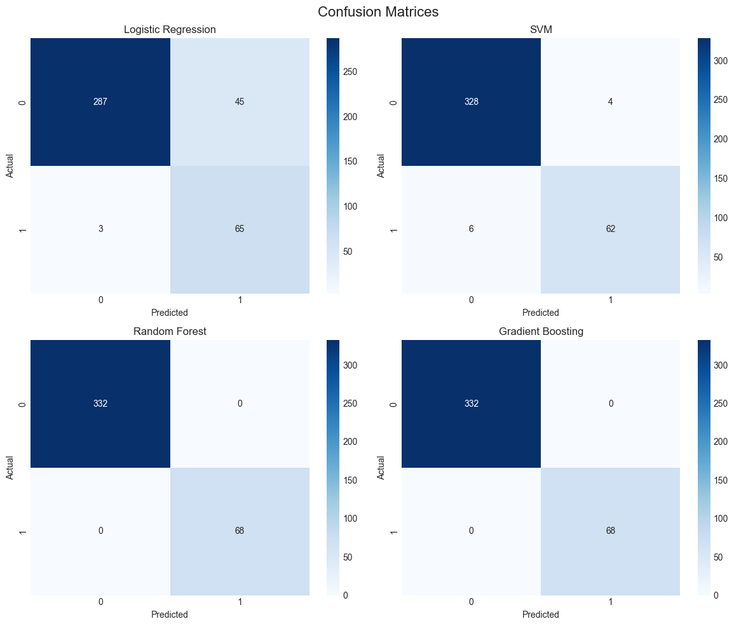
Feature Importance:
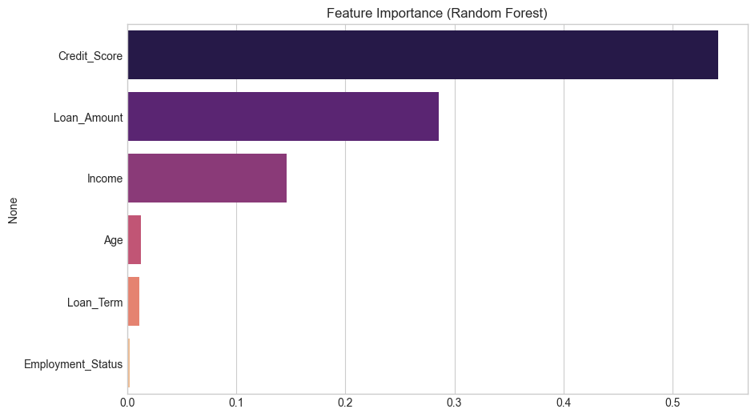

Results Interpretation & Conclusion
The Random Forest model performed best overall based on the evaluation metrics. Random Forest models naturally capture non-linear interactions between features and are highly robust against overfitting, which makes it ideal for financial predictive modeling. Gradient Boosting also exhibits strong capability, but the top-ranked model demonstrates the optimal balance of Precision and Recall.

Future Improvements
Recommendations for future enhancements include gathering more external data (like macroeconomic indicators), creating domain-specific feature engineering (e.g., debt-to-income ratio), and deploying the model as a real-time API. Additional ensemble methods and Deep Learning approaches like TabNet could be explored for further accuracy improvements.

