Customer Commitment

In 2023

Wells Fargo

Strategic Business Communications Consultants, LLC

(SBCC, LLC)

February 20th, 2023

# Table of Contents

**Table of Contents** **1**

Road to Recovery 2

Objective and Focus 2

Proceedings 2

Audit and Analysis 2

Findings of the Analysis 5

Interpretation of the Findings 6

Recommendations for Improvement 6

Preliminary Next Steps 8

**Appendix** **A-1**

1 - Audit Checklist A-2

2 - List of Communications A-2

## 

## Road to Recovery

Wells Fargo has evolved and innovated since its inception in 1852 in order to support its customer’s needs. We at SBCC, LLC believe in that mission and have evaluated the situation since the 2016 cross-selling issues to help you determine the best approach going forward in 2023. The unauthorized customer account problems have had a severe impact on the company's reputation and resulted in substantial fines and compensation to customers. While the final fines were paid in December 2022 and you have made great strides in trying to recover, we believe there are a few weaknesses to be repaired, and strengths to be leveraged.

### Objective and Focus

As we understand it, Wells Fargo’s objectives are to be the leader in financial services in areas of team member engagement, customer services and advice, shareholder value, innovation, corporate citizenship, and risk management. We have kept these objectives in mind as we reviewed the top level communications from public and investor relations from 2016-2022. For Wells Fargo to succeed going forward, we completed this audit to focus your strategy toward what have determined to restore trust and credibility in the company among the customers:

To provide transparent and accurate information about the past issues, how it was addressed, and to demonstrate the company's commitment to ethical business practices and customer satisfaction.

By improving upon your transparency, Wells Fargo can regain the trust of its current customers and maintain its position as a leading financial institution. The improvement in reputation will instill confidence in the general market, attracting new customers. The additional revenue from the new customers will lead to shareholder satisfaction and lead to better availability of services provided by the company.

### Proceedings

SBCC will address the methodology and analysis performed for this communication audit. This will include any trends we have found and the averages in the data. We scored the communications and we will discuss what those scores mean. Then we will talk about the strengths and weaknesses that the analysis has uncovered in our findings as well as opportunities and threats that must be addressed. Conclusions extrapolated from these findings will be laid out followed by our recommendations going forward. The following strategy implementation will be what SBCC believes is best for Wells Fargo.

## Audit and Analysis

The methodology used for the analysis of the data collected from the communications of Wells Fargo to the past, present, and future customer audience involved several steps. First, all the communications were gathered and rated based on a pre-decided checklist (1-5) for the questions related to the communicator, message, and delivery. Next, the mean scores were calculated for individual communications and then combined based on each prompt. A correlation analysis was performed using the excel CORREL function to determine the relationship between the scores for different questions against their final scores. The scores were then plotted over time charts and trend lines were included to identify any trends or patterns in the data. Finally, the results from the mean and total scores, correlation analysis, and trend analysis were interpreted to understand the overall perception of the communicator, message, and delivery.

Based on Exhibit 1 representing individual total scores, it is observed that the communications received an overall positive evaluation by the audience with an average score of ~31. The communicator's credibility and appropriateness were rated positively with an average score above 4, while the delivery received a slightly lower score with an average of 4. The message, however, received a lower score with an average of 3.20 for addressing the audience's needs and 2.96 for anticipating resistances. The key point structure received a higher score of 4.20.

**Exhibit 1:** Score Score for Each Communication Audited

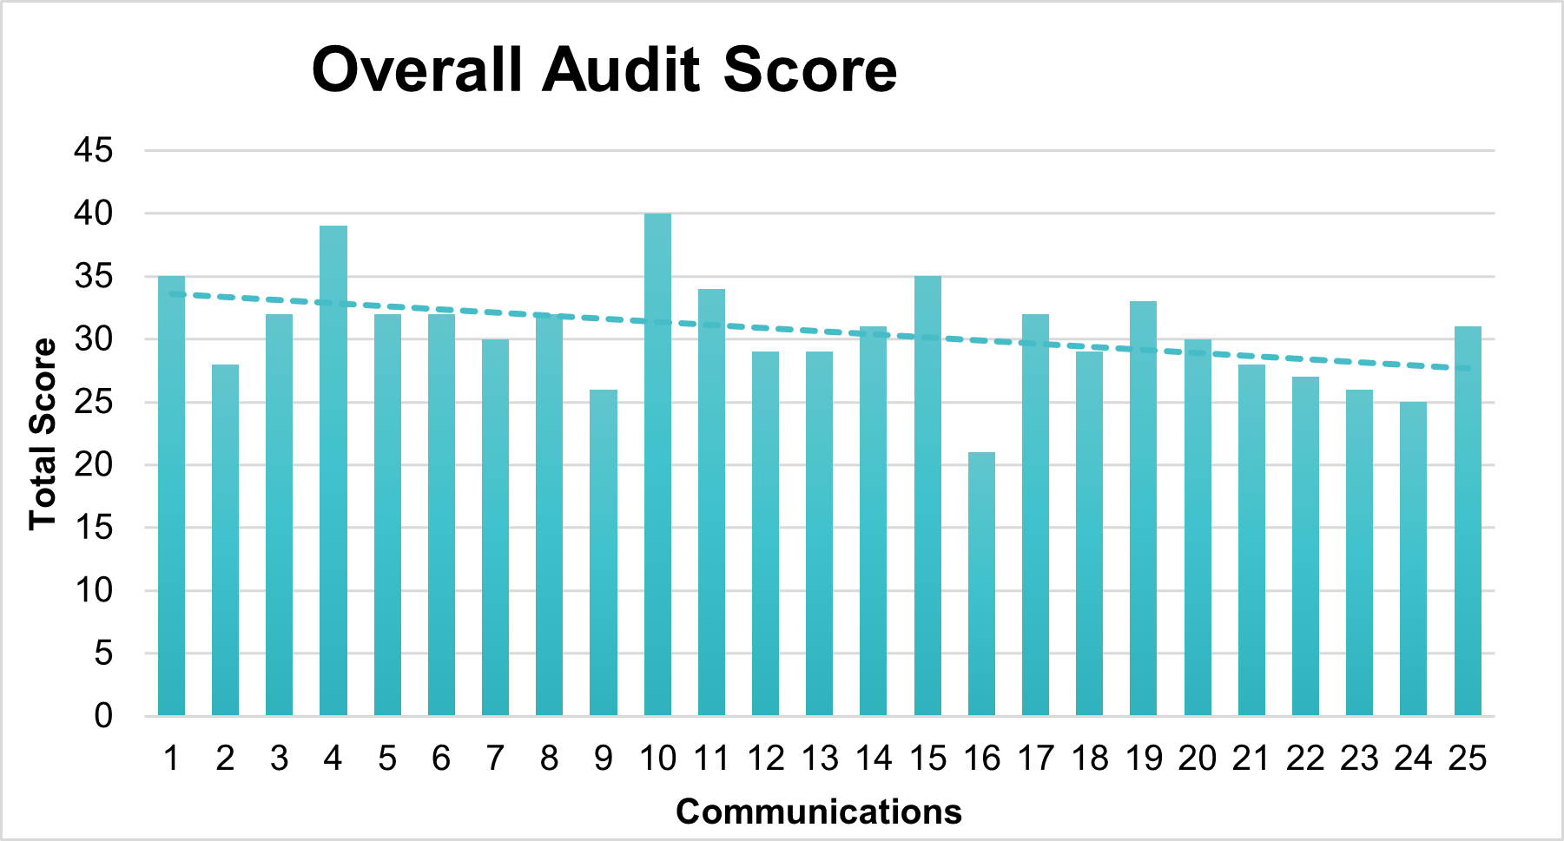

A correlation analysis was performed using the CORREL function in Excel to observe the correlation between the scores for different prompts.Exhibit 2 helps us notice that a strong positive correlation was observed between the scores for the prompts "How appropriate was the communicator for the message?" and "How appropriate was the channel?" **(r = 0.68)**, a moderate positive correlation was observed between the scores for the prompts for “How credible was the communicator?” and “How appropriate was the communicator for the message?” **(r = 0.57)**, and a moderate positive correlation was observed between the scores for the prompts “How well did the content address the audience’s needs?” and “How effectively were the key points structured?” **(r = 0.51)**.

**Exhibit 2:** Correlations in Communication

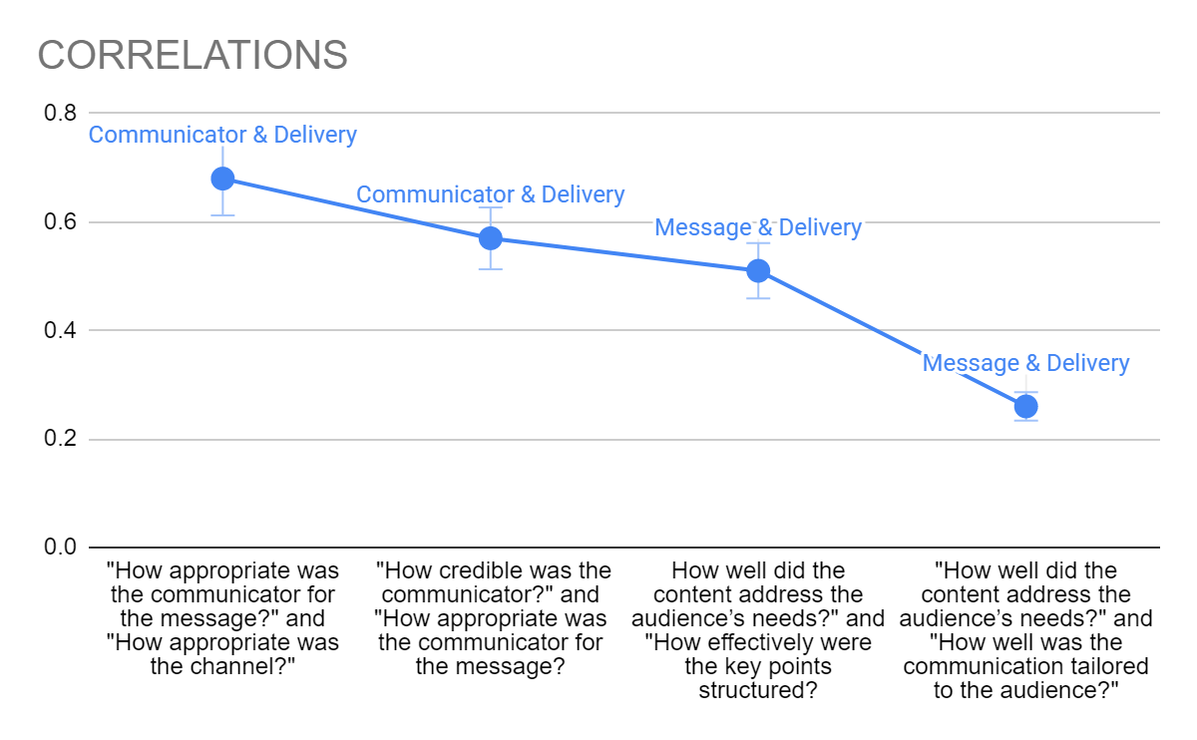

Message & Delivery shows a weak negative positive relationship **(0.26)**. Exhibit 3 taken from the Well Fargo 2017 proxy statement shows evidence on why the relationship is not strong in this case.

**Exhibit 3:** Letter to the Stockholders

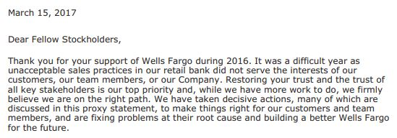

The statement asks the audience to read through the report in order to find information on Wells Fargo’s next steps of recuperation; however, the audience has to dig through thin text to obtain the desired information.

The trend analysis showed a downward sloping trend curve indicating a moderate inconsistency in the overall scores among various communications. However, no outliers were observed in the data with all communications scoring in the range 2.90-4.20 forming a normal distribution curve.

## Findings of the Analysis

Exhibit 4 represents the strengths, weaknesses, opportunities and threats of Well Fargo’s communications. The communicator's credibility and appropriateness were rated highly, while the delivery received a slightly lower score. The message received a lower score, particularly in addressing the audience's needs and anticipating resistances. There is a strong positive correlation between the appropriateness of the communicator and the channel, while the relationship between message and delivery is weak. The trend analysis showed a downward sloping trend with a moderate inconsistency among various communications. No outliers were observed and all scores formed a normal distribution.

**Exhibit 4:** SWOT Analysis of Wells Fargo

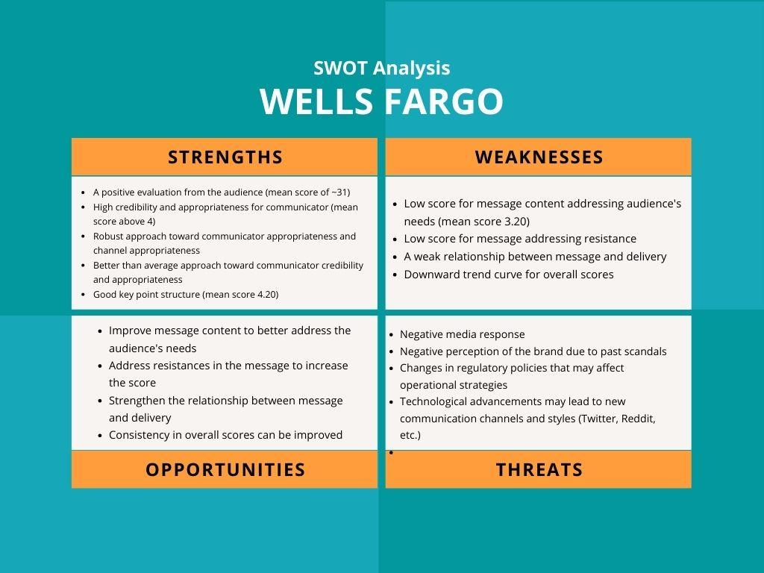

In light of these findings, it is suggested to prioritize the appropriateness of the communicator and the channel to enhance the credibility and effectiveness of the communication. Additionally, it is recommended to focus on the structure and tailoring of the content to the audience's needs for better communication.

### Interpretation of the Findings

Based on the analysis, we can see that the communicator was perceived as credible and appropriate for the message by the majority of the members. The key points were structured effectively, and the channel was appropriate.

By sorting the 25 communications in ascending order by time, the trendline is slightly negative, showing that the messages from Wells Fargo were less and less effective since their original communication. A company wants to see improved communication over time or, at a minimum, a flatline of constant good communication. Since effectiveness was deteriorating, we can expect a bad overall score for Wells Fargo if the weak points are not improved.

Since the worst score on average was not addressing nor anticipating resistances we can conclude that they did not do an effective communication strategy and therefore failed in these areas of the checklist. The content Wells Fargo provided also did not always address the audience's needs. If they want to communicate efficiently they need to ensure this area of communication has high standards. The communication was tailored to the audience, but not to the extent that it could have been.

Our recommendations below talk more about how to fix the problems identified above. We can extrapolate from this data that if we were to find more communications then we could expect low scores in each of these two areas.

## Recommendations for Improvement

SBCC, LLC recommends a direct, formal, and consultative approach as the most appropriate form of communication to present to the customers. The recommended message to improve the understanding about the situation should be a memo to current and former customers of Wells Fargo with an attached survey. This direct approach helps to build trust and transparency for the future of Wells Fargo.

The communicator for this memo should be a high-level executive at Wells Fargo. Based on our audit analysis results, we highly recommend the CEO to be the spokesperson. We know the current CEO has a strong reputation for ethical leadership and a deep understanding of the company's values and mission.

In the memo, the CEO should acknowledge the scandal and its impact on the company's reputation and provide transparent and accurate information about the measures taken to address it. They should also be open to feedback and questions from customers most affected by the scandal for promotions on how they might continue with Wells Fargo.

Benefits to the Recommendations

By demonstrating transparency and taking responsibility for the scandal, Wells Fargo can regain the trust of its current customers and maintain its position as a leading financial institution. The improvement in reputation and communications will instill confidence in the general market, attracting new customers. The additional revenue from the new customers will lead to better availability of services provided by the company to the customers.

Evidence and Examples That Support the Recommendations

The two communication areas Wells Fargo needs to improve on include: addressing customers needs and anticipating their resistances. This is noted in Exhibit 4, the SWOT Analysis. Wells Fargo’s primary weakness is its lack of anticipation to resistive responses from their customers. The extrapolations show that communications were not strong in the anticipation and responses to resistances by the customers. The customers directly impacted by the scandal may have some resistance towards Wells Fargo's efforts to address the scandal and remedy the situation.

One of their key concerns might be the authenticity and sincerity of the company's actions. The customers may doubt the company's commitment to ethical business practices and question the effectiveness of the measures being taken. To counter these concerns, remind the customers that Wells Fargo has taken several steps to address the issues as observed in Exhibit 5. The company has accepted responsibility for its part in the cross-selling scandal and has taken action against those who were involved, including terminating community bankers who promoted the cross-selling practices. Additionally, changes have been made to the company's leadership structure. Furthermore, Wells Fargo has made changes to its sales culture, including centralizing its risk management and human resources organizations, to prevent future cross-selling pressure practices. To further demonstrate its commitment to rectifying the situation, the company's Board has cut the compensation of executives, including the CEO.

**Exhibit 5:** Wells Fargo One Year Later - Sloan Testimony - October 3rd, 2017

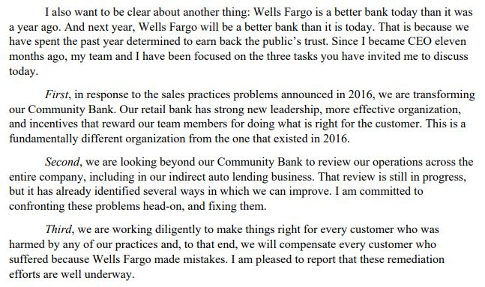

Another issue that arose from the cross selling scandal was that customers who were directly affected may be openly hostile toward the company. They believe that their trust was violated. They were angry that the bank had opened unauthorized accounts in their name and had used their personal information without their consent. Many of these accounts incurred fees, which led to financial difficulties for the customers.

The bank's response to the scandal only added to the hostility of its customers. Instead of taking full responsibility for the actions of its employees, the bank tried to deflect blame and minimize the impact of the scandal. For example, the bank initially tried to argue that the unauthorized accounts were not the result of a widespread problem, but were the actions of a few rogue employees. This lack of accountability and transparency only fueled the anger of the bank's customers and led to a further erosion of trust in the company.

This lack of transparency and trust would be hard to recover from. Many customers will want compensation or see changes to be reconciled. Wells Fargo can offer promotions for new products and reiterate the steps they have taken to recover from the scandal since 2016. Some steps that have been taken are launching the office of consumer practices to “ensure that their business practices are fair and transparent”, revised incentives which eliminates product and sales goals.

Past, current, and future customers may be resistant to the appointment of a new CEO due to credibility and unfamiliarity with the company. However, having an external CEO brings a fresh perspective and may offer an objective view on the situation, providing better insights and solutions to the scandal. Furthermore, the departure of the previous CEO, who was implicated in the scandal, may signal the company's commitment to making real change and regaining customer trust. The appointment of a new CEO can be seen as a step towards a brighter future for Wells Fargo and its customers. The Wells Fargo bio website for Charles Scharf has a strong history in initiating and leading change and strengthening operation risk and compliance. The addition of a regulatory relations to corporate risk organization is a plus in helping to ensure Wells Fargo meet regulatory commitments and as well assist Mr. Scharf to better communicate with regulators.

Tim Sloan was seen having trouble answering congresswomen Alexandria Ocasio Cortez’s questions in a video of a congressional hearing that was posted on CSPAN’s Twitter account on March 12th, 2019. We can improve the new CEO’s responses and communication preparations going forward. His advisory consultations regarding regulatory communications and questions will be accompanied by the newly created head of regulatory relations position. They will both collaborate on these types of responses to both the government and to other stakeholders.

### Preliminary Next Steps

To address the remaining damage resulting from the aftermath of the 2016 cross-selling scandal, we implore you to gather information for a questionnaire based on the several remedies that former and present customers may want that are financially feasible to the company. Attaching this survey to the memo drafted by your CEO will show that the new CEO is not pushing the past behind them. Remember and emphasize your core values, “what’s right for customers, people as a competitive advantage, ethics, diversity and inclusion, leadership.” Wells Fargo should show these values hold true and be transparent about letting the mistakes of the past guide them toward a better future of customer commitment.

# Appendix

## 1 - Audit Checklist

| **Communication 1-25 =>** | **1** | **2** | **3** | **4** | **5** | **6** | **7** | **8** | **9** | **10** | **11** | **12** | **13** | **14** | **15** | **16** | **17** | **18** | **19** | **20** | **21** | **22** | **23** | **24** | **25** | **AVG** |
| --- | --- | --- | --- | --- | --- | --- | --- | --- | --- | --- | --- | --- | --- | --- | --- | --- | --- | --- | --- | --- | --- | --- | --- | --- | --- | --- |
| **Questions (1 poor - 5 good)** | **Rank 1-5** | | | | | | | | | | | | | | | | | | | | | | | | |
| **Communicator** |  |  |  |  |  |  |  |  |  |  |  |  |  |  |  |  |  |  |  |  |  |  |  |  |  |  |
| How credible was the communicator? | 5 | 3 | 2 | 5 | 5 | 5 | 5 | 5 | 4 | 5 | 4 | 3 | 3 | 2 | 5 | 2 | 5 | 2 | 5 | 5 | 5 | 2 | 2 | 5 | 5 | 3.96 |
| How appropriate was the communicator for the message? | 5 | 4 | 5 | 5 | 4 | 4 | 4 | 5 | 4 | 5 | 4 | 4 | 4 | 5 | 5 | 3 | 5 | 5 | 4 | 5 | 5 | 2 | 4 | 3 | 5 | 4.32 |
| **Message** |  |  |  |  |  |  |  |  |  |  |  |  |  |  |  |  |  |  |  |  |  |  |  |  |  |  |
| How well did the content address the audience’s needs? | 5 | 4 | 5 | 5 | 3 | 3 | 4 | 3 | 3 | 5 | 4 | 4 | 3 | 2 | 4 | 2 | 2 | 2 | 3 | 1 | 2 | 4 | 2 | 2 | 3 | 3.20 |
| How well did the communication anticipate resistances and address them? | 4 | 2 | 2 | 4 | 3 | 3 | 4 | 4 | 2 | 5 | 4 | 3 | 4 | 2 | 4 | 2 | 3 | 2 | 3 | 1 | 4 | 3 | 2 | 2 | 2 | 2.96 |
| How effectively were the key points structured? | 5 | 4 | 4 | 5 | 4 | 4 | 4 | 4 | 2 | 5 | 5 | 3 | 5 | 5 | 4 | 4 | 4 | 5 | 5 | 5 | 2 | 5 | 4 | 4 | 4 | 4.20 |
| **Delivery** |  |  |  |  |  |  |  |  |  |  |  |  |  |  |  |  |  |  |  |  |  |  |  |  |  |  |
| How appropriate was the channel? | 4 | 3 | 5 | 5 | 4 | 4 | 3 | 5 | 4 | 5 | 4 | 4 | 4 | 5 | 5 | 2 | 4 | 5 | 5 | 5 | 2 | 2 | 4 | 3 | 4 | 4.00 |
| How timely was the communication? | 3 | 5 | 5 | 5 | 5 | 5 | 3 | 3 | 4 | 5 | 4 | 4 | 3 | 5 | 3 | 4 | 4 | 5 | 4 | 4 | 3 | 5 | 5 | 5 | 5 | 4.24 |
| How well was the communication tailored to the audience? | 4 | 3 | 4 | 5 | 4 | 4 | 3 | 3 | 3 | 5 | 5 | 4 | 3 | 5 | 5 | 2 | 5 | 3 | 4 | 4 | 5 | 4 | 3 | 1 | 3 | 3.76 |
| **Overall Audit Score** | 35 | 28 | 32 | 39 | 32 | 32 | 30 | 32 | 26 | 40 | 34 | 29 | 29 | 31 | 35 | 21 | 32 | 29 | 33 | 30 | 28 | 27 | 26 | 25 | 31 | 3.83 |
| **Average Score of All Communications** | 30.64 | | | | | | | | | | | | | | | | | | | | | | | | |  |

## 2 - List of Communications

**Primary Sources**

Amernic, J., & Craig, R. (2022). Evaluating assertions by a Wells Fargo CEO of a ‘return to ethical conduct.’ Leadership, 18(3), 400–426. https://doi.org/10.1177/17427150211064397

CSPAN on Twitter: "Complete exchange between @RepAOC @AOC and @WellsFargo CEO Timothy Sloan AOC: "Why was the bank involved in the caging of children and financing the caging of children to begin with?" SLOAN: "I don't know how to answer ..., 12 March 2019, https://twitter.com/cspan/status/1105534121093283840. Accessed 17 February 2023.

“Conference Call with Analysts (March 28, 2019) - Transcript.” Wells Fargo, 28 March 2019, https://www08.wellsfargomedia.com/assets/pdf/about/investor-relations/presentations/2019/conference-call-transcript.pdf. Accessed 17 February 2023.

Couret, Jacques. “Wells Fargo sends customers statement about unauthorized account opening scandal - Atlanta Business Chronicle.” The Business Journals, 22 October 2016, https://www.bizjournals.com/atlanta/news/2016/10/22/wells-fargo-sends-customers-statement-about.html. Accessed 17 February 2023.

“DEFINITIVE NOTICE AND PROXY STATEMENT.” SEC.gov, https://www.sec.gov/Archives/edgar/data/72971/000119312519073314/d699854ddef14a.htm. Accessed 17 February 2023.

“Definitive Notice & Proxy Statement.” SEC.gov, https://www.sec.gov/Archives/edgar/data/72971/000119312516506771/d897049ddef14a.htm. Accessed 17 February 2023.

“Excerpt from Form 8-K dated March 28, 2019 filed by Wells Fargo & Company with the U.S. Securities and Exchange Commission.” Wells Fargo, 28 March 2019, https://www08.wellsfargomedia.com/assets/pdf/about/investor-relations/sec-filings/2019/8k.pdf. Accessed 17 February 2023.

“Highlights of Board and Company Actions in Response to Sales Practices.” Wells Fargo, 1 March 2017, https://www08.wellsfargomedia.com/assets/pdf/about/investor-relations/presentations/2017/board-and-company-actions.pdf. Accessed 17 February 2023.

“Key Findings from Board Investigation, Action Plan Update, and Our Path Forward.” Wells Fargo, 12 April 2017, https://www08.wellsfargomedia.com/assets/pdf/about/investor-relations/annual-reports/2017-supplemental-proxy-materials.pdf. Accessed 17 February 2023.

Modjtabai, Avid. “Our Commitment.” Wells Fargo, 31 March 2017, https://www08.wellsfargomedia.com/assets/pdf/about/investor-relations/annual-reports/2016-annual-report.pdf. Accessed 17 February 2023.

“News Release (March 21, 2017).” Wells Fargo, 21 March 2017, https://www08.wellsfargomedia.com/assets/pdf/about/investor-relations/presentations/2017/ceo-town-hall.pdf. Accessed 17 February 2023.

“Statement of Tim Sloan, Wells Fargo & Co. Before the U.S. Senate Committee on Banking, Housing and Urban Affairs Wells Fargo.” Senate Banking Committee, 3 October 2017, https://www.banking.senate.gov/imo/media/doc/Sloan%20Testimony%2010-3-17.pdf. Accessed 17 February 2023.

“Stephen Sanger CBNC Squawk on the Street Interview with Wilfred Frost on April 10, 2017.” Wells Fargo, 10 April 2017, https://www08.wellsfargomedia.com/assets/pdf/about/investor-relations/presentations/2017/cnbc-interview-transcripts.pdf. Accessed 17 February 2023.

“Transforming for the Future, March 2019.” Wells Fargo, https://www08.wellsfargomedia.com/assets/pdf/about/investor-relations/presentations/2019/proxy-presentation.pdf. Accessed 17 February 2023.

“Video Transcript: Our Road Ahead.” Wells Fargo, https://www08.wellsfargomedia.com/assets/pdf/about/investor-relations/annual-reports/our-road-ahead-transcript.pdf. Accessed 17 February 2023.

“Wells Fargo CEO and President Tim Sloan to Retire; Board of Directors Elects Allen Parker as Interim CEO and President.” Wells Fargo Newsroom, 28 March 2019, https://newsroom.wf.com/English/news-releases/news-release-details/2019/Wells-Fargo-CEO-and-President-Tim-Sloan-to-Retire-Board-of-Directors-Elects-Allen-Parker-as-Interim-CEO-and-President/default.aspx. Accessed 17 February 2023.

“Wells Fargo & Company 2017 Proxy Statement.” Wells Fargo, 15 March 2017, https://www08.wellsfargomedia.com/assets/pdf/about/investor-relations/annual-reports/2017-proxy-statement.pdf. Accessed 17 February 2023.

“Wells Fargo & Company 2018 Annual Report.” Wells Fargo, 27 February 2019, https://www08.wellsfargomedia.com/assets/pdf/about/investor-relations/annual-reports/2018-annual-report.pdf. Accessed 17 February 2023.

“Wells Fargo & Company 2018 Proxy Statement.” Wells Fargo, 14 March 2018, https://www08.wellsfargomedia.com/assets/pdf/about/investor-relations/annual-reports/2018-proxy-statement.pdf. Accessed 17 February 2023.

“Wells Fargo & Company 2019 Annual Report.” Wells Fargo, 20 February 2020, https://www08.wellsfargomedia.com/assets/pdf/about/investor-relations/annual-reports/2019-annual-report.pdf. Accessed 17 February 2023.

“Wells Fargo & Company 2021 Annual Report.” Wells Fargo, 8 September 2016, https://www08.wellsfargomedia.com/assets/pdf/about/investor-relations/annual-reports/2021-annual-report.pdf. Accessed 17 February 2023.

“Wells Fargo Enters into Agreement with CFPB to Resolve Multiple Issues.” Wells Fargo Newsroom, 20 December 2022, https://newsroom.wf.com/English/news-releases/news-release-details/2022/Wells-Fargo-Enters-into-Agreement-with-CFPB-to-Resolve-Multiple-Issues/default.aspx. Accessed 17 February 2023.

“Wells Fargo Issues Statement on Agreements Related to Sales Practices.” Wells Fargo Newsroom, 8 September 2016, https://newsroom.wf.com/English/news-releases/news-release-details/2016/Wells-Fargo-Issues-Statement-on-Agreements-Related-to-Sales-Practices/default.aspx. Accessed 17 February 2023.

“Wells Fargo Statement Regarding Board Investigation into the Community Bank's Retail Sales Practices.” Newsroom, 10 April 2017, https://newsroom.wf.com/English/news-releases/news-release-details/2017/Wells-Fargo-Statement-Regarding-Board-Investigation-into-the-Community-Banks-Retail-Sales-Practices/default.aspx. Accessed 17 February 2023.

White, Mary Jo. “Rebuilding Trust.” Wells Fargo, 1 March 2018, https://www08.wellsfargomedia.com/assets/pdf/about/investor-relations/annual-reports/2017-annual-report.pdf. Accessed 17 February 2023.

**Secondary Sources**

“Charles W. Scharf Biography – CEO and President – Wells Fargo.” Wells Fargo, https://www.wellsfargo.com/about/corporate/governance/scharf/. Accessed 17 February 2023.

“Wells Fargo Launches Office of Consumer Practices.” Newsroom, 12 January 2021, https://newsroom.wf.com/English/news-releases/news-release-details/2021/Wells-Fargo-Launches-Office-of-Consumer-Practices/default.aspx. Accessed 17 February 2023.

“Wells Fargo's transformation.” Wells Fargo, https://www08.wellsfargomedia.com/assets/pdf/commitment/progress-report.pdf. Accessed 17 February 2023.