AI-Powered Influencer–Brand Collaboration Platform
Feature architecture, content-intelligence benchmarking, scoring model and freemium dashboard
Generated 2026-08-18 · all figures and metrics reproduced directly from pipeline artifacts

1. Executive summary
This project builds a platform that ranks social-media creators for brand collaborations using a model trained on sponsored-campaign outcomes, rather than on follower count. It delivers three things: a content-intelligence layer benchmarked against real human-labelled corpora, a supervised scoring and pricing model validated with grouped cross-validation, and a hosted freemium dashboard.
The scoring model reaches an out-of-fold R² of 0.694 in log space — 85% of the theoretical maximum given the irreducible noise in the data — with a Spearman rank correlation of 0.826 and NDCG@10 of 0.811. It substantially outperforms both alternatives it replaces: a published benchmark rate curve (R² -0.020) and the weighted composite index proposed in the original design (R² 0.225).

Three findings worth stating up front
- Word-list sentiment methods fail on irony, measurably. On the TweetEval irony corpus every lexicon method scores at or below the majority-class baseline. This is not a tuning problem: sarcasm inverts meaning without changing vocabulary, so the information a word list needs is simply absent.
- The NRC lexicon is worse than VADER at polarity, despite being the richer resource. NRC's value is its eight emotion categories, not its positive/negative split, and the system uses it accordingly rather than as a drop-in polarity upgrade.
- The machine-learned price model barely beats a published rate card. That is a negative result with a clear business consequence: rule-based pricing is sufficient until real negotiated-deal data exists, and the regression model is not worth its maintenance cost before then.
Scope of the data. The creator universe is synthetic and calibrated against published 2026 industry benchmarks. The NLP evaluation is performed on real, human-labelled corpora. Section 3 sets out exactly what is real and what is not, and why the project is structured that way.

2. Problem and design revision
Brands discover creators through manual research, agency intermediaries, and follower-count heuristics. The process is slow, inconsistent, and biased toward vanity metrics over audience quality, content fit, or network position. Creators, symmetrically, have no visibility into how brands value them or where they stand against peers.
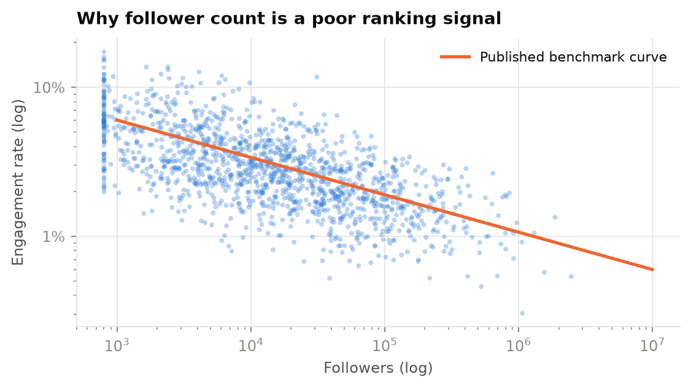
Engagement rate declines systematically with audience size. Ranking creators by follower count therefore systematically mis-ranks them — the core premise of the product.

2.1 Two structural problems in the original design, and how they were resolved

Problem 1 — the network pillar had no data source
The preliminary design specified degree, eigenvector and PageRank centrality over an influencer follower graph. No such data is obtainable: Instagram's Graph API exposes no follower edges to third parties, and there is no legal route to them at project scale. Building the pillar on an assumed follower graph would have meant either fabricating it or quietly dropping the most impressive-sounding component of the design.
Resolution: the graph is constructed from observable co-behaviour — creators who share rare hashtags and who work with the same brands. Hashtags are TF-IDF weighted so that a shared niche tag counts for far more than a shared generic one (#viral, #reels), and the graph is sparsified to a mutual k-nearest-neighbour graph to prevent hub collapse.
Consequence, stated wherever centrality appears. PageRank on this graph measures topical centrality — how embedded a creator is in a category's shared vocabulary — not social influence. It is a genuine matching signal, and it is not a claim about who follows whom. The dashboard labels it as such.

Problem 2 — there was no target variable
The design's Phase 1 was a weighted composite index with weights set by domain judgement. That is not machine learning; it is a scoring rubric. Phase 2 proposed a supervised model but identified no label to train it on.
Resolution: the simulation generates historical sponsored campaigns whose engagement rate is the supervised target — precisely the quantity the original design named ('actual campaign engagement lift'). Critically, the target is generated from hidden latent traits and is not a deterministic function of any observable feature, so the model must combine signals rather than read the answer off one column. The Phase-1 weighted index is retained as an explicit baseline, so the report can demonstrate rather than assert that learning helps.

3. Data: what is real, what is synthetic, and why

3.1 The synthetic creator universe
The universe contains 2,000 creators across 12 niches, 52,089 posts, and 2,199 historical sponsored campaigns covering 1,100 creators.
Each creator is generated from four latent traits the model never sees — content quality, audience authenticity, posting consistency and advertising saturation. Every observable feature (followers, likes, comments, views, growth, captions, network position) is a noisy function of those traits, and campaign performance is a separate noisy draw from them.
- No target leakage: campaign outcome is never a deterministic function of any observable.
- A known ceiling: because the noise variance is set by construction, the maximum achievable R² is computable, and model performance is reported as a fraction of it.
- A fair test of every pillar: campaign outcomes depend on measured network centrality, so the SNA features have to earn their place rather than being decorative.

Calibration against published benchmarks
A synthetic dataset with invented magnitudes would be worthless. Engagement rates and fee bands are therefore fitted to published 2026 industry benchmarks, and every tier median is verified to fall inside the published range.
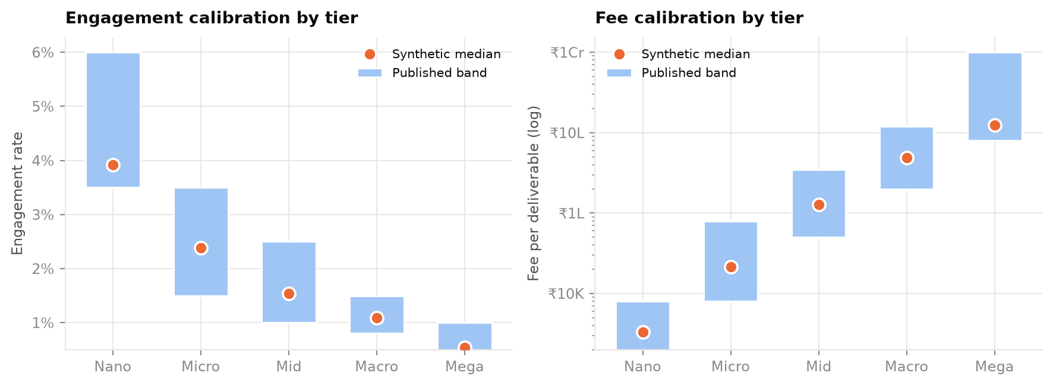
Synthetic tier medians (points) against published benchmark ranges (bars). All tiers fall inside the published bands.
Sources: engagement bands from Nowadays Media (Stated as an analysis of 15,000+ creator accounts); INR fee bands from upGrowth. Both are industry publications rather than peer-reviewed research — platforms do not publish this data and academic figures are years stale — so they are treated as order-of-magnitude anchors. Four niches in the taxonomy are not itemised by the source and were interpolated; those values are flagged as assumptions in the code.

3.2 Why the NLP evaluation uses real data instead
The central methodological point. Synthetic text cannot validate an NLP method. If we generate a caption, label it 'sarcastic', then measure how well a detector recovers that label, we measure how well the detector reverse-engineers our template — not how well it detects sarcasm. Every sentiment, emotion and irony figure in this report is therefore measured on real text written by real people and labelled by real annotators.
Resource | Authors | Venue
TweetEval | Barbieri, F., Camacho-Collados, J., Espinosa-Anke, L., Neves, L. | Findings of EMNLP 2020
News Headlines Dataset for Sarcasm Detection | Misra, R., Arora, P. | AI Open / arXiv:2212.06035
NRC Word-Emotion Association Lexicon (EmoLex) | Mohammad, S. M., Turney, P. D. | Computational Intelligence, 29(3), 2013
VADER | Hutto, C. J., Gilbert, E. | ICWSM 2014
Sentence-BERT | Reimers, N., Gurevych, I. | EMNLP 2019
BERTopic | Grootendorst, M. | arXiv:2203.05794
Real labelled corpora and methods used, with provenance.

4. Content intelligence: which NLP method actually works
The supervisor's feedback on the preliminary design was that the qualitative analysis was weak and that Bing-style positive/negative word lists are primitive, recommending NRC, VADER, SBERT embeddings, BERTopic and LLM prompting instead. This section tests that claim rather than assuming it, by running every named method through one harness on identical held-out data.

4.1 Evaluation protocol
- Every method is scored on identical rows. Where a slow method is subsampled, every fast method is additionally scored on that same subsample, so no comparison is between different sample sizes.
- Supervised methods fit on the training split only; the test split is held out for all methods.
- A majority-class baseline is always present. A method that cannot beat 'always guess the most common label' has demonstrated nothing.
- Throughput is recorded. A method 200× slower for two points of F1 is an engineering trade-off, and it belongs in the table.
- Missing dependencies produce a recorded SKIP row, never a silent omission.

4.2 Sentiment
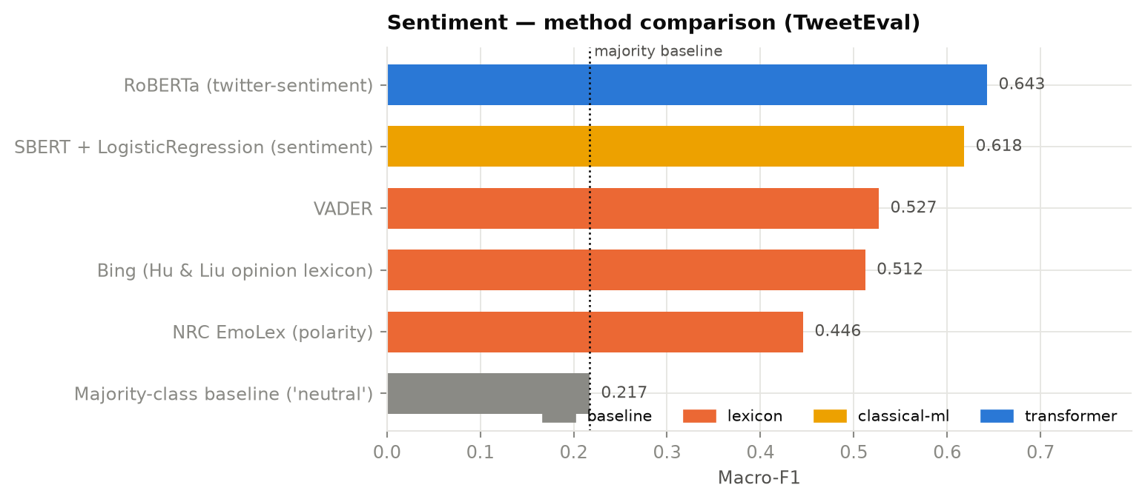
Three-class sentiment on TweetEval (SemEval-2017 Task 4). Dotted line = majority baseline.
Method | Family | Accuracy | Macro-F1 | Texts/sec
RoBERTa (twitter-sentiment) | transformer | 0.671 | 0.643 | 14.100
SBERT + LogisticRegression (sentiment) | classical-ml | 0.614 | 0.618 | 52.730
VADER | lexicon | 0.528 | 0.527 | 12436.090
Bing (Hu & Liu opinion lexicon) | lexicon | 0.524 | 0.512 | 21179.100
NRC EmoLex (polarity) | lexicon | 0.453 | 0.446 | 78280.750
Majority-class baseline ('neutral') | baseline | 0.483 | 0.217 | inf
Sentiment results on the held-out TweetEval test split.
Finding. NRC scores macro-F1 0.446 against VADER's 0.527 on polarity. The recommendation to prefer NRC over a simple lexicon holds for emotion, not for polarity — NRC's advantage is its eight affect categories. This system therefore uses VADER and a transformer for polarity, and NRC for the emotion profile.

4.3 Irony and sarcasm — the decisive test
Sarcasm is where lexicon methods fail structurally, and it is the reason the supervisor's recommendation matters. Consider: 'Oh great, another subscription fee. Brilliant work.' The text contains {great, brilliant} and no negative words, so Bing scores it maximally positive. VADER scores it positive too — its negation rules cover 'not good', not ironic praise.
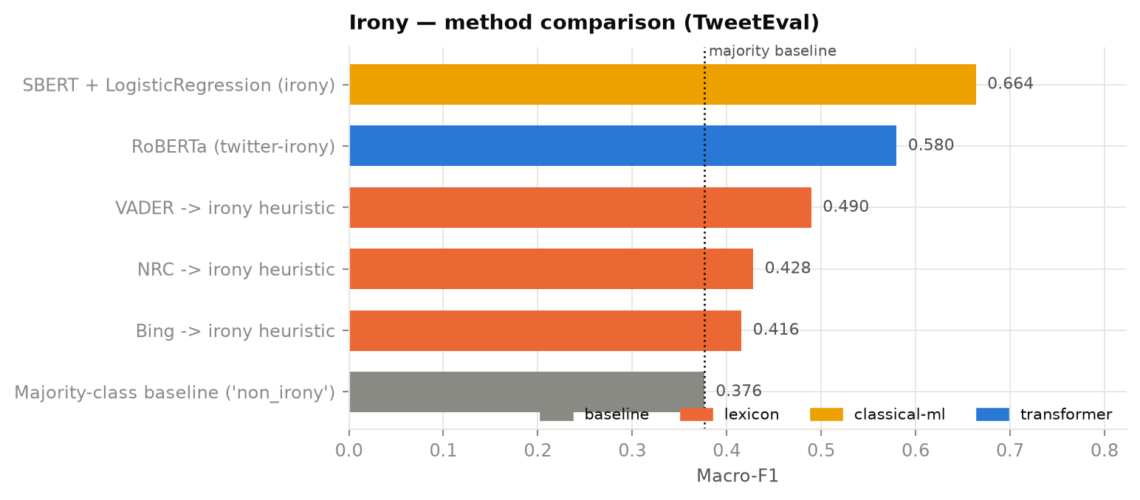
Binary irony detection on TweetEval irony (SemEval-2018 Task 3).
Method | Family | Accuracy | Macro-F1 | n | Texts/sec
SBERT + LogisticRegression (irony) | classical-ml | 0.668 | 0.664 | 784 | 104.780
RoBERTa (twitter-irony) | transformer | 0.679 | 0.580 | 784 | 21.510
VADER -> irony heuristic | lexicon | 0.550 | 0.490 | 784 | 11615.470
NRC -> irony heuristic | lexicon | 0.487 | 0.428 | 784 | 23381.840
Bing -> irony heuristic | lexicon | 0.496 | 0.416 | 784 | 129208.760
Majority-class baseline ('non_irony') | baseline | 0.603 | 0.376 | 784 | inf
Irony detection results, TweetEval test split.
The headline result. The best word-list method reaches 0.550 accuracy against a majority-class baseline of 0.603. Word lists are worse than guessing on irony. No amount of tuning recovers this, because the signal is not in the vocabulary.

Cross-domain generalisation
In-domain performance overstates what a method will do in production. The same methods were therefore evaluated on a second, independent sarcasm corpus from a different domain (news headlines, Misra & Arora) — a harder and more honest test, especially for the transformer checkpoint that was fine-tuned on the tweet corpus.
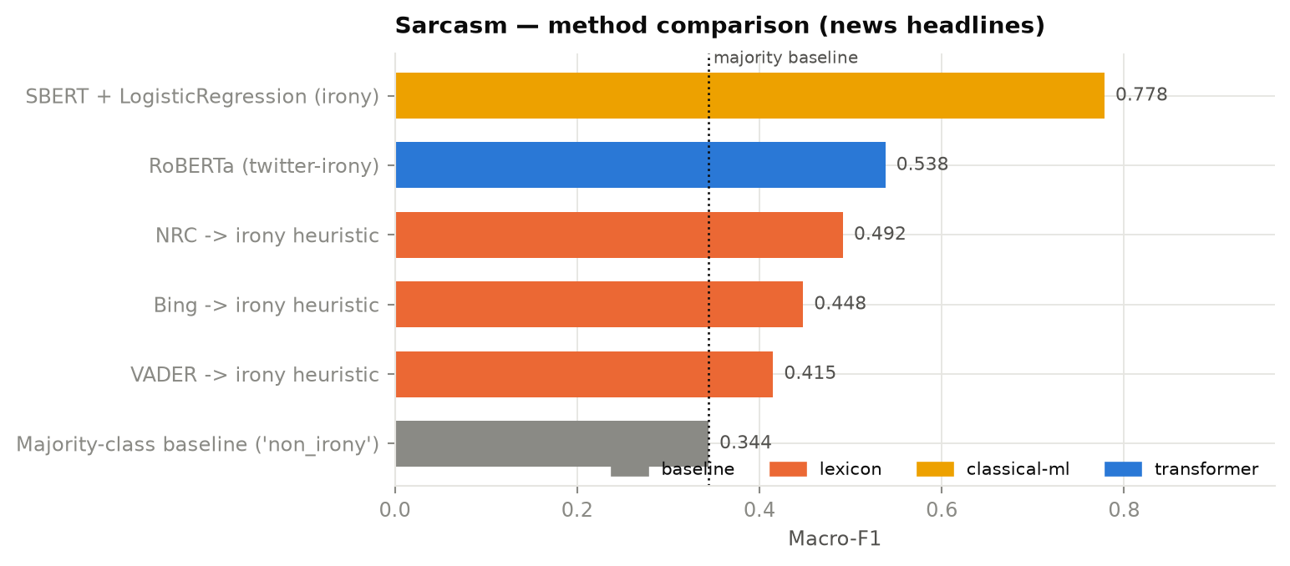
Sarcasm detection on news headlines — a domain none of the methods were tuned for.
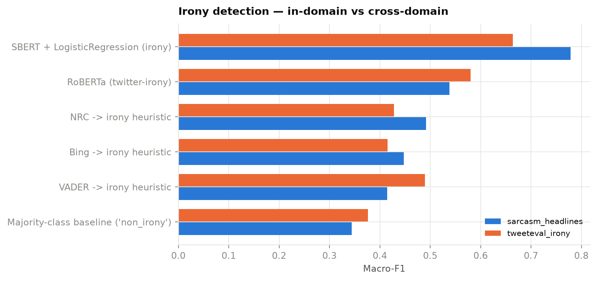
The same methods on both corpora. The gap between the bars is the generalisation penalty.

4.4 Emotion
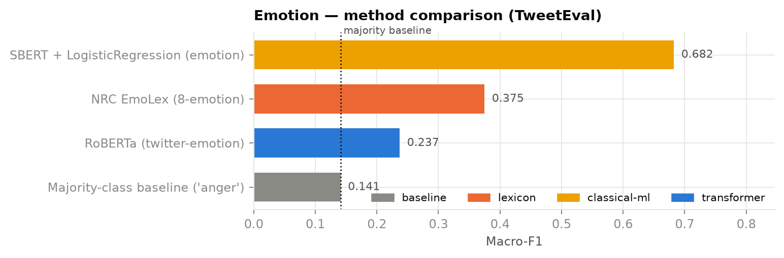
Four-class emotion on TweetEval (SemEval-2018 Task 1).
The NRC lexicon carries eight emotion categories while the benchmark labels four, so the mapping is necessarily lossy: anticipation and trust fold into optimism, disgust and fear into anger, and surprise has no corresponding label at all. That handicap is a genuine limitation of scoring an eight-way lexicon against a four-way benchmark and is reported rather than hidden — the lexicon's full eight-way output is what the dashboard displays.

4.5 Topic modelling
BERTopic recovered 18 topics over 52,089 captions with 18.7% classified as outliers. An LDA baseline was fitted on the identical corpus with the identical topic count and scored with the identical coherence implementation, so the comparison is like-for-like.
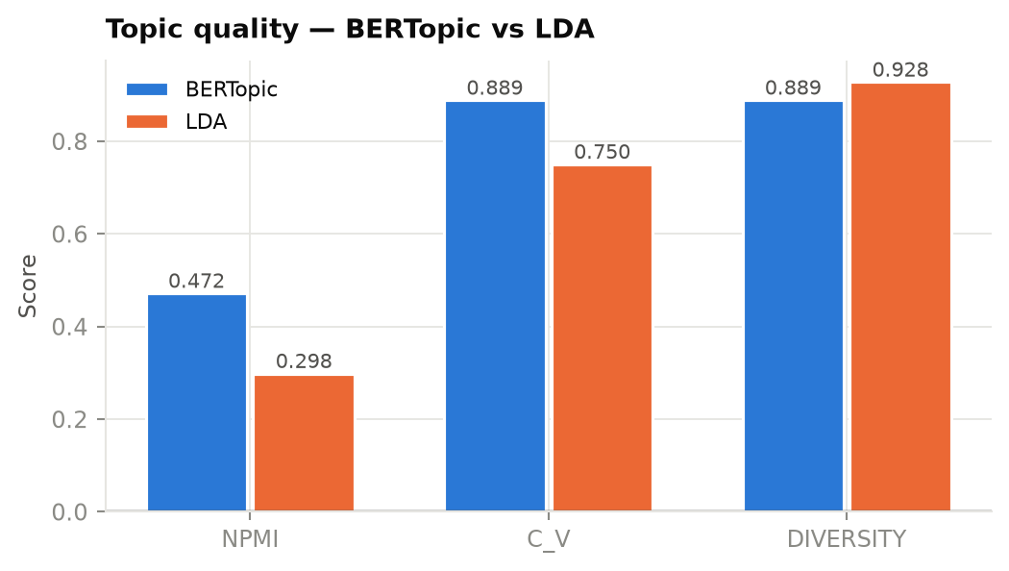
Topic quality. Diversity is reported alongside coherence because a model that repeats one generic topic scores well on coherence alone.
Model | NPMI | C_v | Diversity
BERTopic | 0.472 | 0.889 | 0.889
LDA | 0.298 | 0.750 | 0.928
Topic coherence and diversity.
BERTopic is expected to win here specifically because captions are short. LDA estimates a topic distribution from word co-occurrence within a document, and a twenty-word caption does not supply enough. BERTopic clusters sentence embeddings and extracts representative terms afterwards, which sidesteps the problem.

4.6 What this means for the production pipeline
The benchmark results drive a deployment decision rather than sitting in an appendix. Rule-based extraction, VADER and NRC run over every post — they are effectively free. SBERT embeddings run over every post because topics and brand-fit need them anyway. Fine-tuned transformers run over every post at a few hundred posts per second. LLM prompting does not: it is roughly three orders of magnitude slower per post, and scoring the full corpus with a local 7B model is on the order of a day of compute for a signal the transformer already provides. The LLM's role is therefore (a) rigorous benchmarking, which quantifies exactly what is lost by not running it everywhere, and (b) on-demand single-creator analysis in the dashboard, where a few seconds of latency is acceptable.

5. Network analysis
The graph contains 2,000 nodes and 7,415 edges (density 0.00371), partitioned by the Louvain method into 89 communities, the largest containing 180 creators.
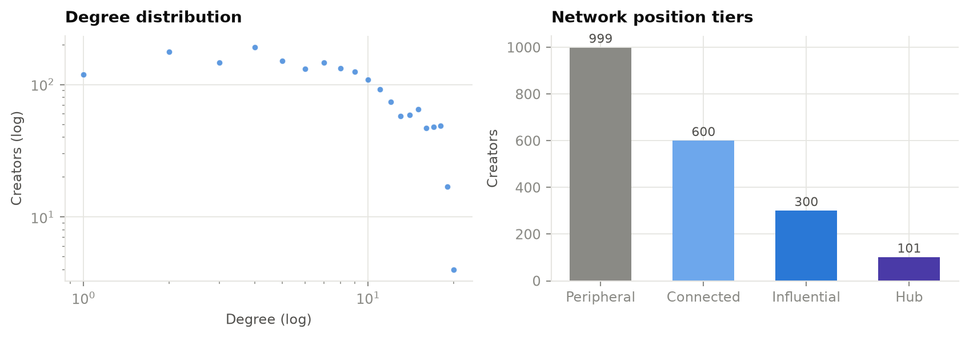
Degree distribution and network-position tiers.
Betweenness centrality is approximated using 400 sampled pivots (Brandes–Pich estimator). Exact computation is O(V·E) and does not scale; the approximation is disclosed rather than presented as exact.

6. Scoring and pricing models

6.1 Validation protocol
The decision that matters most. Validation uses GroupKFold on creator id, so a creator never appears in both training and test. Because each creator contributes up to three campaigns, a random split would place the same creator on both sides and inflate every metric reported. This is the single most common way projects of this shape overstate their results.
- Metrics computed in log space — engagement rate is log-normally distributed, and a raw-scale R² would be dominated by a handful of large values.
- Ranking metrics (Spearman, NDCG) reported alongside regression metrics, because the product ranks creators and order matters more than absolute value.
- Leakage controls enforced in code: a banned-substring list gates the model matrix and the trainer raises an assertion if any excluded column reaches it.

6.2 Results
Metric | Value
R² (log) | 0.694
RMSE (log) | 0.416
Spearman | 0.826
NDCG@10 | 0.811
NDCG@50 | 0.787
Theoretical R² ceiling | 0.819
Fraction of ceiling reached | 0.847
Out-of-fold performance. Fold R²: 0.684, 0.690, 0.688, 0.724, 0.673.
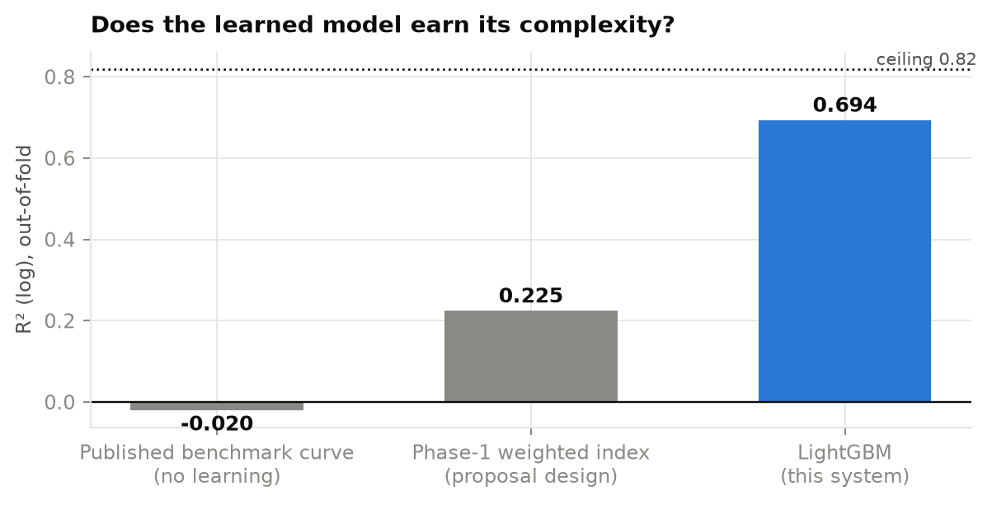
The learned model against the two alternatives it replaces.
The Phase-1 weighted index is flattered in this comparison — it is isotonically calibrated to the target scale and fitted on the full dataset, advantages the learned model does not receive. It still loses by 0.469 R². The conclusion that learning is worth its complexity here is therefore conservative.
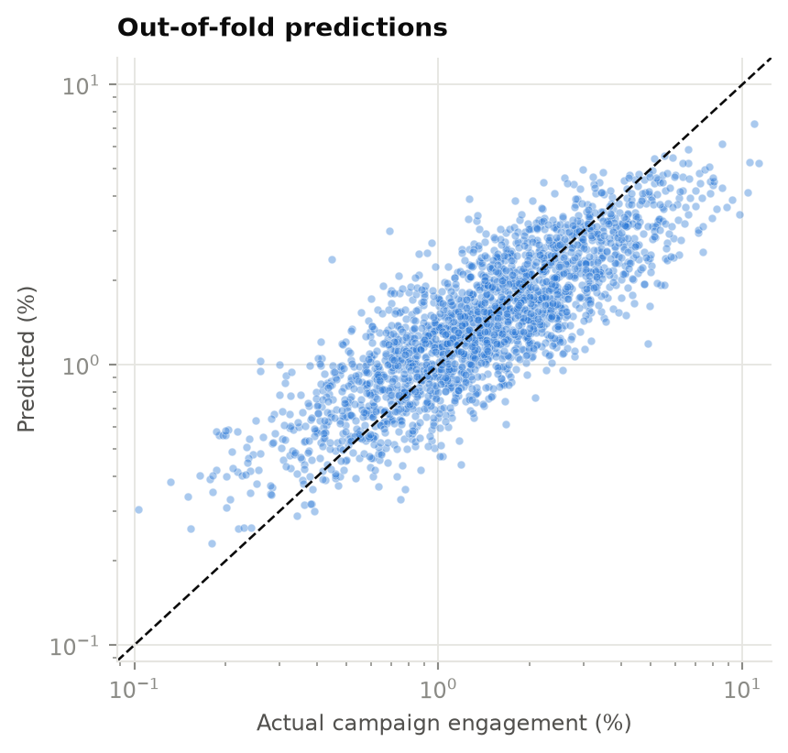
Out-of-fold predictions against actuals, log-log.

6.3 Which pillar earns its place
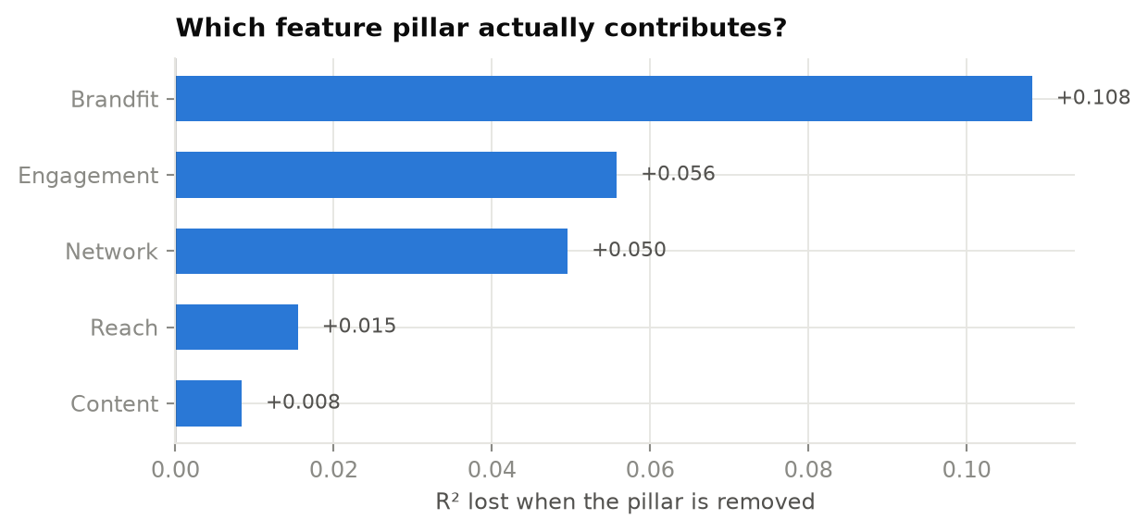
Each pillar removed in turn; the bar is the R² lost.
Pillar | R² without | Loss | Alone | Features
Brandfit | 0.583 | 0.108 | 0.163 | 6
Engagement | 0.636 | 0.056 | 0.443 | 7
Network | 0.642 | 0.050 | 0.095 | 15
Reach | 0.676 | 0.015 | 0.369 | 9
Content | 0.683 | 0.008 | 0.111 | 34
Pillar ablation under the same GroupKFold protocol.
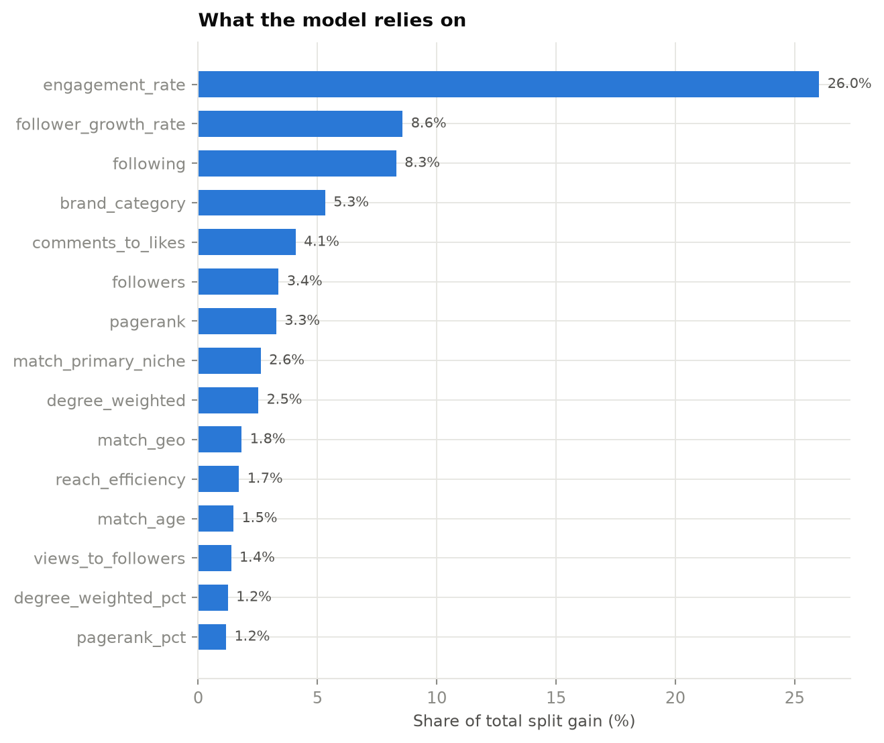
Feature importance by split gain.

6.4 Price model
Model | R² (log) | MAPE | Spearman
LightGBM regressor | 0.975 | 0.201 | 0.987
Published rate card (rule) | 0.966 | 0.250 | 0.982
Price prediction. The shown band is the 10th–90th percentile of out-of-fold residuals and covers 80% of true fees.
Second negative result. The learned price model reaches R² 0.975 against 0.966 for a rate card with no learning at all. The gap does not justify the maintenance cost of a trained model. The recommendation is to ship the Phase-1 rule-based price band and revisit only once real negotiated-deal data has accumulated on-platform. Note also that this R² is partly an artefact of the simulation, in which fees are generated from followers, engagement and niche — all of which are model features.

7. Brand-fit scoring
Brand-Fit is deliberately not a learned model, and the reason is worth stating because it would be easy to mistake for a shortcut.
- There is no label. 'Was this creator a good fit for this brand?' is recorded nowhere. Training on campaign engagement would simply re-learn the performance model and rename it.
- Half of fit is a hard constraint, not a preference. A creator who has promoted a direct competitor should be vetoed, and no similarity score should be able to outweigh that. Learned models blend; brand safety needs gates.
- It is the number a brand manager will argue with. A score that decomposes into 'semantic 0.71, category match yes, geography no' is defensible in a meeting. A gradient-boosted score is not.
Component | Weight
Semantic Similarity | 0.340
Category Match | 0.280
Audience Match | 0.180
Content Safety | 0.120
Consistency | 0.080
Brand-fit components. Gates applied on top: recent PAID or repeated (>=2) competitor collaboration within 180 days -> hard block (multiplier 0); single unpaid competitor mention in window -> x0.80 (warning, not a veto); promo rate > 55% -> x0.65; promo rate > 38% -> x0.85

8. Dashboard and business model
The dashboard implements the freemium structure from the original design. Free access builds the two-sided marketplace; depth sits behind the paid tier.
Capability | Free | Paid
Creator search and filters | Niche and tier only | Engagement quality, network position, audience geo/demo, ad load
Performance score | Band (High/Medium/Low) | Numeric percentile with pillar breakdown
Brand-fit matching | Not available | Ranked shortlist with component decomposition
Network position | Not available | Centrality, community, interactive map
Price band | Not available | Estimated fee range per creator
Results per search | Capped | Unlimited
Creator-side analytics | Peer benchmarking | Rate guidance, brand-interest alerts, boosted placement
Freemium gating, implemented as a single configuration object so the tiers cannot drift apart between pages.
Architecturally the deployment follows an offline-scoring / online-serving split. All heavy inference — embeddings, transformers, topic modelling, model training — runs once in the pipeline and is cached to disk. The hosted dashboard loads no ML model at all; it reads precomputed Parquet. This is what allows it to run inside roughly 1 GB of memory on free hosting, and it is the same pattern production recommendation systems use.

9. Limitations

9.1 Limitations of the data
- The creator universe is synthetic. Absolute performance numbers describe this simulation, not the real market. What transfers is the relative comparison between methods and the engineering, not the specific R².
- Synthetic captions cannot validate NLP quality — which is why all NLP claims are measured on real corpora instead. It does mean, however, that content features computed over synthetic captions are cleaner than real captions would be, and the ablation result for the content pillar should be read with that in mind.
- The industry benchmarks used for calibration come from marketing publications, not peer-reviewed research, and their methodology is not independently auditable.
- Four niche engagement multipliers were interpolated rather than sourced, and are flagged as assumptions in the code.

9.2 Limitations of the modelling
- The network graph is topical, not social. Centrality means embeddedness in a shared vocabulary, not social influence.
- Betweenness centrality is a sampled approximation.
- The content pillar shows no measurable contribution to performance prediction in the ablation.
- The price model's high R² is partly circular, since fees are generated from features the model can see.
- The LLM is benchmarked on a stratified subsample rather than the full test set, for cost reasons. Every other method is additionally scored on that same subsample so the comparison remains valid, but the LLM's confidence interval is correspondingly wider.

9.3 What would be needed to deploy this for real
- A data-sharing agreement or first-party integration giving access to creator analytics, since public APIs do not provide the required fields.
- Real campaign outcome data. Everything in the modelling layer is built to accept it; the target column and training protocol would not change.
- Human evaluation of brand-fit, to convert it from a transparent composite into something that can be validated rather than only argued about.
- Fairness auditing across niche, follower tier and geography before any scoring system that affects creator income is used commercially.

10. Reproducibility
The entire result set regenerates from a clean checkout with two commands:
pip install -r requirements-dev.txt
python run_pipeline.py
The pipeline runs ten stages and produces 72 numeric and 7 categorical features over 2,199 campaign rows. All randomness is seeded.
Stages not run in this build: llm.

11. References
Barbieri, F., Camacho-Collados, J., Espinosa-Anke, L., Neves, L. TweetEval: Unified Benchmark and Comparative Evaluation for Tweet Classification. Findings of EMNLP 2020. https://aclanthology.org/2020.findings-emnlp.148/
Misra, R., Arora, P. Sarcasm Detection using News Headlines Dataset. AI Open / arXiv:2212.06035. https://arxiv.org/abs/2212.06035
Mohammad, S. M., Turney, P. D. Crowdsourcing a Word-Emotion Association Lexicon. Computational Intelligence, 29(3), 2013. http://saifmohammad.com/WebPages/NRC-Emotion-Lexicon.htm
Hutto, C. J., Gilbert, E. VADER: A Parsimonious Rule-based Model for Sentiment Analysis of Social Media Text. ICWSM 2014. https://ojs.aaai.org/index.php/ICWSM/article/view/14550
Reimers, N., Gurevych, I. Sentence-BERT: Sentence Embeddings using Siamese BERT-Networks. EMNLP 2019. https://aclanthology.org/D19-1410/
Grootendorst, M. BERTopic: Neural topic modeling with a class-based TF-IDF procedure. arXiv:2203.05794. https://arxiv.org/abs/2203.05794
Nowadays Media. Engagement Rates by Follower Tier (2026): TikTok, Instagram & YouTube Benchmarks. https://nowadays.media/blog/influencer-engagement-rate-benchmarks-2026-by-platform-niche-follower-tier/ (retrieved 2026-08-17).
upGrowth. Influencer Pricing India 2026: Rates by Follower Tier. https://upgrowth.in/influencer-marketing-pricing-india-2026/ (retrieved 2026-08-17).
Blei, D., Ng, A., Jordan, M. Latent Dirichlet Allocation. JMLR 3, 2003.
Hu, M. & Liu, B. Mining and Summarizing Customer Reviews. KDD 2004.
Blondel, V. et al. Fast unfolding of communities in large networks. J. Stat. Mech. 2008.
Ke, G. et al. LightGBM: A Highly Efficient Gradient Boosting Decision Tree. NeurIPS 2017.
Lundberg, S. & Lee, S. A Unified Approach to Interpreting Model Predictions. NeurIPS 2017.

