**Creating an IAM user with programmatic access**

1. Under “Security , Identity and Compliance” choose IAM .
2. Click on users and provide the user name .

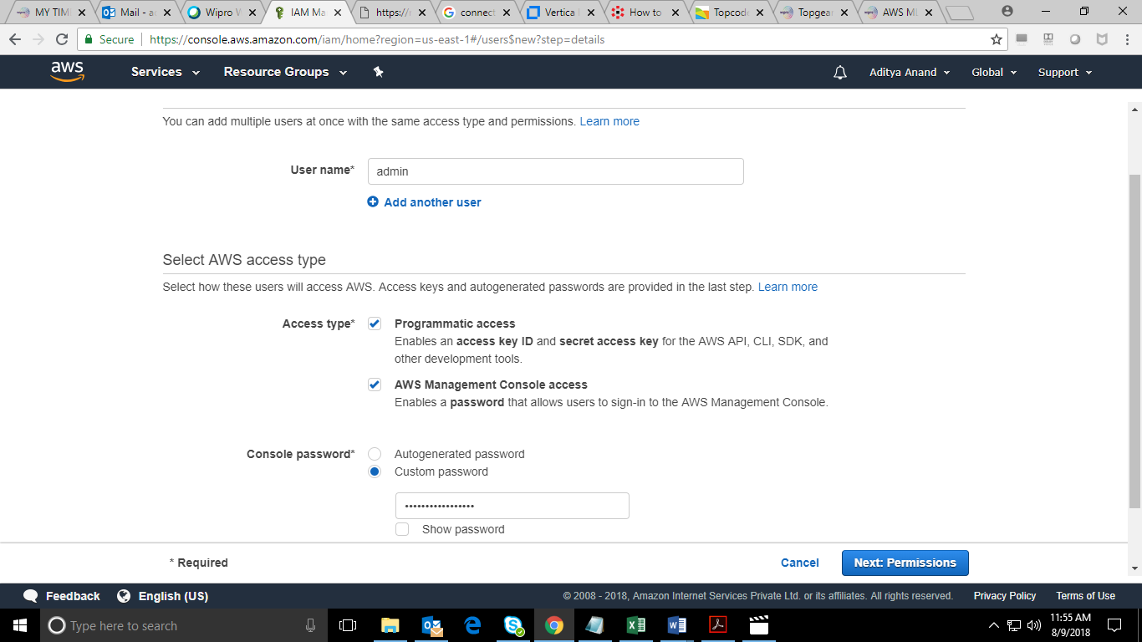

1. Create a group with full administrator access .

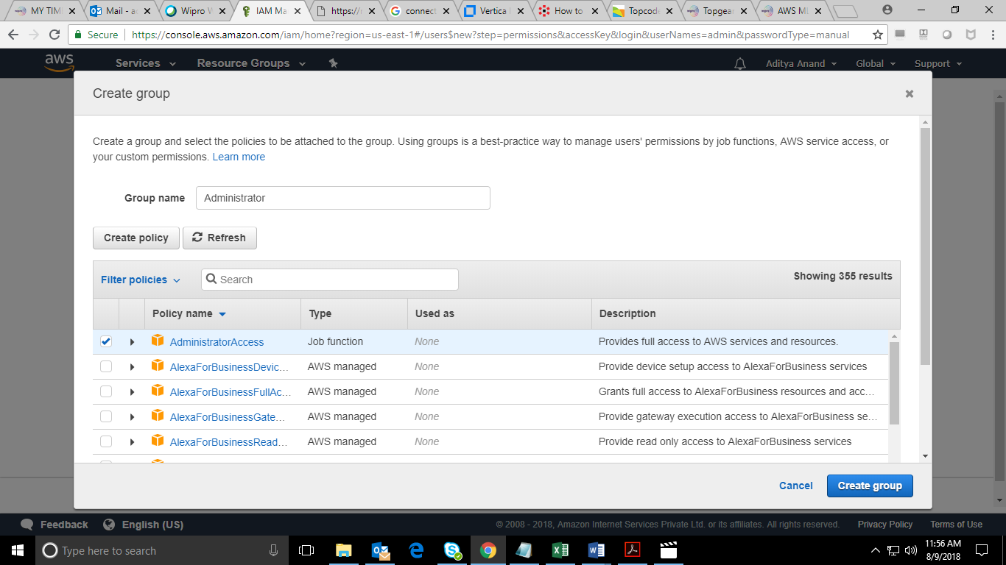

1. Add the created user to the group .

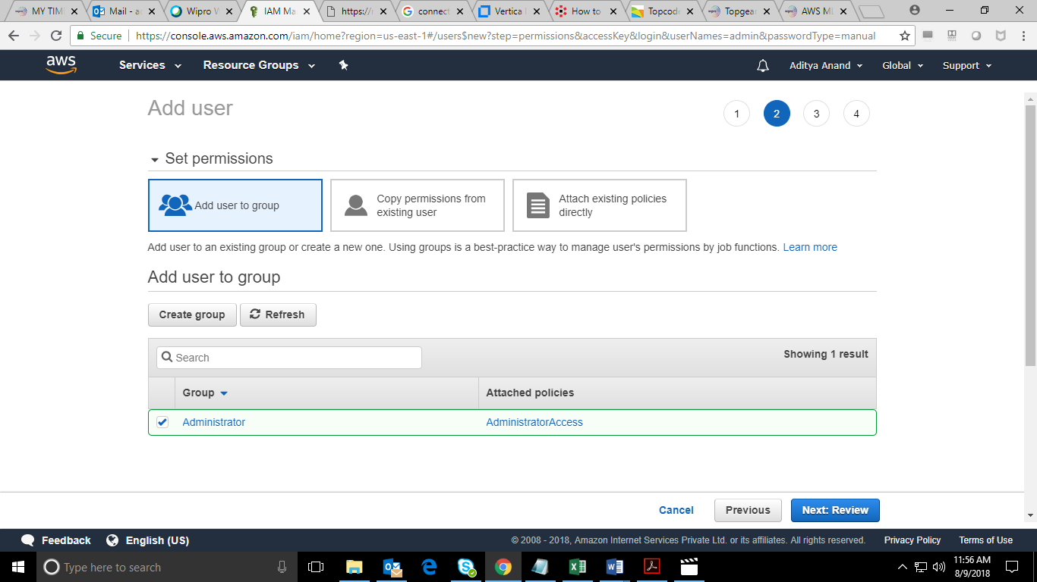

1. Review and select create user .

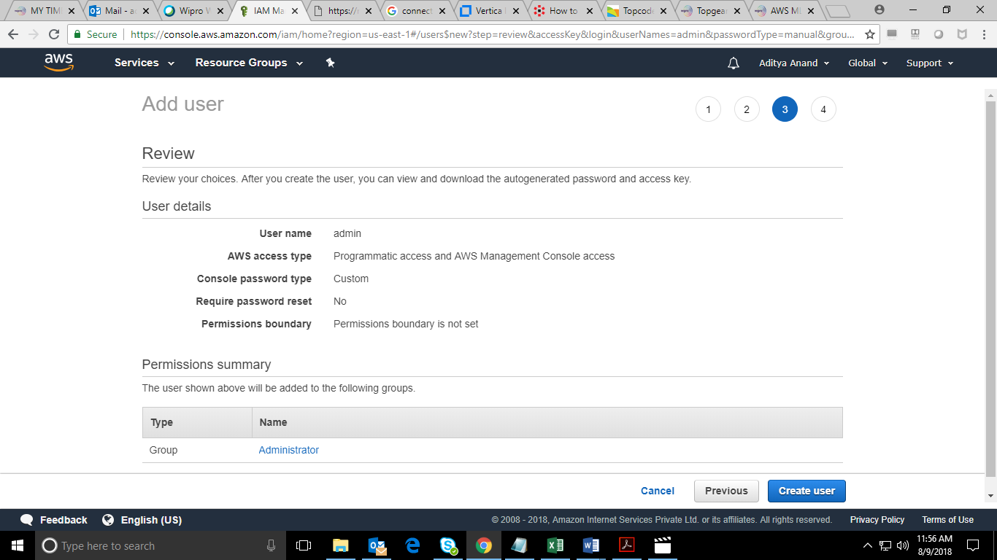

1. Login through the created IAM user credentials .

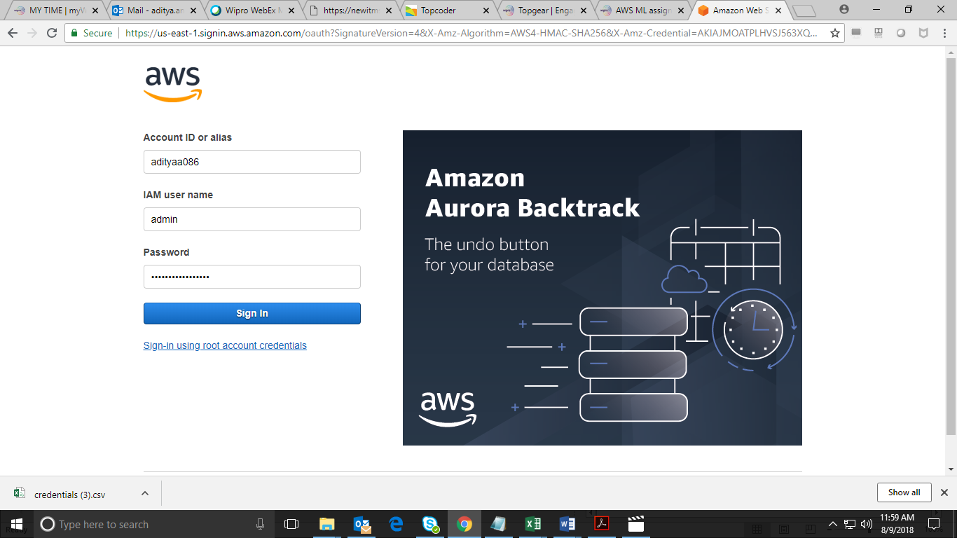

1. We can see we are under the created IAM user .

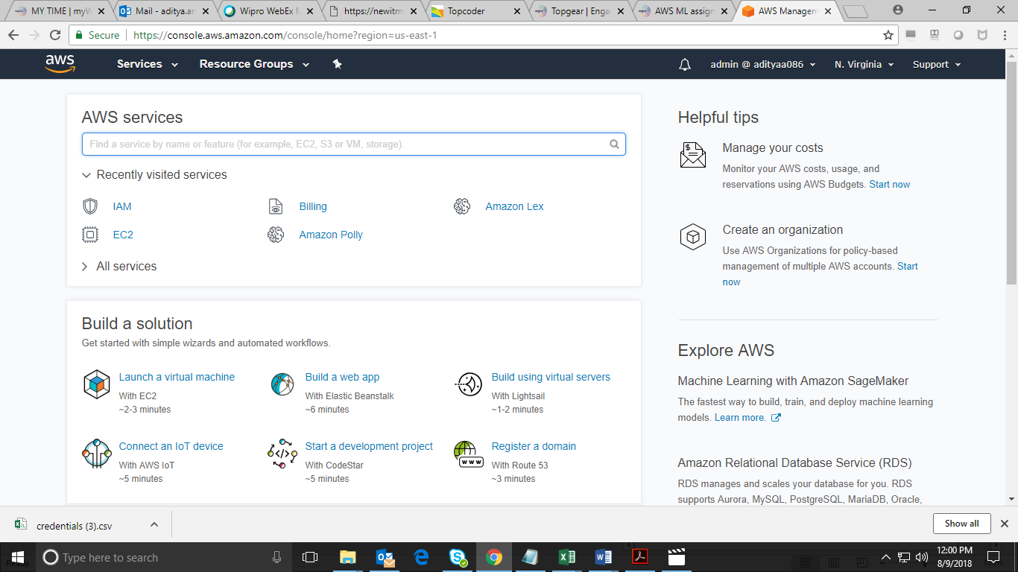

**Solution to the given question**

1. Select Amazon Polly from Machine learning . Put the text there “The sun does arise and make happy the skies. The merry bells ring to welcome the spring.”
2. From voice choose “Mathew,Male” . Listen to speech and download the MP3 .

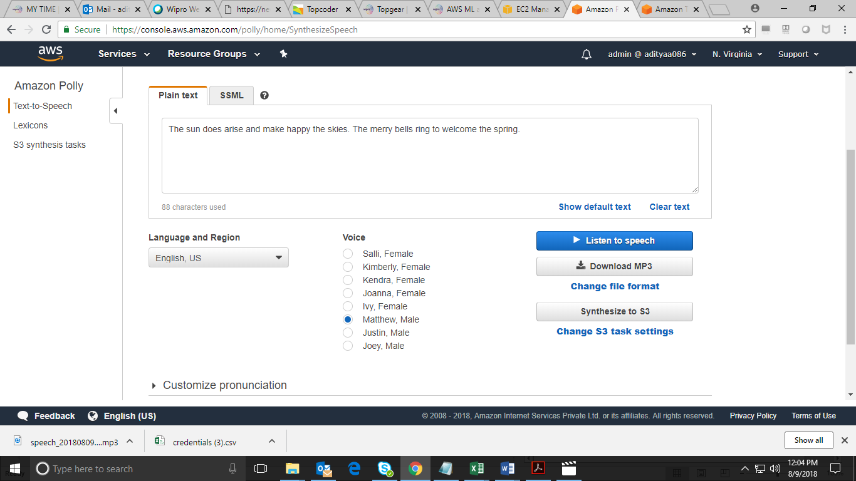

1. Under storage select S3 . Click on create bucket option and give the bucket name .

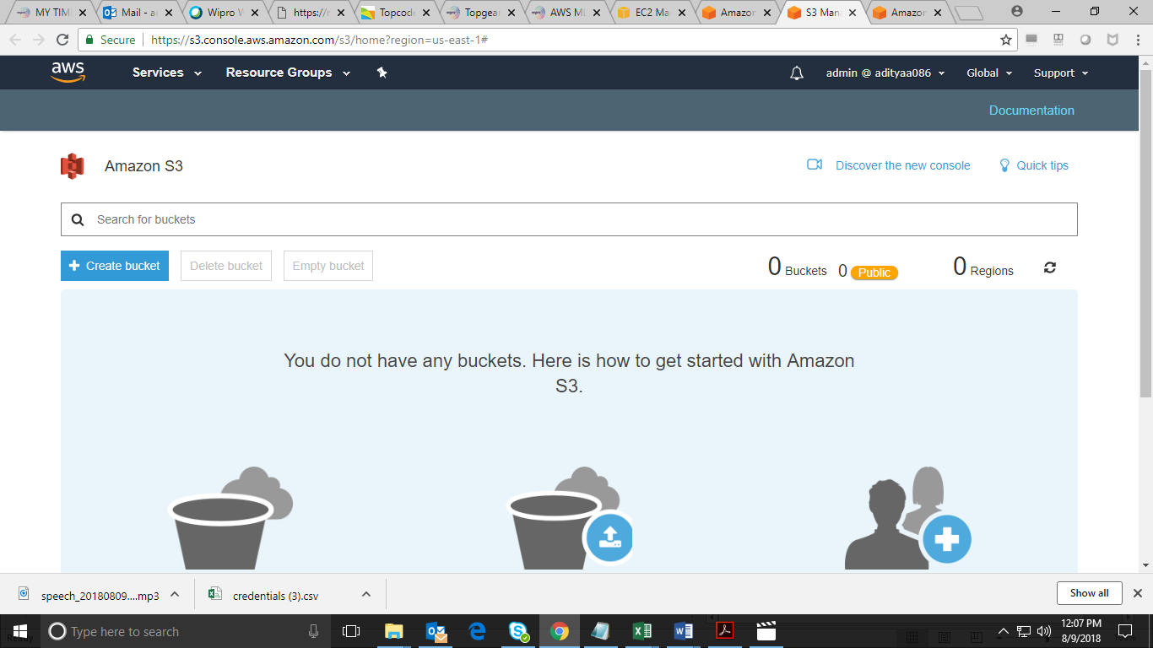

1. Set the permissions for the created bucket .

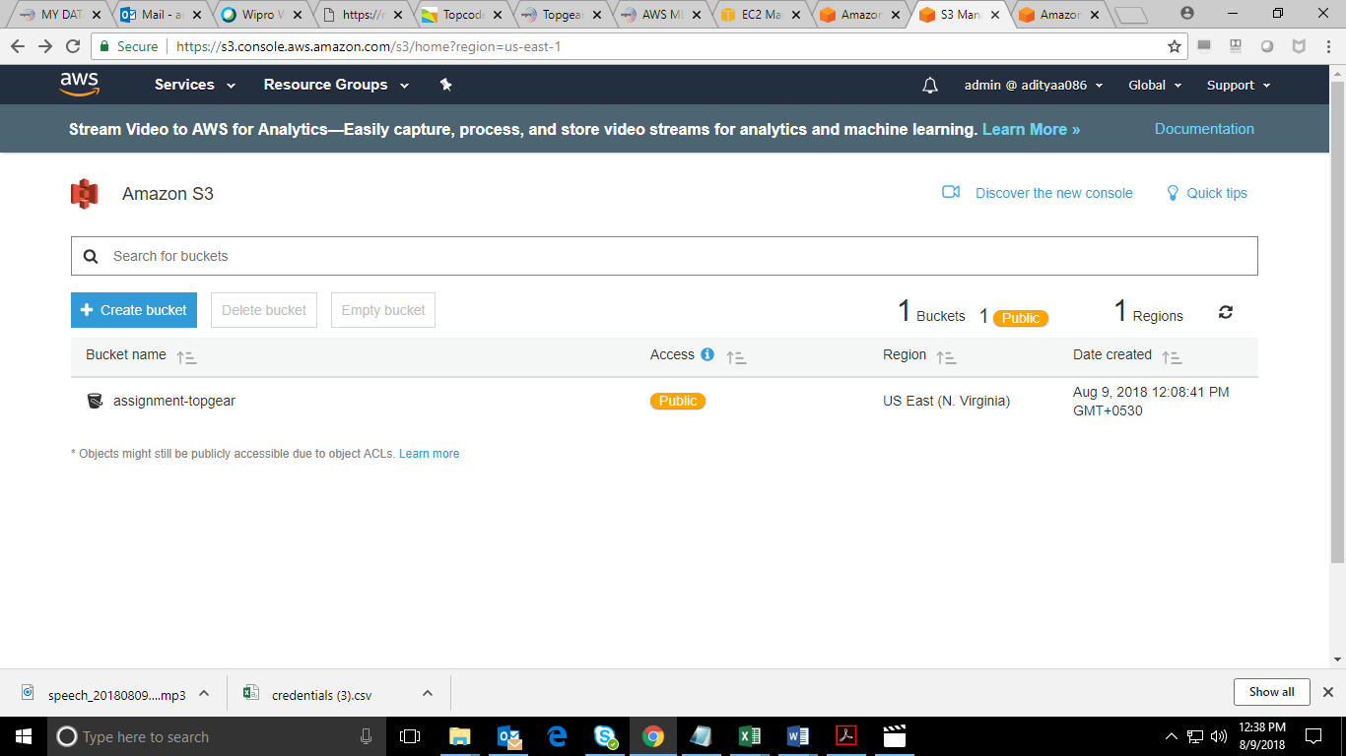

1. Upload the downloaded MP3 inside the bucket .

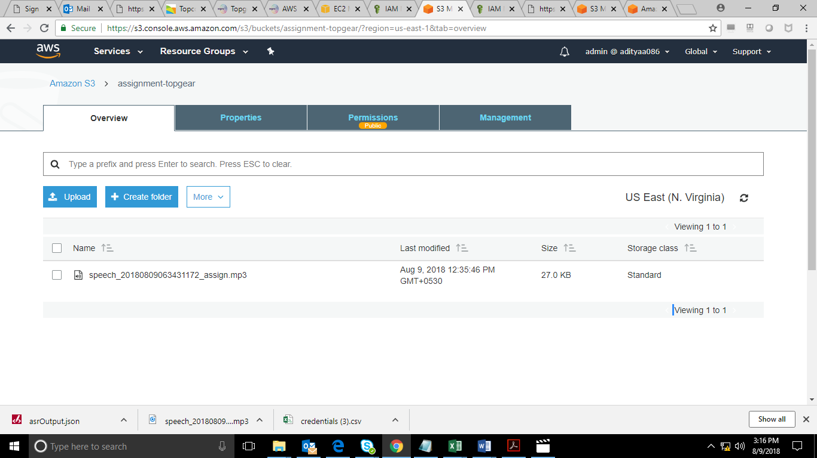

1. Under Machine Learning choose Amazon Transcribe . Provide the name and the S3 input URL .

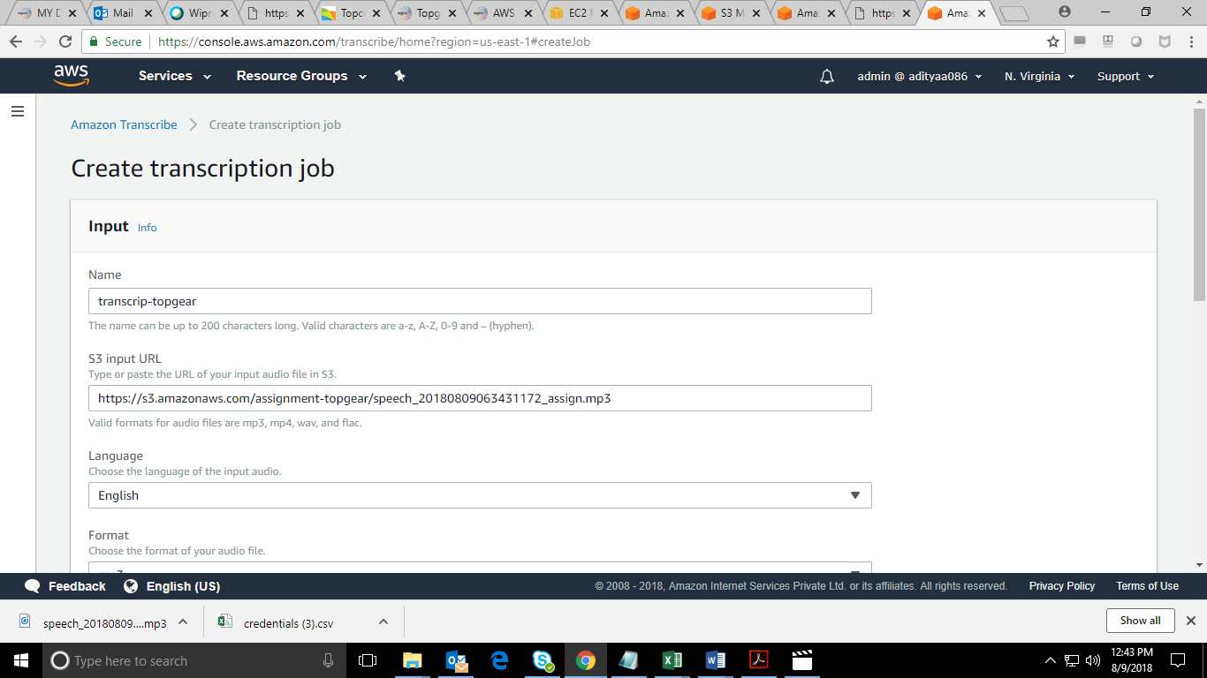

1. After Transcription we found that we got the exact same text .

