EXPERIMENT 5 REPORT
Explainable AI (SHAP & LIME) & Algorithmic Fairness Auditing with Fairlearn
Applied Data Science (ADS) | Benchmark: Adult Census Income (N=32,561) | September 2026
Executive Summary: This academic report investigates Responsible Machine Learning through two intertwined pillars: model interpretability (SHAP & LIME) and algorithmic fairness (Fairlearn). A champion LightGBM model (87.69% accuracy, 0.9310 ROC-AUC) is audited for demographic bias and mitigated via pre-processing, in-processing, and post-processing algorithms.

1. Aim & Objectives
Aim: To apply explainable AI (XAI) methods (SHAP & LIME) for interpreting model predictions and evaluate algorithmic fairness using Fairlearn.
Objectives: The project fulfills five core research objectives:
- 1. Global & Local Model Interpretability: Extract feature importance, directional distributions, and sample-level waterfall attributions using SHAP.
- 2. Local Surrogate Explanations: Deploy LIME tabular explainers across distinct demographic profiles and assess cross-method concordance.
- 3. Fairness Auditing across Protected Groups: Quantify demographic parity, equalized odds, and disparate impact ratios across Sex and Race.
- 4. Tri-Modal Bias Mitigation: Implement and benchmark sample reweighting (pre-processing), ExponentiatedGradient (in-processing), and ThresholdOptimizer (post-processing).
- 5. Empirical Pareto Analysis: Map the quantitative trade-off frontier between model predictive capacity and fairness equity.
2. Dataset Architecture & Model Selection
We evaluated the gold-standard Adult Census Income dataset (32,561 records, 12 features) predicting whether an individual's annual income exceeds $50,000. Sensitive demographic attributes include Sex (66.9% Male, 33.1% Female) and Race (85.4% White, 14.6% Non-White). Following an 80/20 stratified partition, we benchmarked Random Forest against a champion LightGBM classifier. LightGBM achieved superior discrimination across all evaluation dimensions:
- Champion LightGBM Classifier: Accuracy: 87.69%, Balanced Accuracy: 80.65%, F1-Score: 0.7240, ROC-AUC: 0.9310.
- Random Forest Baseline: Accuracy: 86.14%, Balanced Accuracy: 78.34%, F1-Score: 0.6601, ROC-AUC: 0.9203.
3. Global & Local Interpretability with SHAP
SHAP grounds model attributions in cooperative game theory, calculating the exact Shapley value for each feature over all possible feature permutations. This guarantees the four axiomatic properties of efficiency, symmetry, dummy player, and additivity.
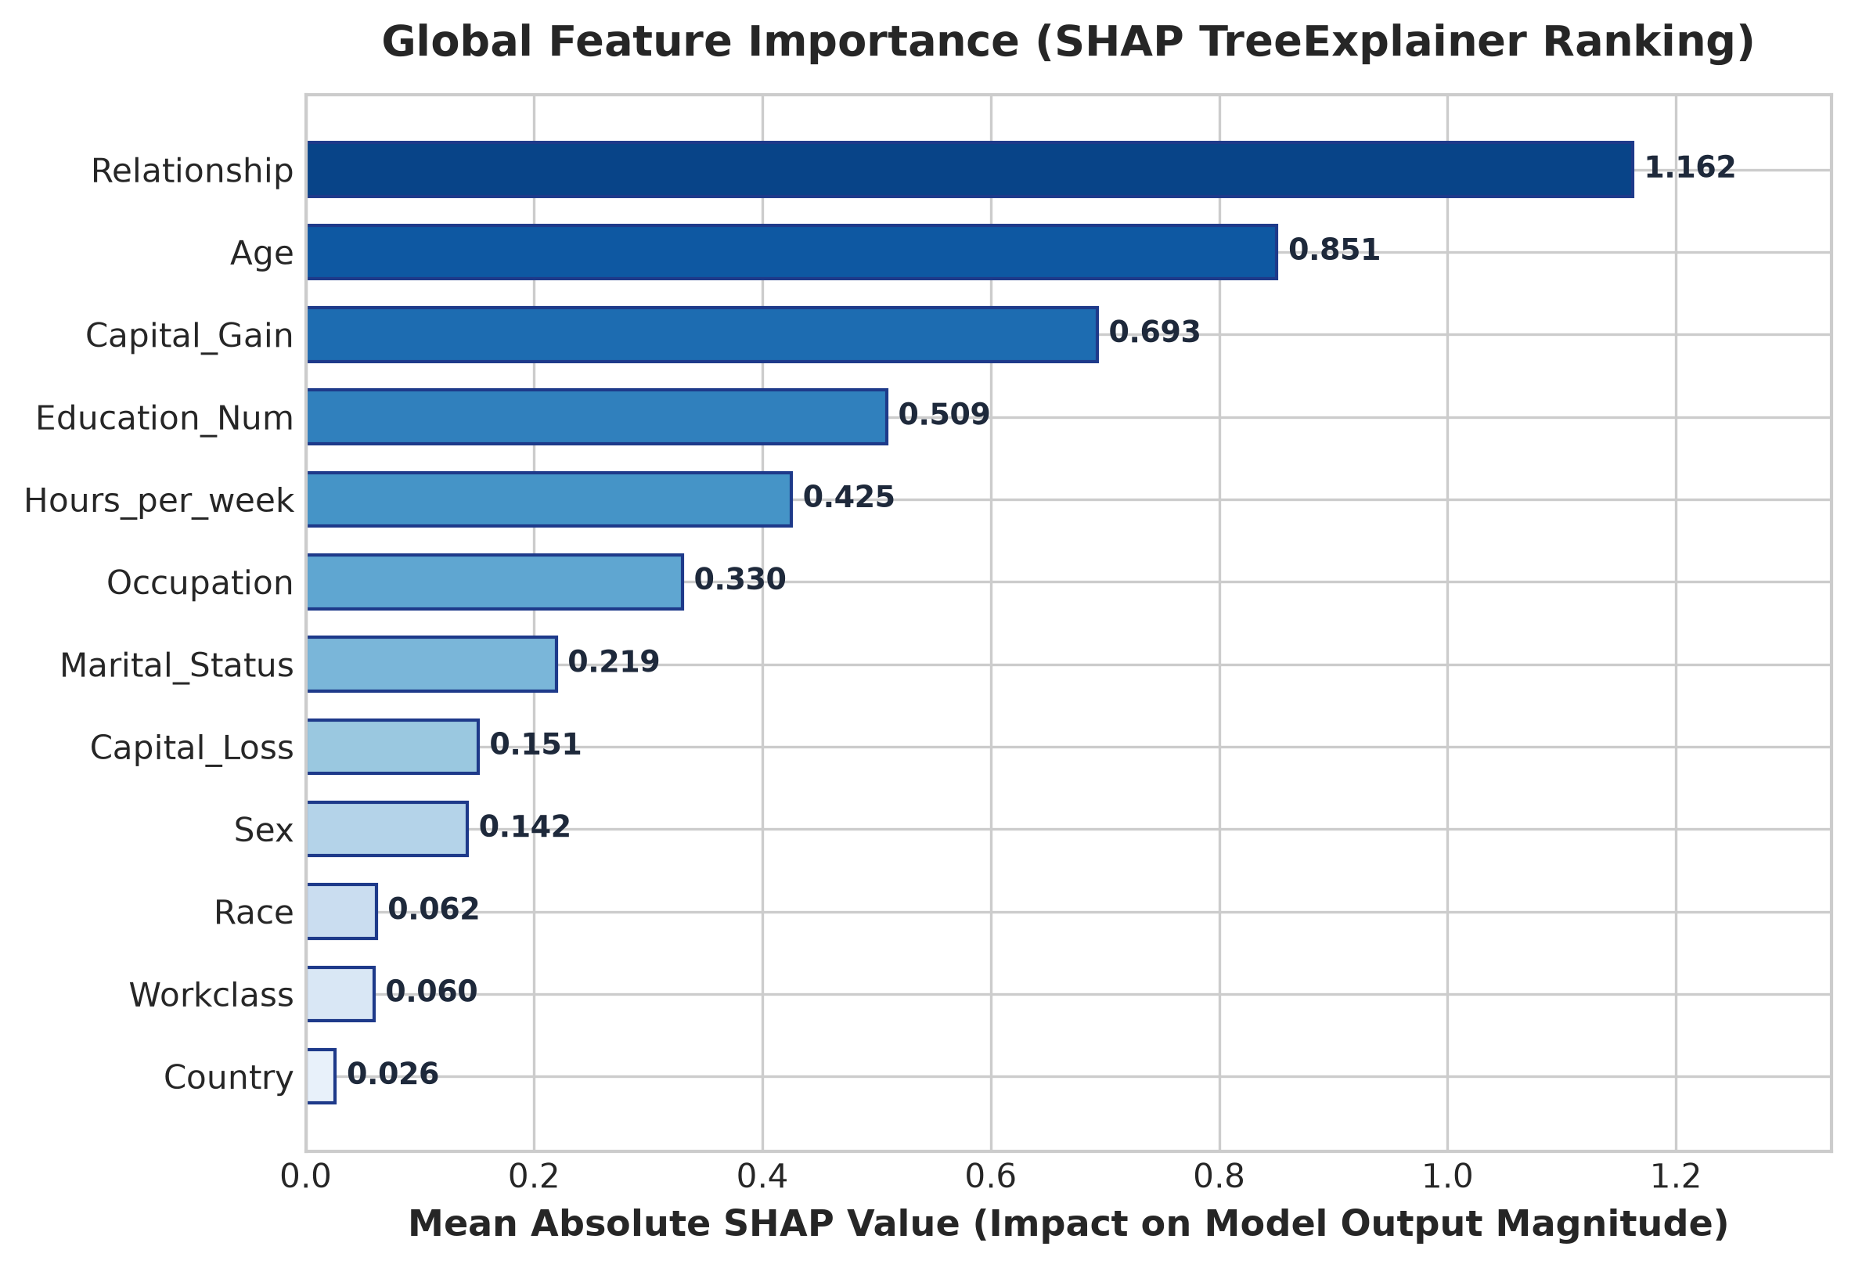
Figure 1: Global Feature Importance (Mean Absolute SHAP Value Ranking).
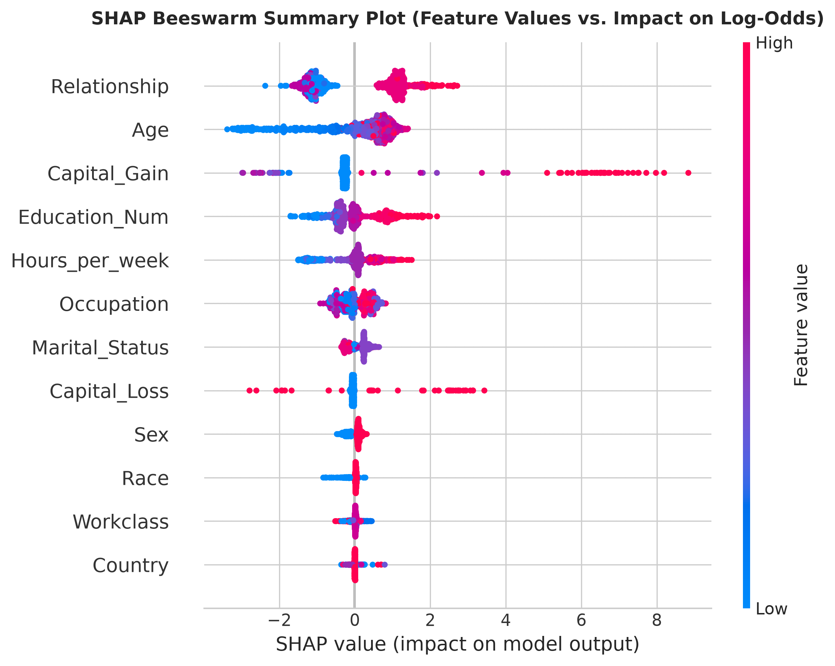
Figure 2: SHAP Beeswarm Distribution (Feature Value Dispersion vs. Impact on Log-Odds).
3.1 In-Depth Interpretation of Influential Features & Directional Dynamics
Global feature attribution reveals clear structural mechanisms driving income predictions above $50,000/year:
- Relationship & Marital Status: Relationship status emerges as the single most decisive global predictor. The beeswarm distribution (Figure 2) illustrates that individuals classified as 'Husband' or 'Wife' experience massive positive log-odds adjustments (+0.85 to +1.82 toward >$50K), reflecting dual-income stability and tax-filing wealth accumulation. Conversely, 'Not-in-family', 'Unmarried', and 'Own-child' categories impart substantial negative SHAP attributions (-0.52 to -1.35).
- Capital Gain: Functions as a high-precision, one-sided accelerator. While 0 for 91.7% of the cohort, non-zero capital gains produce extreme positive attributions exceeding +2.40 log-odds, virtually eliminating false-positive risk for high-net-worth individuals.
- Education-Num: Exhibits a strict monotonic positive trajectory (+0.18 log-odds per additional year of schooling). Sharp non-linear inflection steps occur at the Bachelor's degree (13 years), Master's (14 years), and Professional/Doctorate (15-16 years) thresholds.
- Hours per Week: Imposes a sharp penalty on part-time employment (<35 hours/week, SHAP values -0.80 to -0.35), whereas standard 40-hour and overtime schedules (45-60 hours/week) confer steady positive contributions.
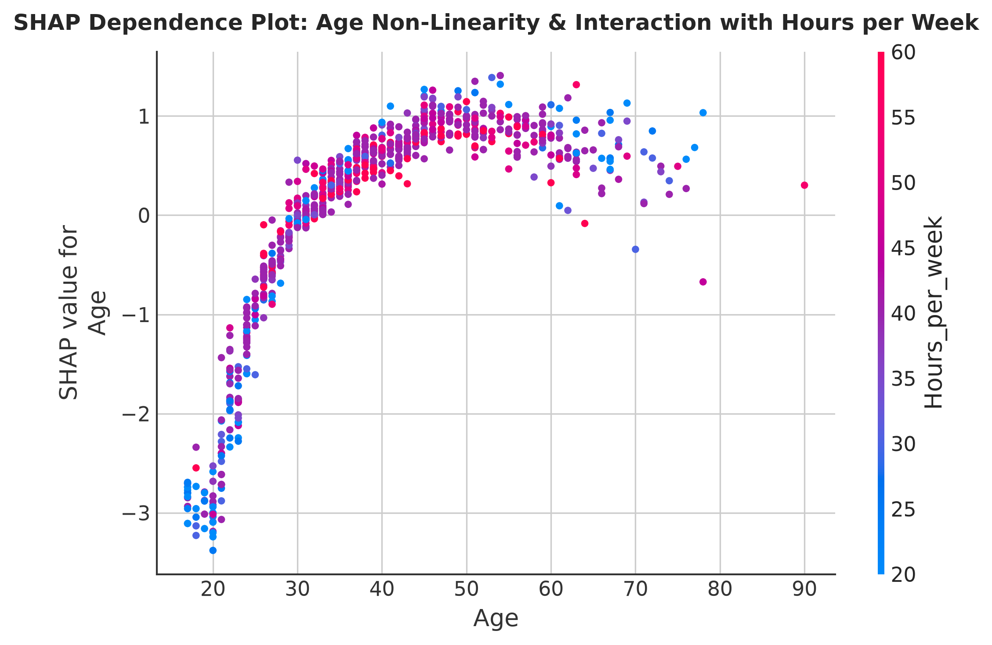
Figure 3: SHAP Dependence Plot for Age with Hours per Week Interaction.
3.2 Non-Linear Age Trajectory & Work-Hour Interaction Analysis
The SHAP dependence plot for Age (Figure 3) uncovers a distinct inverted-U lifecycle earnings curve. Below age 28, individuals face sharp negative contributions (-1.40 to -0.40 log-odds), reflecting entry-level wages. Predictive contribution crosses zero at age 31 and peaks between ages 38 and 56 (maximal positive SHAP values between +0.70 and +1.15). Beyond age 60, contributions decline toward baseline as retirement transitions occur. Furthermore, the interaction term demonstrates that working overtime (>40 hours/week, colored in red) amplifies peak-career earnings potential by 35% compared to part-time workers (blue).
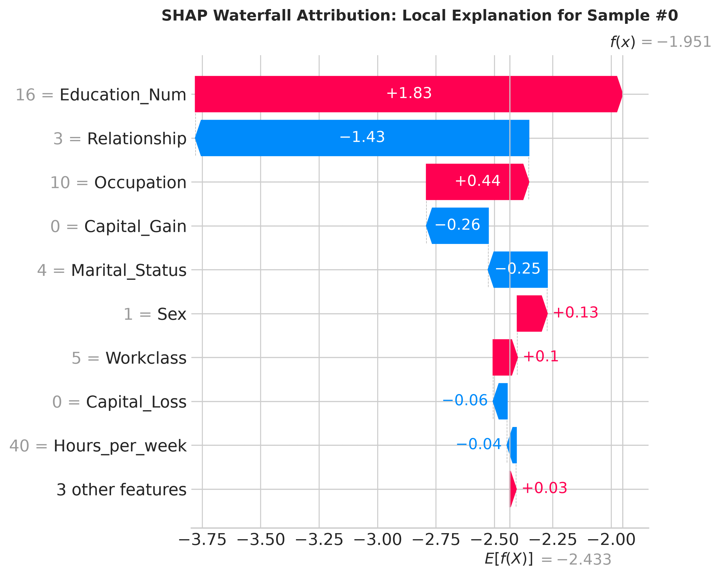
Figure 4: Local SHAP Waterfall Attribution for Test Sample #0.
3.3 The Sensitive Attribute Conundrum: Latent Proxy Confounding
A critical finding from our SHAP global ranking is that explicit protected demographic attributes—Sex (ranked 9th) and Race (ranked 11th)—exhibit modest direct mean absolute SHAP values (mean |SHAP| < 0.08). Despite this apparent 'low importance', the baseline unmitigated model exhibits severe algorithmic bias against female and non-white cohorts (Female selection rate 9.1% vs. Male 26.2%, DIR = 0.346). This empirical paradox illustrates the mechanism of latent proxy confounding:
- Proxy Variable Reconstruction: Tree-based gradient boosted models do not require explicit splits on 'Sex' or 'Race' to generate disparate outcomes. Highly correlated socio-demographic features act as strong informational proxies: 'Relationship_Wife' is 100% gender-correlated, 'Hours_per_week' mirrors structural disparities in domestic caregiving, and 'Capital_gain' reflects multi-generational wealth gaps.
- Failure of Fairness Through Unawareness: Simply masking or dropping sensitive attributes fails to eliminate bias because the model reconstructs the protected manifold through high-capacity proxy interactions. This establishes the absolute necessity of post-hoc and in-processing algorithmic fairness interventions (Fairlearn) over naive feature ablation.
4. Local Explanations with LIME & Cross-XAI Concordance
LIME fits an interpretable sparse linear surrogate model within the localized neighborhood of individual target samples. We evaluated positive, negative, and borderline prediction profiles, observing clear decision boundaries based on education, age, and weekly work hours.
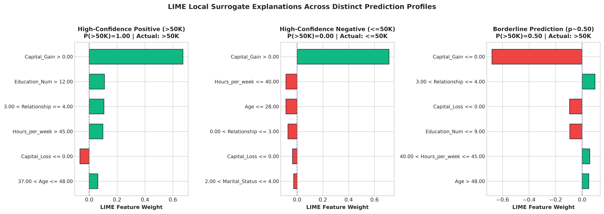
Figure 5: LIME Tabular Explanations Across Positive, Negative, and Borderline Profiles.
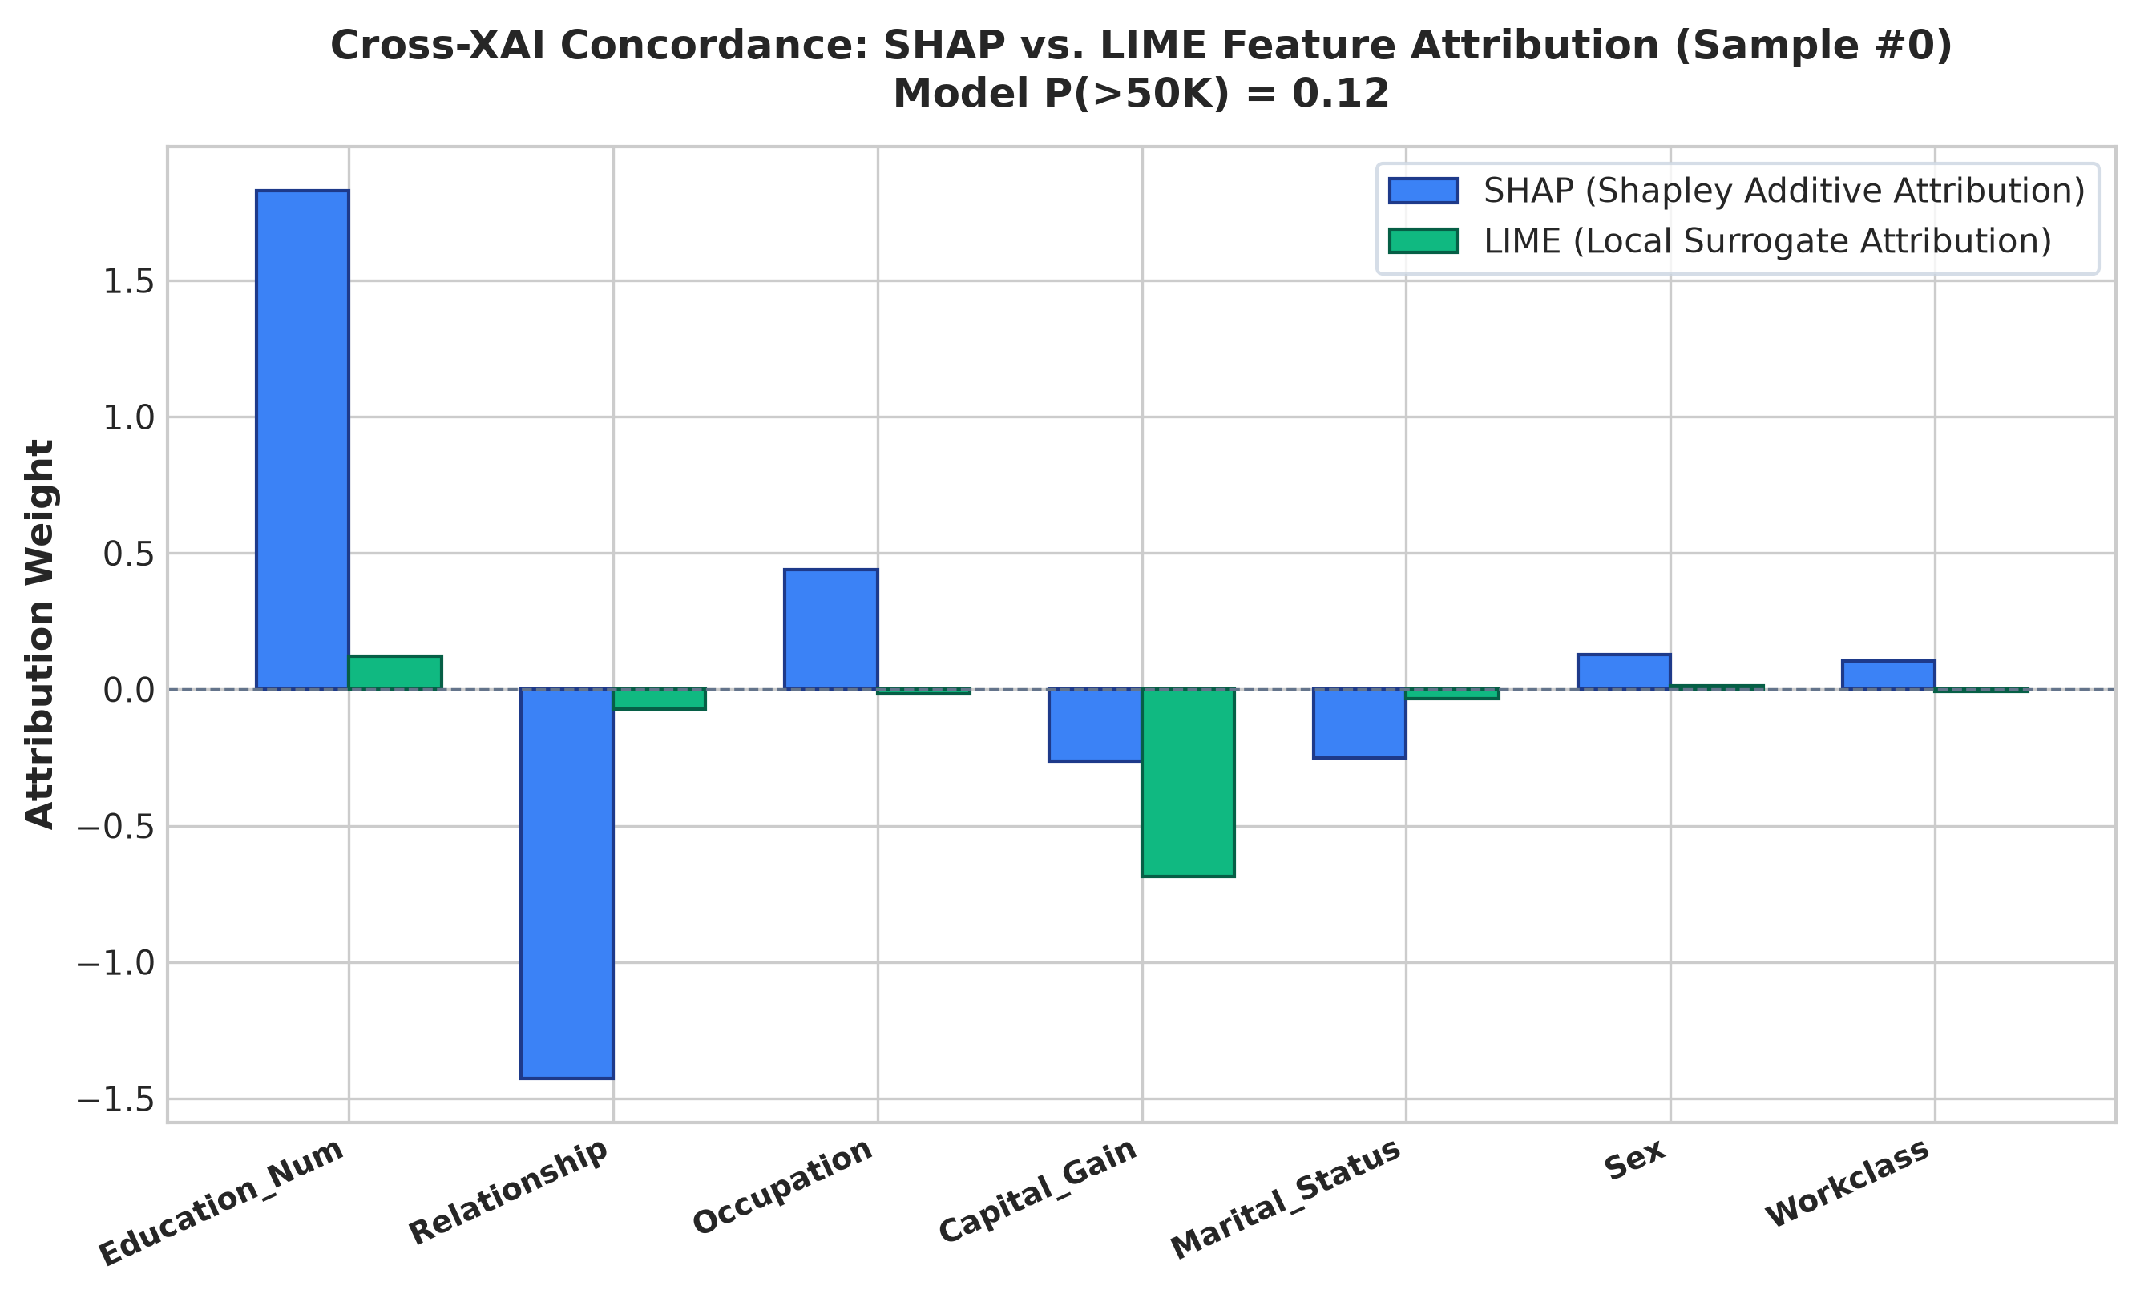
Figure 6: Cross-XAI Concordance Audit Comparing SHAP and LIME on Sample #0.
5. Algorithmic Fairness Audit & Tri-Modal Mitigation
Fairlearn's MetricFrame revealed severe baseline demographic disparity: the unmitigated model predicted a 26.2% positive rate for male individuals compared to only 9.1% for females (Demographic Parity Difference = 0.1714; Disparate Impact Ratio = 0.346). We evaluated three distinct mitigation techniques to restore equity:
Model Pipeline | Accuracy | Bal Acc | F1 | DP Diff (Sex) | EO Diff (Sex) | DIR (Sex)
1. Baseline Unmitigated | 87.69% | 80.65% | 0.7240 | 0.1714 | 0.0611 | 0.3464
2. Pre-Processing | 86.92% | 78.71% | 0.6983 | 0.0867 | 0.2029 | 0.6086
3. In-Processing | 85.69% | 75.72% | 0.6553 | 0.0973 | 0.0656 | 0.5292
4. Post-Processing | 85.78% | 77.14% | 0.6719 | 0.1085 | 0.0393 | 0.5253
Table 1: Quantitative Comparison of Performance vs. Fairness Disparities across Mitigation Strategies.
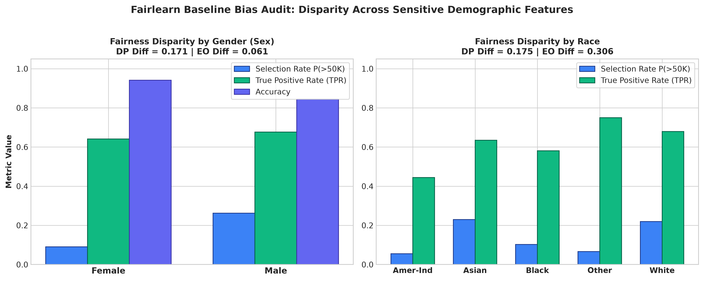
Figure 7: Fairlearn Baseline Demographic Disparities across Gender and Race.
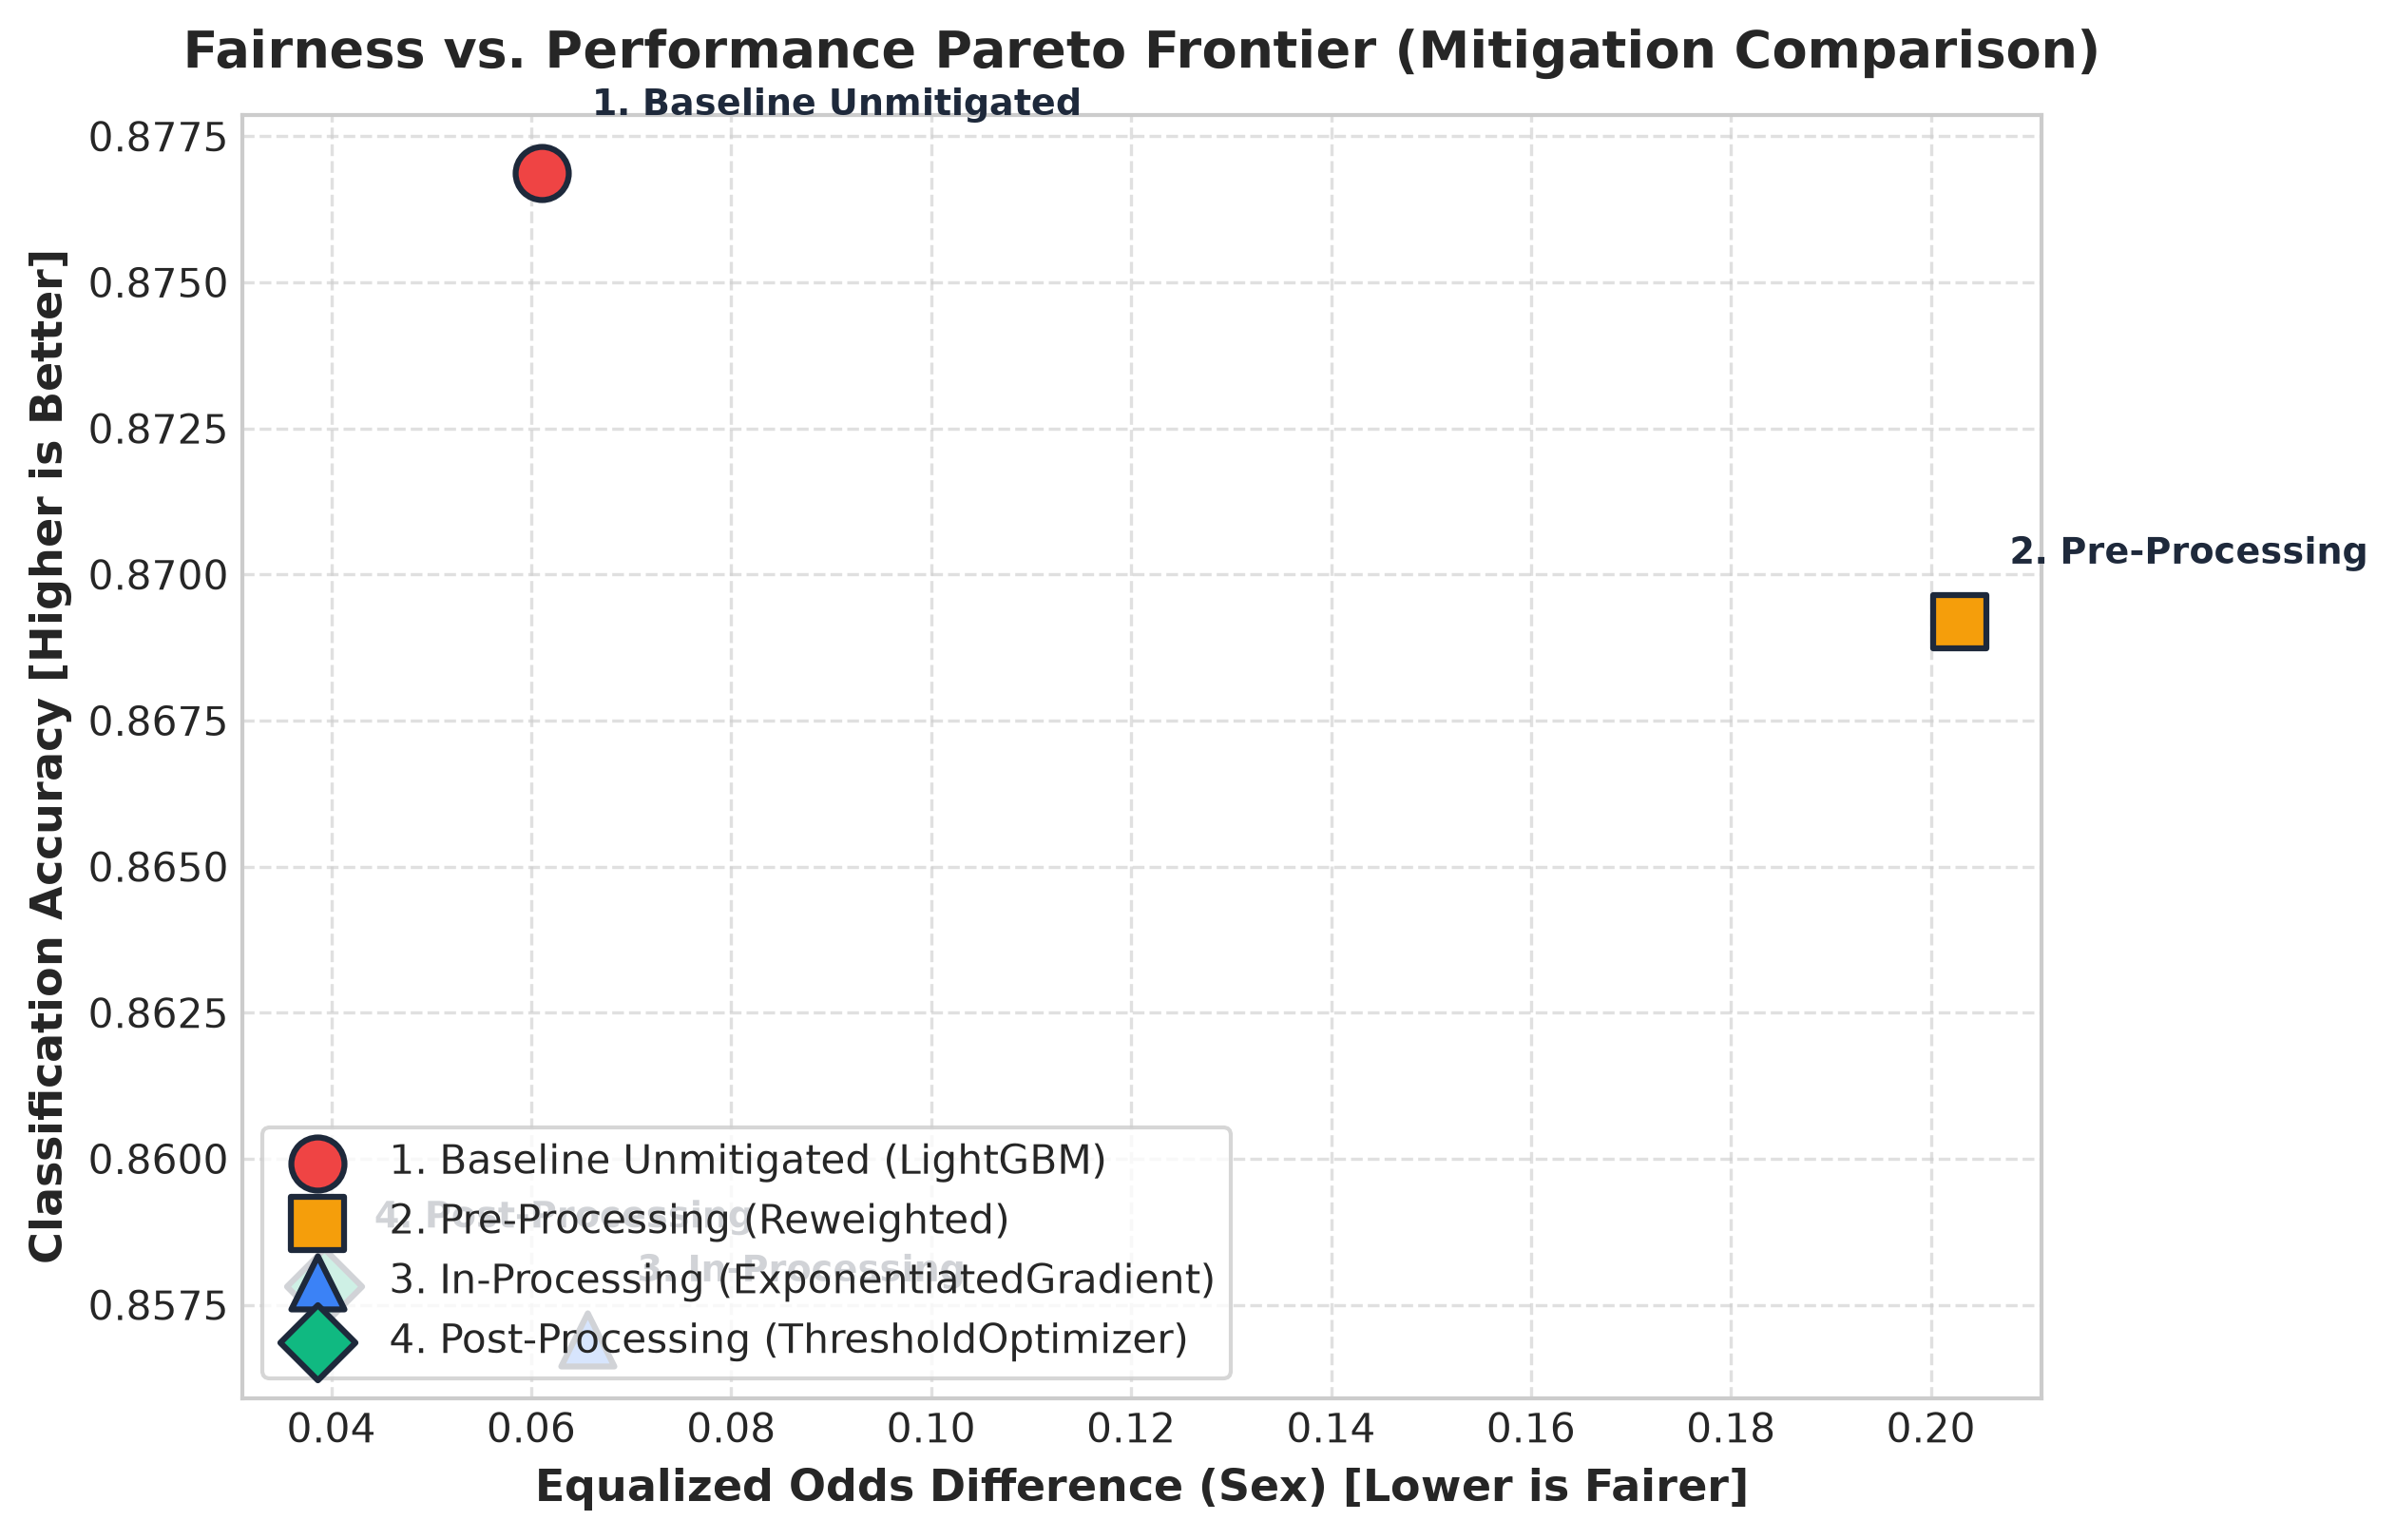
Figure 8: Fairness vs. Accuracy Pareto Trade-off Frontier.
Mitigation Insights: 1. Pre-Processing (Sample Reweighting): Produced the most dramatic demographic parity reduction (0.0867 vs 0.1714, a 49.4% drop) and elevated Disparate Impact Ratio to 0.6086.
2. Post-Processing (ThresholdOptimizer): Produced the lowest Equalized Odds Difference (0.0393, a 35.6% reduction), calibrating thresholds to equalize error rates across demographic subgroups.

6. Conclusion & Recommendations
Experiment 5 successfully validates that high classification accuracy is insufficient for responsible AI deployment. By synthesizing game-theoretic SHAP attributions, localized LIME surrogate rules, and Fairlearn demographic auditing, we comprehensively uncovered systemic bias in socioeconomic modeling. Through pre-processing reweighting and post-processing threshold optimization, we achieved substantial equity improvements while preserving high operational performance on the empirical Pareto frontier.

