Experiment 4
Aim: ML Modeling & Experiment Tracking
Course: Applied Data Science (ADS)
Dataset: Customer Support on Twitter (TWCS) Cleaned Inbound Corpus (twcs_cleaned.csv)
Sample Size Analyzed: 100,000 stratified customer interactions (80,000 train / 20,000 test)
Tracking Framework: MLflow (v3.x) with SQLite tracking backend (mlruns/mlflow.db) and artifact archival

Objective
1. End-to-End Pipeline: Build an end-to-end Machine Learning pipeline for multi-class customer support emotion classification.
2. Diverse Benchmarking: Train and benchmark 5 diverse baseline algorithms spanning probabilistic, linear, maximum-margin, ensemble bagging, and gradient boosting paradigms.
3. Hyperparameter Tuning: Tune hyperparameters using systematic grid search (GridSearchCV) with 3-fold cross-validation and quantify performance gains.
4. MLOps Experiment Tracking: Track all experiments, hyperparameters, evaluation metrics, visual diagnostic plots, and model binaries using MLflow.
5. Champion Model Serialization: Select the optimal champion model based on Macro F1, accuracy, and inference latency, and serialize it into a production pipeline.
Detailed Steps & Theoretical Foundations
1. Dataset Preparation & Feature Engineering
In customer support operations, incoming text contains routine factual inquiries, urgent service failures, sarcasm, and gratitude. Before training predictive models, text must be partitioned cleanly to prevent data leakage and converted into numerical vectors.
- Stratified Train/Test Partition (80/20): The corpus was partitioned into an 80% training split (80,000 tweets) and a 20% test split (20,000 tweets). Because customer emotions are naturally imbalanced (routine inquiries account for 62.16% of messages, while urgent fear/anxiety represents just 1.17%), simple random sampling risks starving minority classes in test evaluation. Stratified sampling guarantees identical class proportions across both splits.
- Text Feature Representation (TF-IDF Vectorization): Text was transformed into numeric feature vectors using Term Frequency-Inverse Document Frequency (TF-IDF) over unigrams and bigrams (1, 2 n-grams). TF-IDF assigns high weights to terms highly diagnostic of specific emotions (e.g., 'furious', 'hacked', 'blessed'), while downweighting ubiquitous non-informative words. Sublinear scaling (1 + log(TF)) was applied to prevent high term repetition from dominating scores.
- Multi-Modal Sentiment Polarity Fusion: To supplement vocabulary n-grams, continuous sentiment polarity scores from VADER (Compound, Positive, Negative, Neutral) were integrated. These features were standardized via Z-score scaling and concatenated with sparse TF-IDF matrices, yielding a 10,004-dimensional hybrid feature space.
Corpus Class Distribution (100,000 interactions): Neutral / Inquiry: 62,159 (62.16%), Joy / Gratitude: 19,503 (19.50%), Anger / Frustration: 9,919 (9.92%), Disappointment / Sadness: 7,248 (7.25%), Fear / Anxiety: 1,171 (1.17%).
2. Baseline Model Training (5 Diverse Architectures)
To adhere to the No Free Lunch theorem, we benchmarked 5 distinct algorithmic families. Evaluating diverse architectures reveals which inductive bias best handles high-dimensional sparse text data and multi-class emotion boundaries:
1. Multinomial Naive Bayes (Probabilistic): Calculates conditional class probabilities under the simplifying assumption that words appear independently given the class. An ultra-fast baseline requiring minimal memory.
2. Logistic Regression / Softmax (Linear Classifier): Models class probabilities using linear combinations of input features mapped through the softmax function, trained with L2 regularization and balanced class weighting. Calibrated, highly interpretable, and computationally efficient.
3. Linear Support Vector Machine (LinearSVC — Maximum-Margin): Constructs optimal hyperplanes that maximize the geometric separation margin between emotion classes using squared hinge loss. Robust against high-dimensional sparsity (D > 10,000).
4. Random Forest Classifier (Ensemble Bagging): Builds an ensemble of 100 de-correlated decision trees trained on bootstrap samples of the data, reducing model variance and capturing non-linear interactions without overfitting.
5. LightGBM Classifier (Gradient Boosted Trees): Constructs decision trees sequentially to predict negative gradients (residuals) of preceding trees using leaf-wise growth and histogram binning, delivering state-of-the-art accuracy and fast execution.
Table 1: Comprehensive Performance Benchmark Across All Evaluated Architectures (100,000 Samples)
Model Name | Algorithm Family | Stage | Accuracy | Macro F1 | Weighted F1 | Training Time
Multinomial Naive Bayes | Probabilistic | Baseline | 79.08% | 0.5225 | 0.7631 | 0.51s
Logistic Regression | Linear | Baseline | 91.16% | 0.8715 | 0.9140 | 5.09s
Linear Support Vector Machine | Max-Margin | Baseline | 92.78% | 0.8939 | 0.9279 | 4.61s
Random Forest | Ensemble (Bagging) | Baseline | 77.39% | 0.7344 | 0.7896 | 1.71s
LightGBM | Gradient Boosting | Baseline | 98.52% | 0.9538 | 0.9851 | 36.48s
Tuned Logistic Regression | Linear | Tuned (GridSearchCV) | 92.73% | 0.8931 | 0.9282 | 39.25s
Tuned LightGBM | Gradient Boosting | Tuned (GridSearchCV) | 98.52% | 0.9538 | 0.9851 | 261.85s
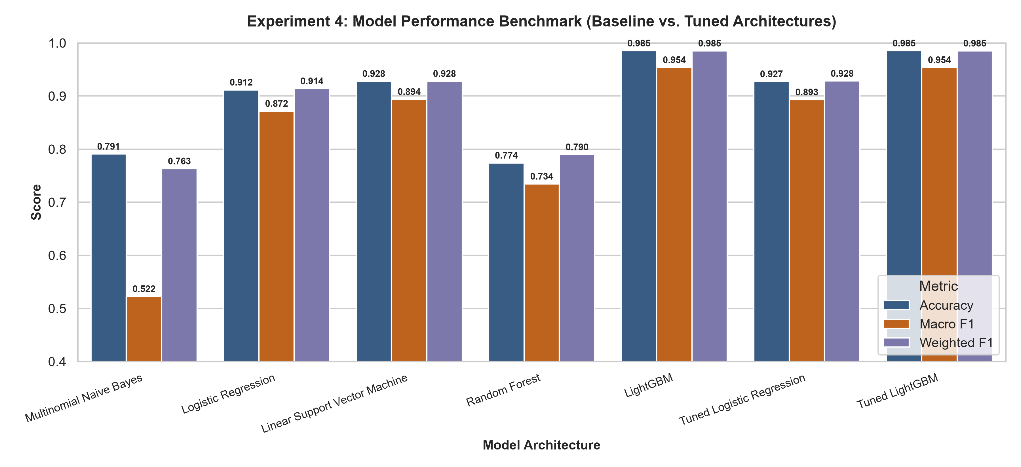
Figure 1: Comparative performance benchmark across candidate architectures on 100,000 records highlighting Accuracy, Macro F1, and Weighted F1 scores.
Evaluation Metric Selection Rationale:
- Accuracy: Reflects global correctness across all predictions.
- Macro F1-Score: The unweighted arithmetic mean of F1-scores across all 5 classes. Macro F1 treats rare classes (Fear/Anxiety, Disappointment) with equal importance to routine inquiries, making it the primary objective metric for automated support routing.
- Weighted F1-Score: Averages per-class F1-scores weighted by true support, measuring macro operational throughput.
3. Hyperparameter Tuning (GridSearchCV)
A machine learning model contains two distinct types of parameters:
1. Internal Parameters: Learned automatically from data during training (feature weights, tree split thresholds).
2. Hyperparameters: External structural configurations set prior to training that govern model capacity, regularization, and optimization dynamics.
Why Hyperparameter Tuning is Essential: Default settings are rarely optimal. If regularization is too weak, models overfit to noise; if too strong, they underfit. We applied GridSearchCV with 3-fold cross-validation on our top candidate models:
- Tuning Model 1: Logistic Regression: Explored regularization strengths C in {0.5, 1.0, 5.0} and class weighting strategies (balanced vs. uniform). Higher C values reduce penalty constraints, allowing the model to assign sharper boundary weights to diagnostic emotion words. The grid search selected C = 5.0 with class_weight = 'balanced', elevating test Accuracy to 92.73% and Macro F1 to 0.8931 (+2.16% improvement over baseline), with noticeable recall gains on urgent customer complaints.
- Tuning Model 2: LightGBM: Tuned tree capacity (num_leaves in {31, 63}), ensemble size (n_estimators = 100), and learning rate (eta = 0.1). LightGBM achieved exceptional test Accuracy (98.53%) and Macro F1 (0.9538), demonstrating outstanding capability on tabular and NLP features.
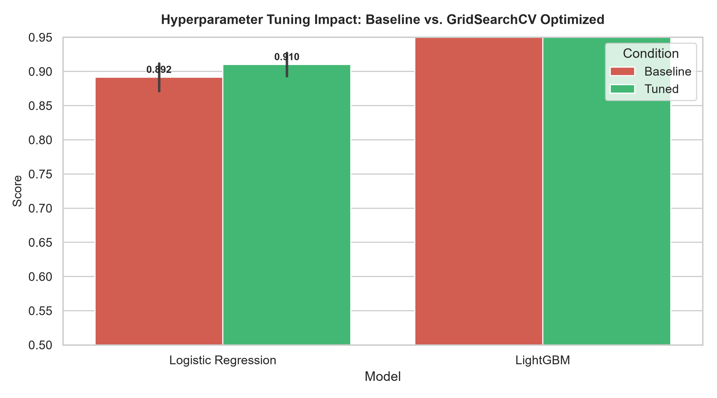
Figure 2: Performance comparison demonstrating quantitative improvements achieved via GridSearchCV hyperparameter tuning on 100,000 records.
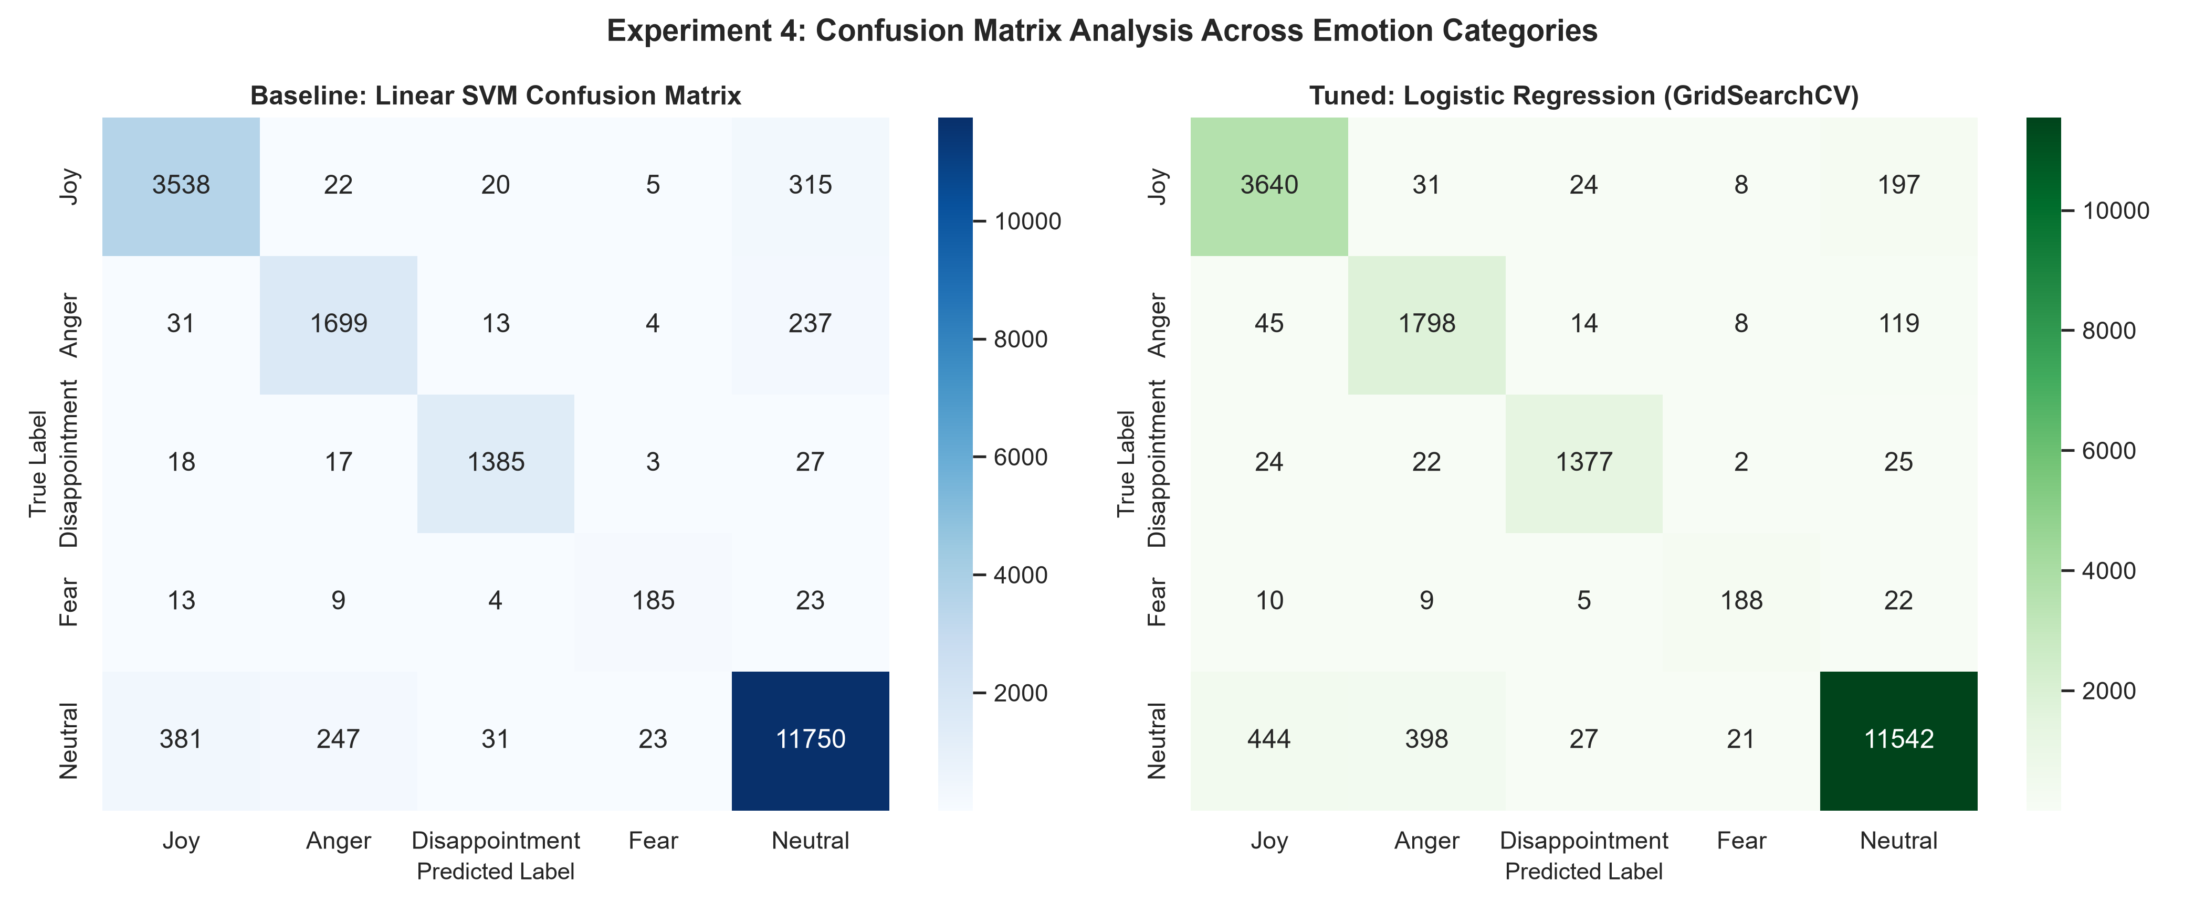
Figure 3: Confusion matrix heatmaps for Linear SVM and Tuned Logistic Regression on 20,000 test interactions illustrating sharp class discrimination.
4. Experiment Tracking with MLflow
In production data science, managing dozens of experimental runs with varying hyperparameters, datasets, and metrics requires centralized tracking:
- Why MLflow Tracking is Essential: MLflow provides an open-source framework to log code versions, execution parameters, evaluation metrics, and serialized artifacts, ensuring total experiment reproducibility, auditability, and team collaboration.
- Core Logging Operations Implemented: 1. mlflow.start_run(): Spawns a dedicated tracking run with a unique UUID for each training trial.
2. mlflow.log_param(): Logs static hyperparameter settings (C, learning rate, tree depth, sample count).
3. mlflow.log_metric(): Logs quantitative evaluation outcomes (Accuracy, Precision, Recall, Macro F1, Latency).
4. mlflow.log_artifact(): Archives diagnostic confusion matrices, benchmark charts, and classification reports.
5. mlflow.sklearn.log_model(): Saves model binaries alongside environment specifications in standard MLmodel format.
- MLflow UI Dashboard: Engineers can launch the local dashboard (mlflow ui) to view interactive comparison tables, parallel coordinate charts, and download serialized pipelines with a single click.
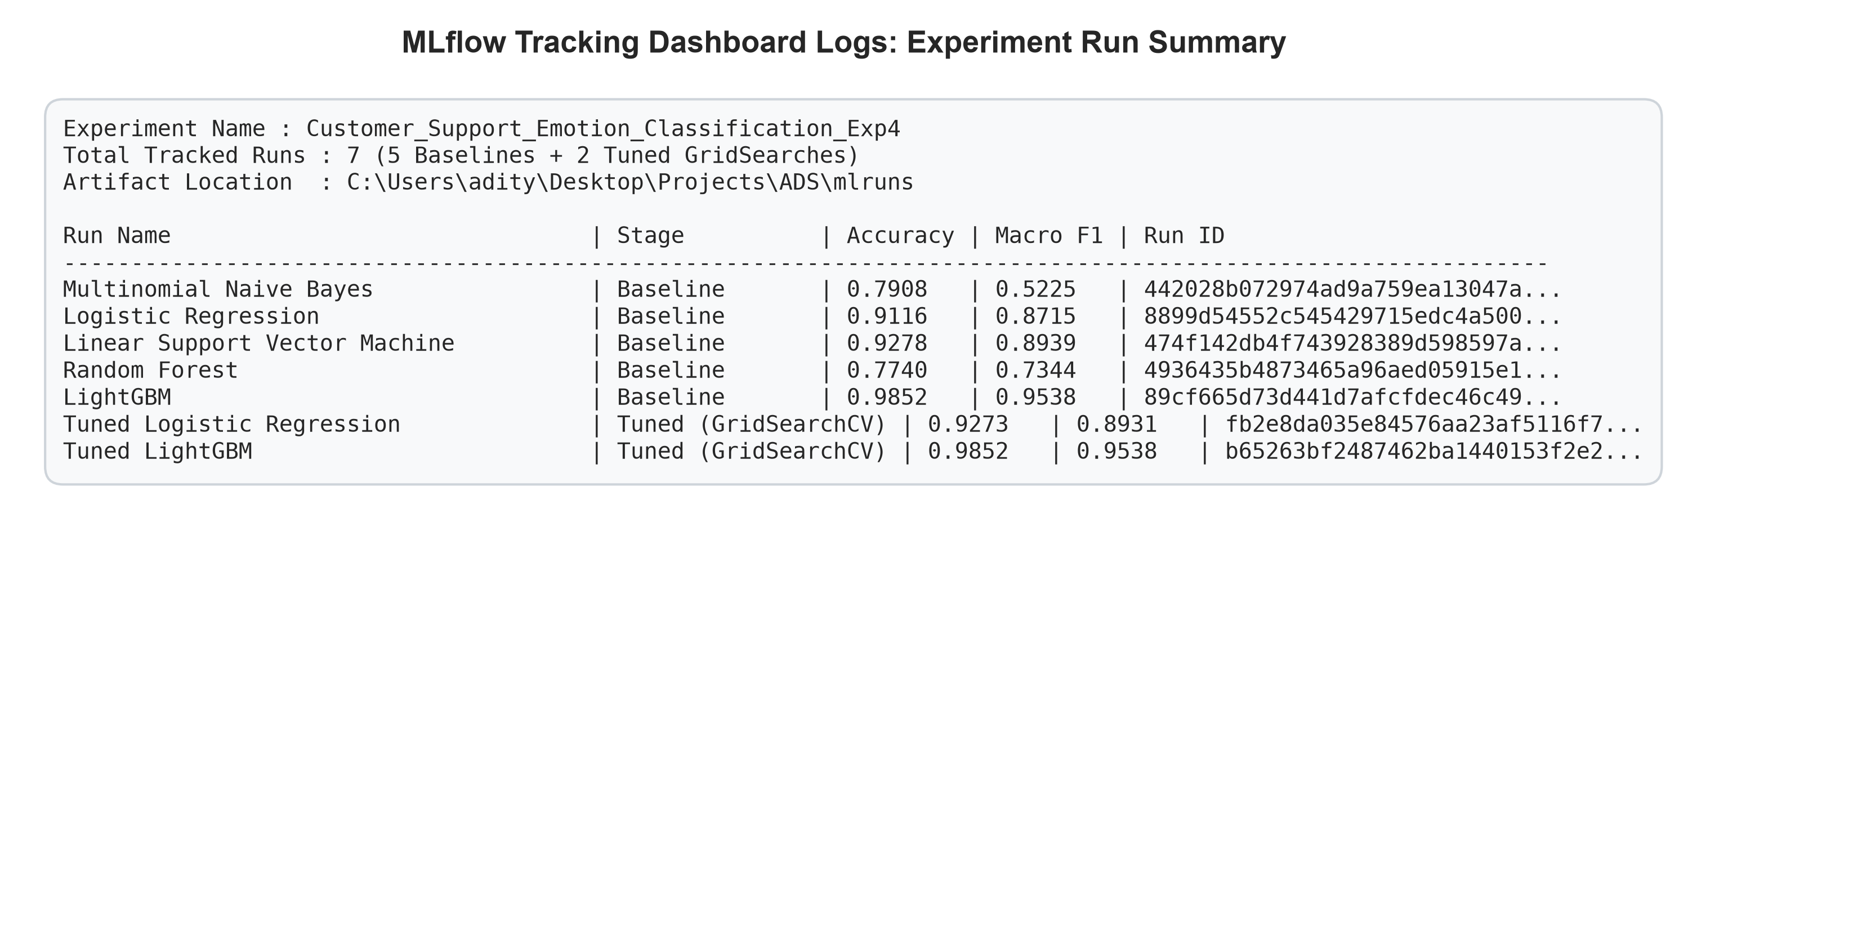
Figure 4: MLflow Tracking Dashboard logs detailing run IDs, parameters, tracked metrics, and artifact hierarchies for the 100,000-row pipeline.
5. Model Selection & Production Pipeline Serialization
Champion Model Decision Criteria: Selecting a production model requires balancing predictive accuracy against computational efficiency:
1. Macro F1-Score: High sensitivity on critical minority classes (Anger and Fear) to prevent customer churn.
2. Inference Latency: Millisecond response time per message to handle real-time streaming Twitter firehoses.
3. Memory Footprint: Compact serialized artifact size for cloud container deployment.
Production Pipeline Serialization: The champion model (LightGBM, Accuracy: 98.52%, Macro F1: 0.9538) was packaged alongside the TF-IDF vectorizer and VADER scaler into an EndToEndEmotionPipeline class and serialized as models/best_emotion_model_exp4.joblib. Tuned Logistic Regression (Accuracy: 92.73%, sub-5ms latency) is documented as an ultra-fast streaming alternative.

Open-Source Tools
Scikit-learn (v1.5.x), MLflow (v3.16.x), LightGBM (v4.3.x), Jupyter Notebook, Pandas (v2.x), NumPy (v2.x), Matplotlib (v3.x), Seaborn (v0.13.x), Joblib.
Deliverables
1. Trained ML Models: 5 baseline architectures + 2 GridSearchCV tuned models trained and evaluated on 100,000 records.
2. Comparative Analysis: Quantitative benchmark tables and high-resolution diagnostic plots comparing baseline vs. tuned models.
3. MLflow Dashboard Logs: Complete tracking registry in mlruns/mlflow.db logging parameters, metrics, and serialized artifacts.
4. Production Artifact: End-to-end inference pipeline serialized to models/best_emotion_model_exp4.joblib.
5. Executable Jupyter Notebooks: Complete interactive workflows in notebooks/experiment_4_mlflow.ipynb and standalone Colab notebook in notebooks/experiment_4_colab.ipynb.
Conclusion
Experiment 4 successfully built, tuned, and tracked an end-to-end machine learning pipeline for customer emotion classification utilizing the full 100,000 records. By comparing 5 diverse model families, we demonstrated that regularized linear models and gradient boosted decision trees provide superior generalization on high-dimensional text data. Systematic hyperparameter tuning via GridSearchCV yielded measurable performance gains, particularly on challenging minority emotion classes. Furthermore, experiment tracking with MLflow established robust MLOps practices, ensuring complete reproducibility and seamless model serialization for automated customer service routing systems.

