2003

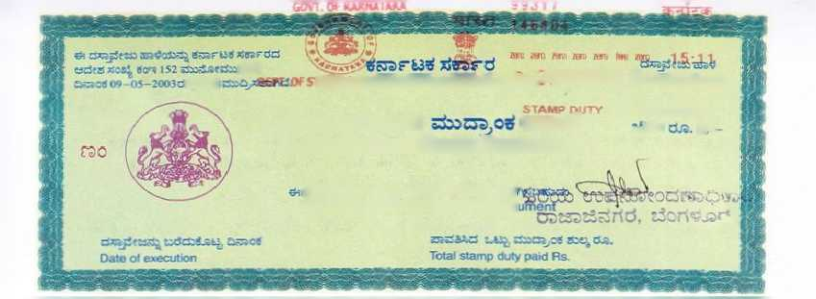

s,«r.s 66v*trm&tf'of *&*Hiiti**<i "30005 0ocn**o»s*<*ot

Ajstoziti assrlfc <sk^33

KARNATAKA

~23: 21-

Registration and Stamps Department

**ssstfaS^ cS^sScSe da^jSf&rt erjaaia?** This sheet can be used for any doc

WR E K T A L A G I< E E M E ft T"

This Rental Agreement is made and Executed on

at Bangalore, by and Between:- wef 1/4/2015

Mr .GiddappA

S/o late Na^ippa

D No.134 2nd cross Srvinthi L/o RamAmurthynagar Bangalore 5600 16

Hereinafter Called the "OWNER" of the One Part* Ms Pottumurthi Udayaiaxmi W/o Ran** Krishna icajjam

H No .2 7-7 Main Bazar,

Miryalaguda, it Nalgonda Dist A p 503207.

Hereinafter called the "TENANT" of the Other Part witnesseth as follows terms and conditions.

1. Whereas the Tenant has paid Advance amount of Rs. 40,000/- ( Forty thousand only ). to the owner.

This amount shall not carry any interest and this is refundable at the time vacating.. If any arrears balance that charges will deducted from the advance amount at the time of vacating.

has agreed to pay the Rental Charges of thousand three hundred only ) to



regularly.

the Electrcity charges separately to

Contd...2.

-2-

1. This R-mtal Agreement Duration for only 11 (Eleven) months from this date of Agreement. if both the parties mutual understanding it can be extended.
2. The Tenancy can be terminated by either party by giving Two Konth notice to the opposite party.
3. whereas the Tenant shall not rr.aXe any additional alteration to the schedule premises and tenant keep the portion clean and good tenantable conditions.
4. Whereas the Tenant shall use the Schedule premises fox Residential purpose only and should not use for any illegal or immoral purposes.
5. Whereas the Tenant should pay painting charges at the. time vacating the premises.

MS_C H E D U 1 S"

The House premises situated at No.184 1st floor 2nd cross

Shanthi Vo. RarrH.murthyrvagar, Bangalore 560016 consists of 1 BttC with bathroom U toilet.

In witness whereof the party is hereto have signed this Rental Agreement on the day.month end year first above written in front of the following witnesses.

WITNESSES t



OWNER

