HERITAGE INSTITUTE OF TECHNOLOGY

Branch: AIML
Subject: Introduction to Image Processing
Subject Code: AIML 3141
PROJECT REPORT
TexScan
A Classical Image-Processing System for Automated Fabric Defect Detection, Real-World Measurement and Four-Point Roll Grading
Submitted by (Group Members)

Roll No. | Name of Student
1 | Aditya Aman
4 | Arya Biswas
51 | K V Rohit
56 | Ashutosh Singh Yadav
58 | Ashish Kumar Jha
64 | Ayush Kumar Roul

November 2026
Source code and documentation: github.com/adityaaman-2120/TexScan
TexScan: Classical Image Processing for Fabric Defect Inspection
Heritage Institute of Technology | AIML | Introduction to Image Processing (AIML 3141)
Abstract
Visual inspection of fabric is slow, subjective and costly to automate. Commercial machine-vision systems are out of reach for many small textile units, and learning-based detectors need large labelled datasets that such units do not have. This report presents TexScan, a complete fabric-inspection application built only with classical image processing (no neural networks). Each photograph is converted into a chain of derived images (grayscale, denoised, contrast-enhanced, texture-anomaly score, colour-deviation map, binary masks) from which defects are located, measured in millimetres with a printed ArUco marker or a ruler, classified by transparent rules, and judged PASS or FAIL. For whole rolls, defects are scored with the four-point system [1] and a graded PDF report is produced. Four detectors (Fourier notch filtering, a Gabor filter bank, local statistics and golden-template subtraction) share one pipeline, and a colour-deviation cue in CIE Lab space is added to find stains that grayscale texture analysis cannot see. On a controlled synthetic set of 120 images the cue raised the detection rate of colour-only stains from 47% to 100% (Gabor) and from 37% to 100% (local statistics) without extra false alarms on clean cloth. The software is covered by 398 backend and 262 frontend automated tests. Limitations, and a plan for benchmarking on MVTec AD against learned baselines, are discussed.
Keywords: fabric defect detection, image processing, Fourier transform, Gabor filter, mathematical morphology, CIE Lab, four-point grading.

1. Introduction

1.1 Motivation
Surface quality decides the value of a fabric roll. In small and medium units the roll is still checked by people who watch it move past a light, mark flaws by hand and add up penalty points on paper. The task is tiring, so results vary between inspectors and between shifts. Automated systems exist, but they are priced for large mills. The practical gap is a tool that needs only a computer and an ordinary camera, can be tuned by the operator without data-science knowledge, and explains why it flagged a region.
A fabric surface is a texture: a repeating or random pattern that differs from one cloth to another. A defect is whatever departs from that pattern, so a fixed brightness threshold is not enough. Classical image-processing theory [2] offers a toolbox that matches the problem: spatial filtering, frequency-domain analysis, histogram methods, morphology, colour spaces and geometric registration. TexScan combines these tools into one inspectable pipeline.

1.2 Objectives
- Detect and localise fabric defects with classical methods only, from a photograph or a live camera.
- Measure each defect in real units (mm and inches) and classify it with readable rules.
- Grade a complete roll with the four-point system and produce a signed-off PDF report.
- Make every processing step visible, so the application doubles as a teaching tool for the syllabus topics.

1.3 Contributions
(i) An end-to-end, test-covered pipeline in which every intermediate image can be inspected. (ii) A colour-deviation cue that complements grayscale texture detectors. (iii) A distance-based grouping of defect fragments so that one damaged spot is counted once. (iv) Profile learning from good samples, including relaxation of the colour cue on cloths whose colours vary. (v) Calibration, measurement and four-point grading integrated with detection.

2. Related Work
Surveys [3, 4] group automated fabric inspection into statistical, spectral, model-based and learning-based families. Statistical methods describe texture by co-occurrence matrices [5] or local moments. Spectral methods exploit the near-periodicity of woven cloth: its Fourier spectrum concentrates in a few peaks, and a defect appears in what remains after those peaks are removed. Gabor filters [6, 7] analyse space and frequency jointly and match the orientation and scale selectivity of the visual cortex. Template methods subtract a registered defect-free reference, with registration usually based on ORB features [8] and RANSAC [9]. The MVTec AD dataset [10] provides five texture categories with pixel-accurate masks and is the usual benchmark. Current leaders on it are deep networks that need training data and give little explanation of a decision. For a small unit, a classical and explainable approach that is tuned from a handful of good samples remains attractive. Classical fabric pipelines mostly use luminance only; this work adds a colour cue.

3. System Overview
TexScan is a web application with a Python backend (FastAPI, OpenCV [11], NumPy, SciPy, scikit-image, SQLite) and a React/TypeScript frontend. Every image-processing step is a pure function (array in, array out, no input/output and no global state) with a short mathematical docstring and its own unit test. The interface has two modes. Product mode shows plain-language pages for an operator; Engineering mode exposes the theory pages used for teaching and experiments. Figure 1 shows the data flow.
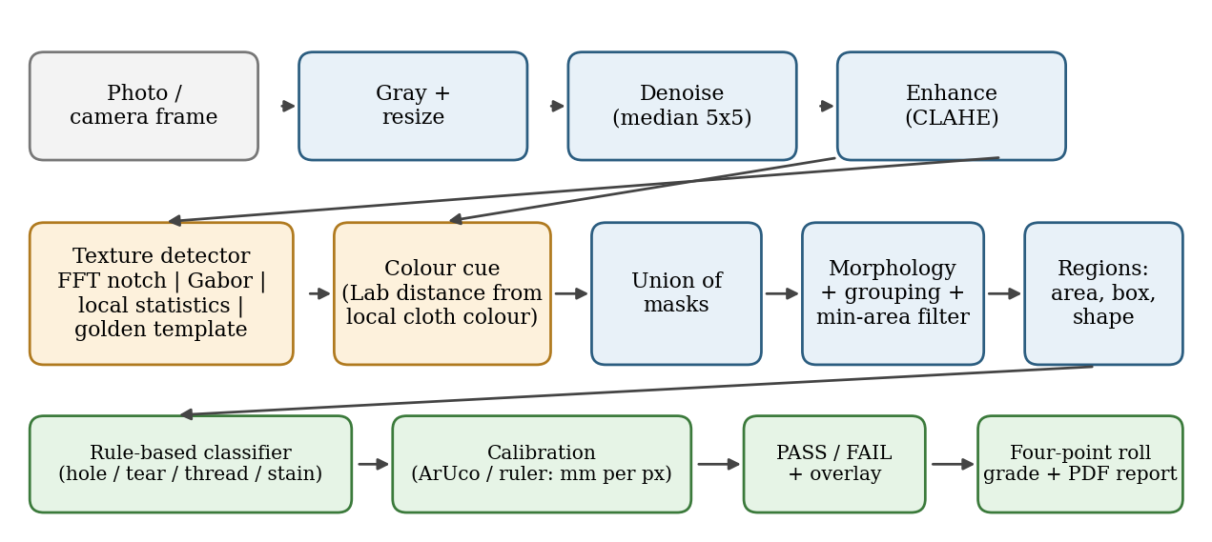
Fig. 1. Data flow of TexScan. Orange blocks are the two detection cues; green blocks are the measurement and decision outputs.

4. Methodology

4.1 Preprocessing
The image is converted to gray with the luma equation (1) [2] and resized so that the longer side is 1024 px (area interpolation when shrinking), which keeps run time and settings comparable across cameras. A 5x5 median filter replaces each pixel by the median of its neighbourhood; it removes impulsive noise while preserving edges, unlike a mean filter. CLAHE [12] equalises the histogram in 8x8 tiles with a clip limit of 2, which flattens uneven lighting without amplifying noise. Equalisation maps each gray level k to s(k), equation (2), where p(j) is the (clipped) tile histogram and L = 256.
Y = 0.299 R + 0.587 G + 0.114 B (1)
s(k) = (L − 1) · Σ_{j ≤ k} p(j) (2)

4.2 Texture detectors
Each detector assigns every pixel an anomaly score; the methods differ in what "normal" means.
- Fourier notch filter. For periodic cloth the 2-D DFT F(u,v) has sharp peaks. Peaks above mean + 5 sigma (outside the DC disc) are removed with Gaussian notches, equation (3), and the inverse transform g leaves the non-periodic residual, which is the defect.
- Gabor filter bank. Quadrature pairs of Gabor kernels, equation (4), at 4 orientations and wavelengths of 4, 8 and 16 px give an energy map; a defect disturbs the local energy.
- Local statistics. Mean and variance in a 31x31 window come from two box filters, equation (5); windows far from the global distribution are suspicious.
- Golden template. A known-good image is aligned to the test image (ORB keypoints, Hamming matching, RANSAC homography) and subtracted.
H(u,v) = ∏_{k} [1 − exp(−d_{k}² / 2σ²)], g = IFFT(F · H) (3)
g(x,y) = exp(−(x′² + 0.25 y′²) / 2σ²) · cos(2π x′ / λ + ψ) (4)
μ = box_{w}(I), σ² = box_{w}(I²) − μ² (5)

4.3 Colour-deviation cue
A flat patch of another colour (a stain, a burn, the material seen through a hole) has almost no texture energy, so grayscale detectors can miss it. The cue works in CIE Lab space [2]: the local cloth colour B(x) is estimated by a large median filter of the Lab image computed on a copy shrunk eight times, and the deviation is the distance of each pixel from it, equation (6), smoothed by a Gaussian (sigma = 2.5). Lightness is weighted by w = 0.25 so that light and dark stripes do not count and only a change of hue or saturation does. The cut-off is median + max(k × 1.4826 × MAD, floor) with k = 6 and a floor of 12 Lab units.
d(x) = √[(w ΔL)² + Δa² + Δb²], (ΔL, Δa, Δb) = Lab(x) − B(x) (6)

4.4 Thresholding
Texture scores are standardised with the robust z-score z = (x - median) / (1.4826 MAD) [13]; a pixel is flagged when z exceeds k (10 for Gabor, 4 for local statistics). The median and the median absolute deviation (MAD) are used instead of the mean and standard deviation because the defect itself would otherwise pull the reference level toward it. For the Fourier method the smoothed residual is cut with Otsu's method [14], which chooses the level t that maximises the between-class variance, equation (7). The Low, Medium and High sensitivity buttons of the application simply scale k.
σ_{B}²(t) = ω₀(t) ω₁(t) [μ₀(t) − μ₁(t)]² (7)

4.5 Morphology and grouping
The union of the texture and colour masks is cleaned with a 3x3 elliptical structuring element: opening (erosion then dilation) removes specks and closing (dilation then erosion) fills small gaps. Neighbouring fragments of one damage (for example a hole and its frayed rim) are then grouped: the mask is dilated by half of a distance equal to 2% of the longer side and 8-connected components are labelled. Group areas are summed before the minimum-area filter (50 px by default), and each group becomes one defect entry with the union bounding box. The mask itself is not altered.

4.6 Region analysis, classification and decision
For each group the system computes area, bounding box, aspect ratio (major to minor axis of the equivalent ellipse), solidity (area over convex-hull area), orientation and contrast against a surrounding ring, and the longest side of the minimum-area rotated rectangle as the defect length. A rule-based classifier with fuzzy ramp memberships labels the defect: a hole is dark, round and solid; a tear is elongated and of high contrast; a thread is very long, very thin and faint; a stain is a sizeable, faint, ragged or lighter blotch; otherwise unknown. The labels are heuristics and are shown as such. The decision is FAIL when the number of defects exceeds max_defects (default 0) or their area share exceeds max_area_percent. For display, Canny edge detection [15] on the final mask gives the outline drawn over the photograph.

4.7 Profiles learned from good samples
A single threshold cannot suit every cloth. From 5 to 20 images of good fabric, the auto-tune routine runs the chosen detector, sets the cut-off to the 99.5th percentile of the interior scores times 1.1, and sets the minimum area to twice the largest leftover component on the good images. If that minimum would swallow small defects, the cut-off is raised in steps of 10% (at most five) first. A leave-one-out pass rate and a histogram of the scores are reported. The colour cue is made silent on all good images by raising its k (margin 1.15) or is switched off, with a warning, when the cloth's own colours vary too much (k above 25).

4.8 Real-world size and four-point grading
The scale s = L_mm / L_px is obtained from a printed ArUco marker [16] of known side (corners refined to sub-pixel accuracy) or from two clicks on a ruler, and is stored in the profile; every defect length is multiplied by s. An automated test places a known line defect next to a known marker and requires the measured length to be within 3% of the truth. Roll grading follows the four-point system [1], summarised in Table 1.
Table 1. Four-point rules implemented (defect length is its longest dimension).
Rule | Value used
Points per defect | ≤ 3 in: 1; 3–6 in: 2; 6–9 in: 3; > 9 in: 4
Holes | tiered (≤ 1 in: 2 points, > 1 in: 4) or any hole = 4 (selectable)
Cap | at most 4 points per linear yard; a continuous defect longer than one yard scores 4 in every yard it crosses
Score | points per 100 sq yd = total points × 3600 / (length in yd × width in inch)
Grade | First quality if the score is ≤ 40 (default, adjustable); otherwise Off quality

The text of the standard is not freely available, so the rules were reconstructed from published descriptions and are kept as settings; they are documented in the repository for verification.

5. Implementation and Features
Table 2 lists the application pages. The sidebar shows the first group in Product mode; the second group appears when Engineering mode is switched on in Settings. Figure 2 shows the Inspect and Live pages.
Table 2. Application pages and their purpose.
Page | What it does and how
Inspect | Upload a photo; the full pipeline runs; verdict, boxes, per-defect reasons and a PDF report. Sensitivity and fabric profile are selectable.
Live | Camera frames are sent over a WebSocket (about 4-5 fps); overlay and verdict update continuously; black bars are trimmed and the middle 60% may be inspected; Capture saves a full-resolution inspection; Calibrate learns a profile on the spot.
Roll Inspection | A roll is checked as a sequence of captures; defects are scored by the four-point rules, a defect map and graded PDF with a signature line are produced.
Batch, History, Reports, Dashboard | Many images at once; stored results; PDF reports; charts of pass/fail trend, defect types and roll KPIs.
Profiles / Calibration | Learn thresholds from good samples; set mm per pixel from an ArUco marker (printable PDF) or a ruler.
Pipeline X-Ray (Eng.) | Every stage image with its explanation, formula and timing.
Spectrum Studio (Eng.) | Interactive FFT: draw notches, apply ideal, Butterworth or Gaussian low-pass, high-pass and sharpening filters.
Method Arena (Eng.) | Run the four methods on one image; IoU, Dice, precision, recall and F1 against a ground-truth mask.
Robustness Lab (Eng.) | Degrade an image (noise, blur, brightness, JPEG quality) and plot the effect on detection, with PSNR and SSIM [17].
Bit-Plane viewer (Eng.) | The eight bit planes of the grayscale image.

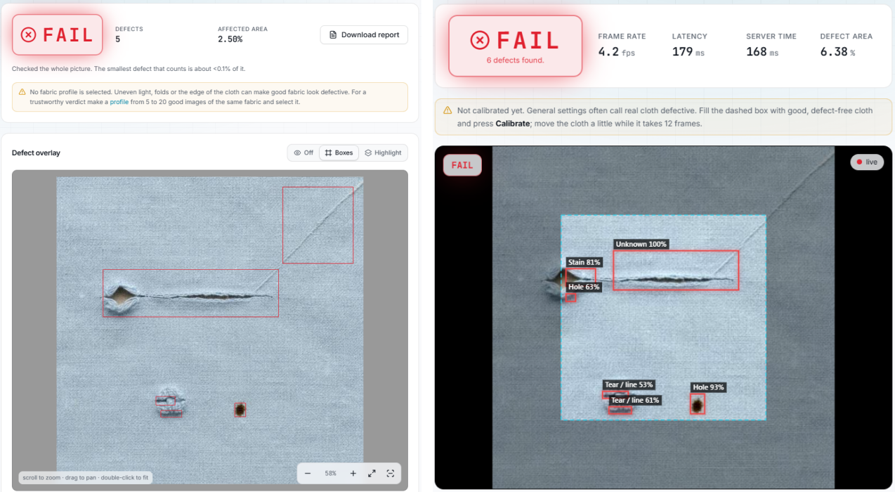
Fig. 2. Left: Inspect page after analysing a cloth sample (five flagged areas). Right: Live page on a camera stream; the dashed square is the inspected middle area.
Engineering practice. The API client types are generated from the backend OpenAPI schema, every pipeline function has a pytest test, the interface uses theme tokens and has loading and empty states, and pure interface logic is tested with Vitest. The suites contain 398 backend and 262 frontend tests, all passing. Everything runs locally; no image leaves the computer.

6. Experiments and Results

6.1 Controlled experiment: effect of the colour cue
Setup. A synthetic generator produced 256x256 pale-blue woven cloth with noise and an illumination gradient. For each of four classes 30 images were made (seed 2026): clean; dark hole; dark thin tear; and a colour-only stain whose hue differs from the cloth but whose gray level is identical (the weave pattern is kept on top), which is the hardest case for a luminance detector. All methods ran with default, untuned settings; the colour cue was switched on or off. We report the share of images flagged FAIL per class and the mean pixel IoU between the final mask and the ground truth, in the style of the benchmark protocol [10]. This is a synthetic study and not a benchmark of real-world performance.
Table 3. Detection rate per class (share of images flagged FAIL), stain IoU and time per 256x256 image.
Method | Cues | Clean (false alarm) | Hole | Tear | Stain | Stain IoU | s / image
Gabor bank | Texture only | 0% | 100% | 100% | 47% | 0.10 | 0.083
Gabor bank | Texture + colour | 0% | 100% | 100% | 100% | 0.77 | 0.087
Local statistics | Texture only | 3% | 100% | 100% | 37% | 0.12 | 0.010
Local statistics | Texture + colour | 3% | 100% | 100% | 100% | 0.78 | 0.014
FFT notch | Texture only | 100% | 100% | 100% | 100% | 0.01 | 0.022
FFT notch | Texture + colour | 100% | 100% | 100% | 100% | 0.08 | 0.025

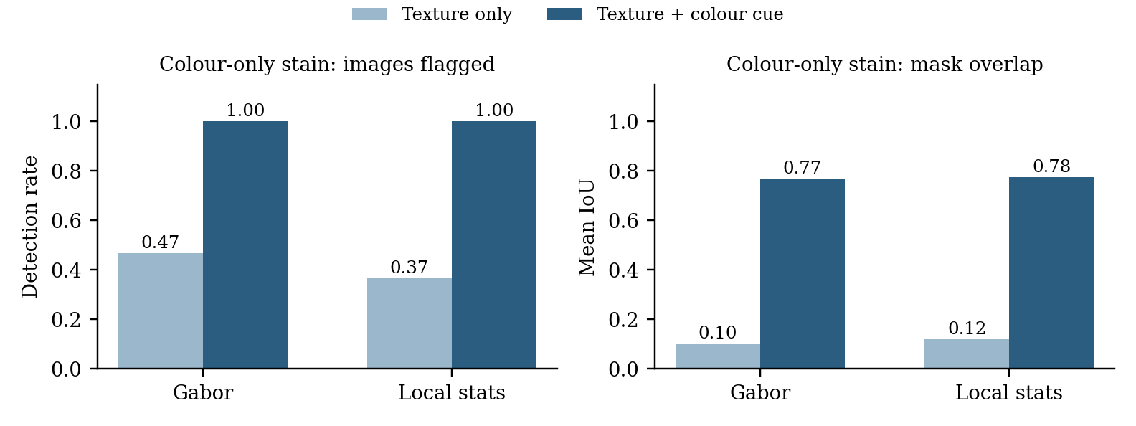
Fig. 3. Colour-only stains: the colour cue raises the detection rate and the mask overlap of both texture detectors.
Findings. The colour cue turns the stain class from partly missed (47% and 37%) into fully detected (100%) and lifts the stain IoU from about 0.10 to 0.77, while the false-alarm rate on clean images and the hole and tear results are unchanged. The extra run time is 4 ms per image or less. The Fourier method flagged every clean image: the generator uses non-integer weave periods and a lighting gradient, which cause spectral leakage, and the default peak detector is not tuned for that; it needs a profile, which agrees with the guidance in Section 4.7. The low IoU of Gabor and local statistics on holes and tears (0.10-0.15) shows that their masks are coarse (wide smoothing windows); they find the defect but do not outline it tightly.

6.2 Case study on a real photograph
Figure 4 follows one real photograph of damaged cloth (a hole with a slit, a pulled thread, a pilled patch and a brown spot) through the pipeline with the Gabor method and default settings. The texture score (c) responds to the slit, the thread and weakly to the patch, but not to the brown spot; the colour mask (d) adds the spot, the hole opening and the patch. Grouping reduced the report from nine fragments to five defect entries. This is a single image and is qualitative evidence only.
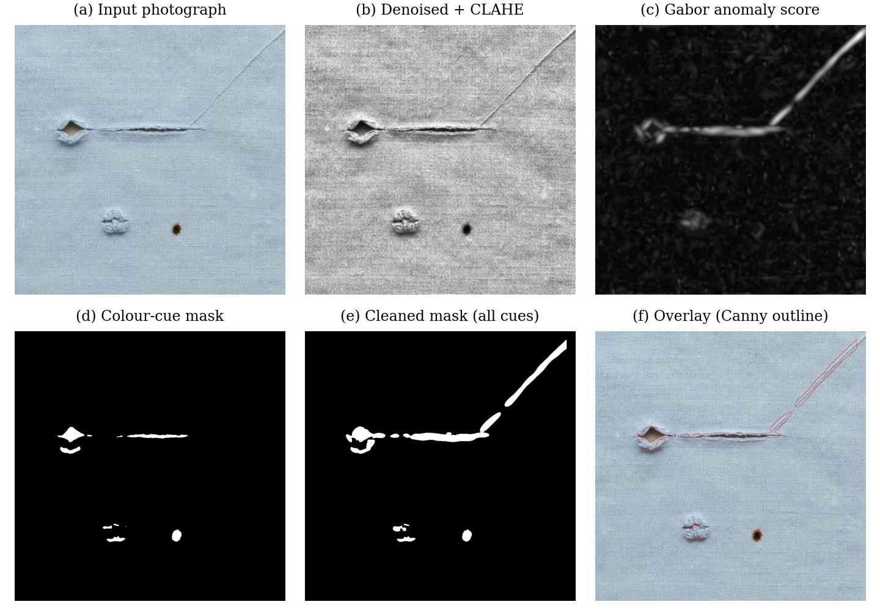
Fig. 4. Pipeline stages on a real photograph: (a) input, (b) after median filter and CLAHE, (c) Gabor anomaly score, (d) colour-cue mask, (e) cleaned mask after union and grouping, (f) overlay.

6.3 Further checks
- Measurement: an automated test places a known line next to a known marker; the measured length is within 3% of the truth.
- Demo samples: four crops of one photograph (clean, hole, stain, tear) are judged correctly by the web demo, but its settings were tuned on those same crops, so this is a demonstration and not an accuracy figure.
- Run time: the Gabor method needs about 1.6 s for a 1024 px image on the development laptop; Live mode runs at about 4 fps with a 320 px working size.

7. Limitations
- A PASS means only that nothing was found where the system looked; the application states the area that was checked and warns about blind spots.
- Small holes in coarse or piled cloth (terry towel, fleece) are not found reliably by any of the four methods or by the colour cue.
- Printed or coloured-stripe cloth can trigger the colour cue; a profile from good samples relaxes or disables it.
- Defect types are heuristic guesses (a dark stain can be called a hole), and one defect can still produce neighbouring boxes.
- The quantitative evaluation is synthetic; the planned MVTec AD benchmark has not yet been run. The four-point rules were reconstructed because the standard is paywalled.

8. Future Work Towards Publication
The following extensions are proposed and not yet implemented.
- Calibrated multi-cue fusion (novel idea). Fuse the texture, colour and template score maps with a single decision rule whose cut-offs are set from good samples so that the expected false-alarm rate on good cloth is controlled by leave-one-out estimates (a conformal-style guarantee), without any labelled defects.
- Adaptive colour weighting. Learn the lightness weight and cut-off from the chroma and luminance statistics of the good samples, so that striped and printed cloth need no manual profile.
- Structure-aware grouping. Merge fragments using orientation continuity (for example a slit leaving a hole) instead of a fixed distance.
- Benchmark and baselines. Evaluate on MVTec AD carpet, grid, leather, tile and wood [10] with image-level and pixel-level AUROC and per-region overlap, and compare with learned baselines (convolutional auto-encoder, PaDiM, PatchCore) trained on the same small number of good images; add a fabric set photographed in partner units.

9. Conclusion
TexScan shows that a complete inspection workflow (detection, measurement, classification, roll grading and reporting) can be built from classical image-processing tools taught in this course, with every step visible and tested. The added colour cue closes a specific blind spot of luminance-only texture detectors, and profile learning adapts the system to a given cloth. The honest limits, notably piled fabrics and the absence so far of a real-benchmark evaluation, define the next steps toward a publishable comparison.

References
[1] ASTM International, "ASTM D5430: Standard Test Methods for Visually Inspecting and Grading Fabrics," West Conshohocken, PA, USA.
[2] R. C. Gonzalez and R. E. Woods, Digital Image Processing, 4th ed. New York, NY, USA: Pearson, 2018.
[3] A. Kumar, "Computer-vision-based fabric defect detection: A survey," IEEE Trans. Ind. Electron., vol. 55, no. 1, pp. 348–363, 2008.
[4] H. Y. T. Ngan, G. K. H. Pang, and N. H. C. Yung, "Automated fabric defect detection - A review," Image Vis. Comput., vol. 29, no. 7, pp. 442–458, 2011.
[5] R. M. Haralick, K. Shanmugam, and I. Dinstein, "Textural features for image classification," IEEE Trans. Syst., Man, Cybern., vol. SMC-3, no. 6, pp. 610–621, 1973.
[6] D. Gabor, "Theory of communication," J. Inst. Electr. Eng., vol. 93, no. 26, pp. 429–457, 1946.
[7] J. G. Daugman, "Uncertainty relation for resolution in space, spatial frequency, and orientation optimized by two-dimensional visual cortical filters," J. Opt. Soc. Am. A, vol. 2, no. 7, pp. 1160–1169, 1985.
[8] E. Rublee, V. Rabaud, K. Konolige, and G. Bradski, "ORB: An efficient alternative to SIFT or SURF," in Proc. IEEE ICCV, 2011, pp. 2564–2571.
[9] M. A. Fischler and R. C. Bolles, "Random sample consensus: A paradigm for model fitting with applications to image analysis and automated cartography," Commun. ACM, vol. 24, no. 6, pp. 381–395, 1981.
[10] P. Bergmann, M. Fauser, D. Sattlegger, and C. Steger, "MVTec AD - A comprehensive real-world dataset for unsupervised anomaly detection," in Proc. IEEE/CVF CVPR, 2019, pp. 9592–9600.
[11] G. Bradski, "The OpenCV Library," Dr. Dobb's Journal of Software Tools, 2000.
[12] K. Zuiderveld, "Contrast limited adaptive histogram equalization," in Graphics Gems IV, P. S. Heckbert, Ed. San Diego, CA, USA: Academic Press, 1994, pp. 474–485.
[13] C. Leys, C. Ley, O. Klein, P. Bernard, and L. Licata, "Detecting outliers: Do not use standard deviation around the mean, use absolute deviation around the median," J. Exp. Soc. Psychol., vol. 49, no. 4, pp. 764–766, 2013.
[14] N. Otsu, "A threshold selection method from gray-level histograms," IEEE Trans. Syst., Man, Cybern., vol. 9, no. 1, pp. 62–66, 1979.
[15] J. Canny, "A computational approach to edge detection," IEEE Trans. Pattern Anal. Mach. Intell., vol. PAMI-8, no. 6, pp. 679–698, 1986.
[16] S. Garrido-Jurado, R. Munoz-Salinas, F. J. Madrid-Cuevas, and M. J. Marin-Jimenez, "Automatic generation and detection of highly reliable fiducial markers under occlusion," Pattern Recognit., vol. 47, no. 6, pp. 2280–2292, 2014.
[17] Z. Wang, A. C. Bovik, H. R. Sheikh, and E. P. Simoncelli, "Image quality assessment: From error visibility to structural similarity," IEEE Trans. Image Process., vol. 13, no. 4, pp. 600–612, 2004.

