

**Aeromodelling Club IITK**

**Drone**

**Bootcamp**

Project Mentors:

1.Mohit Anand 4.Raj Agarwal

2.Moin Ahmed 5.Prathamesh Thakare

3.Pranshu Singhal

Team Members:

1. Deepanshi Maheshwari 5.Devansh Agarwal

2. Aditi Sinha 6.Gargi Naladkar

3. Aditya Anand 7.Mayank Saini

4. Palmate Aditya Tukaram

1. Pranshu 5.Ayush

2. Utkarsh 6.Akanksha

3. Nitin 7.Saurabh

4.Sheeshram

**Timeline**

| Week/  Duration | Topic |
| --- | --- |
| Week 1  24 May 2021-30 May 2021 | Introductory Week:   * Mission Planner Installation * Terminologies * Types of Aircraft * IMU * Quiz 1 |
| Week 2  31 May 2021-6 June 2021 | * Drone kinematics * Mission Planner * Quadcopter and Hexacopter(Assignment) * Matlab & Simulink Installation |
| Week 3  7 June 2021-13 June 2021 | * Drone Dynamics * PID Controls * Ubuntu Installation |

Project Goals

* Introduction to basics of Aeromodelling .
* Exploring the Fluid Mechanics of an Airplane Flight.
* To learn the kinematics and dynamics of a Drone
* Develop an understanding of Drones and their simulation softwares.
* Simulation of flight paths using Mission Planner , ROS and other softwares.
* Explore the role of Flight controller ,IMU and other Drone Avionics.

What is AEROMODELLING ?

Aeromodelling is the art of designing,building and flying aircrafts . Their are many types of aircrafts with their different specialisation:

**1.GLIDER:**

* Cambered airfoil
* High Aspect Ratio
* High Winger
* Dihedral wings
* High Lift/Drag Ratio
* Highly stable

**2. 3D AEROBATIC PLANE:**

* Symmetric Airfoil
* Low Aspect Ratio
* Mid Wing Configuration
* Less stability-high maneuverability
* Large Control Surfaces

**3.TRAINER AIRCRAFT:**

* Cambered/Flat bottom airfoil
* Moderate Aspect Ratio
* Moderately Stable
* Purpose is to learn

basics of fabrication

and flying

**4.IC ENGINE PLANE:**

* IC engines are used instead of electric motor.
* Very powerful
* Flies very fast

**5.SCALE MODELLING**

* Fastest bomber aircraft of its time.
* Prototype made (from balsa).

**6.TANDEM PLANE**

* Has another wing instead of the horizontal stabilizer

**7.DELTA WING**

* Have triangular or delta shaped wings.
* Can fly at higher speeds.
* Includes different aerodynamics

**8.MAGNUS PLANE**

* Lift generation due to magnus effect.

**9.FLYING WING**

* Aircraft without tail and well defined fuselage
* Has reflex airfoil.

**10.ORNITHOPTER**

* Use flapping wing for both the thrust and lift.
* Imitation of birds or insects.

**11.FID AIRCRAFT**

* Rubber propelled aircraft .
* No electronics are used.

**12.MAMA BUG**

* Very light weight.
* Glide without any kind of power.
* Just use of a piece of cardboard is required for lift.

Also aircrafts are made of different type of FABRICATION:

* Styrofoam Fabrication
* Biofoam
* Balsa Fabrication
* Composite Fabrication
* Coroplast

**AIRFOIL:**

Airfoil, also spelled Aerofoil, shaped surface, such as an airplane wing, tail, or propeller blade, that produces lift and drag when moved through the air. The different parts of an airfoil are :

* Leading edge - at the front of the airfoil
* Trailing edge - at the rear of the airfoil
* Chord line - defined by drawing a straight line from the leading edge to the trailing edge
* Camber line - represents the centre line between the upper and lower surfaces

**Angle of attack** - the angle between the chord line and the relative wind direction

**WORKING:** Lift is the force generated by an airfoil perpendicular to the wind, while drag force is measured along the wind direction. These are commonly used as metrics to compare wing performance. Airfoils generate lift by displacing the airflow, inducing a net curvature as air is directed downwards. Air travelling over the upper surface accelerates while air along the lower surface slows down.

* According to Bernoulli’s principle, this creates an area of low pressure above the wing, and high pressure below the wing. The resulting pressure difference between the two surfaces is what generates a lift force.
* ANGLE OF ACTION: The lift and drag forces generated by an airfoil vary as the angle of attack changes. lift coefficient increases with angle of attack, up until a drop-off point around 15 degrees. This is known as the stall point of the wing and is due to boundary layer separation on the suction side. A typical example of this is when an airplane pulls up too fast during take-off; entering the stall zone and losing lift.
* Another effect of increasing the angle of attack is an increase in drag. The lift-to-drag ratio is a popular metric for comparing the trade-off between the two. Here, a higher number indicates a more efficient design.
* DESIGN CONSIDERATIONS: Airfoil performance is usually characterized by the calculation of drag and lift coefficients, instead of the absolute force produced. These generalized coefficients allow you to compare different airfoils for any given cross-sectional area.
* SYMMETRICAL vs ASYMMETRICAL AIRFOIL: An asymmetric aerofoil is more efficient at generating lift than a symmetric aerofoil.Given the same flying conditions such as the angle of attack, the same airspeed, the same density of air, both symmetrical wings and asymmetrical wings can produce lift; however, the asymmetrical wing is designed to create more lift and less drag.

**WORKING OF AN AIRCRAFT**

An airplane in flight is acted on by four forces: LIFT, the upward acting force; GRAVITY, the downward acting force; THRUST, the forward acting force; and DRAG, the backward acting force (also called wind resistance). Lift opposes gravity and thrust opposes drag .

**MOTION:**

There are three types of movement of an aircraft - PITCH, YAW, ROLL.

* ROLL:

A rolling motion is an up and down movement of the wing tips of the aircraft. The rolling motion is being caused by the deflection of the ailerons of the aircraft. The aileron is a hinged section at the rear of each wing. The ailerons work in opposition; when the right aileron goes up, the left aileron goes down. For e.g., if the left aileron goes down, the right aileron will go up which causes rolling to the right.

* PITCH:

A pitch motion is an up or down movement of the nose of the aircraft. The pitching motion is being caused by the deflection of the elevator of this aircraft. The elevator is a hinged section at the rear of the horizontal stabilizer. There is usually an elevator on each side of the vertical stabilizer. The elevators work in pairs; when the right elevator goes up, the left elevator also goes up. For e.g., Up elevator causes the nose of the aircraft to go down and vice versa.

* YAW :

A yaw motion is a side to side movement of the nose of the aircraft. The yawing motion is being caused by the deflection of the rudder of this aircraft. The rudder is a hinged section at the rear of the vertical stabilizer. With greater deflection of the rudder to the left, the side force increases to the right. With greater deflection to the right, the side force increases to the left.

**AVIONICS**

**Avionics** are the [electronic](https://en.wikipedia.org/wiki/Electronics) systems used on aircraft, [artificial satellites](https://en.wikipedia.org/wiki/Artificial_satellite), and [spacecraft](https://en.wikipedia.org/wiki/Spacecraft). Avionic systems include communications, navigation, the display and management of multiple systems, and the hundreds of systems that are fitted to aircraft to perform individual functions.

**Basic avionics that RC aircraft contains**

1. **Brushless DC Motor:** BLDC motors are synchronous motors that have permanent magnets as rotors and windings as stators. I. These types of motors are highly efficient in producing large amounts of torque over a vast speed range. In a regular DC motor the stator is the rotating part while permanent magnets are fixed.
2. **Servo Motor**

A servomotor is a linear actuator or rotary actuator that allows for precise control of linear or angular position, acceleration, and velocity. It consists of a motor coupled to asensor for position feedback.

1. **Receiver** receives signals from the transmitter and processes the operation.It gives output as PWM values.
2. **Transmitter**

Transmitter comes in two modes 1 and mode 2, And we use mode 1. It transmits the signal that will be received by the receiver.

1. **Battery**
2. **IMU**

The IMU sensor contains Magnetometer, Accelerometer and Gyroscope.It uses I2C protocol for communication.

1. **Flight Controller**
2. **BMP SENSOR**

BMP sensor provides barometric pressure and temperature.So we can use it as an altimeter. It also uses a I2C protocol for communication.

1. **Radio Telemetry**
2. **GPS**

**11. Electric Speed Controller (ESC)**

ESC is mainly used for RPM control of BLDC motors.

**12. GPS and many more**

**Mission Planner**

We began with the installation process in week 1.

The shared download link and installation walkthrough:

<https://ardupilot.org/planner/docs/mission-planner-installation.html>

**What is Mission Planner?**

It is a fully-functioning GUI Ground Control Station(GCS) for multicopters, planes, helicopters & Rovers

Week 2 : Introduction to the Mission Planner Interface

After installing Mission Planner, we first have connect Pixhawk flight controller, select the COM Port and then we have to download the firmware for which we will be using Mission Planner for.

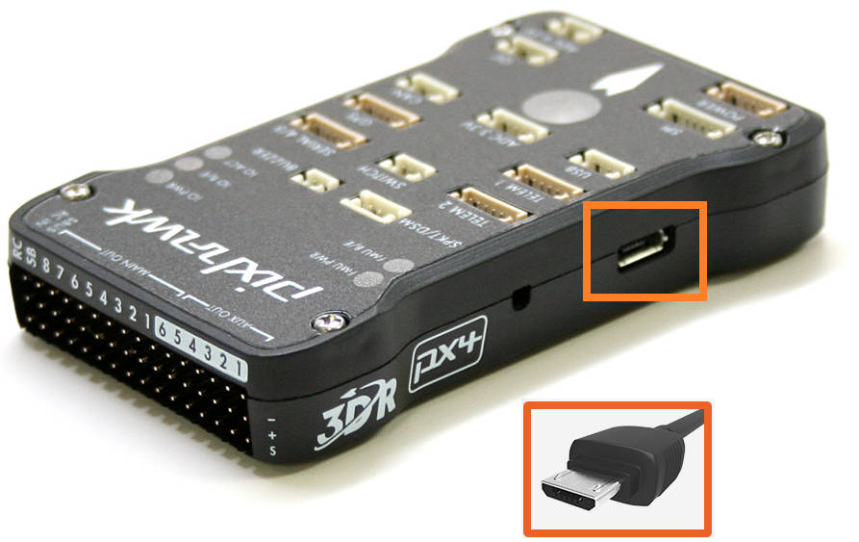Pixhawk Flight Controller

We further discussed:

* Screen Overview of Mission planner

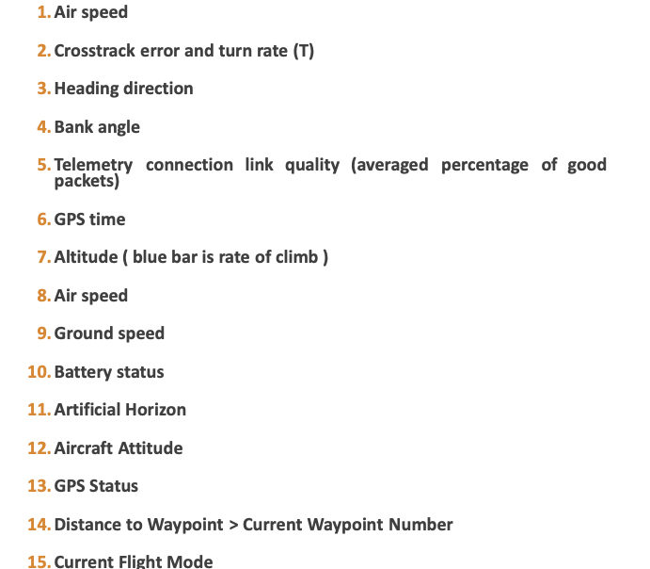 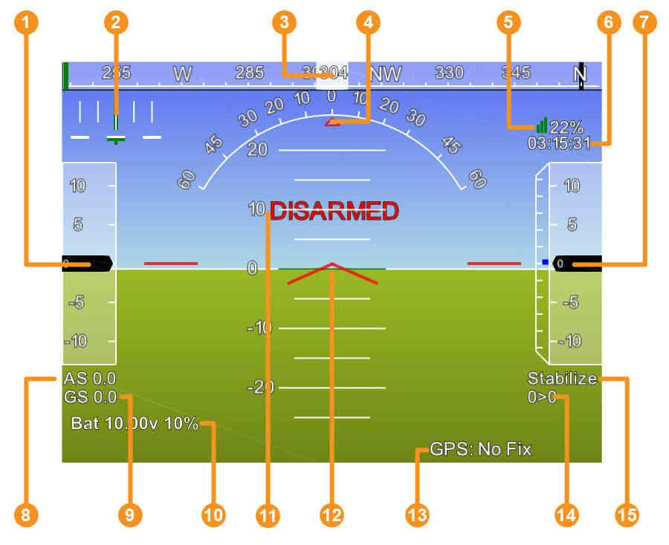

* Flight Modes of Mission Planner
* Acro Mode- Drone maintains its altitude level
* Stabilize Mode- Allows manual control of the Drone, but the roll and pitch axis are self balanced.
* Loiter Mode- The current orientation, altitude and heading direction of Drone are maintained .
* Flight Planning
* The Flight Plan option in mission planner allows us to manually scheme and execute the plan of the vehicle.
* SITL Features
* The Software-in-the-loop feature allows us to virtually fly aerial vehicles without any hardware. It works on autopilot principle, and we can plan and execute missions using it.
* Failsafes

**Controlling the Drone (Quadcopter)-**

Kinematics of quadcopter is based on motion about three axes: pitch, yaw and roll.

Roll is rotation about front to back axis, pitch is about right to left axis and yaw is about vertical axis of the drone. To lift the drone, net upward force by all rotors must be greater than the weight of the drone. 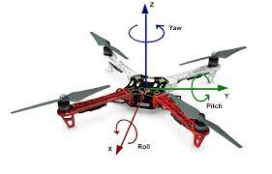

For pitching, we need to reduce the power in front motor and increase in rear motors, the drone will tilt about pitching axis and thrust provided by rotors will move the drone forward.For rolling, increasing power of two motors in left side and reducing power from right motors will tilt the drone and roll about front-back axis.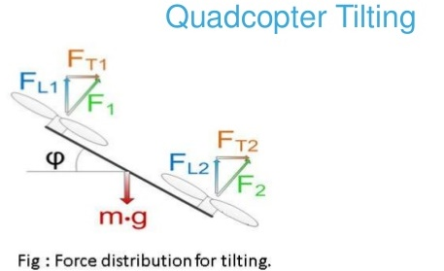

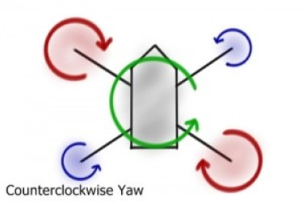

Each rotor produces force as well as torque, to neutralize aerodynamic torque,propellers of two opposite motors(i.e front left and rear right) rotate in clockwise direction and rest two rotates in counter clockwise direction. To perform yawing motion, we disturb the aerodynamic torque (by increasing power of clockwise rotating motors and reducing same power from counter clockwise rotating motors) hence the drone rotates counterclockwise about yawing axis to make aerodynamic torque zero. The basic principle to move a drone in a particular direction is, slow down the motor pointing in that direction and speed up the exactly opposite motor/s.

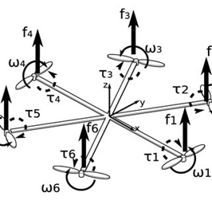

We studied motion of **Hexacopter** and found that handling principles of hexacopter are quite similar to quadcopter. Hexacopter with the advantage of 6 rotors can perform motion in a diagonal direction easily and is more stable than a quadcopter.

Hexacopter which is usually used for heavy payloads delivery and using professional grade camera have higher stability than a drone.The stability is mainly due to higher torque required to alter the hexacopter’s orientation.In Quadcopter, you have four control inputs and six degrees of freedom.Thus, 2 under-actuated states (related to zero dynamics).In Hexcopter, you have six control inputs and we need to tune 6 control loops for the hexacopter and it is easier to do backflips.We also learned that one of the most important difference between quadcopter and hexacopter is that the sense of rotation of opposite rotors are same in a quad. but opposite in a hexacopter.This helps in cancelling the total angular momentum on the drone or hexa. and thus stabilizes it

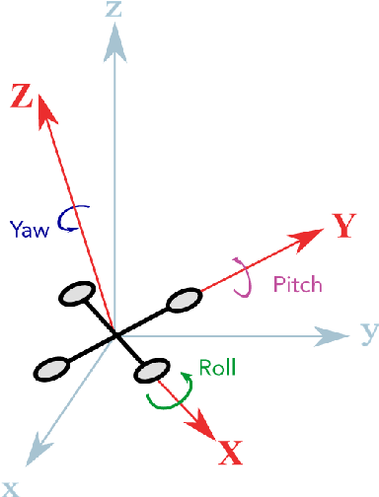

Our goal is to move the drone to destination in a desired configuration. For this, we constantly need to convert data from the body fixed coordinate system of a drone to ground coordinate system to calculate the error term. We studied Euler rule and learnt transformation of vectors in ground coordinates by using rotation tensor. Further, velocity and acceleration of any point on a drone can be calculated (provided some data about point and COM) using some equations !

**Drone Kinematics-**

**Euler Angles:** We define two cartesian frames Body fixed frame and Ground frame, the angles with respect to Body fixed frame are caller Euler angles.

The Roll, Pitch and Yaw angles in body frame are as:

q = (f ,q,ψ)T

**Transformation:** A rotation matrix M relates the body frame to the ground frame that obtains the ZYX Euler angle conventions:

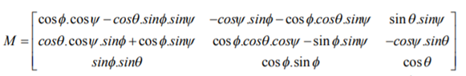

**Rotation:** When a rotor rotates, it’s propeller produces upward thrust given by *F*=*K*_*f * ω²* where *ω* (omega) is rotation rate of rotor measured in radian / second.

The total thrust of all motors (quadcopter) on body frame:

F = F1 + F2 + F3 + F4.

Propellers have same size and pitch, so:

F = K_f * (*ω1² + ω2² + ω3² + ω4²*)

The rotational torque provided is as :

t = R ´ F ;

tyaw = b * (*ω1² - ω2² + ω3² - ω4²*) ;

tpitch = b’ * (*ω2² - ω4²*) ;

troll= b’’ * (*ω1² - ω3²*) .

For hovering, all the *ωi* (omega) are equal to each other.

**Angular Velocity:** Let ω = [p, q, r] T is the angular velocity vector, I is the inertia matrix, then,

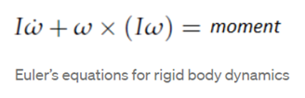

Do not confuse this ‘ω’ with the angular speed of rotors, this is the angular velocity of the drone around the three axes.

The angular velocities are with respect to ground frame but we require them with respect to Body frame and hence a rotation matrix is used to transform the angular velocities.

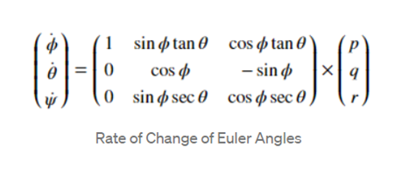

**Drone Dynamics-**

Drone dynamics help in finding the governing equation of our drone. With this governing equation we can model our drone as well as automate our controller. To automate our controller, we need an algorithm which is provided by the governing equation. The algorithm helps to correct our error and obtain our final configuration. The governing equation also provides the mathematical model of our drone which is needed for simulation.

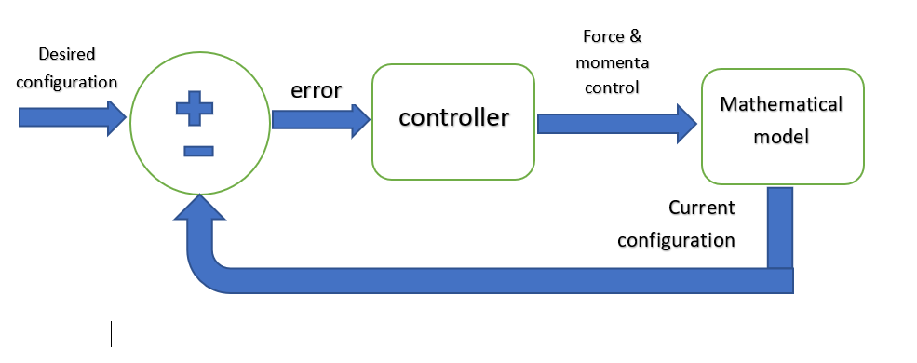

Mathematical model

We provide input to the drone in the form of angular velocity and this mathematical model calculates the current configuration. This is then used to calculate the error and then get the desired configuration.

**Dynamic quantities**

p = Mv

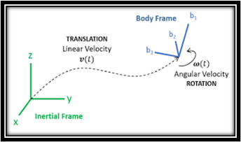 L= r x Mv + I⍵ where

* p - linear momentum
* L - angular momentum
* M - mass of drone
* v - velocity of COM of drone
* I - moment of inertia of drone
* ⍵ - angular velocity
* r - position of drone w.r.t reference point

**The laws**

The three laws that help in obtaining the governing equation are as follows-

* Mass balance - drone is considered as a rigid body. The distance between any points on the drone remains the same. So there is no deformity and thus there is no change in mass.
* Linear momentum balance - sum of all the forces acting on the drone is equal to mass of drone times the acceleration of COM i.e ∑F=Ma
* Angular momentum balance - ∑m=⍵ x (I.⍵) + I.⍺

where m- moment acting on drone and ⍺ - angular acceleration

**PID CONTROL**

PID controller is an instrument which is used to regulate the controlling of our drone. We can control the orientation and position of our drone by using the PID system.

## WORKING OF PID:

Firstly we have to tell the system about the desired configuration. The sensors present at the drone find out the actual configuration of our drone and send the data to our controller. The controller compares the datas and calculates the error/difference between the actual and desired configuration.

Now, the PID comes into play. It consists of 3 tools:

1. Proportion (P)

Multiplies the error with a constant and sends the command to the drone. Slowly the error reduces and we reach near the desired result. However, as the error becomes small, the correction term also gets small and we do not actually reach the target.

1. Integral (I)

It cumulates/integrates the error input and increases the correction term. Thus, we can reach the target with the help of integral action. But, because it keeps adding to the correction term, it overshoots the target configuration.

1. Derivative (D)

The derivative action can prevent or reduce the overshoot. It calculates the rate of change of error and reduces the correction term accordingly. If we are reaching our target too fast then this function helps to smooth it out. However, too much ‘D’ value can make the drone sluggish and we can lose the feeling of control over our drone.

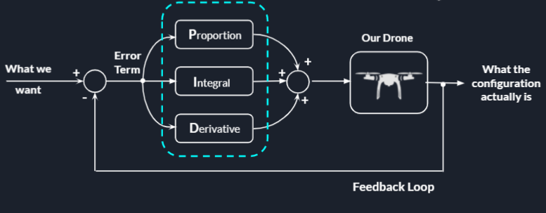

This diagram represents the working of PID control. A feedback loop sends the information collected from the sensors back to the controller. PID comprises 3 functions and their values (gain values) can be tuned according to the performance of our drone.

## MATHS IN PID:

The final mathematical expression represented by the 3 functions and the loop in above diagram is:

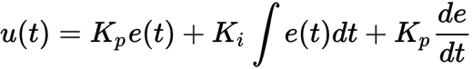

Where,

At time=t

u(t)= PID control variable

K= gain values of P,I

e(t)= error



Finally we ended Week 3 with the Ubuntu Installation

Discord Server link for help:

<https://discord.gg/ubuntu>

Download and Installation Walkthrough:

<https://itsfoss.com/install-ubuntu-dual-boot-mode-windows/>

Reference Links:

1)PID: https://www.youtube.com/watch?v=wkfEZmsQqiA

2)Hexacopter:

http://science.unctv.org/content/hexacopter-forces

3)Quadcopter: <https://en.wikipedia.org/wiki/Quadcopter>

4)Drone Kinematics:

<https://ijorlu.liau.ac.ir/article-1-503-fa.pdf>

5)Drone Dynamics:

<https://www.grc.nasa.gov/www/k-12/UEET/StudentSite/dynamicsofflight.html>