**Description** : This script will send personalized welcome mails to the users who fill google forms.

Sheet Link:

<https://docs.google.com/spreadsheets/d/18KJeN7uscqp24IjE0VTYOpzs2ddHdBziisE5nIWY5Os/edit#gid=1226234816>

Form Link:

<https://docs.google.com/forms/d/e/1FAIpQLSeP12xmX8uOovZMIK3M12m97D1Q0fa0J8FUXE0gKbyBiTFsCA/viewform>

**Steps:**

Step: 1 – Prepare a google form.

Step: 2 – Connect the google form with a google sheet.

Step: 3 – Now, click on **Tools > Script Editor**

Step: 4 – Write below function in code.

function triggerEmail(e)

{

var sheet = SpreadsheetApp.getActiveSheet();

var name = sheet.getRange(e.range.rowStart,2).getValue();

var emailID = sheet.getRange(e.range.rowStart,6).getValue();

MailApp.sendEmail(emailID, "Welcome "+ name, "Hi "+ name + ", Thanks for joining, you will receive a call from us soon.");

}

Step: 5 – Now, click on below button.

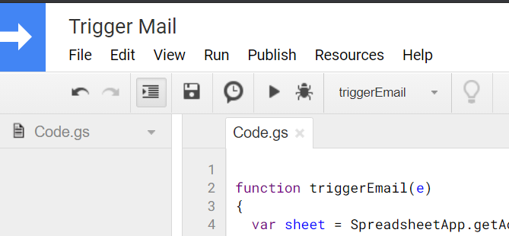

Step: 6 – A page will open of Google Apps Script. Click on “Add Trigger”.

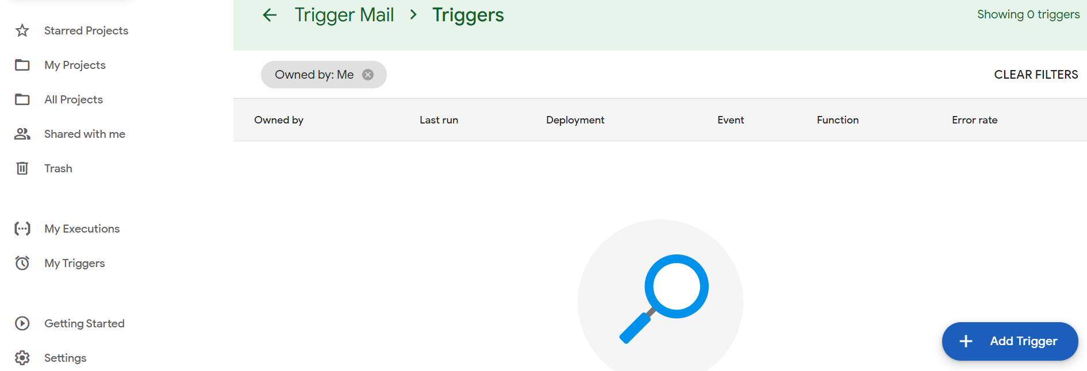

Step: 7 – Select the selection function name. Select event type as “On form submit”.

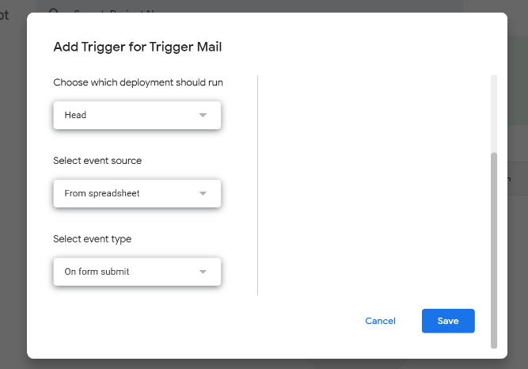

Step: 8 – Click on save. Then sign in with your google account and give required permissions. It is done. Now, fill the form along with correct mail id and after submitting you will receive a welcome mail.