**Problem Statement**

* Crate a machine learning model/solution which read text from an image of a question. If answers to that question is in your database display the image, else do a web search.

**Brief Description**

* We will have a question either in handwritten form or typed. We have to click a picture and read the text from it. If there is an answer, to the question in the image, in the database we will display the answer on the screen.
* If the answer is not available in the database, we will do an automated web search or will give a link which will provide the answer from the web.
* We will use the MS Azure AI-ML services, for building model, and flask for web app implementation.

**Methodology**

* I have a created a module URL_creator that will upload image to a website and get the URL for image, which I am going to pass in the model.
* I will use the Azure computer vision API service to create the model which will read the text from image.
* Then it will find the question in the data base (My project is small that’s why I am using notepad) and if founded return the name of image that contain the answer to that question, else return the link for the web search of that question.
* I am going to use flask for web application implementation for the model.
* I am also going to use gunicorn for web deployment of flask implemented model.

**Tools and APIs:**

* MS Azure AI/ML computer vision services, Flask, Python IDLE.

**Solution**

* First, created a module which will take an image as an input and upload it to a website(pastboard.co), named url_creator.py. Then return the url of that image.
* I am going to import this module inside the model named quickstartfile.py.
* In quickstartfile.py I am going to import the APIs and modules required. I am going create a function that will take url as parameter and get the text from the image. Then it will find the question in the data base (My project is small that’s why I am using notepad) and if founded return the name of image that contain the answer to that question, else return the link for the web search of that question.
* I am going to import the quickstartfile.py module into another file where I am going to implement the model in a web page, using flask.
* I am going to deploy the flask using gunicorn into public ip address.
* I am going to use google cloud service for VM for Linux and using gunicorn.

**Outputs**



**All the directories in project**

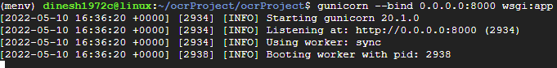

**Running Gunicorn(Public IP:34.125.7.137 & Port 8000)**

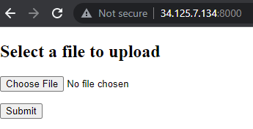

**We Applicaition UI**

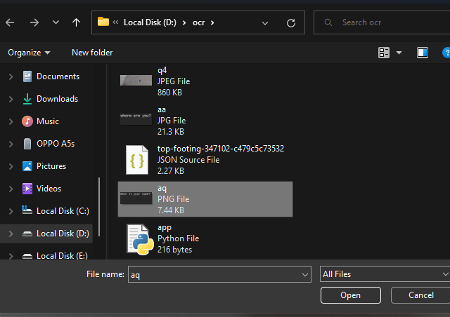

**Select image**

**Case 1:**

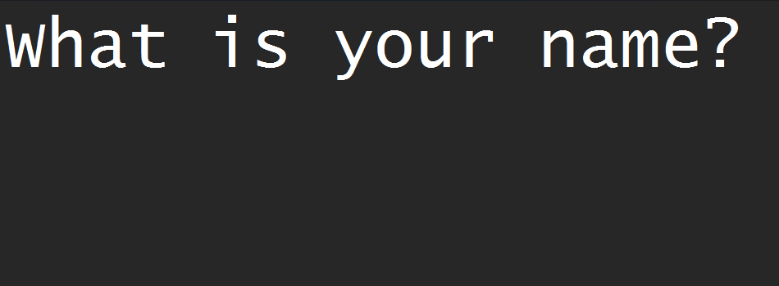

**Image was**

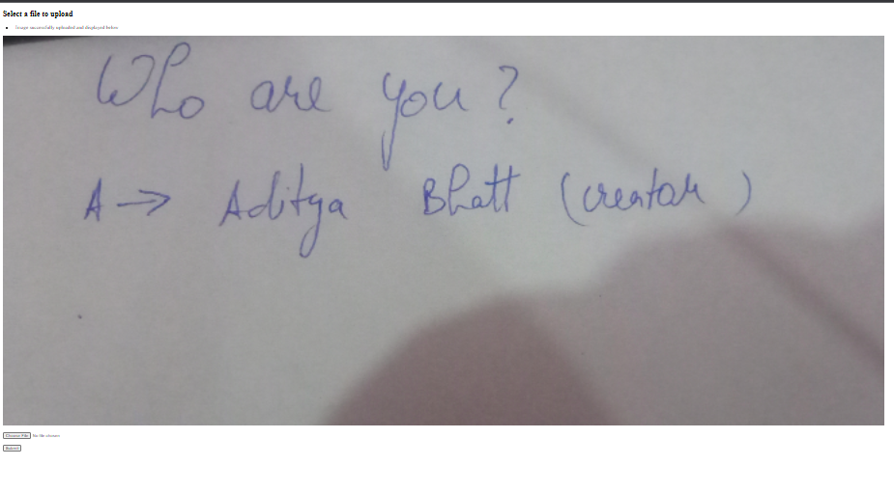

**founded on database**

**Case 2:**

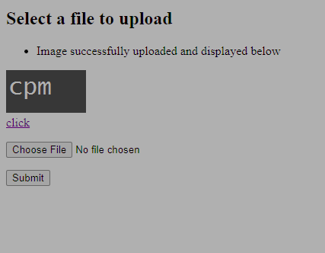

**Not found on database**

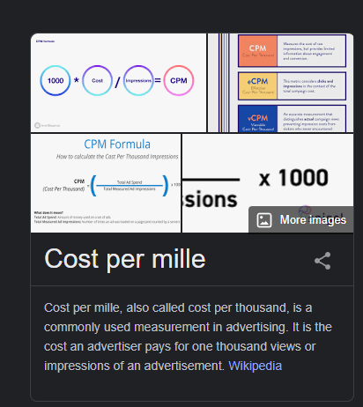

**Google search of the question (from ‘click’ link)**

**Conclusion**

Outcome of this project is a simple web application, which can be accessed on any platform, where we can upload an image and find related answers to the text.