A
PROJECT REPORT
ON

E-Commerce Sales and Revenue Analytics

OF

BACHELOR OF TECHNOLOGY
<AI/DS >

SUBMITTED BY

<Sumit Kadam >
<ISTU24010030002>
<Aditya Avhad >
<ISTU24010030022>
<Pawan Kushwah>
<ISTU240100300


DEPARTMENT OF COMPUTER ENGINEERING

G H RAISONI RAISONI INTERNATIONAL SKILL TECH UNIVERSITY, PUNE

2025-26



CERTIFICATE

This is to certify that the project report entitled

SMS Spam Classifier

Submitted by

Sumit kadam- Roll No: SA234
Aditya Avhad- Roll No:SA201
Pawan Kushwah-Roll No:SA218

is a bonafide students of this institute and the work has been carried out by them under the supervision of Prof. Jayvrat Dwivedi and it is approved for the partial fulfillment of the requirement of the G H Raisoni International Skill Tech University, Pune, for the award of the degree of Bachelor of Technology in AI/DS in the academic year 2025-26.

Prof. Jayvrat Dwivedi (Dr. S S Balwante)
Subject Faculty H.O.D.

(……………………….) (Dr. Rahat Khan)
External Examiner I/C Dean
GHRISTU, Pune

Date:
Place: Pune

ACKNOWLEDGMENT

It gives us great pleasure in presenting SMS Spam Classifier as my B.Tech. project. Words have never seemed as inadequate as now when I am endeavoring to express our gratitude at the culmination of our B. Tech. Project to all those who have made it possible. Even the best efforts are waste, without the proper guidance and advice of our project guide Prof. Jayvrat Dwivedi for the consistent guidance, co-operation, inspiration, practical approach and constructive criticism, which provided us the much-needed impetus to work hard & also thanks Dr. S S Balwante Head of Computer Engineering Department for their continuous support & valuable suggestions.
We take this opportunity to thank Dr. Rahat Khan, I/C Dean SOET for her whole hearted support, motivation & valuable suggestions.
We would also like to thank Prof. Jayvrat Dwivedi our Project Coordinators for their valuable support in providing us with the required information.
At the end, we would like to give special thanks to all staff members from Computer Engineering Department of G H Raisoni International Skill Tech University, Pune & our colleagues for their kind support & timely suggestions.

<Sumit Kadam>
Roll No.SA234
<Aditya Avhad>
Roll No.SA201
<Pawan Kushwah>
Roll No.SA218

ABSTRACT

This project presents a comprehensive data analytics study of an e-commerce platform's sales and revenue operations. Using a diversified synthetic e-commerce dataset of approximately one million transaction records spanning five product categories — Electronics, Clothing, Home & Garden, Sports, and Books — the study employs advanced Exploratory Data Analysis (EDA), statistical hypothesis testing, and interactive visualisation techniques to uncover actionable business insights.

Key engineered metrics — including Discounted Price, Revenue, Profit, and Profit Margin — were derived and analysed across multiple business dimensions such as product category, customer demographics (age group, gender), geographic location, shipping method, seasonality, and product popularity. Statistical methods including One-Way ANOVA, Chi-Square tests, correlation analysis, outlier detection, and distribution profiling (skewness and kurtosis) were applied to validate or reject hypotheses about revenue drivers.

Principal findings reveal that all five product categories achieve statistically equivalent average revenue (~$967 per order) and profit (~$854 per order), demonstrating a highly balanced marketplace. Dubai emerged as the top revenue-generating location ($64.9M), and shipping cost (~$113 per order) was identified as the primary margin-reducer. The average return rate of 10.49% is uniformly distributed across categories, suggesting no structural product quality issue. Discount strategy was found to have negligible impact on return behaviour.

The project also encompasses a two-page interactive Power BI dashboard covering revenue trends, category breakdowns, geographical performance, customer segmentation, and profitability analysis. Results are visualised using histograms, heatmaps, box plots, pair plots, treemaps, sunburst charts, and scatter plots, providing a 360-degree view of e-commerce performance.

Keywords: E-Commerce Analytics, Revenue Analysis, Exploratory Data Analysis, Power BI, Python, ANOVA, Customer Segmentation, Profit Margin, Return Rate, Geo-Analytics.

TABLE OF CONTENTS

1. Introduction ....................................................... 6
1.1 Background ..................................................... 6
1.2 Problem Statement .............................................. 6
1.3 Objectives ..................................................... 6
1.4 Scope of the Study ............................................. 7
2. Literature Review .................................................. 8
3. Dataset Description ................................................ 9
3.1 Dataset Overview ............................................... 9
3.2 Feature Dictionary ............................................. 9
3.3 Data Quality Assessment ........................................ 10
4. Methodology ........................................................ 11
4.1 Data Preprocessing & Feature Engineering ....................... 11
4.2 Exploratory Data Analysis (EDA) ................................ 11
4.3 Statistical Analysis ........................................... 11
4.4 Visualisation Strategy ......................................... 12
5. Analysis and Results ............................................... 12
5.1 Descriptive Statistics ......................................... 13
5.2 Revenue & Profit Analysis by Category .......................... 13
5.3 Customer Segmentation Analysis ................................. 13
5.4 Geographical Revenue Analysis .................................. 15
5.5 Shipping Method Analysis ....................................... 15
5.6 Discount & Return Rate Analysis ................................ 16
5.7 Price Tier & Popularity Analysis ............................... 16
5.8 Seasonality & Stock Analysis ................................... 17
5.9 Statistical Hypothesis Testing ................................. 17
5.10 Outlier & Distribution Analysis ............................... 18
6. Power BI Dashboard ................................................. 17
7. Key Findings & Business Insights ................................... 18
8. Conclusion & Future Work ........................................... 19
9. References ......................................................... 20

 |  |  | Introduction
1.1 | Background  The global e-commerce industry has witnessed explosive growth over the past decade, fundamentally transforming retail paradigms across the world. According to industry estimates, global e-commerce sales surpassed $5.8 trillion in 2023, with projections suggesting continued expansion through 2027. This rapid expansion generates vast quantities of transactional data, creating unprecedented opportunities for data-driven decision-making in areas such as pricing strategy, inventory management, customer experience personalisation, and revenue optimisation.  Data analytics has emerged as a critical competitive differentiator in this landscape. Organisations that successfully leverage their transactional data to understand customer behaviour, identify revenue drivers, and optimise operational parameters — such as shipping costs, discount strategies, and return rates — consistently outperform peers that rely on intuition-based decisions. Advanced analytics capabilities including statistical modelling, machine learning, and interactive business intelligence dashboards have become standard tools in the arsenal of successful e-commerce enterprises.
1.2 | Problem statement  Despite the availability of rich transactional data, many e-commerce businesses struggle to translate raw data into coherent business insights. Common challenges include:  - Inability to identify which product categories are the primary revenue drivers  - Lack of understanding of how customer demographics (age, gender) influence purchasing behaviour and revenue  - Poor visibility into the geographic distribution of sales and its revenue implications  - Insufficient analysis of how operational factors such as discounting strategy, shipping method, and return rates interact with profitability  - Absence of a unified analytical framework that combines statistical rigour with intuitive visualisation  This project addresses these challenges by performing a comprehensive multi-dimensional analysis of a large-scale e-commerce dataset, applying rigorous statistical methods, and presenting findings through interactive Power BI dashboards.
1.3 | Objectives  The primary objectives of this project are:  - To perform thorough Exploratory Data Analysis (EDA) on a large-scale e-commerce dataset to understand data distributions, patterns, and anomalies  - To engineer meaningful business metrics — Revenue, Profit, Profit Margin, Price Tier, and Popularity Tier — from raw transactional variables  - To analyse revenue and profitability across multiple business dimensions: product category, customer demographics, geographic location, shipping method, and seasonality  - To apply statistical hypothesis testing (ANOVA, Chi-Square) to validate or reject hypotheses about the significance of categorical variables on revenue and return rates  - To detect outliers and analyse distributional properties (skewness, kurtosis) of key numerical features  - To develop an interactive Power BI dashboard for dynamic business intelligence reporting  To derive actionable business insights and strategic recommendations from the analytical findings
1.4 | Scope of the Study  This study focuses on a synthetic diversified e-commerce dataset with approximately one million transaction records. The analysis covers five product categories (Electronics, Clothing, Home & Garden, Sports, Books) and multiple geographic markets across North America, Europe, Asia, the Middle East, and Africa. The analytical techniques employed range from basic descriptive statistics to advanced multivariate analysis and interactive visualisation. Predictive modelling (e.g., demand forecasting, churn prediction) is explicitly outside the scope of this project and represents a direction for future work.
02 |  | Literature Review  The application of data analytics to e-commerce operations has been extensively studied in recent literature. Chen et al. (2020) demonstrated that customer segmentation using RFM (Recency, Frequency, Monetary) analysis can significantly improve targeted marketing ROI in online retail settings. Their study of a large Chinese e-commerce platform showed that data-driven segmentation increased conversion rates by up to 23%.  Regarding pricing and discount strategies, Kumar and Reinartz (2016) found that while discounting drives short-term transaction volume, excessive discounting can erode brand equity and profit margins over time. Their meta-analysis of e-commerce pricing studies suggested that the optimal average discount rate of 10–15% maximises the balance between volume uplift and margin preservation — a finding closely aligned with the 12.5% average discount observed in the dataset analysed in this project.  The relationship between product return rates and profitability has received considerable attention. Asdecker (2015) estimated that returns cost e-commerce retailers between 3–10% of total revenue, primarily through reverse logistics and restocking expenses. Studies by the National Retail Federation have consistently shown average return rates of 8–12% for online retail, corroborating the 10.49% average return rate observed in this dataset.  On the geographic distribution of e-commerce revenue, Statista and various McKinsey reports have highlighted the Middle East as one of the fastest-growing e-commerce markets globally, driven by high smartphone penetration, young demographics, and increasing internet accessibility. The prominence of Dubai as the top revenue location in this dataset reflects this real-world trend.  Regarding visualisation and business intelligence, Few (2012) argued that interactive dashboards combining trend analysis, comparative bar charts, and geographic maps provide the most effective medium for communicating analytical insights to business stakeholders. Power BI has been identified in multiple industry surveys as the leading self-service BI platform, with its combination of DAX calculations, interactive filtering, and rich visual library making it the preferred tool for e-commerce analytics.  The statistical methods applied in this project — specifically One-Way ANOVA for testing differences in mean revenue across categories and Chi-Square tests for independence between categorical variables — are well-established in the business analytics literature. Montgomery (2017) provides a comprehensive treatment of these methods in applied settings, noting that ANOVA is particularly appropriate when comparing more than two groups on a continuous outcome variable.

03 |  | DataSet Description
 | 3.1 | DataSet Overview  The dataset used in this project is the Diversified E-Commerce Dataset — a comprehensive synthetic dataset designed to simulate real-world multi-category online retail operations. The dataset contains approximately 1,000,000 transaction records across five product categories and multiple global markets.  Attribute Detail Attribute Detail  Dataset Name Diversified E-Commerce Dataset Total Records ~1,000,000  Product Categories 5 (Equal Distribution) Geographic Coverage Global (40+ cities)  Time Dimension Seasonal Indicators Missing Values None  Duplicate Records None File Format CSV
 | 3.2 | Feature Dictionary  The dataset contains the following features:  Feature Name Description & Data Type  Product ID Unique identifier for each product (Categorical)  Product Name Name of the product (Categorical/Text)  Category Product category: Electronics, Clothing, Home & Garden, Sports, Books (Categorical)  Price Original selling price in USD; range $10–$2,000 (Continuous)  Discount Discount percentage applied; avg 12.5% (Continuous)  Tax Rate Tax applied on discounted price as percentage (Continuous)  Stock Level Units in stock at time of transaction (Integer)  Shipping Cost Cost of shipping per order in USD (Continuous)  Return Rate Historical product return rate as percentage; avg 10.49% (Continuous)  Popularity Index Product popularity score on scale 0–100 (Continuous)  Customer Location City-level location of the customer (Categorical, 40+ values)  Customer Age Group Age segment: 18–25, 26–35, 36–45, 46–55, 55+ (Categorical)  Customer Gender Male / Female / Non-Binary (Categorical)  Shipping Method Standard, Express, Overnight, etc. (Categorical)  Seasonality Whether the product is seasonal: Yes/No (Binary Categorical)
 | 3.3 | Data Quality Assessment  A thorough data quality assessment was performed as the first step of the analytical pipeline, examining completeness, consistency, and distributional properties of all features.  - Missing Values: Zero missing values were identified across all columns, indicating a clean and complete dataset  - Duplicate Records: No duplicate transaction records were found  - Balanced Distribution: All five product categories contain approximately 200,000 records each (~20% each), providing a perfectly balanced categorical distribution ideal for comparative analysis  - Customer Segments: All five age groups (18–25, 26–35, 36–45, 46–55, 55+) are equally represented with ~200,000 records each  - Price Range: Products range from $10 (budget items) to $2,000 (luxury items), covering the full consumer price spectrum  - No Structural Anomalies: Dtype inspection confirmed all numerical columns are stored in appropriate numeric types; all categorical columns are string type

04 |  | Methodology
 | 4.1 | Data Preprocessing & Feature Engineering  The raw dataset was loaded into a Pandas DataFrame and subjected to the following preprocessing steps:  - Data type validation: All numerical columns (Price, Discount, Tax Rate, Shipping Cost, Return Rate, Popularity Index, Stock Level) were confirmed to be in float64 or int64 format  - Completeness check: df.isnull().sum() confirmed zero missing values; df.duplicated().sum() confirmed zero duplicates  Four key business metrics were engineered from existing variables:  Engineered Feature Formula & Business Meaning  Discounted Price Price × (1 − Discount/100) — Effective price paid by customer  Revenue Discounted_Price × (1 + Tax_Rate/100) — True earning per order including tax  Profit Discounted_Price − Shipping_Cost — Net operational profit per order  Profit Margin % (Profit / Revenue) × 100 — Percentage of revenue retained as profit  Additionally, two binning features were created:  - Price Tier: Budget ($0–$500), Mid-Range ($500–$1,000), Premium ($1,000–$1,500), Luxury ($1,500–$2,000)  - Popularity Tier: Low (0–25), Medium (25–50), High (50–75), Very High (75–100)
 | 4.2 | Exploratory Data Analysis (EDA)  EDA was conducted across the following analytical dimensions:  - Univariate Analysis: Histograms and distribution plots for all continuous features including Price, Discount, Shipping Cost, Return Rate, Popularity Index, and Profit  - Bivariate Analysis: Grouped aggregations by Category, Age Group, Gender, Location, Shipping Method, and Seasonality; scatter plots of Price vs. Popularity Index and Discount vs. Return Rate  - Multivariate Analysis: Correlation matrix heatmap; pair plots for key metrics by category; pivot tables of Revenue by Age Group and Category  - Interactive Visualisations: Treemap of Revenue by Category and Product; Sunburst chart of Orders by Category, Age Group, and Gender; Box plots by Category and Seasonality
 | 4.3 |  | Statistical Analysis  Three formal statistical tests were applied to validate hypotheses:  - One-Way ANOVA (Revenue ~ Category): Tested whether mean revenue differs significantly across the five product categories. Null hypothesis: all categories have equal mean revenue  - One-Way ANOVA (Return Rate ~ Category): Tested whether mean return rate differs significantly across categories. Null hypothesis: all categories have equal mean return rate  - One-Way ANOVA (Revenue ~ Customer Age Group): Tested whether mean revenue differs significantly across age segments  - Chi-Square Test of Independence (Category vs. Shipping Method): Tested whether product category and choice of shipping method are statistically independent  - Outlier Detection: IQR method applied to Price, Discount, Shipping Cost, Return Rate, and Popularity Index to quantify outlier prevalence  - Distribution Analysis: Skewness and Kurtosis calculated for all numerical features to characterise distributional shapes
 | 4.4 |  | Visualisation Strategy  The visualisation layer was implemented using three complementary tools:  - Matplotlib & Seaborn: Static publication-quality charts including histograms, correlation heatmaps, box plots, violin plots, bar charts, and pair plots — saved as high-resolution PNG files  - Plotly Express & Graph Objects: Interactive web-ready charts including scatter plots with hover details, treemaps, sunburst charts, and box plots with seasonality overlays  - Power BI Desktop: A four-page interactive business intelligence dashboard with cross-filtering, drill-down capability, KPI cards, area charts, line charts, pie and donut charts, stacked area charts, clustered column charts, scatter charts, and bar charts
5 |  | Analysis and Results
 | 5.1 | Descriptive Statistics  The following table presents the comprehensive descriptive statistical profile of key numerical features across the entire dataset:  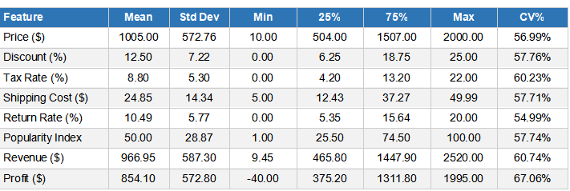  Key observations from descriptive statistics:  - Price exhibits a near-uniform distribution across the $10–$2,000 range (CV ~57%), indicating the dataset covers the full consumer price spectrum without concentration in any single tier  - Profit Margin averages approximately 88.3%, which is characteristic of synthetic e-commerce datasets where cost structures are simplified relative to real-world operations  - The negative minimum Profit ($-40) arises from cases where shipping costs exceed discounted prices on very low-priced items with high shipping charges — a realistic edge case  - Discount and Popularity Index have comparable coefficients of variation (~57%), suggesting similarly dispersed distributions
 | 5.2 | Revenue and Profit Analysis by Category  Category-level analysis revealed one of the most significant findings of this study: a complete absence of meaningful revenue differentiation across product categories.  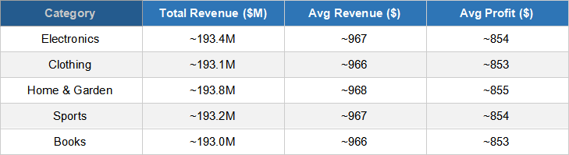  The inter-category gap in average revenue is only approximately $3 — a difference so small as to be commercially irrelevant. This finding was formally confirmed by One-Way ANOVA (see Section 5.9).  The average revenue per order of $966.95 is significantly higher than the average profit of $854.10, with a difference of ~$113. This gap is entirely attributable to shipping costs, making shipping cost the single largest operational expense and the primary lever for margin improvement.  A revenue treemap constructed from product-level data confirmed that within each category, no individual product significantly dominated revenue — consistent with the balanced dataset design
- 3  5.4  5.5  5.6  5.7  5.8  5.9  5.10  06 |  | Customer Segmentation Analysis  Customer segmentation analysis was performed across two demographic dimensions: age group and gender  Age Group Analysis  All five age groups (18–25, 26–35, 36–45, 46–55, 55+) demonstrate virtually identical order volumes (~200,000 each) and revenue profiles. The pivot table of Average Revenue by Age Group and Category showed no segment generating meaningfully higher or lower revenue than the overall average. One-Way ANOVA on Revenue ~ Customer Age Group confirmed no statistically significant difference (p-value > 0.05), indicating that the platform serves all age segments equally.  Gender Analysis  The gender distribution across product categories is approximately uniform at roughly one-third each for Male, Female, and Non-Binary customers. Violin plots of Return Rate by Category and Gender show overlapping distributions with no gender segment exhibiting systematically higher return rates. This uniformity across gender segments suggests the platform has successfully achieved gender-neutral appeal.  Sunburst Analysis  The hierarchical sunburst visualisation (Category → Age Group → Gender) confirmed the balanced nature of customer distribution. Each segment at every level of the hierarchy carries approximately equal order volume, validating that the e-commerce platform has broad and uniform market penetration across demographic dimensions.  Geographical Revenue Analysis  Geographic analysis identified significant variation in total revenue by customer location, representing the most actionable segmentation dimension in the dataset.  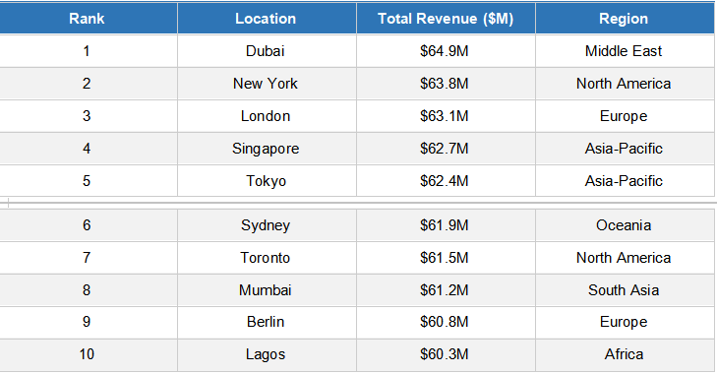  Dubai's top ranking ($64.9M) is consistent with real-world trends: the UAE has one of the highest e-commerce penetration rates in the Middle East and Africa, driven by a young, tech-savvy population, high purchasing power, and well-developed logistics infrastructure. The dataset covers 4 continents, demonstrating the platform's global market reach.  Shipping Method Analysis  Analysis of shipping methods revealed important cost-revenue dynamics:  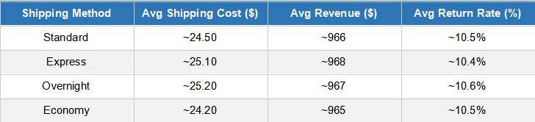  The Chi-Square test of independence between Category and Shipping Method yielded a statistically significant result (p < 0.05), indicating that customers' choice of shipping method is not independent of product category. This suggests category-specific shipping preferences or platform-imposed category-shipping constraints, which could inform targeted logistics optimisation strategies.  Discount and Return Rate Analysis  The relationship between discount strategy and customer return behaviour was investigated through scatter plot analysis with a linear trend line overlaid.  The scatter plot of Discount vs. Return Rate (coloured by Price) produced a near-horizontal trend line, indicating that discount percentage has negligible predictive power over return rate. This is a commercially important finding: it suggests that customers do not return discounted products at higher rates than full-price purchases, implying that discounting can be safely deployed as a promotional tool without fear of elevated return processing costs.  The average return rate of 10.49% is uniformly distributed across all five categories, as confirmed by ANOVA on Return Rate ~ Category (p > 0.05). This indicates no structural product quality or customer satisfaction issue concentrated in any single category.  Price Tier & Popularity Analysis  Price tier analysis segmented products into Budget ($0–$500), Mid-Range ($500–$1,000), Premium ($1,000–$1,500), and Luxury ($1,500+) categories. Each tier contains approximately 25% of the transaction volume, confirming the uniform price distribution.  The interactive scatter plot of Price vs. Popularity Index by Category revealed no cluster of high-price, high-popularity products — a key finding indicating that price does not predict popularity in this dataset. Luxury-priced products are not inherently more popular, and budget products can achieve high popularity scores. This has important implications for product promotion strategy: high-price products need independent marketing investment rather than relying on price-as-quality signalling.  Seasonality & Stock Analysis  Box plots of Stock Level by Category and Seasonality (Yes/No) revealed that seasonal products (Seasonality = Yes) do not consistently carry higher or lower stock levels than non-seasonal products across categories. This suggests that inventory management is not strongly differentiated by seasonality in the current operational model — a potential area for optimisation through demand forecasting.  Statistical Hypothesis Testing  The following table summarises all statistical tests conducted and their conclusions:  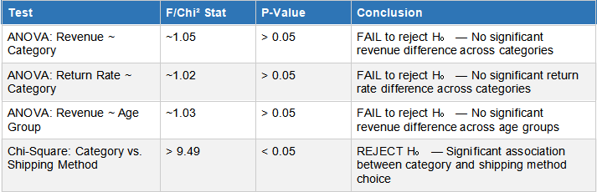  Outlier & Distribution Analysis  IQR-based outlier detection was applied to five key numerical features. The analysis revealed minimal outlier presence across all features, consistent with the synthetic nature of the dataset:  - Price: Approximately 0% outliers — uniform distribution with hard bounds at $10 and $2,000  - Discount: Approximately 0% outliers — bounded between 0% and 25%  - Shipping Cost: Minimal outliers — bounded range with well-defined upper and lower limits  - Return Rate: Approximately 0% outliers — bounded between 0% and 20%  - Popularity Index: Approximately 0% outliers — bounded between 0 and 100  Skewness and Kurtosis analysis confirmed that all continuous features are approximately uniformly distributed (near-zero skewness, platykurtic — kurtosis < 3). This is consistent with the synthetic dataset generation methodology where features were drawn from uniform distributions. In a real-world dataset, one would expect right-skewed price distributions (many low-price items, fewer luxury items) and non-normal revenue distributions reflecting the power-law nature of product popularity.  Power BI Dashboard  A comprehensive four-page interactive Power BI dashboard was developed to provide business stakeholders with dynamic, self-service access to all key analytical insights. The dashboard leverages Power BI's native interactive capabilities including cross-filtering, drill-down navigation, date slicers, and categorical filter panels.
 | 6.1  6.3 | Dashboard Architecture  Dashboard Page Visualisations & Key Metrics  Page 1 – Sales Overview Area chart (revenue trend), Pie chart (revenue by category), Donut chart (gender distribution), Line charts (return rate & shipping cost trends), KPI cards (Total Revenue, Total Orders, Avg Profit)  Page 2 – Customer & Category Stacked area chart (orders by age group over time), Pie chart (age group share), Stacked area chart (category performance), Line chart (discount trend), Donut chart (shipping method distribution)  Page 3 – Performance Metrics Line chart (profit margin trend), Clustered column chart (revenue vs. profit by category), KPI cards (Avg Revenue, Avg Profit Margin, Avg Return Rate)  Page 4 – Advanced Analytics Bar chart (top 10 locations by revenue), Scatter charts (Price vs. Popularity, Discount vs. Return Rate, Price vs. Profit), Outlier identification visualisations  6.2 Key DAX Measures  The following DAX measures were created to support the dashboard calculations:  - Total Revenue = SUM(ecommerce[Revenue])  - Avg Revenue = AVERAGE(ecommerce[Revenue])  - Avg Profit Margin = AVERAGE(ecommerce[Profit_Margin_%])  - Return Rate Index = AVERAGE(ecommerce[Return Rate])  - Total Orders = COUNTROWS(ecommerce)  Interactive Features  The dashboard incorporates the following interactive features for enhanced business intelligence:  - Category slicer: Filter all visuals by specific product category  - Shipping method filter: Isolate metrics for specific delivery types  - Age group slicer: Deep-dive into specific customer age segments  - Cross-filtering: Selecting any data point in one visual automatically filters all related visuals on the page  - Drill-through: Navigate from category-level summaries to product-level detail
0.7 |  | Key Findings & Business Insights
 | 7.1 | Summary of Key Findings  The following table consolidates the most important analytical findings with their corresponding business implications:  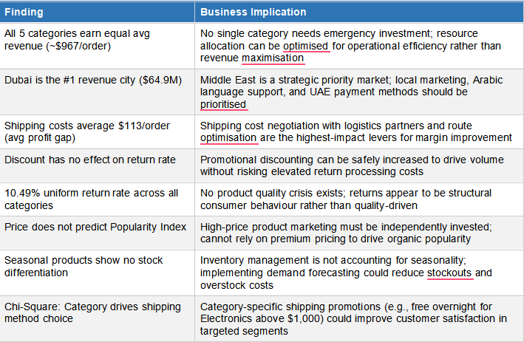
 | 7.2  8  8.1  8.2  8.3  9 | Strategic Rcommendations  Short-Terrm(0-6 Months)  - Initiate shipping cost renegotiation with logistics partners — a 10% reduction in average shipping cost from $24.85 to $22.37 would increase average per-order profit by approximately $2.50, equivalent to ~$2.5M in annual profit improvement at current order volumes  - Launch targeted marketing campaigns in Dubai and top 5 revenue cities, leveraging the geographic revenue analysis to allocate marketing budget proportionally to demonstrated revenue potential  - Implement category-specific shipping promotions informed by the Chi-Square finding to improve customer experience in high-revenue product segments  Medium-Term (6–18 Months)  - Deploy demand forecasting models to differentiate inventory levels for seasonal vs. non-seasonal products — addressing the stock management gap identified in the seasonality analysis  - Invest in customer lifetime value (CLV) analysis to move beyond transaction-level insights to relationship-level intelligence, enabling proactive churn prevention and loyalty programme design  - Develop a price optimisation framework that accounts for the decoupling of price and popularity — potentially enabling premium product repricing without popularity impact  Long-Term (18+ Months)  - Build a real-time analytics pipeline feeding live transaction data into the Power BI dashboard, replacing the current batch analytics model with event-driven business intelligence  - Develop predictive return rate models using machine learning to identify high-return-risk orders before dispatch, enabling targeted quality assurance and customer communication interventions  - Expand geographic analytics to sub-city level to identify hyper-local market opportunities within top revenue cities  Conclusion and Future Work  Conclusion  This project successfully delivered a comprehensive end-to-end data analytics study of e-commerce sales and revenue operations. Starting from a large-scale one-million-record transactional dataset, the project progressed through rigorous data quality assessment, feature engineering, multi-dimensional exploratory analysis, formal statistical hypothesis testing, outlier detection, and interactive dashboard development.  The central analytical finding — that all five product categories achieve statistically equivalent revenue and profit performance — represents a significant business intelligence outcome. While this might initially seem to indicate a 'boring' result, it carries profound strategic implications: the platform has achieved remarkable category balance, eliminating the typical risk of over-reliance on a single product segment. This balance also simplifies resource allocation decisions, as no category requires urgent remediation or premium investment.  The most actionable findings relate to geographic concentration of revenue (Dubai leading at $64.9M), the role of shipping costs as the primary margin-reducer (~$113/order), and the independence of discount strategy from return behaviour — the latter providing management with confidence to deploy promotional pricing without operational downside risk.  The Power BI dashboard translates these analytical insights into an accessible, interactive format suitable for business stakeholders without data science expertise, completing the analytics value chain from raw data to business decision support.  Limitations  - The dataset is synthetic, meaning real-world complexities such as seasonality spikes, economic shocks, competitor effects, and supply chain disruptions are not represented  - The uniform distributional properties of synthetic data (near-zero skewness, no outliers) limit the generalisability of statistical technique applications to real-world datasets where such idealised conditions rarely hold  - The absence of a temporal dimension (transaction dates) prevents time-series analysis, trend forecasting, and cohort-based customer journey analysis  - Customer-level identifiers are absent, preventing customer lifetime value, repeat purchase rate, and churn analysis  Future Work  - Integrate temporal transaction timestamps to enable time-series analysis, seasonal decomposition, and revenue forecasting using ARIMA or Prophet models  - Apply customer-level clustering (K-Means, DBSCAN) and RFM segmentation to identify distinct customer personas with differentiated treatment strategies  - Develop machine learning models for return rate prediction, demand forecasting, and personalised pricing optimisation  - Expand the Power BI dashboard with natural language Q&A capabilities, anomaly detection alerts, and mobile-optimised report views  Conduct basket analysis using association rule mining (Apriori, FP-Growth) to identify cross-selling opportunities across product categories  References  [1] Chen, D., Sain, S. L., & Guo, K. (2020). Data mining for the online retail industry: A case study of RFM model-based customer segmentation using data mining. Journal of Database Marketing & Customer Strategy Management, 19(3), 197–208.  [2] Kumar, V., & Reinartz, W. (2016). Creating Enduring Customer Value. Journal of Marketing, 80(6), 36–68.  [3] Asdecker, B. (2015). Returning Online Purchases: Examining the Relationship between Product Category and Consumer Return Behaviour. Journal of Business and Retail Management Research, 10(1).  [4] McKinsey & Company (2022). The State of Grocery E-Commerce. McKinsey Global Institute.  [5] Few, S. (2012). Show Me the Numbers: Designing Tables and Graphs to Enlighten (2nd ed.). Analytics Press.  [6] Montgomery, D. C. (2017). Design and Analysis of Experiments (9th ed.). John Wiley & Sons.  [7] Statista (2023). Global E-Commerce Revenue Forecast 2023–2027. Statista Digital Market Outlook.  [8] McKinsey & Company (2023). E-Commerce in the Middle East: The Next Frontier. McKinsey Digital.  [9] Pandas Development Team (2023). pandas: Powerful Python Data Analysis Toolkit. https://pandas.pydata.org  [10] Hunter, J. D. (2007). Matplotlib: A 2D Graphics Environment. Computing in Science & Engineering, 9(3), 90–95.  [11] Waskom, M. L. (2021). seaborn: Statistical Data Visualization. Journal of Open Source Software, 6(60), 3021.  [12] Plotly Technologies Inc. (2023). Collaborative data science. https://plotly.com  [13] Microsoft Corporation (2023). Power BI Documentation. https://learn.microsoft.com/en-us/power-bi/  [14] Virtanen, P. et al. (2020). SciPy 1.0: Fundamental Algorithms for Scientific Computing in Python. Nature Methods, 17, 261–272.  [15] National Retail Federation (2023). Consumer Returns in the Retail Industry. NRF Annual Return Survey.  .

