Name = Aditya Ray
Enrollment = S24cseu1020

import sys
from pathlib import Path
print("Python:", sys.version.split()[0])
print("Folder:", Path.cwd().name)
for name in ["numpy", "pandas", "sklearn"]:
try:
__import__(name)
print(name, "- ok")
except ImportError:
print(name, "- missing")
Python: 3.14.6
Folder: MLOPS
numpy - ok
pandas - ok
sklearn - ok
import csv
from pathlib import Path
import numpy as np
SEED = 42
N_ROWS = 600
DATA = Path("data") / "delivery_times.csv"
from pathlib import Path
print(Path.cwd())
/Users/apple/Documents/work/Class/sem 5/MLOPS
def make_delivery_csv(path=DATA):
rng = np.random.default_rng(SEED)
distance_km = np.round(rng.uniform(0.5, 12.0, N_ROWS), 2)
prep_time_min = np.round(rng.uniform(5, 30, N_ROWS), 0)
traffic_level = rng.integers(1, 4, N_ROWS)
rain = rng.binomial(1, 0.25, N_ROWS)
delivery_min = np.round(
6.0 + 3.1 * distance_km + 0.65 * prep_time_min
+ 4.2 * traffic_level + 5.5 * rain
+ rng.normal(0, 2.5, N_ROWS), 1)
path.parent.mkdir(parents=True, exist_ok=True)
with path.open("w", newline="", encoding="utf-8") as fh:
w = csv.writer(fh)
w.writerow(["distance_km", "prep_time_min", "traffic_level", "rain", "delivery_min"])
for i in range(N_ROWS):
w.writerow([distance_km[i], int(prep_time_min[i]), int(traffic_level[i]), int(rain[i]), delivery_min[i]])
return path
if not DATA.exists():
make_delivery_csv()
print("dataset ready:", DATA)
dataset ready: data/delivery_times.csv
import sys
from pathlib import Path
print("Python version:", sys.version.split()[0])
print("Python program:", sys.executable)
print("Inside .venv :", ".venv" in sys.executable)
Python version: 3.14.6
Python program: /opt/anaconda3/bin/python
Inside .venv : False
from importlib.metadata import version
LIBRARIES = ["numpy", "pandas", "scikit-learn", "matplotlib"]
for name in LIBRARIES:
print(name, version(name))
numpy 2.4.6
pandas 3.0.3
scikit-learn 1.9.0
matplotlib 3.11.0
WORK = Path("work")
WORK.mkdir(exist_ok=True)
lines = [f"{name}=={version(name)}" for name in LIBRARIES]
(WORK / "requirements.txt").write_text("\n".join(lines) + "\n")
print((WORK / "requirements.txt").read_text())
numpy==2.4.6
pandas==3.0.3
scikit-learn==1.9.0
matplotlib==3.11.0
careless = np.random.default_rng()
print(np.round(careless.uniform(0, 10, 3), 2))
[6.6 4.66 4.72]
first = np.random.default_rng(42).uniform(0, 10, 3)
second = np.random.default_rng(42).uniform(0, 10, 3)
print(np.round(first, 2))
print(np.round(second, 2))
print("identical:", np.array_equal(first, second))
[7.74 4.39 8.59]
[7.74 4.39 8.59]
identical: True
import hashlib
def sha256_of(path):
return hashlib.sha256(Path(path).read_bytes()).hexdigest()
make_delivery_csv(WORK / "run_a.csv")
make_delivery_csv(WORK / "run_b.csv")
print("identical files:", sha256_of(WORK / "run_a.csv") == sha256_of(WORK / "run_b.csv"))
identical files: True
import pandas as pd
orders = pd.read_csv(DATA)
print(orders.shape)
print(orders.head())
print(orders.describe().round(1))
(600, 5)
distance_km prep_time_min traffic_level rain delivery_min
0 9.40 17 1 0 51.3
1 5.55 24 2 1 54.2
2 10.37 28 3 0 67.7
3 8.52 23 2 0 51.2
4 1.58 29 2 1 42.1
distance_km prep_time_min traffic_level rain delivery_min
count 600.0 600.0 600.0 600.0 600.0
mean 6.2 17.6 2.0 0.3 46.6
std 3.3 7.4 0.8 0.4 12.1
min 0.6 5.0 1.0 0.0 18.5
25% 3.2 11.0 1.0 0.0 37.8
50% 6.2 17.0 2.0 0.0 46.5
75% 9.1 24.0 3.0 1.0 55.7
max 12.0 30.0 3.0 1.0 75.1
import json
run_info = {
"python": sys.version.split()[0],
"seed": SEED,
"rows": len(orders),
"data_sha256": sha256_of(DATA),
"libraries": {n: version(n) for n in LIBRARIES},
}
(WORK / "run_info.json").write_text(json.dumps(run_info, indent=2))
print(json.dumps(run_info, indent=2))
{
"python": "3.14.6",
"seed": 42,
"rows": 600,
"data_sha256": "9e9f7a46c817d5bb81c3e458f66617d17a116a3218c6bb5f555c05dd831f59a1",
"libraries": {
"numpy": "2.4.6",
"pandas": "3.0.3",
"scikit-learn": "1.9.0",
"matplotlib": "3.11.0"
}
}

YOUR TURN: THINGS TO BE DONE ---
# T1: Generate distance values with seed 7
rng_7 = np.random.default_rng(7)
distance_km_7 = np.round(rng_7.uniform(0.5, 12.0, N_ROWS), 2)
print("First three distance values (seed 7):", distance_km_7[:3])
First three distance values (seed 7): [ 7.69 10.82 9.42]
# T2: Pinned requirements for numpy, pandas, and scikit-learn
MY_LIBRARIES = ["numpy", "pandas", "scikit-learn"]
my_lines = [f"{name}=={version(name)}" for name in MY_LIBRARIES]
(WORK / "my_requirements.txt").write_text("\n".join(my_lines) + "\n")
print((WORK / "my_requirements.txt").read_text())
numpy==2.4.6
pandas==3.0.3
scikit-learn==1.9.0
# T3: Fingerprint function
def fingerprint(path, seed=SEED):
df = pd.read_csv(path)
return {
"rows": len(df),
"sha256": sha256_of(path),
"seed": seed
}
# Test fingerprint on DATA
print(json.dumps(fingerprint(DATA), indent=2))
{
"rows": 600,
"sha256": "9e9f7a46c817d5bb81c3e458f66617d17a116a3218c6bb5f555c05dd831f59a1",
"seed": 42
}

The Requirements.txt

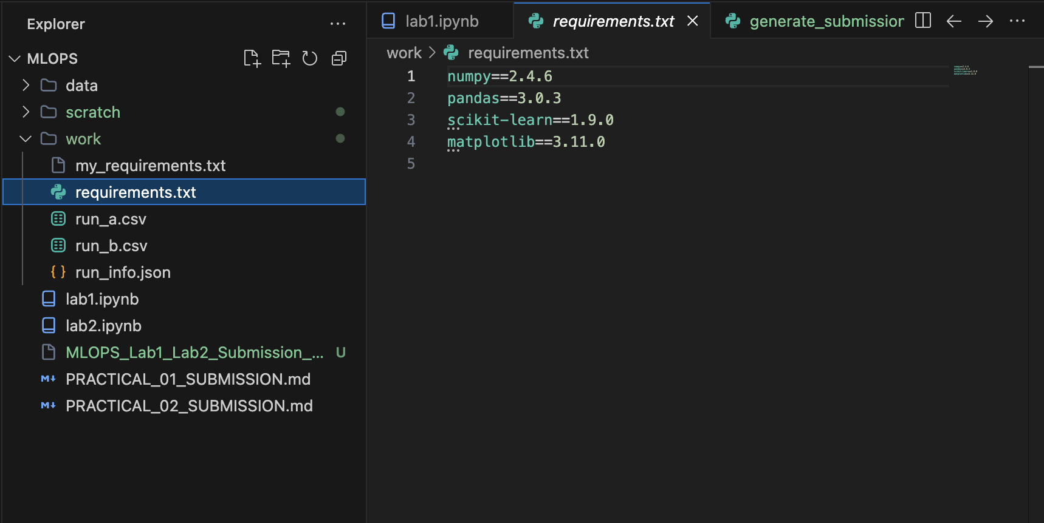

Git Photo
