Computer
Science

Class XII
Practical Journal

Submitted By:-

ADITYA SAMBHAJI BABAR
(XII - SCIENCE)

Shri Vasantrao Banduji Patil Trust's
APPASAHEB BIRNALE PUBLIC SCHOOL, SANGLI
SENIOR SECONDRY
(AFFILIATED TO CBSE, NEW DELHI, NO: 1130074)

Behind Railway Station, Shinde Mala, Sangli., Maharashta


DEPARTMENT OF COMPUTER SCIENCE

CERTIFICATE
Certified that this is a bonafide record of the project work in COMPUTER SCIENCE

Submitted to the Central Board of Secondary Education in partial fulfillment of
Senior Secondary Examination.

-------------- -----------------
DATE Principal

Submitted for Practicle Examination and VivaVoice held on ___________________

____________________________ ____________________________

Internal Examiner External Examiner
DECLARATION

I, ADITYA SAMBHAJI BABAR, hereby declare that this work entitled “Class XII Practical Journal” submitted to APPASAHEB BIRNALE PUBLIC SCHOOL
SENIOR SECONDRY, Shinde Mala, Sangli., Maharashta, 416416 (Affiliated to CBSE, New Delhi, and Affiliation No. 1130074) is orginal record work done by me under the supervision and guidance of Mr. Sushant Pawar, Department of Computer Science.

Name of Candidate Register No. Signature of the Candidate

______________________ __________________ _____________________

Countersigned By:
Mr. Sushant Pawar
Teacher incharge
Department of Computer Science
Appasaheb Birnale Public School
Senior Secondry, Shinde Mala
Place: Sangli

Date : _____________________

ACKNOWLEDGEMENT

The success and final outcome of this project required a lot of guidance and assistance from many people and I am extremely fortunate to have got this all along the completions of my project work. Whatever I have done is only due to such guidence and assistance and i would not forget to thank them.

I have taken efforts in this project. However, it would not have been possible without the kind support and help of many individuals. I would like to extend my sincere thanks to all of them.

I am highly indepted to my computer teacher Mr. Sushant Pawar for his guidance and constant supervision as well as for providing necessary information regarding the project & also for supporting me in completing the project. I also thank our respected Principal Shradha khot for their support.

I am thankful to and fortunate enough to get constent encouragment, support and guidence from all teaching staff of Department of computer science which helped us in succesfully completing this project.

I would like to express my gratitude towards my parents for their kinf co-operation and encouragment which help me in completion of this project.

My thanks and appreciations also go to my colleague in developing the project and people who have willingly helped me out with their abilities.

INDEX-PYTHON

S. NO. | Content
1. | Program to generate a pattern
2. | Program to arrange dictionary in accending order
3. | Working with functions to calculate sum of squares
4. | Program to find the area of a regular polygon
5. | File handling : Edit a phone number
6. | Data visuallisation using pyplot-bar chart
7. | Data visuallisation using pyplot-line chart
8. | Data visuallisation using pyplot-pie chart
9. | Data stucture : to insert an element in a sorted list
10. | Data structure : to insert in a reverse order
11. | Binary Search
12. | Fibonacci Series
13. | Factoral Number
14. | File Handling-Absolute Path, Reverse Path
15. | File Handling
16. | SQL connection

Index-MySQL

Sr. No. | Program Name
1. | Create Table, Entering Data
2. | Joining Table
3. | Performing Arithmetic operations
4. | Grouping by using groups by clause
5. | Arranging by using Order by clause

# 01. Write a program to genarate patterns

no_of_rows = int(input("enter no of row you want the pattern to be followed :\t"))

for i in range(no_of_rows):
for _ in range(i+1):
print("*", end='')
print()

Output :-

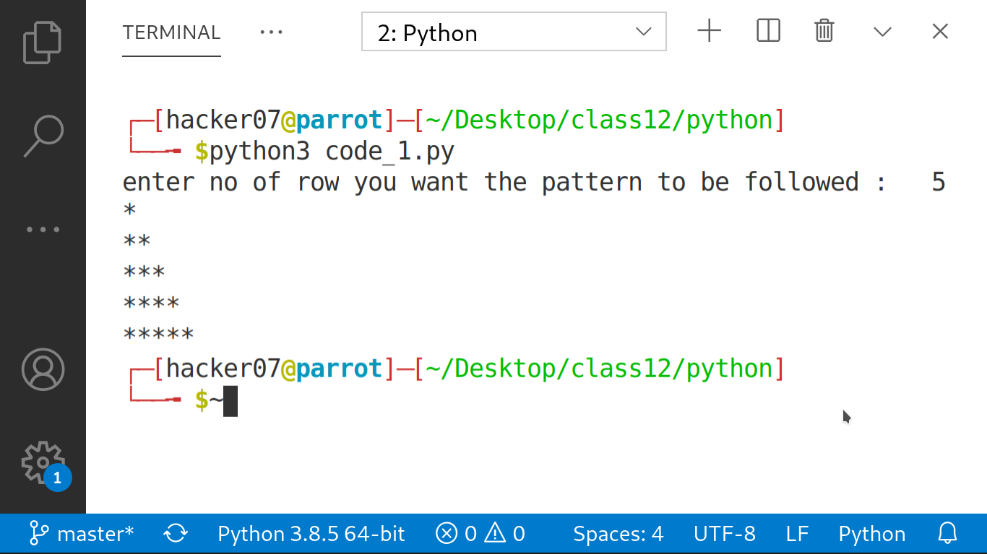

# 02. Program to arrange dictionary in accending order

data = {"aditya":85, "alan":89, "soman":75, "ravi":98, "lokesh":83}

a = []
for key, values in data.items():
b = (key, values)
a.append(b)
print(a)
print(sorted(a, key= lambda kv: (kv[1], kv[0])))

Output:-

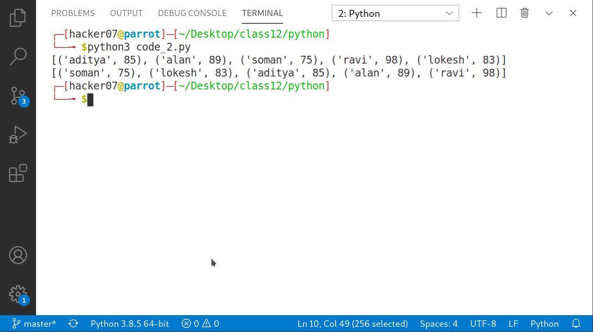

# 03. Write a program that recieves 4 digit no. and calculate sum of squares of first 2 digits and last 2 digits.

import math

def sum_of_squares(number):

x = int(number[0:2])
y = int(number[2:5])
z = math.pow(x, 2)+ math.pow(y, 2)
print(f"the sum of the square of the two numbers is {z}.")

number = input("enter a four digit number:\t")

sum_of_squares(number)

Output:-

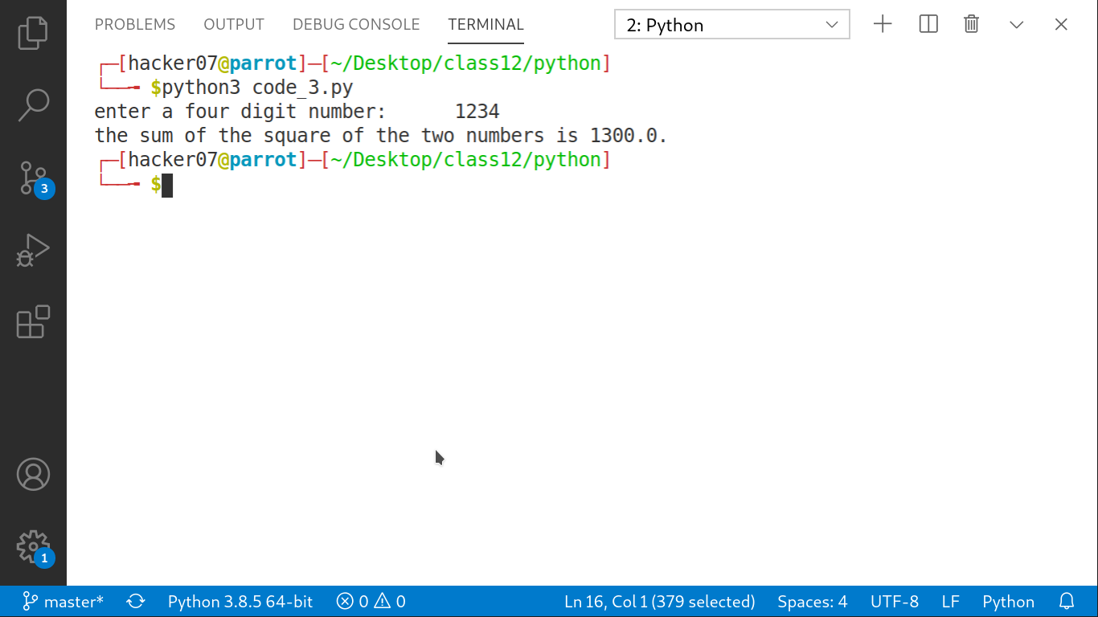

# 04. write a program to find the area of a regular polygon.

from math import tan, pi

no_sides = int(input("enter the number of sides in your regular polygon :\t"))

length = int(input("enter the length of a side:\t"))

a = (length**2)*no_sides/(4 * tan(pi/no_sides))

print(f"the area of the regular polygon is {a} ")

Output:-

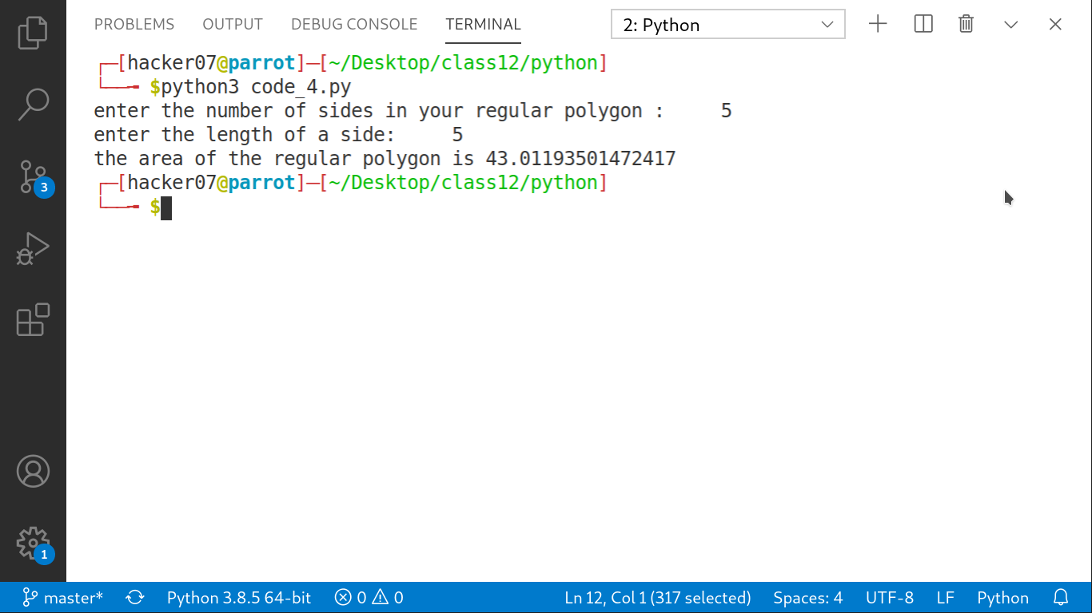

# 05. write a program to edit the phone number of arvind in file phonebook.txt

import re , os

with open("phonebook.txt", "w") as f:

no_of_entries = int(input("enter the no. of entries u have to do :\t"))

for _ in range(no_of_entries):
entry1 = input("enter name of the person :\t")
entry2 = int(input("enter the phone number of the person :\t"))
entry = (f"{entry1} : {entry2}\n")
f.write(entry)
f.close()
permmision = input("Do you want to edit phone numbers (y/n) :\t")

if permmision == "y":
name = input("enter the name of the person who's phonenumber you want to edit :\t")
with open("phonebook.txt", "r+") as f:
for line in f:
if name in line:
a = line
current_ph_no = re.compile(r'\d\d\d\d\d\d\d\d\d\d')
mo = current_ph_no.search(a)
old_number = mo.group()
print(f"Current number of {name} is {old_number}.")
new_entry = int(input("enter the new phone number :\t"))
new_no = f"{name} : {new_entry}\n"
f.writelines(new_no)
with open("phonebook.txt", "r") as f:
data = f.readlines()
with open("phonebook.txt", "w") as f:
for line in data:
if line.strip("\n") != f"{name} : {old_number}":
f.write(line)
else:
print("thank you")
exit()

Output:-

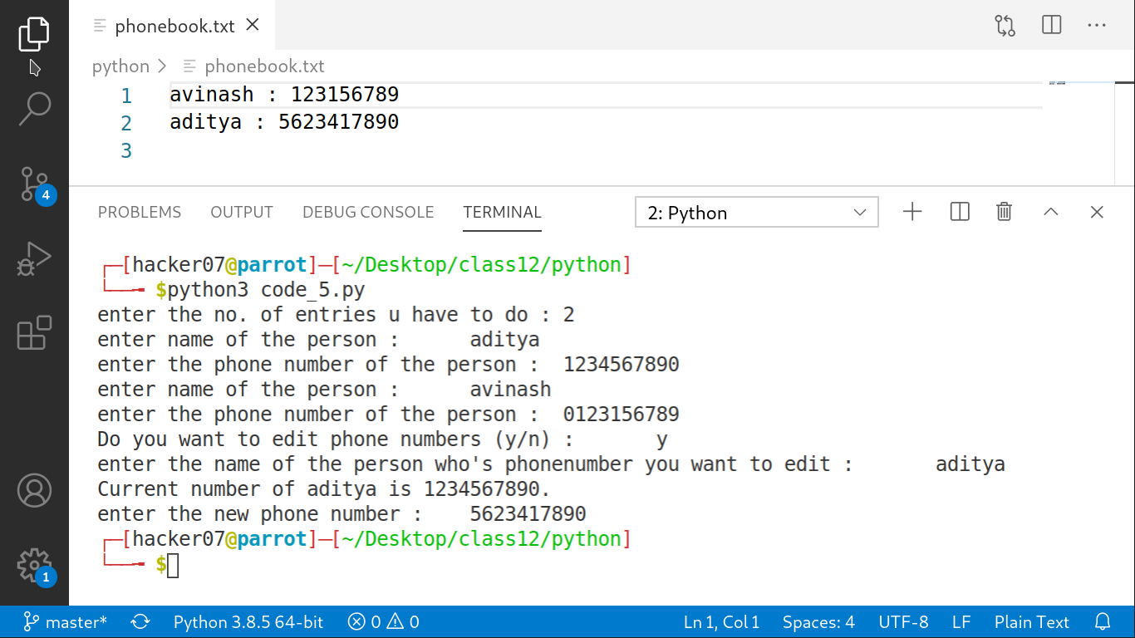

# 06. write a program to display bar graph between person and score

import numpy as np
import matplotlib.pyplot as plt

# data to plot

n_groups = 4
aditya = (90, 55, 40, 65)
avinash = (85, 62, 54, 20)

# create plot

index = np.arange(n_groups)
bar_width = 0.35
opacity = 0.8

rects1 = plt.bar(index, aditya, bar_width,
alpha = opacity,
color = 'b',
label = 'Aditya')

rects2 = plt.bar(index, avinash, bar_width,
alpha = opacity,
color = 'r',
label = 'Avinash')

plt.xlabel('Person')
plt.ylabel('Scores')
plt.title('Scores by person')
plt.xticks(index + bar_width, ('A', 'B', 'C', 'D'))
plt.legend()

plt.tight_layout()
plt.show()

Output:-

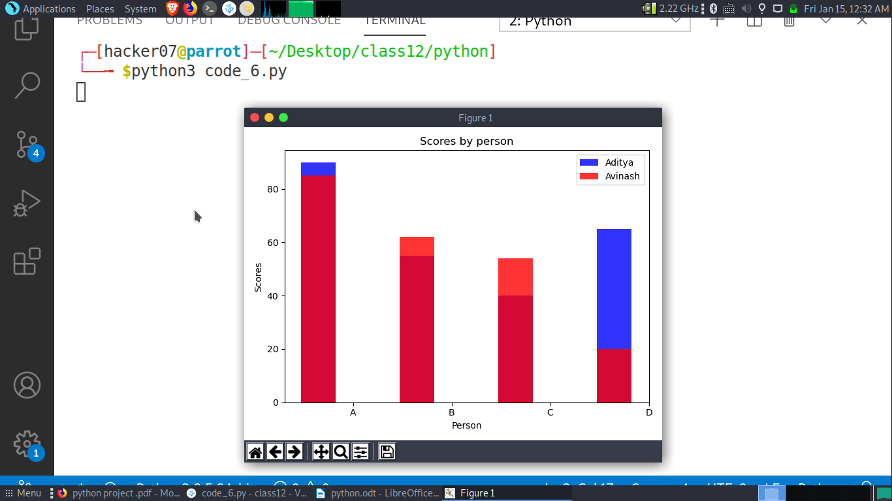

# 07. write a program to display line graph between person and score

import numpy as np
import matplotlib.pyplot as plt

# data to plot
n_group = 4
aditya = (90, 55, 40, 65)
avinash = (85, 62, 54, 20)

# create plot
index = np.arange(n_group)
bar_width = 0.35
opacity = 0.8

rects1 = plt.plot(index, aditya, bar_width,
alpha = opacity,
color = 'b',
label = 'Aditya')

rects2 = plt.plot(index, avinash, bar_width,
alpha = opacity,
color = 'g',
label = 'Avinash')

plt.xlabel('Person')
plt.ylabel('Scores')
plt.title('Scores by person')
plt.xticks(index + bar_width, ('A', 'B', 'C', 'D'))
plt.legend()

plt.tight_layout()
plt.show()

Output:-

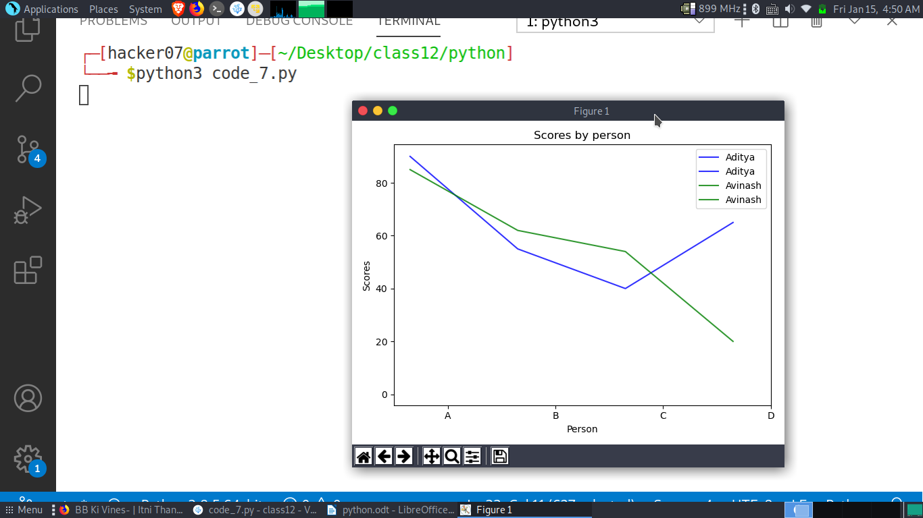

# 08. write a program to display a pie chart

import matplotlib.pyplot as plt
c = (23, 16, 43, 24, 53)
zones = ('East', 'West', 'North', 'South', 'Central')
plt.axis("equal")
plt.pie(c,labels=zones, explode=[0,0,1,0,0], autopct="%1.2f%%")
plt.show()

Output:-

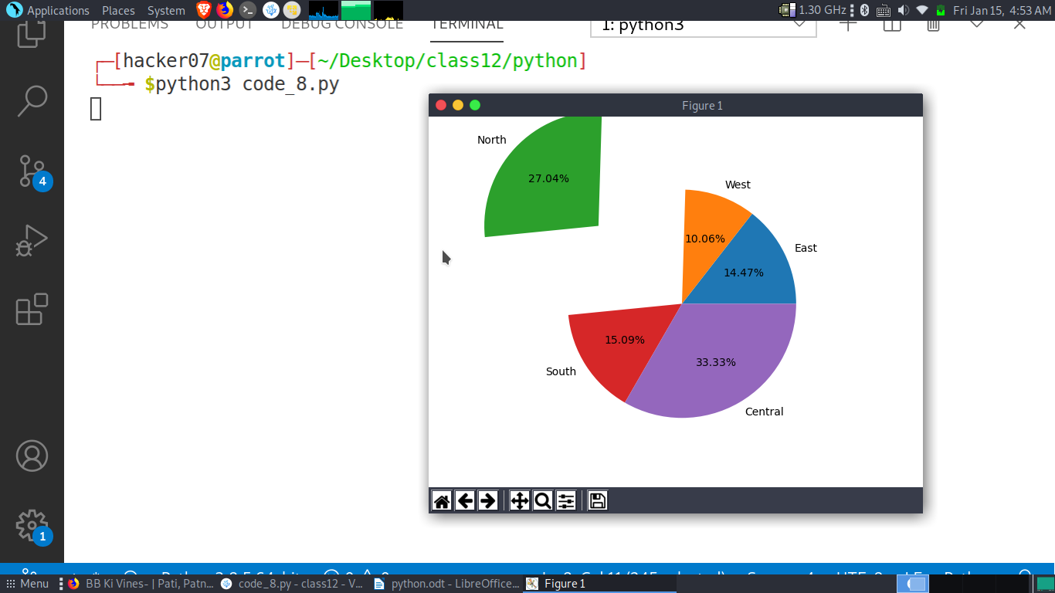

# 09. write a program to add a element at end of a list only if element is not in list.

a = [1, 7, 5, 25, 78, 38]

while True:
try:
input0 = int(input("Enter a number between 0-100 :\t"))
except:
print("Invalid entery")

if input0 in a:
print("The element you want to enter already exists in the list. Try again!!")
else:
a.append(input0)
print(a)
decision = input("Do you want to countinue ? | ('y','n') :\t")
if decision == 'n':
exit()

Output:-

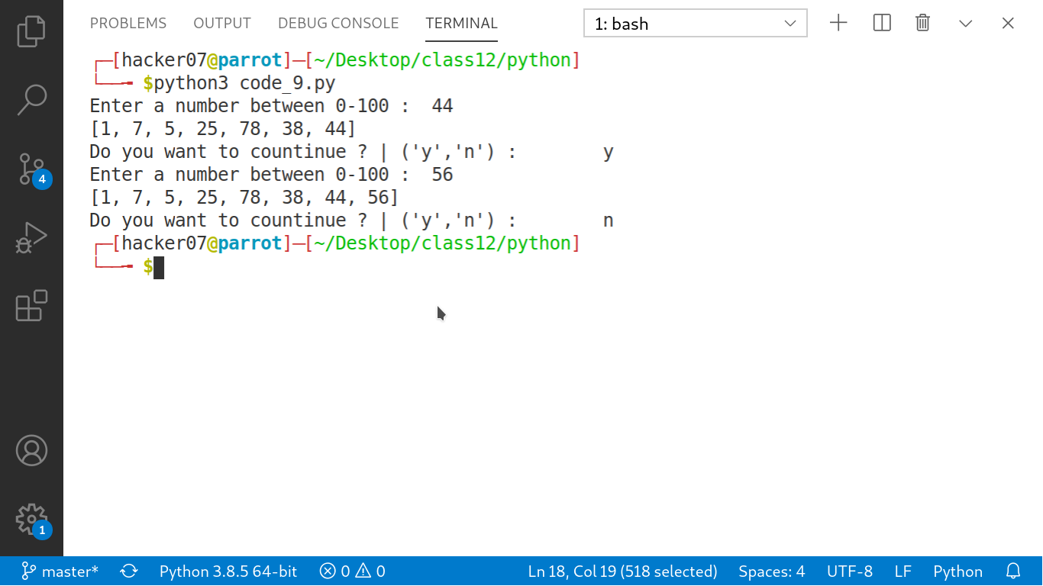

# 10. write a program to show string in a reverse order.

string = input("Enter the string that you want in reverse order. :\t")

print(string[::-1])

Output:-

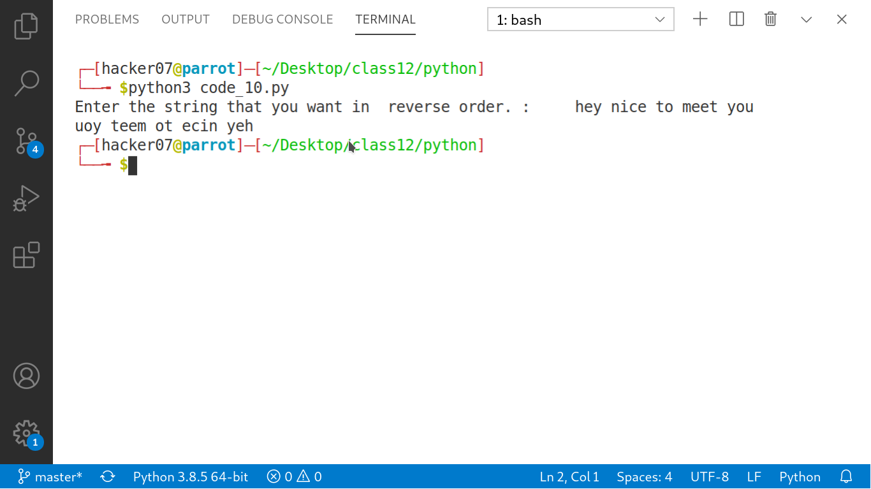

# 11. write a python code to demonstrate working of binary search in library

data = []
input0 = int(input("How much numbers you want to enter :\t"))
for _ in range(input0):
input1 = int(input("Enter the no to the list :\t"))
data.append(input1)
print(data)
print("List data is being sorted .....")
data.sort()
print(f"Sorted data is {data}.")

def findValue(data, number_to_find, low, high):
if high >= low:
middle = low + (high - low) // 2

if data[middle] == number_to_find:
return middle
elif data[middle] < number_to_find:
return findValue(data, number_to_find, middle + 1, high)
else:
return findValue(data, number_to_find, low, middle - 1)
else:
return -1

number_to_find = int(input("Enter the no. you want to search :\t"))
final = findValue(data, number_to_find, 0, len(data) - 1)

if final == -1:
print("This item was not found in the list.")
else:
print("The number " + str(number_to_find) + " was found at index position " + str(final) + ".")

Output:-

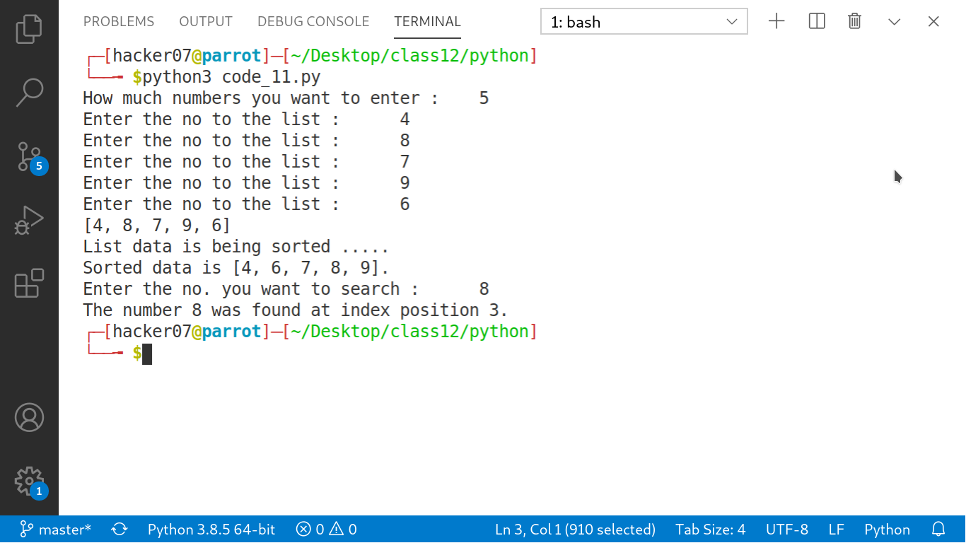

# 12. write a program for fabonacci series.

a = 0
b = 1
fabonacci_series = [0]

c = int(input("Enter the number of items in a fabonacci series :\t"))
for _ in range(c):
d = a + b
a = b
b = d
print(a)
fabonacci_series.append(a)

for items in fabonacci_series:
print(items, end=",")
print("\n")

Output:-

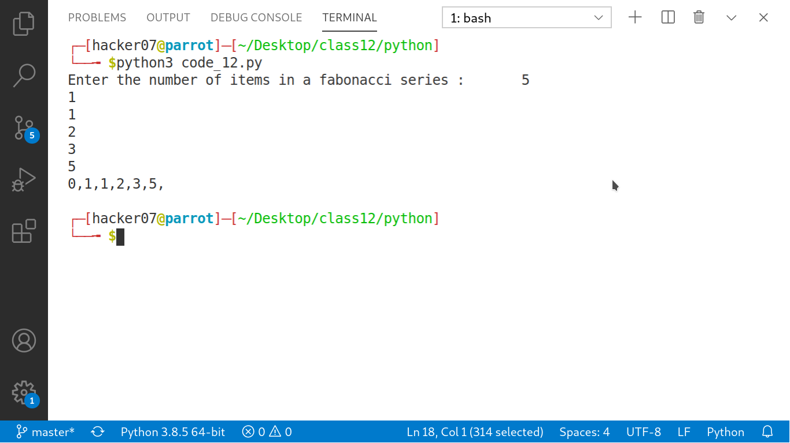

# 13. Write a program to find factorial of a number.

number = int(input("Enter the number whose factorial you want :\t"))

factorial = 1

# check if the number is negative, positive or zero
if number < 0:
print("Sorry, factorial does not exist for negative numbers")
elif number == 0:
print("The factorial of 0 is 1")
else:
for i in range(1,number + 1):
factorial *= i
print(f"The factorial of {number} is {factorial}.")

Output:-

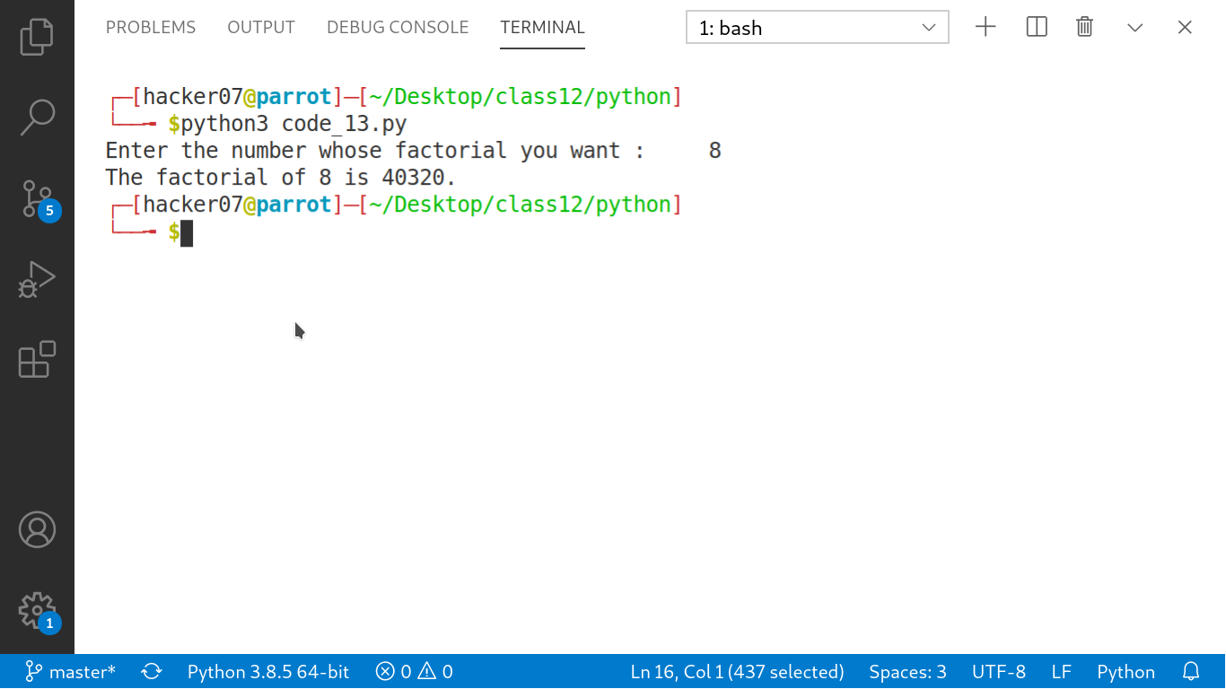

# 14. Write a python program showing practical example of absolute path

import os

def absolute_file_path(path_fname):
return os.path.abspath('path_fname')
print("Absolute file path: ",absolute_file_path("phonebook.txt"))

Output:-

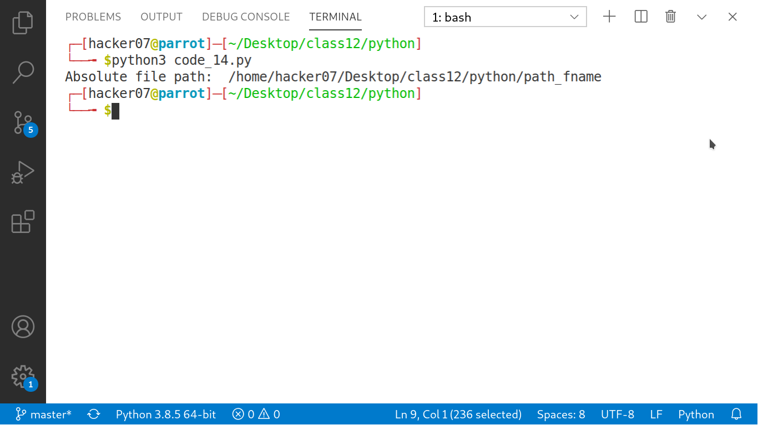

# 15. write a program that reads character one by one and store them in UPPER if in upper case or in LOwer if in other.

def convertOpposite(str):
ln = len(str)
for i in range(ln):
if str[i] >= 'a' and str[i] <= 'z':
# Convert lowercase to uppercase
str[i] = chr(ord(str[i]) - 32)
elif str[i] >= 'A' and str[i] <= 'Z':
# Convert lowercase to uppercase
str[i] = chr(ord(str[i]) + 32)
# Driver code
if __name__ == "__main__":
str = input("Enter the sting :\t")
str = list(str)
# Calling the Function
convertOpposite(str)
str = ''.join(str)
print(str)

Output:-

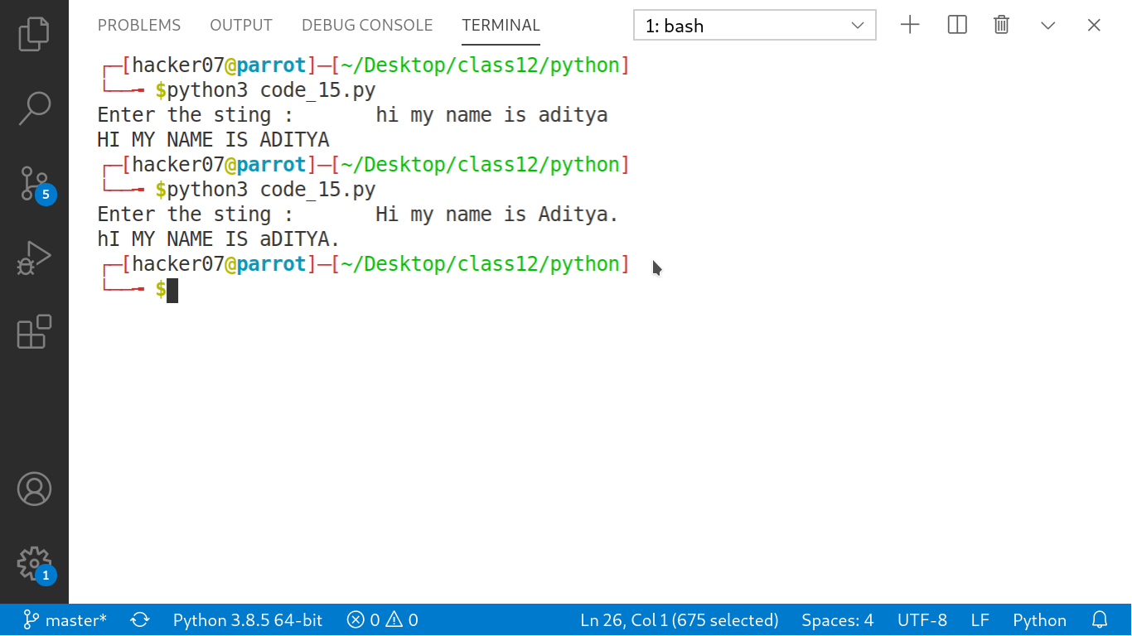

# 16. Write a program for sql connection.

import mysql.connector
from tabulate import tabulate

mysqldb = mysql.connector.connect(
host="localhost",
user="hacker07",
passwd="admin1234",
db = "test"
)

cursor = mysqldb.cursor()
cursor.execute("SELECT * FROM test.student_master")

rows = cursor.fetchall()
print("\n",tabulate(rows, headers=cursor.column_names),"\n")

Output:-

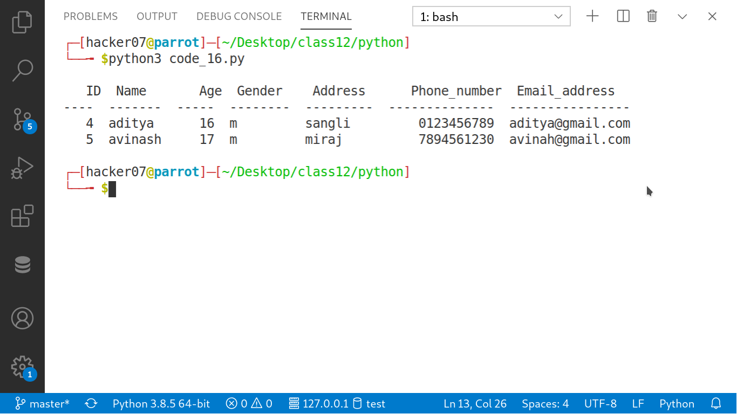

SQL

-- 17. Create table and insert data into it

CREATE TABLE if not exists student(
ID int Primary Key NOT NULL,
Name varchar(30) NOT NULL,
Age int NOT NULL,
Gender char(1) NOT NULL,
Address varchar(50) NOT NULL,
Phone_number char(10) ,
Email_address varchar(20) ,
CONSTRAINT chk_stu CHECK (Age<=20 AND Gender in ('m','f','o'))
);

INSERT INTO test.student VALUES (01,'Jhonny',17,'m','sangli','1452367895','jhonny@gmail.com');
INSERT INTO test.student VALUES (02,'arvind',16,'m','miraj','7485425614','arvind@gmail.com');
INSERT INTO test.student VALUES (03,'saloni',18,'f','ashta','8547956514','saloni@gmail.com');
INSERT INTO test.student VALUES (04,'jackson',17,'m','bedag','1578469853','jackson@gmail.com');

SELECT * FROM test.student;

CREATE TABLE if not exists student_marks(
ID int primary key NOT NULL,
Phy_marks int NOT NULL,
chem_marks int NOT NULL,
maths_marks int NOT NULL,
);

INSERT INTO test.student_marks VALUES (01,92);
INSERT INTO test.student_marks VALUES (02,95);
INSERT INTO test.student_marks VALUES (03,87);
INSERT INTO test.student_marks VALUES (04,85);

SELECT * FROM test.student_marks;

Output:-

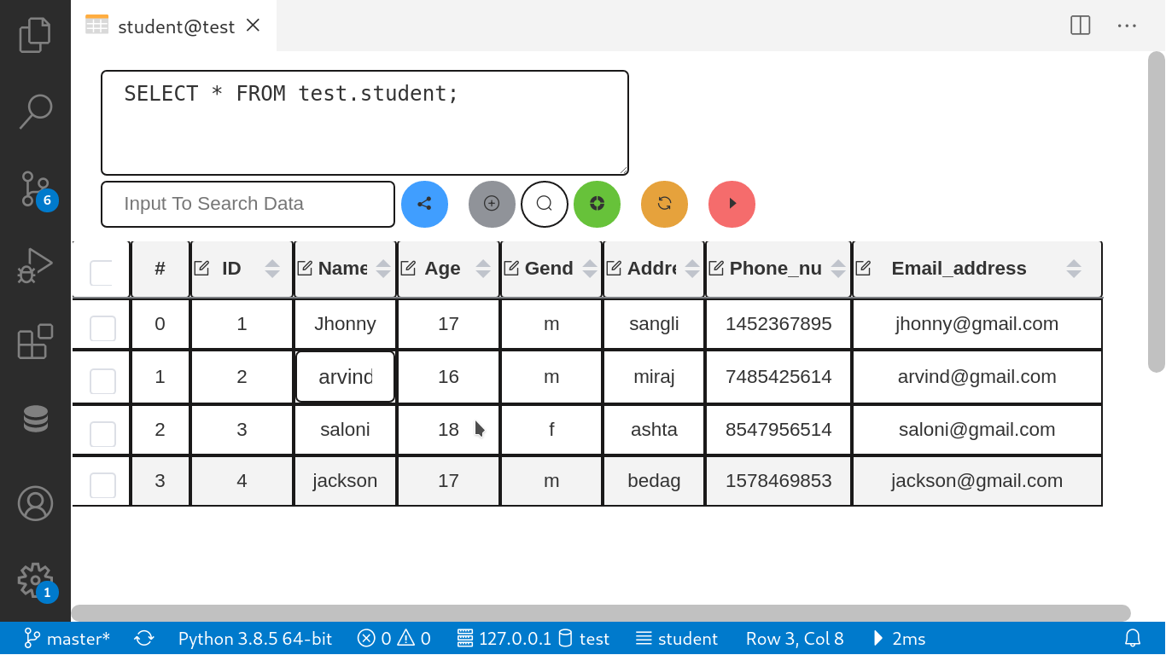
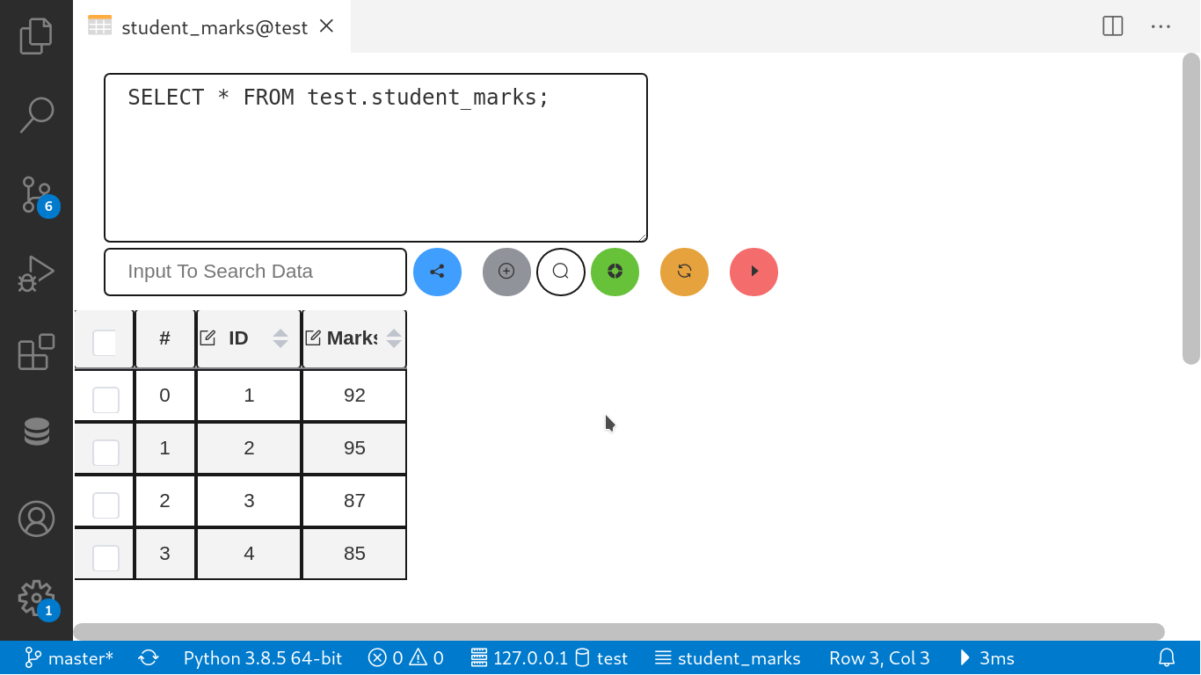

-- 18. Write a SQL program for joining two tables using select statement

select student.Name, student_marks.marks
from student, student_marks
where student.ID=student_marks.ID;

Output:-

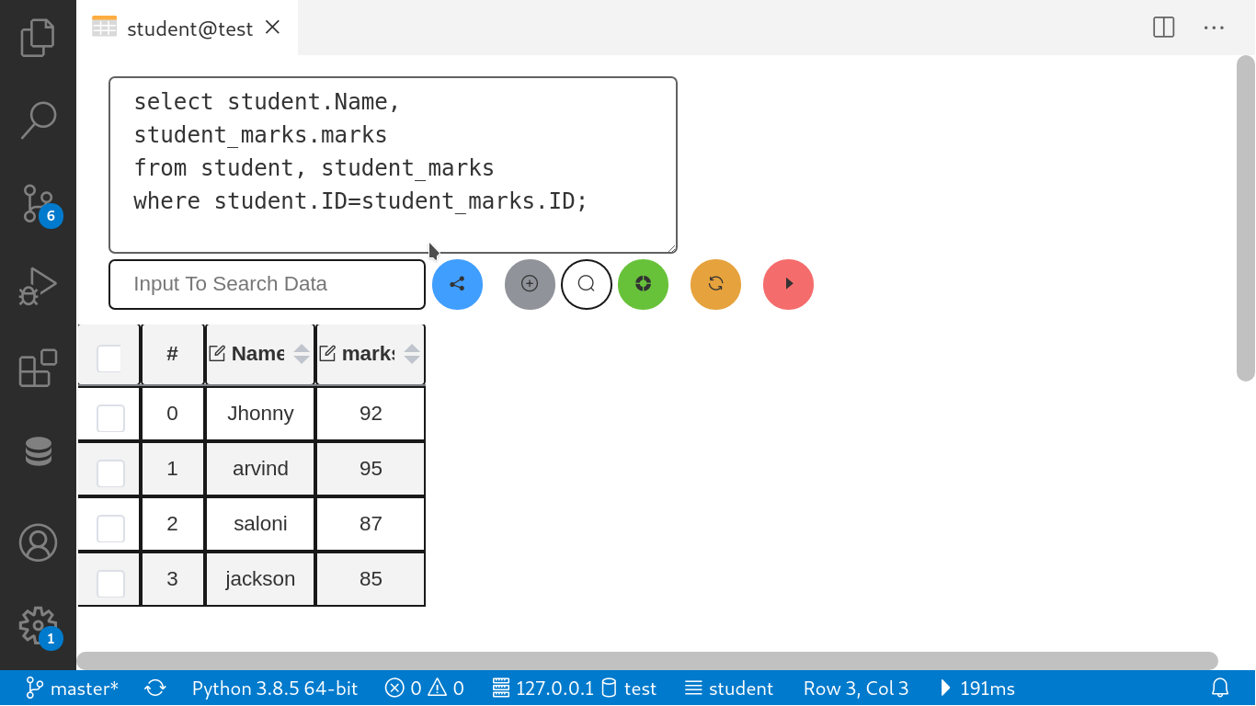

-- 19. Joining two tables using select statement and applying arithmetic operations

select student.Name, student_marks.Phy_marks, student_marks.chem_marks, student_marks.maths_marks, student_marks.Phy_marks + student_marks.chem_marks +student_marks.maths_marks as 'Total'
from student, student_marks
where student.ID=student_marks.ID;

Output:-

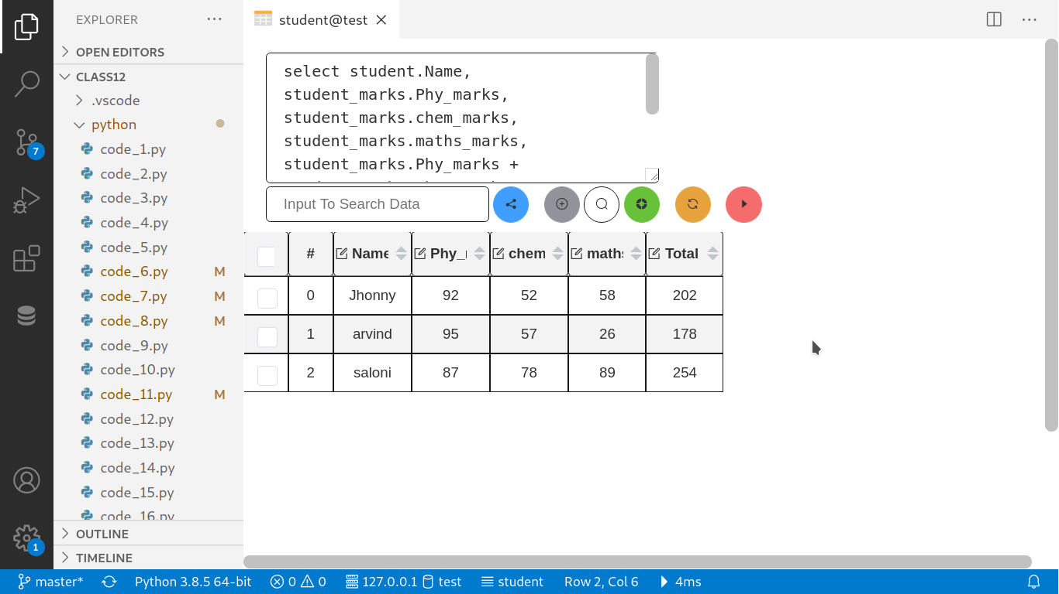

-- 20. Joining two tables using select statment and apllying Order by clause.

select student.Name, student_marks.Phy_marks, student_marks.chem_marks, student_marks.maths_marks,student_marks.Phy_marks + student_marks.chem_marks +student_marks.maths_marks as 'Total'
from student, student_marks
where student.ID=student_marks.ID
order by Total asc;

Output:-

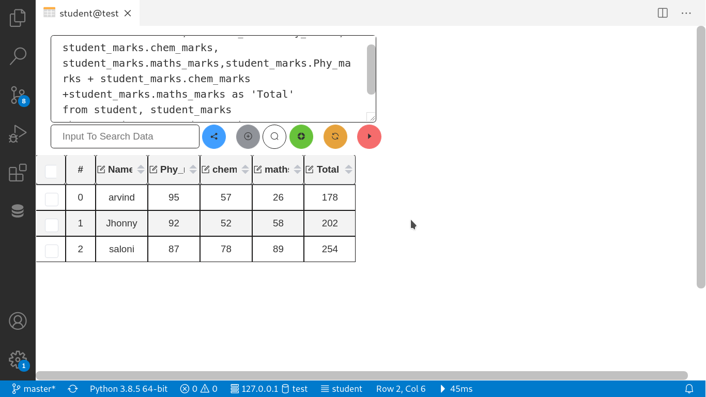

-- 20. Joining two tables using select statment and applying GROUP BY clause.

select student.ID, student.Name
from student
GROUP BY gender = 'm' or 'f'

Output:-

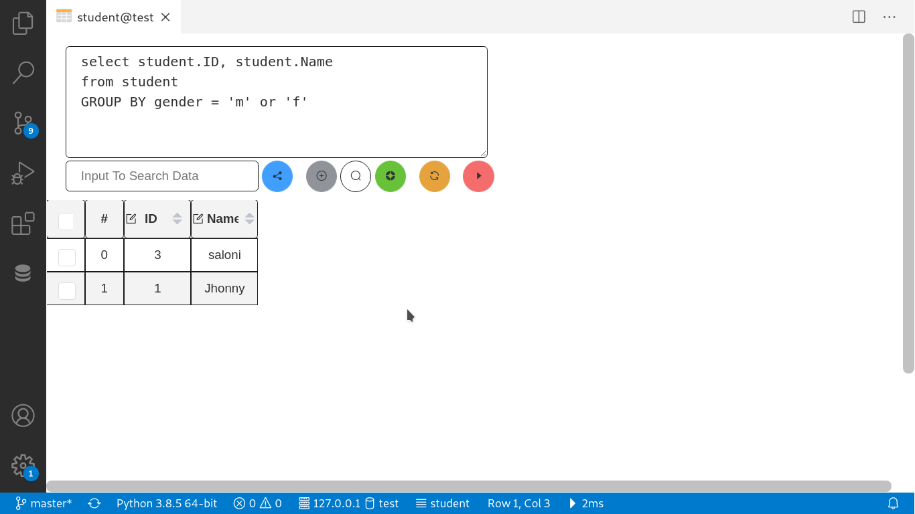

----------!!! Thank you !!!--------

