# **To create new database and table :**

## **To create new Database:-**

create Database db;

show databases;

## **Output:-**

# 

## **To create new table:-**

use db;

create Table student (

roll_no int primary key auto_increment,

name varchar(100) not null,

address varchar(100),

marks int not null );

Show tables;

**Output:-**

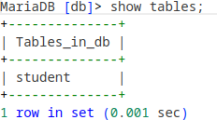

**Altering a Table:-**

**Add Column:-**

alter table student add column class varchar(3);

## **Output:-**

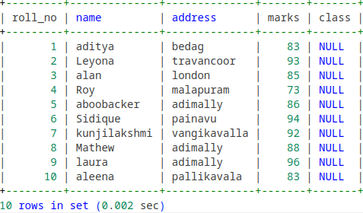

**Rename Column :-**

Alter Table student rename column address to town;

## **Output:-**

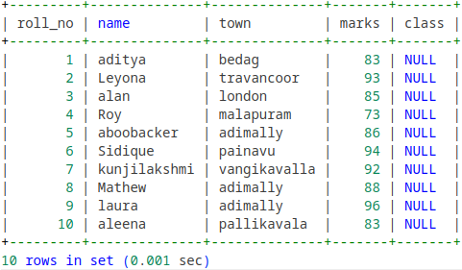

**Drop Column :-**

alter table drop class;

## **Output:-**

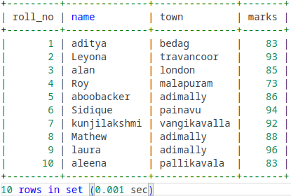

**Modify Column:-**

alter table student modify column address varchar(50);

select COLUMN_NAME, DATA_TYPE, CHARACTER_MAXIMUM_LENGTH from information_schema.columns where table_name="student";

## **Output:-**

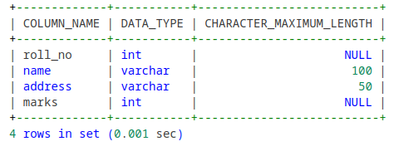

**Drop :-**

**Drop a Table:-**

drop table student;

show tables;

## **Output:-**



**Drop Database:-**

drop database db;

show databases;

## **Output:-**

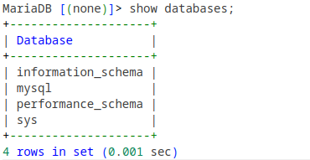

**Rename :-**

rename table student to stu;

show tables;

## **Output:-**

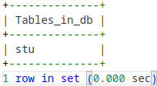

**Truncate Table:-**

Truncate table stu;

select * from stu;

## **Output:-**

