## **Insert Values into Table :-**

insert into student (name, address, marks) values ("aditya", "bedag", 83),

("Leyona", "travancoor", 93),

("alan", "london", 85),

("Roy", "malapuram", 73),

("aboobacker", "adimally", 86),

("Sidique", "painavu", 94),

("kunjilakshmi", "vangikavalla", 92),

("Mathew", "adimally", 88),

("laura", "adimally", 96),

("aleena", "pallikavala", 83);

select * from student;

## **Output:-**

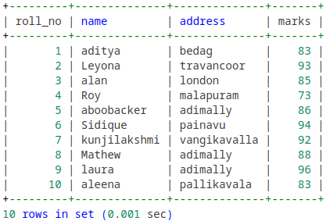

**Update :-**

update student set class="fy" where roll_no=10;

select * from student;

**Output:-**

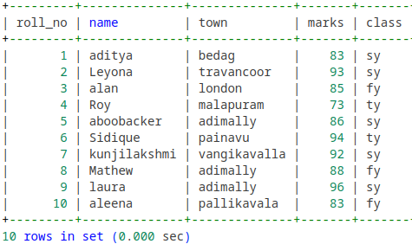

**Delete:-**

delete from student where roll_no=10;

select * from student;

**Output:-**

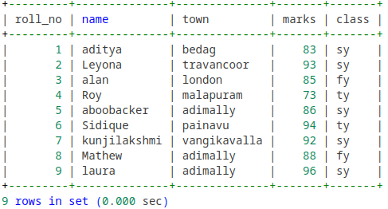

**Select:-**

select * from student;

**Output :-**



select name, marks from student;

**Output :-**

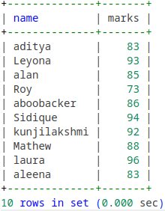

select distinct(class) from student;

**Output :-**

