Primary Key and Not Null

use sy1_student_;

Create table emp(

id int primary key auto_increment,

ename varchar(100) not null,

email varchar(100),

phone bigint not null,

salary int not null,

city varchar(100) not null

);

insert into emp(ename, email, phone, salary, city) values ("rahul", "rahul@gmail.com", 897568978, 35000, "miraj"),

("akash", "akash@gmail.com", 8955978985, 25000, "sangli"),

("sonu", "sonu@gmail.com", 8478965897, 45000, "kavlapur"),

("nidhi", "nidhi@gmail.com", 9751458789, 50000, "bisur"),

("tejas", "tejas@gmail.com", 5456445978, 55000, "bisur");

select * from emp;

## Output:-

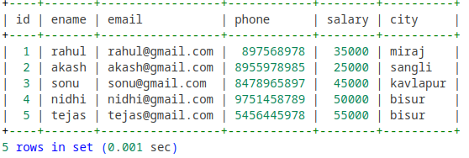

# Not Null with Error:-

insert into emp(ename, email, phone, city) values ("leyona", "leyona@gmail.com", 880935000, "miraj");

## Output :-



# Primary Key with error :-

insert into emp(id, ename, email, phone,salary, city) values (null,"leyona", "leyona@gmail.com",

880935000, 50000, "miraj");

## Output :-

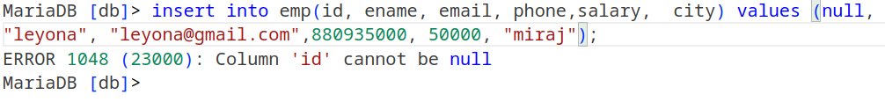

Foreign Key

create table clients(

c_id int primary key,

c_name varchar(100) not null

);

insert into clients values (4, 'sanjana'),

(5, 'rohan'),

(6, 'arun');

select * from clients;

create table project(

p_id int primary key,

e_id int ,

c_id int,

p_date Date ,

foreign key (e_id) references emp(id),

foreign key (c_id) references clients(c_id)

);

insert into project values (2345, 1, 4, 20120126),

(9876, 2, 5, 20190228),

(3455, 3, 6, 20171012);

select * from project;

## Output :-

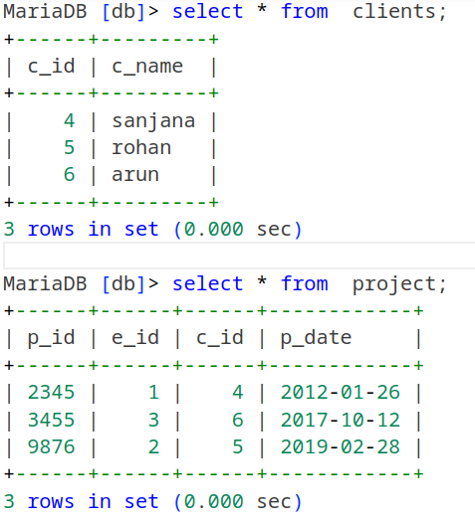

# Foreign Key with no values existing in reference table :-

insert into project values (235, 1, 3, 20120120);

## Output :-

