select * FROM STUDENT WHERE town="adimally";

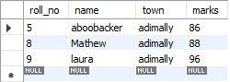

select * from student where marks>=90;

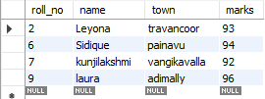

select name from student where marks<=90 and marks>= 85;



select * from student where roll_no between 3 and 8;

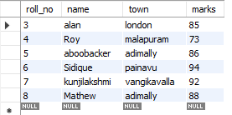

select * from student where roll_no in (3, 8);

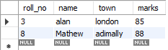

select name, marks from student order by marks desc limit 4;

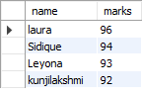

select count(name),count(town) from student group by town having town="adimally";



Group by :-

select count(class ), class from student group by class;

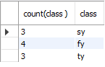

select count(marks), marks from student group by marks;

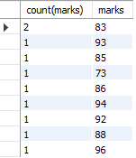

select class, min(marks), max(marks), avg(marks), sum(marks) from student group by class order by class asc ;

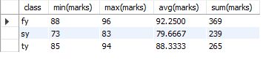

Like:-

select * from student where name like "a%";

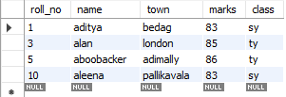

select * from student where name like "_a%a";



Limit :-

select name, marks from student order by marks asc limit 3;

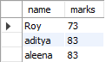

Foreign Key:-

use sy1_student_;

Create table emp(

id int primary key auto_increment,

ename varchar(100) not null,

email varchar(100),

phone bigint not null,

salary int not null,

city varchar(100) not null

);

insert into emp(ename, email, phone, salary, city) values ("rahul", "rahul@gmail.com", 897568978, 35000, "miraj"),

("akash", "akash@gmail.com", 8955978985, 25000, "sangli"),

("sonu", "sonu@gmail.com", 8478965897, 45000, "kavlapur"),

("nidhi", "nidhi@gmail.com", 9751458789, 50000, "bisur"),

("tejas", "tejas@gmail.com", 5456445978, 55000, "bisur");

select * from emp;

Drop table emp;

select id,ename, count(ename) from emp where salary >30000 group by city ;

use sy1_student_;

create table clients(

c_id int primary key,

c_name varchar(100) not null

);

insert into clients values (4, 'sanjana'),

(5, 'rohan'),

(6, 'arun');

select * from clients;

create table project(

p_id int primary key,

e_id int ,

c_id int,

p_date Date ,

foreign key (e_id) references emp(id),

foreign key (c_id) references clients(c_id)

);

insert into project values (2345, 1, 4, 20120126),

(9876, 2, 5, 20190228),

(3455, 3, 6, 20171012);

select * from project;