Enterprise SSI Startup Scaling Blueprint & Strategic Roadmap
Transforming the 3-VM SSI Proof of Concept into a High-Scale Multi-Tenant Startup Platform
KEY STRATEGIC SHIFT: Moving from manual MetaMask wallet interactions and raw Ethereum transactions to Account Abstraction (ERC-4337 / Passkeys), Multi-Tenant SSO Integration, Native Mobile & Google/Apple Wallet Integration, and Zero-Knowledge Ephemeral Verification.

TARGET HOSTING INFRASTRUCTURE: Optimized for E2E Networks (India's premier AI/Cloud GPU & Node provider) using Docker containers, NGINX Reverse Proxy, PostgreSQL (Multi-Tenant), Redis, and Paymaster Gas Relayers.

1. User Review Required
This strategic document establishes the core technical decisions and deployment roadmap for transitioning the current 3-VM POC into an enterprise-ready identity solution.
2. Technical Architecture & Vision
The diagram below illustrates the end-to-end architecture across Holders, Multi-Tenant Institutes, Enterprise Verifiers, Identity/Messaging Backbone, and Blockchain Paymaster layers:
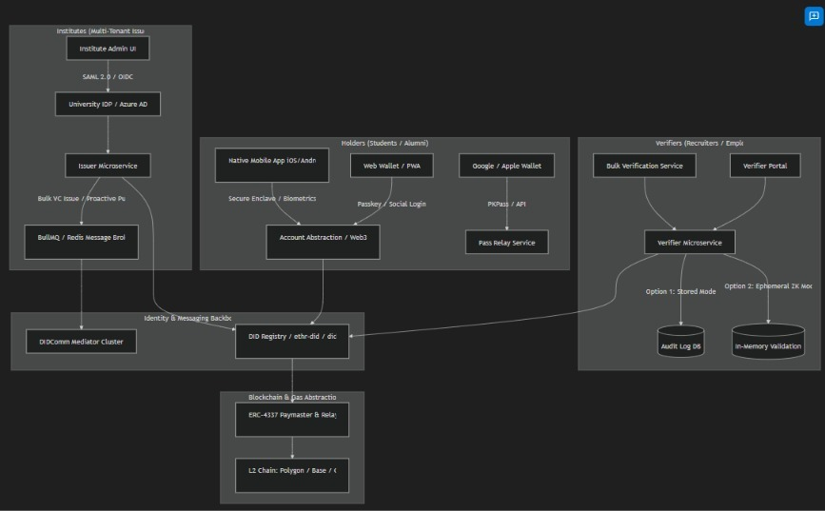
Figure 1: High-Level Multi-Tenant Enterprise SSI Architecture
3. Deep-Dive Strategy & Solutions
A. Account Abstraction & Seamless User Onboarding (Hiding MetaMask)
Problem: End users (students, employees) struggle with browser extension wallets (MetaMask), seed phrases, and gas fees.
Solution: Implement Web3Auth / Privy or WebAuthn Passkeys (Biometric FaceID / TouchID). User keys are generated using Multi-Party Computation (MPC) sharding across the user's device and identity provider. The system auto-provisions a did:ethr or did:jwk address seamlessly under the hood.
B. Proactive vs. Reactive Flow Architecture
Proactive Issuance (Push): When a student graduates or finishes a course, the University IDP triggers a webhook to issuer-service. The issuer generates the VC and delivers it directly to the Holder's DIDComm Mediator queue via push notification (FCM/APNS) or email claim link.
Proactive Verification Requests: Verifiers can send batch credential requests (e.g., background check agency requesting verification from 50 candidates). Candidates receive push alerts to approve with one click.
C. Mobile Holder App & Wallet Migration Roadmap
Short Term (Current Phase): Enhance holder-wallet as a Mobile-First Progressive Web App (PWA) with local IndexedDB storage, WebAuthn passkey support, and push notifications.
Medium Term (Target Product): Build a cross-platform mobile wallet using React Native / Flutter with hardware Secure Enclave key storage, biometric authentication, and cloud encrypted backups.
D. Advanced Verifier System (Bulk Verification & Data Modes)
1. Bulk Verification Service: CSV / Excel / JSON upload endpoint for batch processing hundreds of VPs/VCs in parallel.
2. Ephemeral / Non-Storage Mode (GDPR & DPDP Compliant): Verifies VC cryptographic signature, issuer public key, and on-chain revocation state entirely in-memory without storing candidate PII.
3. Audit Log / Stored Mode: Stores encrypted VP hash, timestamp, verifier ID, and verified claims in PostgreSQL for compliance records.
E. Native Wallet Pass Integration (Google & Apple Wallet)
The vc-to-pass microservice converts W3C VC JWTs into Google Wallet Passes (Google Wallet API) and Apple Wallet Passes (.pkpass bundle with embedded QR code). Automated emails dispatch pass download links directly to holders.
F. Multi-Tenant Institute Architecture
Features master multi-tenant database structure with tenant_id row-level security and custom subdomains (mit.verifiable.id). Connects University Identity Providers (Azure AD, Shibboleth, Okta) via SAML 2.0 / OpenID Connect.
G. Scalability, L2 Chains & Blockchain Gas Management
Implements ERC-4337 Paymaster and ERC-2771 Meta-Transactions (TrustedForwarder) so institutions cover gas fees while end users pay zero gas. Migrates to L2 networks (Polygon, Base, Cheqd) with a Redis caching layer to handle 95% of read queries off-chain.
H. Infrastructure, Dockerization & E2E Networks Hosting Plan
Dockerizes microservices (issuer-service, verifier-agent, holder-agent, didcomm-mediator). Deploys to E2E Networks Cloud Instances using NGINX reverse proxy with automated SSL certificates and PostgreSQL + Redis clusters.
4. Startup Business & Monetization Model
Tier | Target Audience | Pricing Model | Key Features Included
Freemium / Pilot | Small Academies / Bootcamps | Free up to 100 VCs/mo | Basic VC Issuance, Web Wallet, Standard Verification
Growth Institute | Universities & Colleges | $499 - $1,999 / month | Unlimited VCs, Multi-Tenant SSO, Google/Apple Wallet passes, Bulk Verification
Enterprise Verifier | Recruiters, Banks, BPO | $0.10 - $0.50 / verification | Bulk API Access, Ephemeral & Audit Logging, SLA 99.9%, Custom Webhooks
White-Label SaaS | Government / Consortia | Custom Enterprise Licensing | Custom L2 Blockchain deployment, On-premise DIDComm nodes, Dedicated Support

5. Execution & Engineering Checklist
Phase 1: UX Transformation & Account Abstraction (Weeks 1 - 3)
☐ Integrate Web3Auth / Passkeys into holder-wallet to remove MetaMask requirement.
☐ Implement ERC-2771 / Paymaster meta-transactions in VCRegistry.sol for gasless signing.
☐ Redesign holder-wallet, issuer-dashboard, and verifier-wallet UI with modern design systems.
Phase 2: Proactive Flows & Multi-Tenancy (Weeks 4 - 6)
☐ Build tenant isolation middleware & SAML/OIDC SSO connectors for issuer-service.
☐ Implement proactive credential push engine via didcomm-mediator & Webhooks.
☐ Develop vc-to-pass service for Google Wallet & Apple Wallet export via email.
Phase 3: Advanced Verification & Bulk Operations (Weeks 7 - 8)
☐ Add Bulk VC/VP verification endpoint & UI upload drag-and-drop in verifier-wallet.
☐ Build toggle for Ephemeral Zero-Knowledge Mode vs Audit-Logged Stored Mode in verifier-agent.
☐ Integrate Redis caching for resolved DIDs and VC revocation status.
Phase 4: Production Dockerization & E2E Networks Deployment (Weeks 9 - 10)
☐ Create Dockerfile for each microservice (holder-agent, issuer-service, verifier-agent, mediator).
☐ Create unified docker-compose.yml and production deployment configurations.
☐ Configure NGINX reverse proxy with SSL termination and E2E Networks server deployment.
☐ Perform stress testing & audit verification end-to-end.
6. Proposed Codebase Modifications Summary
• VCRegistry.sol: Add ERC-2771 TrustedForwarder support for gasless meta-transactions and batch verification.
• docker-compose.yml: Define container orchestrated stack for issuer-service, verifier-agent, holder-agent, mediator, postgres, redis, and nginx.
• services/wallet-pass-service: Microservice to convert W3C VCs into Apple .pkpass and Google Wallet Objects.
• issuer-service: Introduce multi-tenant architecture (tenantId), SSO OAuth2/OIDC integration, and batch/proactive VC dispatch.
• verifier-agent: Implement bulk verification engine, ephemeral ZK validation mode, and audit logging database.
7. Verification & Testing Strategy
Automated Tests: npx hardhat test to verify updated smart contracts with meta-transactions and paymaster relayers. Integration test suite for bulk verification & ephemeral mode APIs.
Manual Verification: Test onboarding flow with Passkey/Google login (no MetaMask). Test proactive credential push notification and Google/Apple Wallet pass generation. Deploy full containerized stack to local Docker environment and E2E Networks test server.

