OOP Practice / MC

**Practice Module 9**

**Inheritance and Polymorphism 2**

1. **Objectives**

Students have ability to create classes and objects with Inheritance and Polymorphism.

1. **Basic Theory**

This week will discuss about constructors and interface. Constructors of a superclass are not inherited by its subclasses. We must define a constructor for a class or use the default constructor added by the compiler. Every class has a superclass. If the class declaration does not explicitly designate the superclass with the extend clause, then the class’s superclass is the Object class. Next topic is about Interface. Interface is similar with inheritance, but their intended uses are quite different. We use the Java interface to share common behavior and the inheritance to share common code.

1. **Practice Task**

1.

Create a class

based on the diagram below :

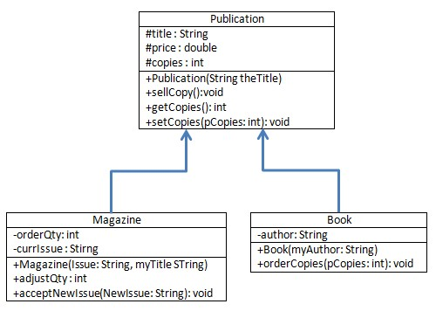

C. Thomas Wu, An Introduction to Object-Oriented Programming with Java, McGraw-Hill Companies Inc, 2010

Page 1

OOP Practice / MC

1. Create a class named demoPublication.java to show the constructor in inheritance.
2. Determine instances to describe how constructor in inheritance from superclass and subclasses that you created. Show the result of the program (use the snipping tool to capture image) and describe it.

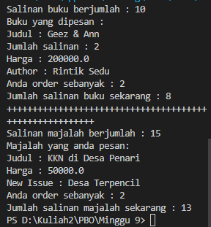

1. Create an interface named LibraryCollectionXY, (XY is your last two digits of NIM). Then rewrite class Book to implement the interface and inherit from class Publications.

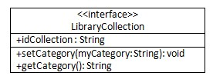

1. Create a class named demoLibraryXY. (XY is your last two digits of NIM) that will show inheritance and implementation of the interface by your own idea.
2. Determine instances to describe the implementation of the interface and constructor in inheritance from subclasses and interface that you created from number 4 and 5. Show the result of the program (use the snipping tool to capture image) and describe it.

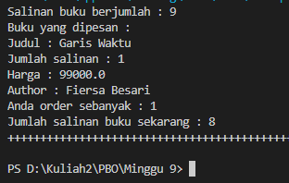

1. Write down your **opinion** about **the implementation of the interface** and **constructor in inheritance** based on your own work!

**Save your report named P9_NIM.doc and your java files to your directory named P9_NIM.**

C. Thomas Wu, An Introduction to Object-Oriented Programming with Java, McGraw-Hill Companies Inc, 2010

Page 2