PPT for our ideas: <https://docs.google.com/presentation/d/18_8SidpLrVui9pb282kD7a7ogTc0rf2f/edit?usp=sharing&ouid=114638022653622617783&rtpof=true&sd=true>

Wireframes:

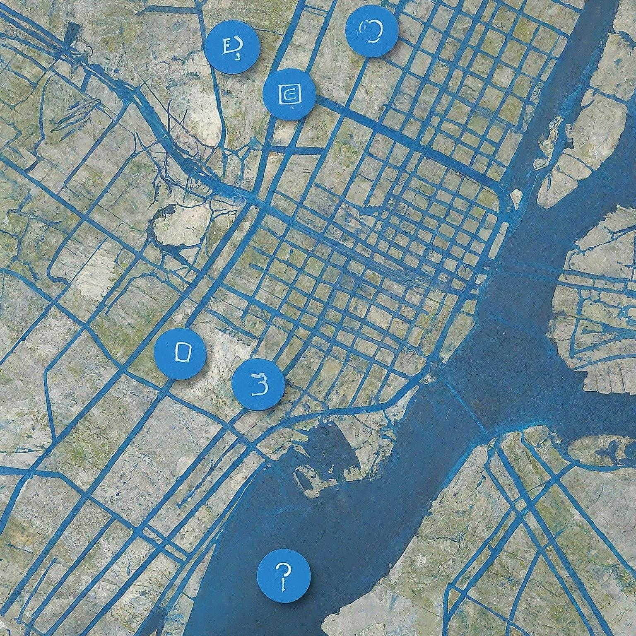

Test Webpage: Only a blank map, but it will be designed later

<https://frozenexplorer.github.io/Hackenza_Website/>