|  |  |  |  |  |  |
| --- | --- | --- | --- | --- | --- |
| D:\sep2k3\COLLEG~1\LOGO.JPG | SHRI SANT GAJANAN MAHARAJ COLLEGE OF ENGG. SHEGAON | | | **LABORATORY MANUAL** | |
| **PRACTICAL EXPERIMENT INSTRUCTION SHEET** | | | | |
| LABORATORY MANUAL NO.:SSGMCE/WI/IT/BCF/7IT08/15 | | ISSUE NO.: 00 | | ISSUE DATE: 18/07/2022 | |
| REV.DATE: | | DEPTT:INFORMATION TECHNOLOGY | | | |
| LABORATORY: Block Chain Fundamental | | | SEMESTER: 4N/VII | | PAGE: 1 OF 3 |

1. **AIM: Visual demonstration of Block chain.**
2. **THEORY**

**Generic Structure of a Blockchain**

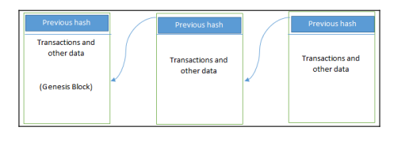

**Elements of generic Blockchain**

1. **Address**: Address are unique identifiers used in blockchain transaction to denote senders & receipts. An address is usually a public key derived from public key.
2. **Transaction**: A transaction is fundamental unit of blockchain. A transaction represents a transfer of value from one address to another.
3. **Block**: A block is composed of multiple transaction & other elements such as previous block hash ,timestamp and nonce. A block is composed of a block header and a selection of transaction bundled together and organized logically. A block contains several elements, which are follows

* A reference to a previous block is also included in the block unless it is a genesis block. This reference is the hash of the header of the previous blocks.The genesis block is the first block in the blockchain that is hardcoded at the time the blockchain was first started.
* **Nonce**: A nonce is a number that is generated & used only once. A nonce is used extensively in many cryptographic operation to provide reply protection, authentication and encryption.
* A **timestamps** is the creation time of the block.
* **Merkle Root:** Merkle root is hash of all the nodes of a Merkle tree. It is used to validate large data structure securely & efficiently.

|  |  |  |  |  |  |
| --- | --- | --- | --- | --- | --- |
| D:\sep2k3\COLLEG~1\LOGO.JPG | SHRI SANT GAJANAN MAHARAJ COLLEGE OF ENGG. SHEGAON | | | **LABORATORY MANUAL** | |
| **PRACTICAL EXPERIMENT INSTRUCTION SHEET** | | | | |
| LABORATORY MANUAL NO.:SSGMCE/WI/IT/BCF/7IT08/15 | | ISSUE NO.: 00 | | ISSUE DATE: 18/07/2022 | |
| REV.DATE: | | DEPTT:INFORMATION TECHNOLOGY | | | |
| LABORATORY: Block Chain Fundamental | | | SEMESTER: 4N/VII | | PAGE: 2 OF 3 |

* **List of transaction:** A transaction is a record of an event for example transferring cash from a sender’s account to a beneficiary’s account.
* **Peer-to-Peer network**:Wherein all peers can communicate with each other & send and receive message.
* **Scripting or Programming Language**:It perform various operation on a transaction in order to facilitate various functions.
* **Virtual Machine**:It allows Turing complete code to be run on a blockchain
* **State Machine**: A Blockchain can be viewed as state transaction mechanism, where by a state is modified from initial form to the next one by nodes on the blockchain network as a result of transaction execution, validation & finalization process.
* **Node**: Perform various function like validation, mining, verification etc. A node can propose and validate transaction and perform mining to facilitate consensus and secure blockchain.
* **Smart Contract**: These programs run on top of blockchain & encapsulate the business logic to be executed when certain condition met.

**04** In visual demo, there is block having block no, Nonce, data, hash information**.**

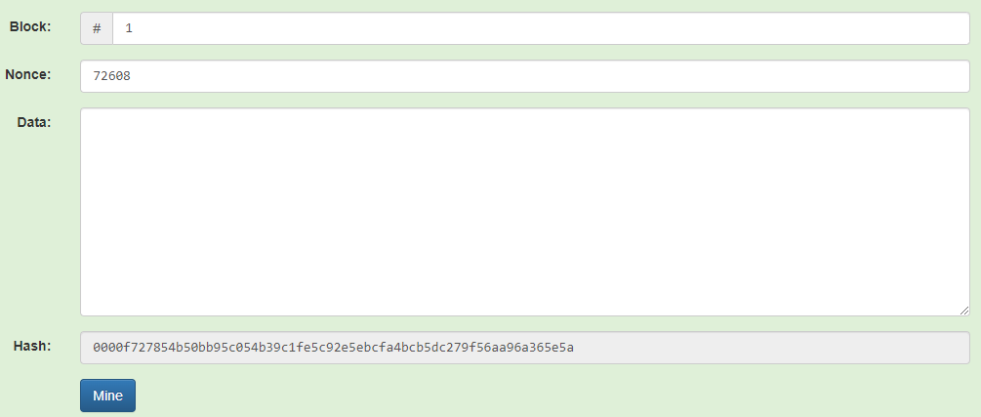

In below figure we have two blocks that are connected. The first block in blockchain are known as genesis block, the value of previous hash is 0000.The second block having hash value of first

|  |  |  |  |  |  |
| --- | --- | --- | --- | --- | --- |
| D:\sep2k3\COLLEG~1\LOGO.JPG | SHRI SANT GAJANAN MAHARAJ COLLEGE OF ENGG. SHEGAON | | | **LABORATORY MANUAL** | |
| **PRACTICAL EXPERIMENT INSTRUCTION SHEET** | | | | |
| LABORATORY MANUAL NO.:SSGMCE/WI/IT/BCF/7IT08/15 | | ISSUE NO.: 00 | | ISSUE DATE: 18/07/2022 | |
| REV.DATE: | | DEPTT:INFORMATION TECHNOLOGY | | | |
| LABORATORY: Block Chain Fundamental | | | SEMESTER: 4N/VII | | PAGE: 3 OF 3 |

Block. If intruder try to change the data in the blocks, the blocks get disconnected, because their hash values changes.

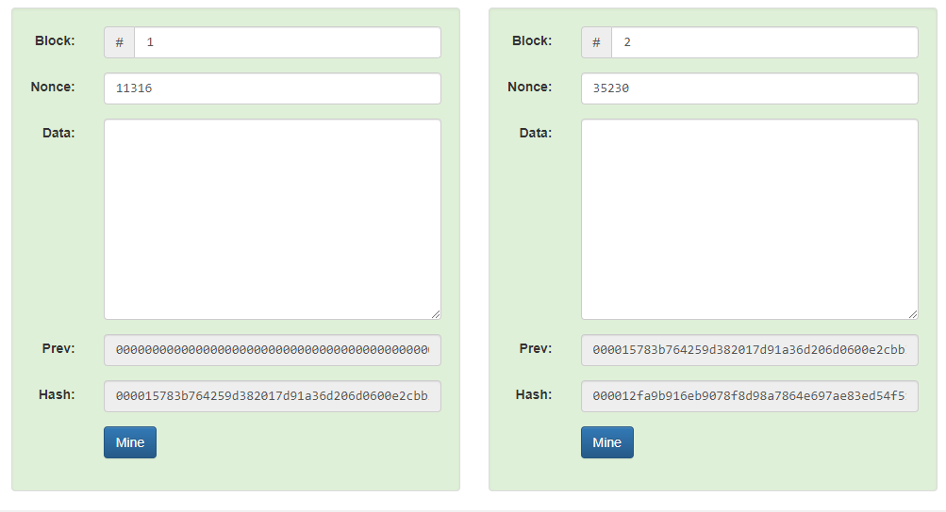

**03 CONCLUSION:**. In this way, we have visually demonstrated blockchain.