|  |  |  |  |  |  |
| --- | --- | --- | --- | --- | --- |
| D:\sep2k3\COLLEG~1\LOGO.JPG | SHRI SANT GAJANAN MAHARAJ COLLEGE OF ENGG. SHEGAON | | | **LABORATORY MANUAL** | |
| **PRACTICAL EXPERIMENT INSTRUCTION SHEET** | | | | |
| LABORATORY MANUAL NO.:SSGMCE/WI/IT/BCF/7IT08/15 | | ISSUE NO.: 00 | | ISSUE DATE: 18/07/2022 | |
| REV.DATE: | | DEPTT:INFORMATION TECHNOLOGY | | | |
| LABORATORY: Block Chain Fundamental | | | SEMESTER: 4N/VII | | PAGE: 1 OF 3 |

**AIM:** Demonstration of Metamasks.

1. **THEORY**

MetaMask is a cryptocurrency wallet that enables users to store Ether and other ERC-20 tokens. The wallet can also be used to interact with decentralized applications, or dapps. The decentralized internet, Web3, is built on a foundation of [cryptocurrencies](https://decrypt.co/?post_type=post&p=5742" \t "blank) and decentralized applications ([dapps](https://decrypt.co/resources/dapps" \t "_blank)). But in order to use them, you need a user interface. Ideally, an elegant, intuitive, easy to use interface.

MetaMask is one of the leading crypto [wallets](https://decrypt.co/?post_type=post&p=5702), and relies on browser integration and good design to serve as one of the main gateways to the world of Web3, decentralized finance (DeFi) and [NFTs](https://decrypt.co/resources/non-fungible-tokens-nfts-explained-guide-learn-blockchain). [MetaMask](https://metamask.io/) is a browser plugin that serves as an [Ethereum](https://decrypt.co/?post_type=post&p=5726" \t "blank) wallet, and is installed like any other browser plugin. Once it's installed, it allows users to store Ether and other [ERC-20](https://decrypt.co/resources/erc20) tokens, enabling them to transact with any Ethereum address. By connecting to MetaMask to Ethereum-based dapps, users can spend their coins in games, stake tokens in gambling applications, and trade them on decentralized exchanges ([DEXs](https://decrypt.co/resources/what-is-decentralized-exchange-dex)). It also provides users with an entry point into the emerging world of decentralized finance, or [DeFi](https://decrypt.co/?post_type=post&p=25908" \t "blank), providing a way to access DeFi apps such as [Compound](https://decrypt.co/resources/compound-defi-ethereum-explained-guide-how-to) and [PoolTogether](https://decrypt.co/resources/what-is-pooltogether-the-no-loss-crypto-lottery-explained" \t "_blank).

How To use Metamask?

1) You’ll need to download and install the official Metamask extension (also known as a plugin or add-on) for your chosen browser. For most people, this is the [Google Chrome extension](https://chrome.google.com/webstore/detail/metamask/nkbihfbeogaeaoehlefnkodbefgpgknn?hl=en) or the [Firefox addon](https://addons.mozilla.org/en-US/firefox/addon/ether-metamask/). For our guide, we’ll be using the Firefox version, but the steps are nearly identical for other browsers.Once installed, you should see the below splash screen. Click the ‘Get Started’ button to begin creating your Ethereum wallet using MetaMask.

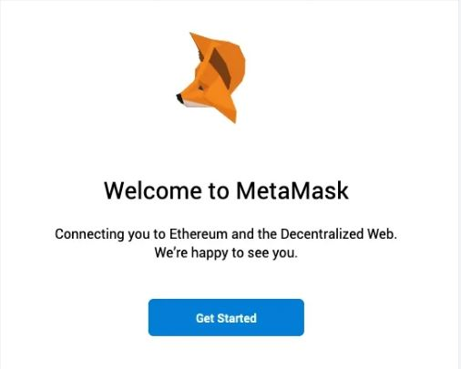

## ****2. Create an account****.

* Click on the extension icon in the upper right corner to open MetaMask.
* To install the latest version and be up to date, **click Try it now**.
* **Click Continue**.
* You will be prompted to create a new password. **Click Create**.

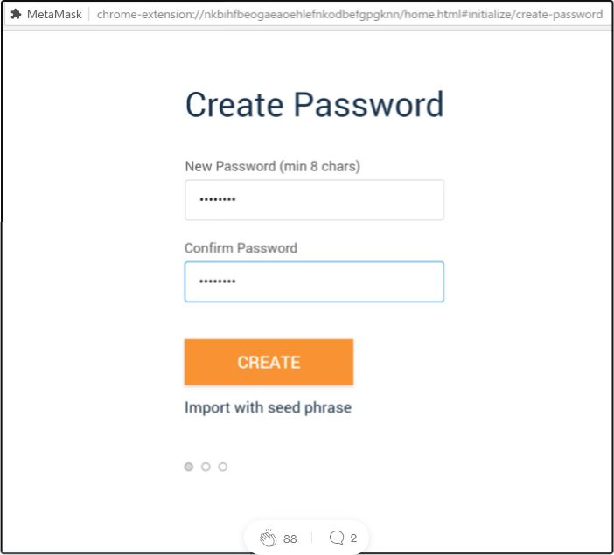

* Proceed by **clicking Next** and accept the Terms of Use.

**Click Reveal Secret Words**. There you will see a 12 words seed phrase. This is really important and usually not a good idea to store digitally, so take your time and write it down.

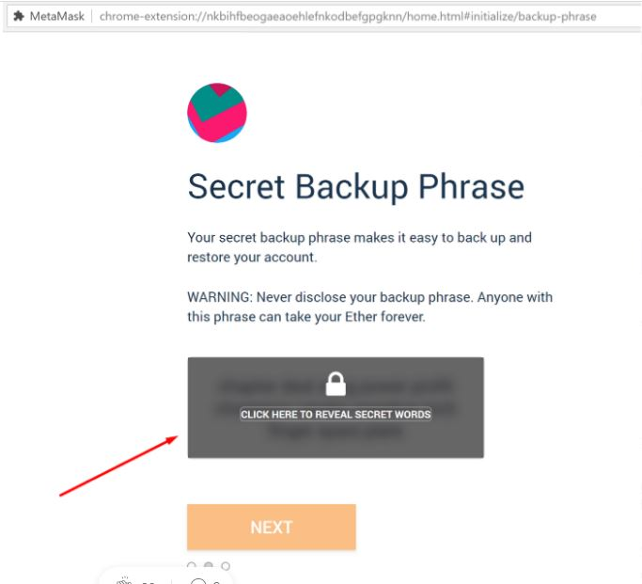

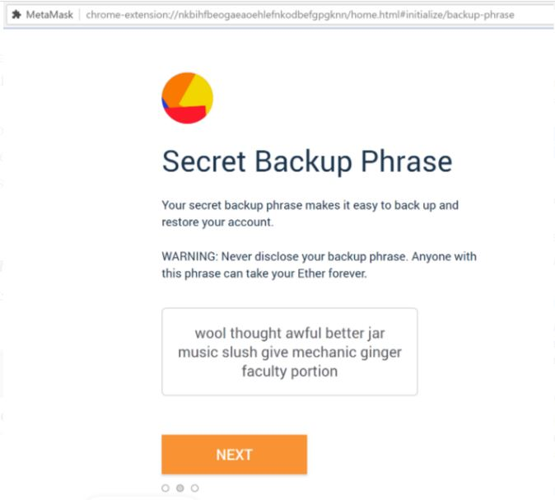

Confirm your backup phrase on the next screen by entering the words in the same order saved previously. Click ‘Confirm’ once done.

* Verify your secret phrase by selecting the previously generated phrase in order. **Click Confirm**.

And that’s it; now you have created your MetaMask account successfully. A new Ethereum wallet address has just been created for you. It’s waiting for you to deposit funds, and if you want to learn how to do that, look at the next step below.

## ****Step 3. Depositing funds.****

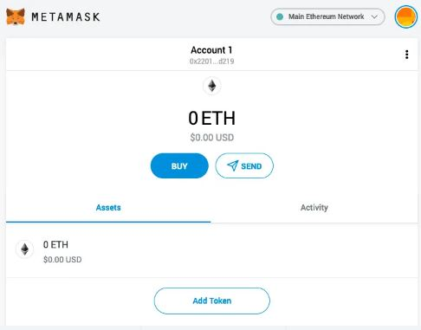

You can now access your list of assets in the ‘Assets’ tab and view your transaction history in the ‘Activity’ tab.

Sending crypto is as simple as clicking the ‘Send’ button, entering the recipient address and amount to send, and selecting a transaction fee. You can also manually adjust the transaction fee using the ‘Advanced Options’ button, using information from ETH Gas Station or similar platforms to choose a more acceptable gas price.

After clicking ‘Next’, you will then be able to either confirm or reject the transaction on the subsequent page.

**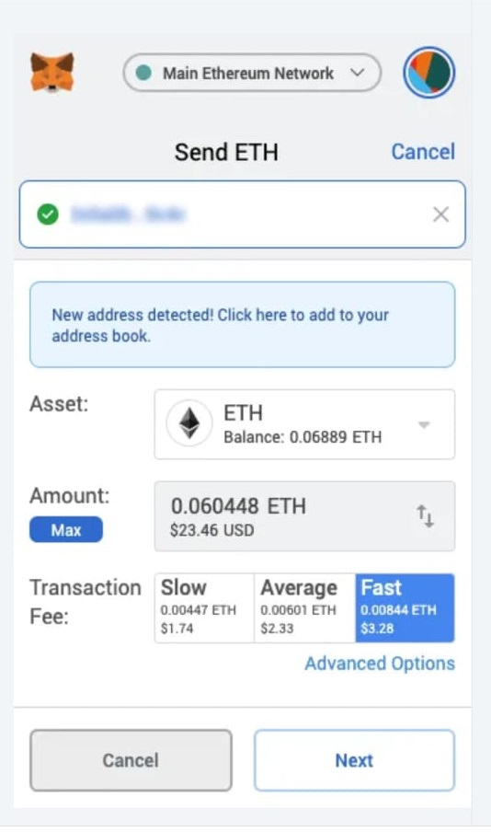**

To use MetaMask to interact with a dapp or [smart contract](https://decrypt.co/resources/smart-contracts), you’ll usually need to find a ‘Connect to Wallet’ button or similar element on the platform you are trying to use. After clicking this, you should then see a prompt asking whether you want to let the dapp connect to your wallet.

The below example shows how you connect MetaMask to decentralized exchange [Uniswap](https://decrypt.co/resources/what-is-uniswap" \t "_blank), but a similar process should be observed for other dapps. Simply connecting with a dapp means it can view your addresses—it cannot access your funds.

Once connected, you'll then be able to interact with the dapp and use its features.

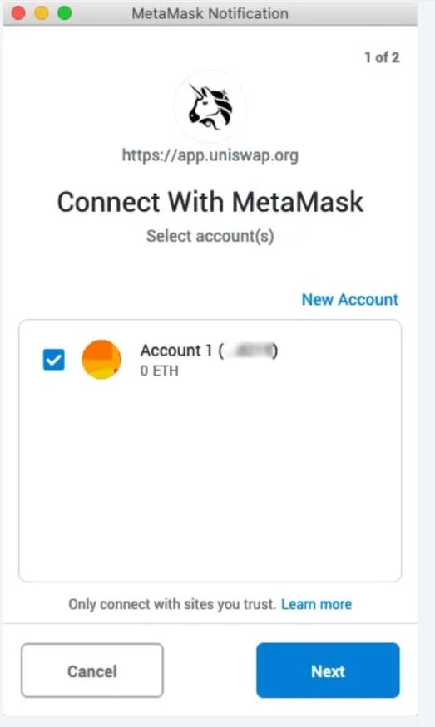

Dapps automatically connect to MetaMask, simplifying the connection process. Within the dapp, if payment is required, a pop-up window will appear asking to confirm the transaction from the MetaMask account.

## What advantages does MetaMask have?

* **Popular** - It is commonly used, so users only need one plugin to access a wide range of dapps.
* **Simple** - Instead of managing private keys, users just need to remember a list of words, and transactions are signed on their behalf.
* **Saves space** - Users don’t have to download the Ethereum blockchain, as MetaMask sends requests to nodes outside of the user’s computer.
* **Integrated** - Dapps are designed to work with MetaMask, so it becomes much easier to send Ether in and out.

**03 CONCLUSION:**. In this way,we studies Demonstration of Metamasks.