|  |  |  |  |  |  |
| --- | --- | --- | --- | --- | --- |
| D:\sep2k3\COLLEG~1\LOGO.JPG | SHRI SANT GAJANAN MAHARAJ COLLEGE OF ENGG. SHEGAON | | | **LABORATORY MANUAL** | |
| **PRACTICAL EXPERIMENT INSTRUCTION SHEET** | | | | |
| LABORATORY MANUAL NO.:SSGMCE/WI/IT/BCF/7IT08/15 | | ISSUE NO.: 00 | | ISSUE DATE: 18/07/2022 | |
| REV.DATE: | | DEPTT:INFORMATION TECHNOLOGY | | | |
| LABORATORY: Block Chain Fundamental | | | SEMESTER: 4N/VII | | PAGE: 1 OF 3 |

**01 AIM: Demonstration of one Click DAPP.**

**02 Theory**

OneClickDapp instantly builds you a dApp with a simple URL to bookmark or share with a friend. Anyone with the dApp URL can interact with your shiny new smart contract, and access all functions at the correct address/network. There is no need to write a single line of front-end code

Smart Contract: A smart contract refers to a self-executing contract with the terms of the agreement between buyer and seller being directly written into lines of computer code. The code and the agreements contained therein exist across a distributed, decentralized blockchain network.

Smart contracts permit trusted transactions and agreements to be carried out among disparate, anonymous parties without the need for a central authority, legal system, or external enforcement mechanism. They render transactions traceable, transparent, and irreversible.

Smart contracts are shaping up to be the next big thing in the blockchain space with various start-ups moving in to become the best players when it comes to smart contract creation and adoption.

Consider the case of an online store, where a business owner could easily create a decentralized application (dApp) on the dApp Builder platform without any coding skills. Users can select Escrow smart contracts from the marketplace and use drag and drop functionality to quickly create Escrow dApps; and this will ensure that delivery confirmations and release of payments can be initiated and tracked over the blockchain. This takes out the need for a third-party escrow service when facilitating peer-to-peer transactions.

**03 Working with OneClickDapp.**

Follow the following steps

**1**. Open the url <https://oneclickdapp.com/> Click on Get Start

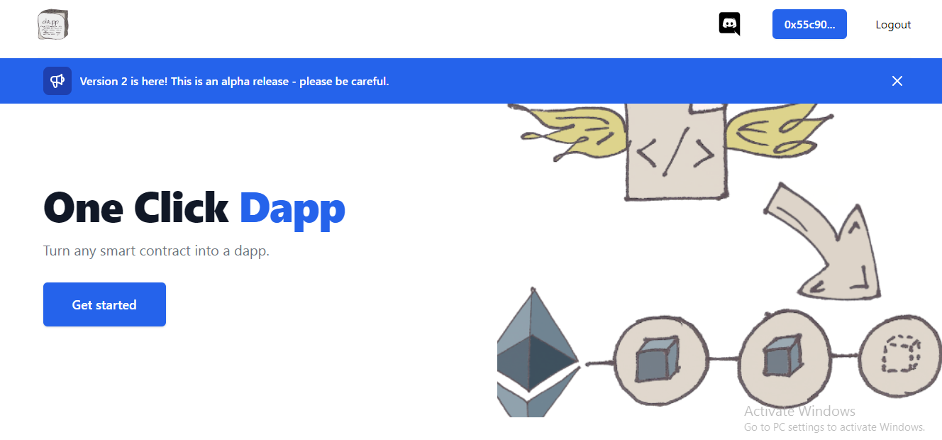

**2.** Choose your wallet and collect with it

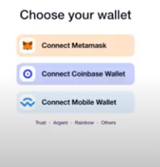

In below example it is connected to Metamask.

**3.**Fill the detail

Before filling the details Create Smart Contract in Remix

E g

pragma solidity ^0.6.0;

contract Counter{

    uint value;

    function intialize(uint x)public{

        value =x;

    }

    function get()view public returns(uint){

        return value;

    }

    function increment(uint n)public{

        value = value +n;

        //return (optional)

    }

    function decrement (uint n)public{

        value = value-n;

    }

}

**Compile & deploy the code in Remix**

**Name** i..e Mention the name of your App

**Description** i..e provide decriptionn of your App

**ABI (**Application Binary Interface)copy ABI file from Solidity Compiler Remix

Contract Address: This address can be copyed from Deploy & run transaction from Remix

**Network Name:** Goreli

**Save it.**

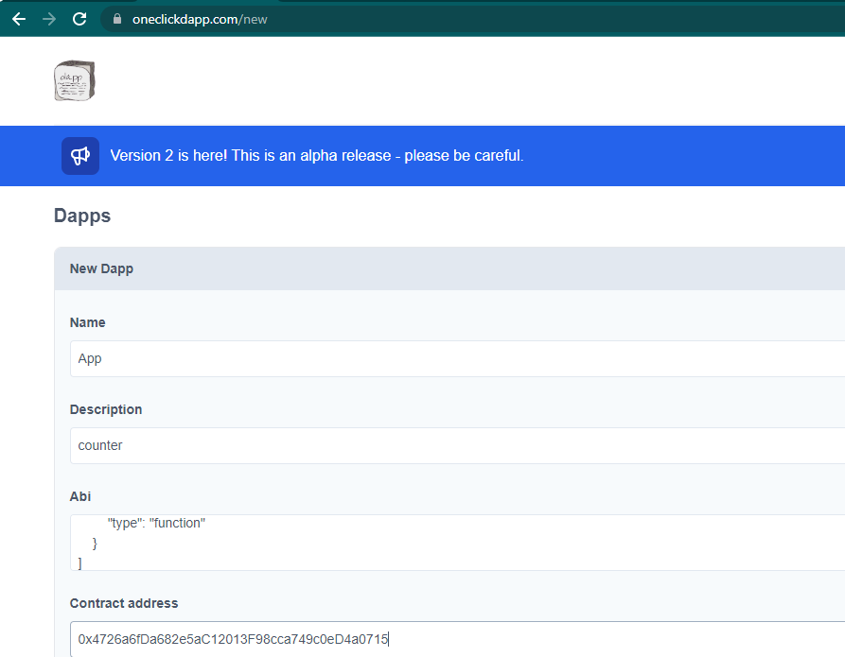

**s4. App is created**

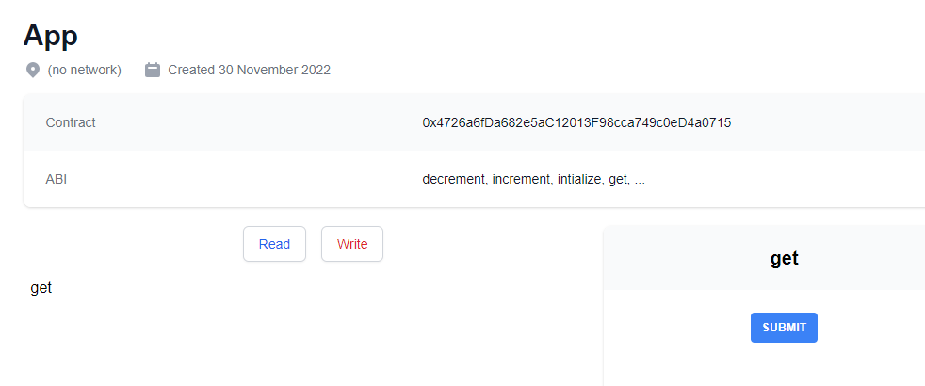

**04 Conclusion:** In this practical we have studied OneClickApp.