Production Deployment [Non-PCR Process]

The below document provides insight on how the development team will be using the new Non-PCR (aka RITM) process to schedule a Prod deploy in Octopus.

**IMPORTANT**

Make sure you create a **NEW** release & also make sure it is ready for Production Deploy in Octopus (Meaning it has been deployed to all lower environments). **Any release originally dated before 2/28/2019 is not compatible with this new process! Please create a new release in Octopus and promote it through your non-prod environments before attempting to use this new process**

**Overview of Steps to Setup:**

1. Have your Octopus release promoted through any required non-prod environments so its ready to be deployed to your production environment(s).
2. Create a ServiceNow change ticket for the Production Release.
3. Submit an AetnaITNow Prod Deploy Request (RITM Request). The development team does not need to wait for the change ticket to be approved to submit this request. Just make sure the ServiceNow change ticket is approved/scheduled **at least 10 minutes before scheduled deploy time**!

Submit an AetnaITNow Prod Deploy Request (RITM Request)

**NOTE**

RITMs can't be scheduled more than 30 days in advance. Also, make sure you give **at least 10 minutes** between getting the ServiceNow change ticket approved/scheduled and the RITM's "Requested Deploy Start Time". More on this below.

1. Navigate to [AetnaITNow](https://aetnaprod1.service-now.com/itnow) and search for octopus in the search box.

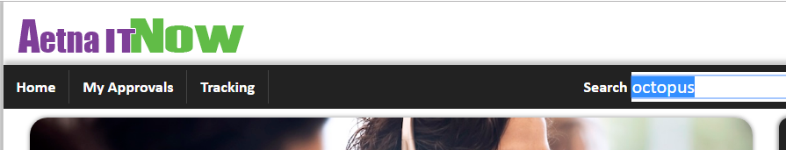

1. Click **Octopus Deploy** to start the process of scheduling your Prod deployment in Octopus.

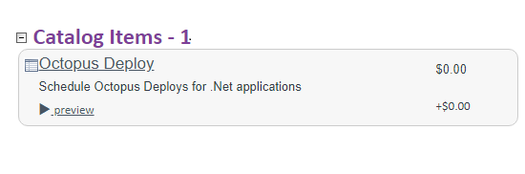

1. Select **Octopus Instance** and type - AETH. *Other options include HEH for the HealthTheHost environment.*

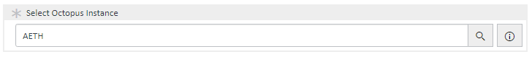

1. Type the exact Octopus **Project** Name.

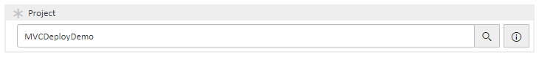

1. Select the production **Environmnet** this deploy will be going into.

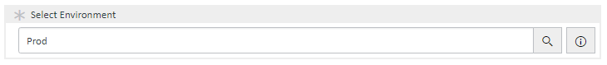

1. Type the **Change Request Number** you have submitted for this production deployment. NOTE: If you don't see any change requests in this field, make sure you have an [ITIL Role](https://aetnaprod1.service-now.com/itnow/catalog.do?v=1&uri=com.glideapp.servicecatalog_cat_item_view.do%3Fv%3D1%26sysparm_id%3De0db047fdba4fe809979f1e51d961957%26sysparm_link_parent%3D9874b72e6fefe10007a5f00dba3ee48e%26sysparm_catalog%3De0d08b13c3330100c8b837659bba8fb4&sysparm_document_key=sc_cat_item,e0db047fdba4fe809979f1e51d961957).

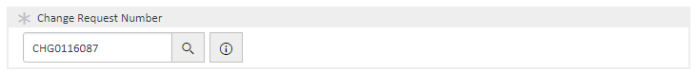

1. The above entered change request ticked will auto populate the **Change Start Time** and **Change Expire Time**. Those values are called the "Change Request Window". You do get an option to reschedule the deploy time, but only inside of the change request window. This can be done multiple times in case of deploy failures or Prod Issues.

**NOTE**

The grayed-out text boxes are the time entered in the ServiceNow change request ticket, which cannot be modified. The "**Requested Deploy Start Time**" **must** be used if the current time is later than the start time of the change ticket. If you want your migration to start at a specific time within the change ticket time you would specify it in the Requested Deploy Start Time field. If you find you need a fix or redo you must put in either the current time or a later time (must be within change request times). **The "Requested Deploy Start Time" MUST be the current time or later or it will fail.** Also, the ServiceNow change ticket must be approved/scheduled **at least 10 minutes before** the "**Requested Deploy Start Time**". If this isn’t followed, a new RITM will need to be submitted.

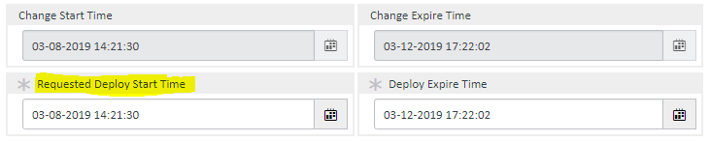

1. Select the **Release ID** that needs to be deployed to production.

**NOTE**

This Release ID **must** be ready to be deployed to the production environment! Meaning it has to have first successfully gone through the prerequisite non-prod environments first in Octopus Deploy. **Release ID's created before 2/28/2019 are not supported by this process! Please use the legacy PCR process for those.**

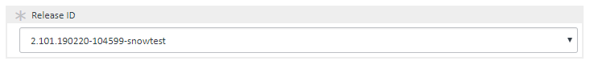

1. *[Optional Step]* If you have multiple deploys for same change request number, you can use **Add to Cart** to add them one after the other. Repeat the process by filling out the form and clicking **Add to Cart** for each Octopus Project/Release.

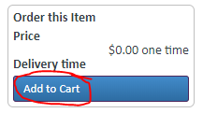

1. Once done, click on the **Proceed to Checkout** button to review your cart.

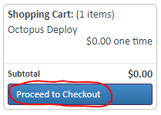

1. Click the **Checkout** button to submit the order and create the RITM(s).

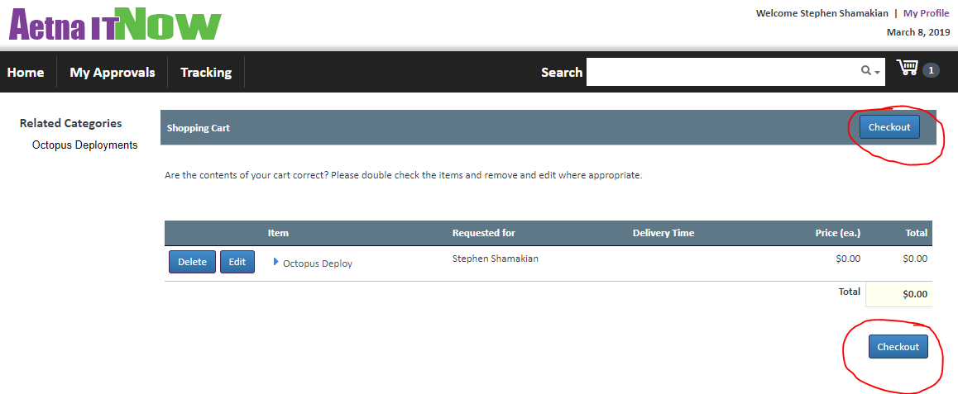

Deploying With Octopus

**IMPORTANT**

If the ServiceNow change ticket is already approved/scheduled at time of submitting the RITM request, it will schedule the deploy right away in Octopus (you will see this in your project's overview page in Octopus). Otherwise, it will wait until the ServiceNow change ticket is approved to schedule the deploy in Octopus. **Make sure the ServiceNow change ticket is approved atleast 10 minutes before the scheduled deploy time!**

1. In [Octopus Deploy](xref:OctopusDeploy), check to see if the deployment is scheduled.

**NOTE**

Image shows QA as scheduled, since this is just a demonstration this normally would be your Prod or Prod2 environment.

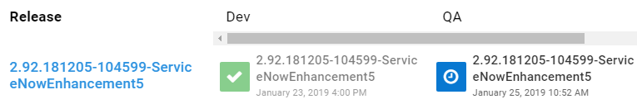

1. Once your deployment has started at the time mentioned in Octopus an email will be sent to the QA approvers group and a box will appear like this on the deployment page.

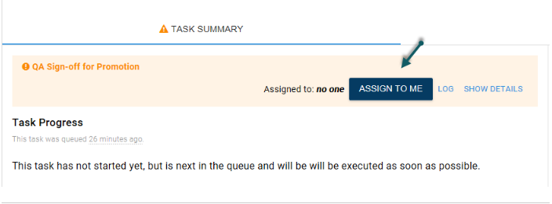

1. You will need to click **Assign to me** and optionally enter in any notes and finally click **Proceed**.

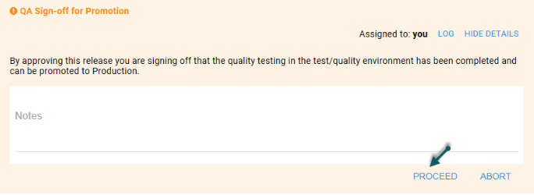

1. You can also track the status of Deploy in AetnaITNow.

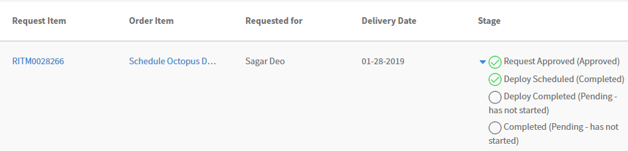

1. Once the Deploy is complete, the status will change to **Completed**.

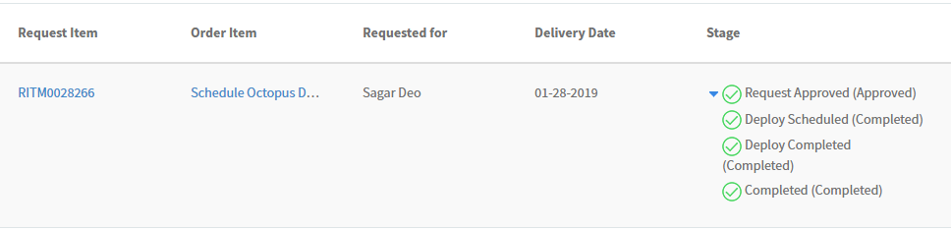

Cancelling A Prod Deploy

You can now self-cancel production deployments inside of Octopus Deploy. Look for the large orange "Cancel" button (top right of the screen when viewing the deployment). You can cancel at any time; while its scheduled/pending, waiting approval or durring the deploy.

* This is what the cancel button looks like:

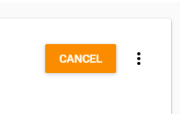

Emergency Changes

If you require an Octopus deploy for an emergency move you can create an Emergency Change ticket and create a RITM request for an automated deploy **without the Emergency ticket being scheduled/approved** to get the code in to production. You will then have 48 hours to make sure the emergency ticket gets approved and scheduled.

Searching for an RITM request in AetnaITNow

If you wish to search for the Octopus RITM request that you submitted, follow the below steps:

1. Navigate to [AetnaITNow](https://aetnaprod1.service-now.com/itnow)
2. Click on **Tracking** to see all open/closed requests submitted by you

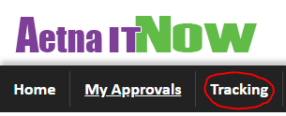

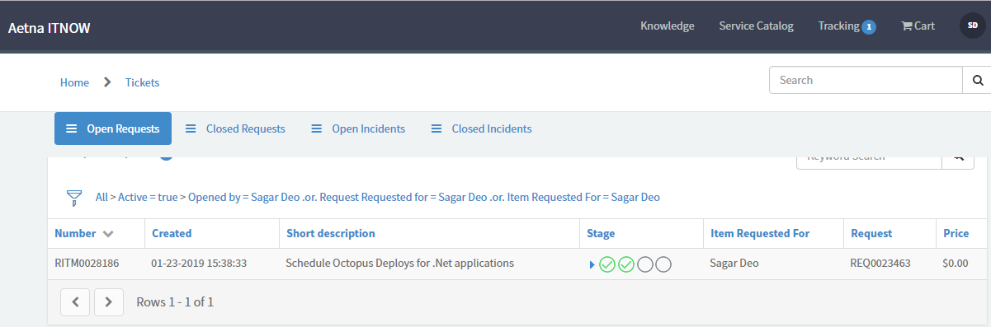

1. You can modify the **search filter** to look for specifc RITM

