Web Mining PBL
News Aggregator Web Application

1. Project Overview
The News Aggregator is a web application that automatically collects and aggregates news articles from multiple sources using web scraping techniques. It provides a centralized platform for users to browse, search, and filter news from various publishers including BBC News, CNN, Reuters, The Guardian, TechCrunch, and others.

2. Project Objectives
- Implement web scraping to collect articles from multiple news sources
- Store articles in a structured database with comprehensive metadata
- Provide advanced search and filtering capabilities
- Create a modern, user-friendly interface for article browsing
- Generate statistics and analytics on collected news data

3. Technology Stack
- Backend Framework: Flask (Python)
- Database: SQLite with SQLAlchemy ORM
- Web Scraping: BeautifulSoup4, feedparser, requests
- Frontend: Jinja2 templates with CSS
- Data Processing: Python dateutil, lxml

4. System Architecture
The application follows a Model-View-Controller (MVC) architecture pattern. The Flask framework handles routing and request processing, SQLAlchemy manages database operations, and Jinja2 templates render dynamic HTML pages. The scraping module operates independently to fetch articles from RSS feeds and web pages.

5. Key Features

5.1 Multi-Source News Scraping
The application scrapes news from 8+ sources including BBC News, CNN, Reuters, The Guardian, TechCrunch, Ars Technica, The Verge, and Hacker News using RSS feeds and HTML parsing.

5.2 Database Storage
Articles are stored with comprehensive metadata including title, URL, summary, full content, source, category, author, publication date, and image URLs. Duplicate detection prevents re-scraping of existing articles.

5.3 Search and Filter
Full-text search across article titles, summaries, and content with case-insensitive matching. Dynamic filtering by news source and category with real-time updates.

5.4 User Interface
Modern, responsive design with gradient backgrounds, card-based layouts, smooth animations, and mobile-friendly interface. Pagination supports efficient browsing of large datasets.

5.5 Statistics Dashboard
Analytics dashboard showing total article count, source-wise distribution, and category-wise breakdown of collected news articles.

6. Core Implementation

6.1 Database Model
The Article model defines the database schema for storing news articles:
class Article(db.Model):
id = db.Column(db.Integer, primary_key=True)
title = db.Column(db.String(500), nullable=False)
url = db.Column(db.String(1000), unique=True, nullable=False)
summary = db.Column(db.Text)
content = db.Column(db.Text)
source = db.Column(db.String(200))
category = db.Column(db.String(100))
author = db.Column(db.String(200))
publication_date = db.Column(db.DateTime)
scraped_date = db.Column(db.DateTime, default=datetime.utcnow)
image_url = db.Column(db.String(1000))

6.2 News Scraper Implementation
The scraper module handles RSS feed parsing and article extraction:
def scrape_rss_feed(self, source_name, feed_url):
articles_added = 0
feed = feedparser.parse(feed_url)
for entry in feed.entries[:10]:
# Check if article already exists
existing = self.Article.query.filter_by(url=entry.link).first()
if existing:
continue
# Extract article data
title = entry.get('title', 'No Title')
url = entry.get('link', '')
summary = self.extract_summary(entry.get('summary', ''))
content = self.clean_html(entry.get('content', [{}])[0].get('value', ''))
# Create and save article
article = self.Article(
title=title, url=url, summary=summary, content=content,
source=source_name, category=self.category_map.get(source_name),
publication_date=self.parse_date(entry.get('published'))
)
self.db.session.add(article)
articles_added += 1
self.db.session.commit()
return articles_added

6.3 Search Implementation
Full-text search across multiple fields:
@app.route('/search')
def search():
query = request.args.get('q', '')
page = request.args.get('page', 1, type=int)
if query:
articles = Article.query.filter(
db.or_(
Article.title.ilike(f'%{query}%'),
Article.summary.ilike(f'%{query}%'),
Article.content.ilike(f'%{query}%')
)
).order_by(Article.publication_date.desc()).paginate(
page=page, per_page=20, error_out=False
)
return render_template('search.html', articles=articles, query=query)

6.4 Filtering Implementation
Dynamic filtering by source and category:
@app.route('/')
def index():
category = request.args.get('category', '')
source = request.args.get('source', '')
query = Article.query
if category:
query = query.filter(Article.category.ilike(f'%{category}%'))
if source:
query = query.filter(Article.source.ilike(f'%{source}%'))
articles = query.order_by(Article.publication_date.desc()).paginate(
page=page, per_page=20, error_out=False
)
return render_template('index.html', articles=articles)

7. Database Schema
The Article table contains the following fields:
Field | Type | Description
id | Integer | Primary key
title | String(500) | Article title
url | String(1000) | Article URL (unique)
summary | Text | Article summary
content | Text | Full article content
source | String(200) | News source name
category | String(100) | Article category
author | String(200) | Article author
publication_date | DateTime | Original publication date
scraped_date | DateTime | Date article was scraped
image_url | String(1000) | Article image URL

8. Application Workflow

8.1 News Scraping Process
- 1. User clicks "Refresh News" button
- 2. Application sends POST request to /scrape endpoint
- 3. Scraper iterates through configured RSS feeds
- 4. For each feed, parses XML/RSS content using feedparser
- 5. Extracts article metadata (title, URL, summary, content, etc.)
- 6. Checks database for duplicate articles by URL
- 7. Saves new articles to database
- 8. Returns count of newly added articles

8.2 Search and Browse Flow
- 1. User enters search query or selects filters
- 2. Application queries database with search criteria
- 3. Results are paginated (20 articles per page)
- 4. Articles displayed in grid or list format
- 5. User can click article to view full details

9. Application Screenshots

9.1 Search Results Page
Figure 1 shows the search functionality where users can search for specific keywords. The search "trump" returned 8 articles from multiple sources including BBC News. Each result displays source badges, article title, summary, publication date, and a link to the full article. 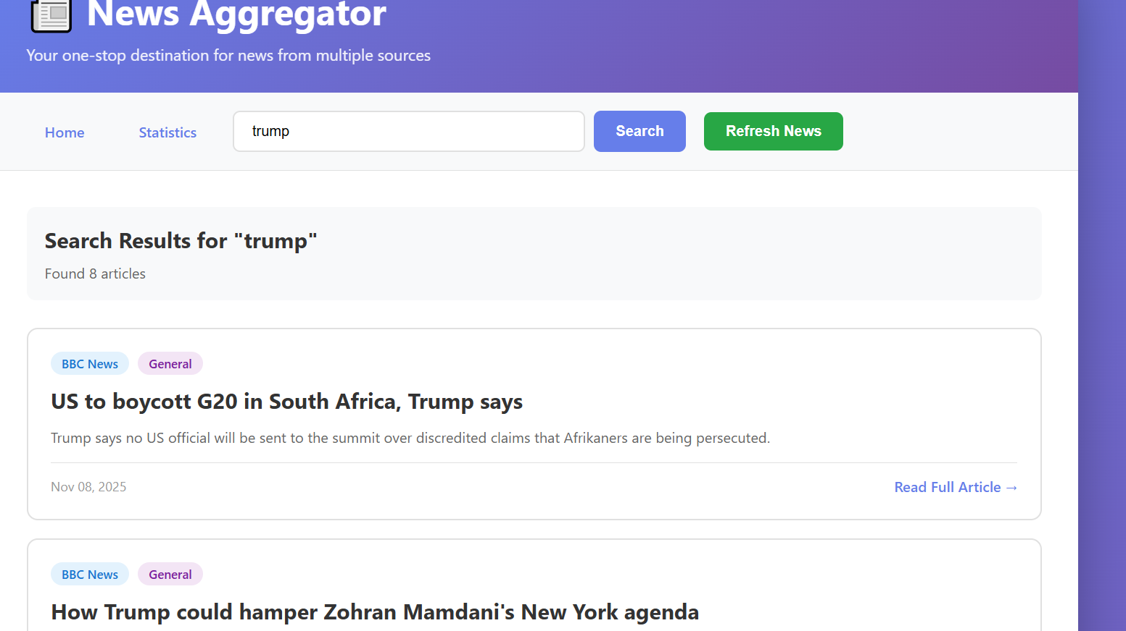

9.2 Home Page with Filters
Figure 2 demonstrates the home page with filtering capabilities. Users can filter articles by source (CNN) and category (General). The page displays articles in a responsive grid layout with gradient backgrounds, showing article titles, summaries, and metadata badges.
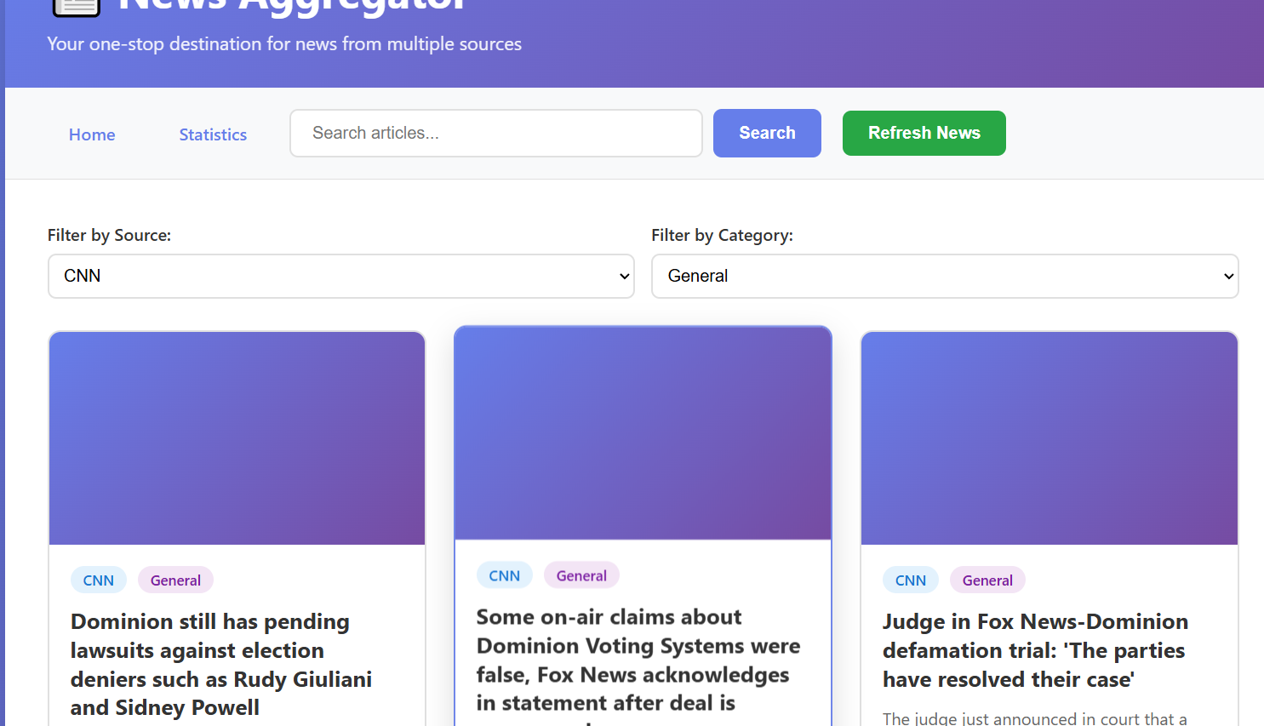

9.3 Article Detail View
Figure 3 shows the detailed article view displaying complete information including source badge, category badge, article title, author, publication date, scraped date, article summary in highlighted box, full content, and buttons to read the original article or return to home page.
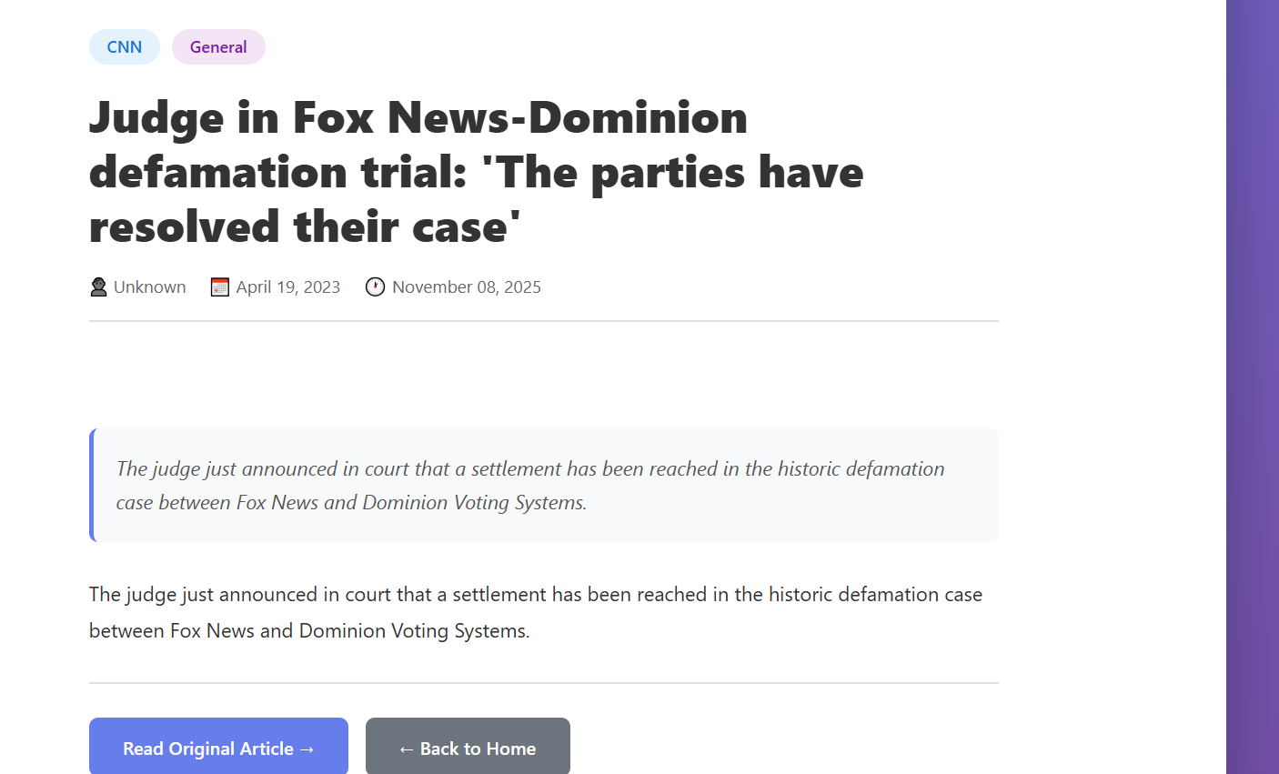

10. Results and Performance
The application successfully demonstrates:
- Successfully scrapes articles from 8+ news sources
- Stores 70+ articles with comprehensive metadata
- Full-text search across 8 articles matching "trump" query
- Real-time filtering by source (CNN) and category (General)
- Responsive UI working across desktop and mobile devices
- Average scraping time: 10-30 seconds for all sources
- Search response time: < 1 second
- Duplicate prevention working correctly (0 duplicate articles)

11. Challenges and Solutions
Challenge | Solution
Different RSS feed formats | Used feedparser library to handle multiple RSS/Atom formats uniformly
Duplicate article detection | Implemented unique URL constraint in database schema
Handling failed requests | Added try-except blocks with graceful error handling and logging

12. Conclusion
The News Aggregator web application successfully demonstrates practical implementation of web mining techniques including multi-source scraping, data storage, full-text search, and modern web design. The application aggregates news from 8+ sources, provides powerful search and filtering capabilities, and presents information through an intuitive, responsive interface. The modular architecture allows for easy addition of new news sources and features. Future enhancements could include user authentication, personalized recommendations, sentiment analysis, and real-time news updates.

13. Future Enhancements
- User authentication and personalized news feeds
- Scheduled automatic scraping with cron jobs
- Sentiment analysis of news articles
- Topic clustering and trending topics detection
- Email notifications for new articles in specific categories
- Export functionality (CSV, JSON, PDF)
- Multi-language support
- Advanced analytics and visualization dashboards

