**LAPORAN PENUGASAN TEORI PEMWEBLAN**

**RENCANA PROJECT UAS**



**Disusun oleh :**

Kelompok 2/ TIA

**Anggota Kelompok :**

Aditya Cahya Adhadin M3118003

Ainul Fitriyah M3118005

Alifudin Niko Priambodo M3118007

Annisa Yuliana Rahma P M3118009

Bagus Mahmudie M3118016

**PROGRAM DIPLOMA III TEKNIK INFORMATIKA**

**SEKOLAH VOKASI**

**UNIVERSITAS SEBELAS MARET**

**SURAKARTA**

**2020**

**TUGAS 6. PEMBUATAN ERD, RELASI ANTAR TABEL,DETAIL TABEL**

1. Tema Project UAS : Peminjaman Buku Perpustakaan
2. Entity Relationship Diagram (ERD)

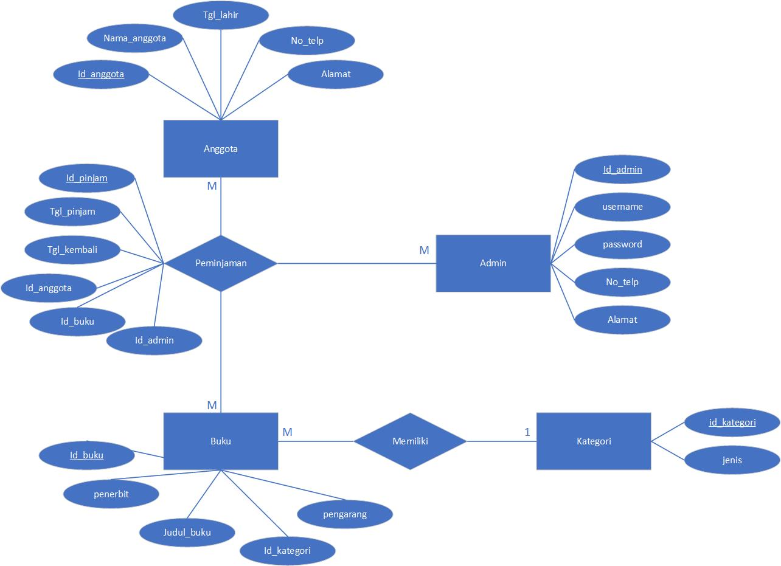

1. Relasi Antar Tabel

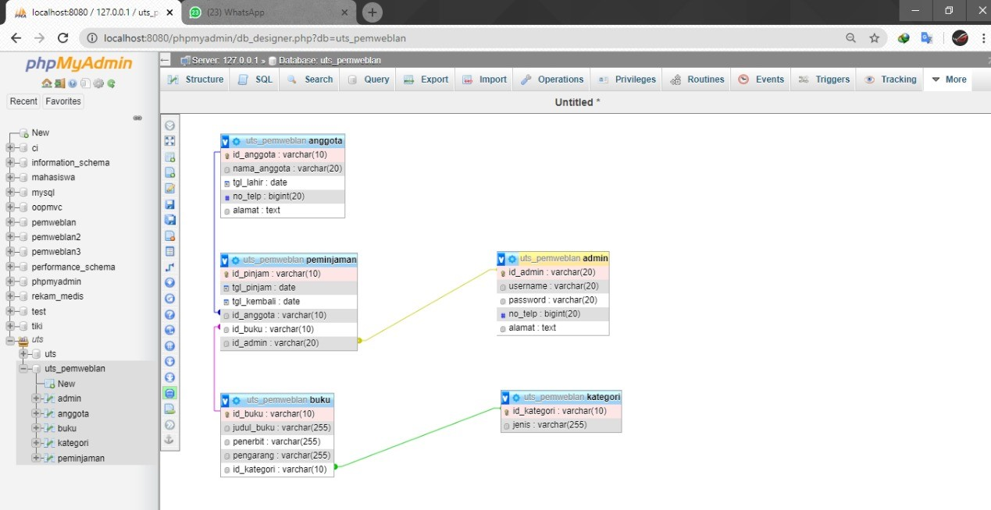

1. Detail Tabel
2. Admin

|  |  |  |  |  |
| --- | --- | --- | --- | --- |
| No | Nama Field | Type Data | Length | Keterangan |
| 1 | id_admin | Varchar | 20 | Primary Key |
| 2 | username | Varchar | 20 |  |
| 3 | password | Varchar | 20 |  |
| 4 | no_telp | Bigint | 20 |  |
| 5 | alamat | Text | - |  |

1. Peminjaman

|  |  |  |  |  |
| --- | --- | --- | --- | --- |
| No | Nama Field | Type Data | Length | Keterangan |
| 1 | id_pinjam | Varchar | 10 | Primary Key |
| 2 | tgl_pinjam | Date | - |  |
| 3 | tgl_kembali | Date | - |  |
| 4 | jumlah_buku | Int | 12 |  |
| 5 | id_anggota | Varchar | 10 | Foreign Key |
| 6 | id_buku | Varchar | 10 | Foreign Key |
| 7 | id_admin | Varchar | 20 | Foreign Key |

1. Buku

|  |  |  |  |  |
| --- | --- | --- | --- | --- |
| No | Nama Field | Type Data | Length | Keterangan |
| 1 | id_buku | Varchar | 10 | Primary Key |
| 2 | judul_buku | Varchar | 255 |  |
| 3 | penerbit | Varchar | 255 |  |
| 4 | pengarang | Varchar | 255 |  |
| 5 | id_kategori | Varchar | 10 | Foreign Key |

1. Anggota

|  |  |  |  |  |
| --- | --- | --- | --- | --- |
| No | Nama Field | Type Data | Length | Keterangan |
| 1 | id_anggota | Varchar | 10 | Primary Key |
| 2 | nama_anggota | Varchar | 20 |  |
| 3 | tgl_lahir | Date | - |  |
| 4 | no_telp | Bigint | 20 |  |
| 5 | alamat | Text | - |  |

1. Kategori

|  |  |  |  |  |
| --- | --- | --- | --- | --- |
| No | Nama Field | Type Data | Length | Keterangan |
| 1 | id_kategori | Varchar | 10 | Primary Key |
| 2 | jenis | Varchar | 255 |  |